MONDAY 8th JUNE 2020
Literacy 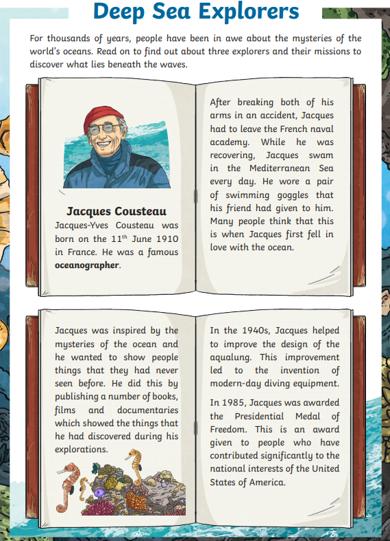
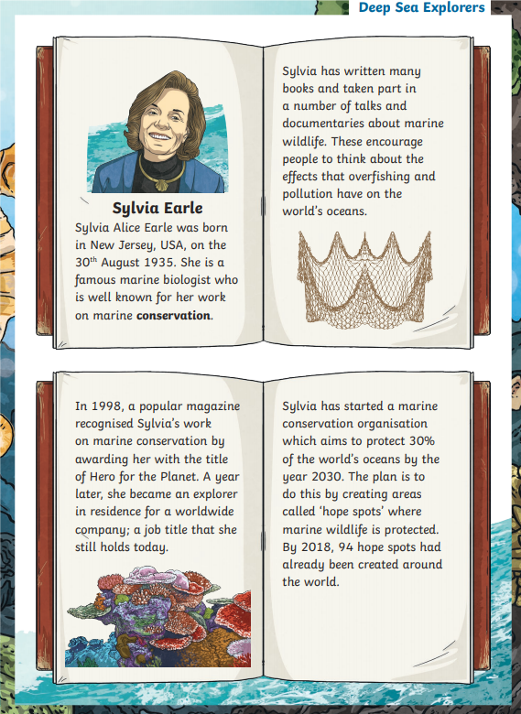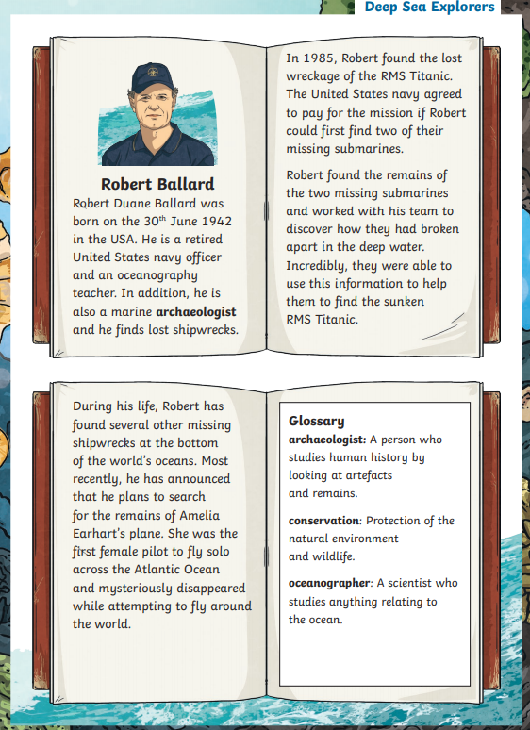

- Number the events from 1-4 to show the order in which they occurred.
  - Jacques Cousteau helped to improve the design of the aqualung.
  - 94 hope spots had been created around the world.
  - Sylvia was born.
  - Jacques Cousteau was born.
- Which of these has not been one of Robert Ballard's jobs. Tick one.
  - Oceanography teacher
  - Archaeology Teacher
  - Marine archaeologist
  - United States Navy Officer
- Draw four lines to match each achievement to the explorer who achieved it. Some explorers may have more than one achievement.
  - Discovered the wreckage of the RMS Titanic Jacques Cousteau
  - Was awarded the Presidential Medal of Freedom Sylvia Earle
  - Helped to improve the design of the aqualung Robert Ballard
  - Started an organisation to protect the oceans
- What are hope spots? Tick one
  - Areas of conversation which will start being built in 2030
  - Areas where marine wildlife is protected
  - Areas of land or sea where all wildlife is protected
  - Areas where people can learn about the effects of overfishing.
- Look at the section on Jacques Cousteau. Find and copy one word which means 'helped towards'.
- What did Robert Ballard and his team use to help them to find the wreckage of the RMS Titanic?
- Do you think that Sylvia Earle deserves the title of Hero for the Planet? Explain your answers.

Maths
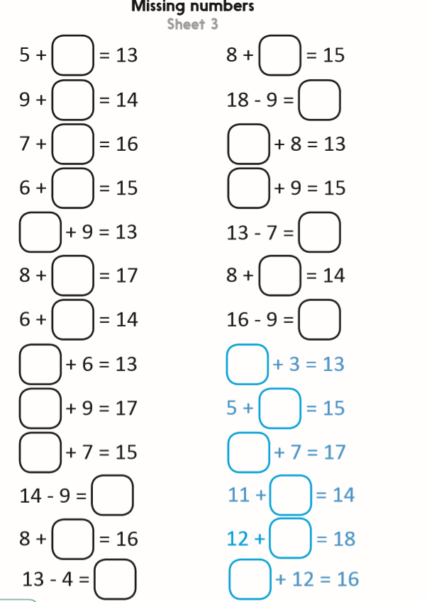

Water, Water, Water!
Our topic at the moment should be Water, Water, Water! The last week of school we got a chance to discuss this and come up with questions. We wanted to learn about the following:
- Sea Creatures
- Plastic Pollution
- Dirty Water
- The Sea Empress
- Science (Ice, food chains, types of water, water cycle, floating and sinking)
- Films – Nemo, Happy Feet, Little Mermaid, Free Willy, Sponge Bob
- Rivers, lakes and Seas
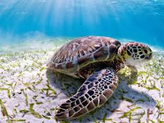

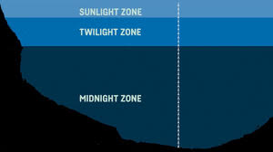

Could you find out a little more about each of the zones in the ocean including the distance from the surface?

Draw the zones out on paper and annotate with pictures of creatures that live in each zone. Remember to label each creature with its name.

For example
A turtle lives in the sunshine zone.

TUESDAY 9th JUNE 2020

Literacy

We are going to start the topic with The Sea Empress Disaster.

Use the following websites and videos to find out about the Sea Empress Disaster.
Write bullet points of what you have found out, ready to use in other lessons.

You will need to think about the following:
- Where?
- When?
- What?
- Why? How?
- What effect did it have on the beaches?
- What effect did it have on the wildlife?
- How did they clear the oil?
- What made it hard to stop the oil from pouring into the sea?
- How did they save the animals?
- How did it look?
- What it looks like now?
- Who was to blame?
- How will they make sure it does not happen again?

Useful Videos
https://www.bbc.co.uk/news/av/uk-wales-35550888/sea-empress-disaster-how-the-oil-spill-was-reported

https://www.bbc.co.uk/news/av/uk-wales-35582916/lessons-learned-from-1996-sea-empress-oil-spill

https://www.bbc.co.uk/programmes/p048lx96

https://youtu.be/GC0jHxN7H38

Useful Websites
http://news.bbc.co.uk/1/shared/spl/hi/picture_gallery/06/uk_the_sea_empress_disaster/html/1.stm

Maths
Partitioning means splitting the number into 10s and 1s. So if you had 34 +22 you would first add 4 + 2 = 6, then 30 + 20 = 50. You then add both together to get the answer 6 + 50 = 56
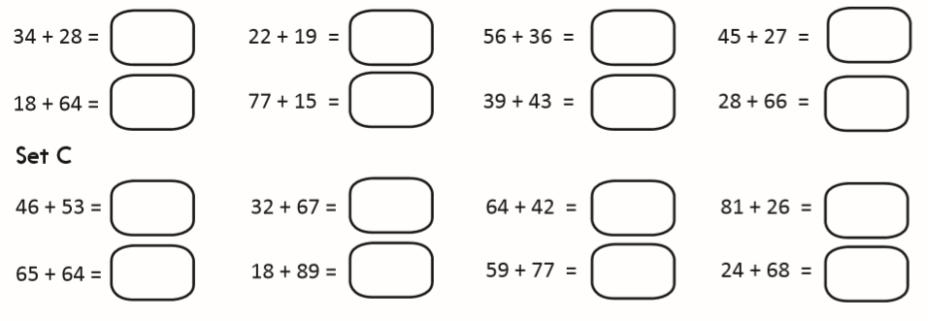

Expressive Arts
Create a mood board for the Sea Empress Disaster. Look at the images online for parts of the disaster you are interested in.

It could be:
- Animals
- Birds
- Oil refineries
- Tanker Ships
- The sea and beaches
- Environmental Impact

Pick a topic or include all of the above. You then find images that make you feel a certain way and either print out and stick to a large piece of paper or draw out. Your mood board should have lots of pictures on it. Once you have filled the piece of paper with pictures you can then add single words for how it makes you feel. Write these words in bubble writing and add to your mood board.

WEDNESDAY 10th JUNE 2020

Welsh

Beth wyt ti'n hoffi wneud? (What do you like doing?)

The word for doing is wneud.

The word for playing is chwarae.

Can you write three sentences on what you like and give a reason?

Dw in hoffi_______achos__________.

Can you write three sentence on what you don’t like and give a reason?

Dw i ddim yn hoffi ______achos_______.

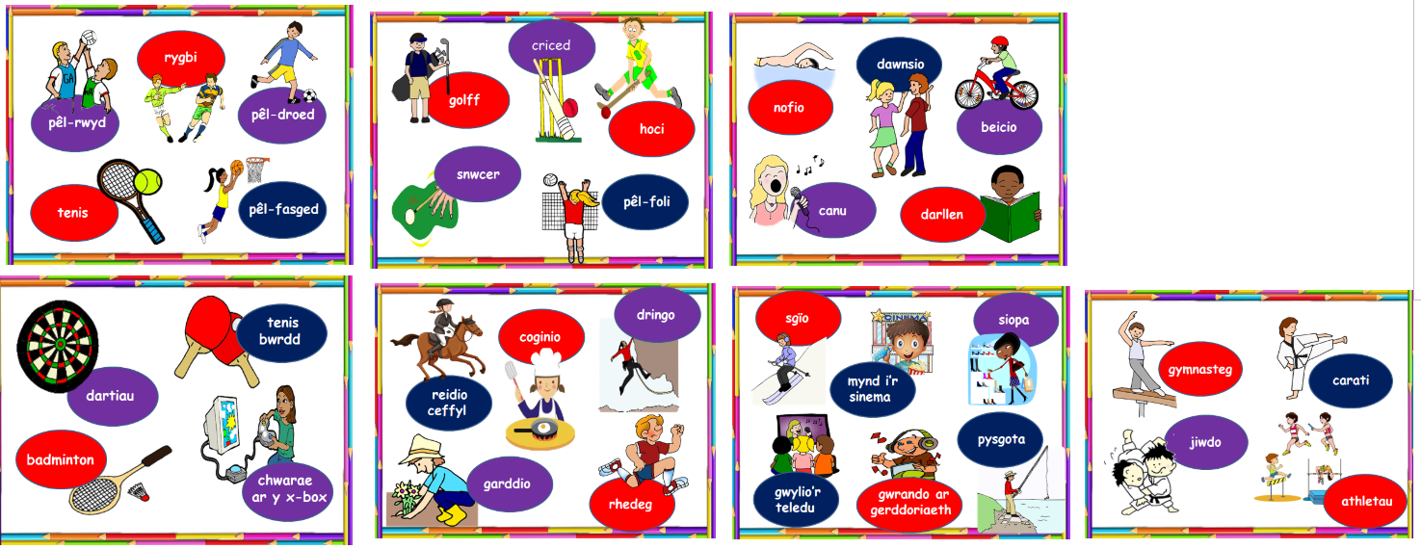
Maths
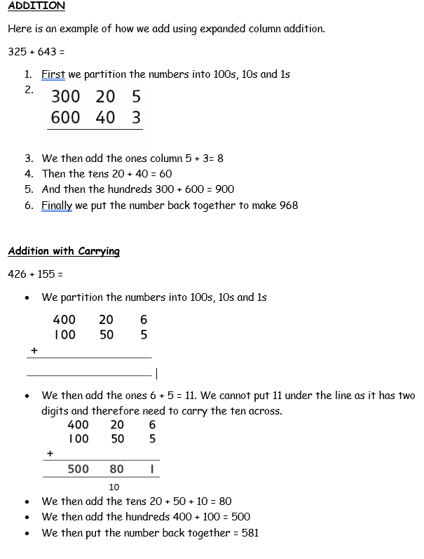

Using expanded column addition can you create your own number sentences.
1. Create two 3-digit number
2. Write the number sentence
3. Expand the numbers by placing the 100s, 10s and 1s in columns
4. Always add the 1s first

Science
Results

Draw a graph from the table of results. You should do this on HWB J2E and JIT chart.

Remember to create a title and label the axis.

Conclusion

What did your results show?
Explain what happened.
What have you found out?

Would you change anything?

THURSDAY 11th JUNE 2020
Literacy
Look at these pictures and create a word bank to use in other lessons.

What can you see?
How do you feel?
What would you hear, smell and touch?

Think of as many words as you can.

Imagine you were there when it happened. You were asked by BBC News to explain what had happened and how it made you feel. What would you have said? Write it out.
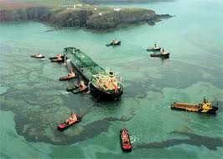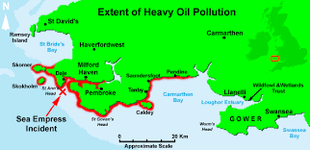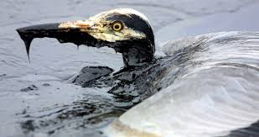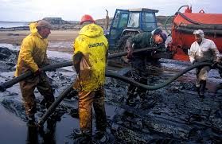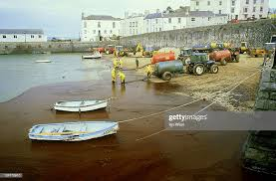

Maths
1. 627 children are in the swimming pool. An extra 44 children enter the swimming pool. How many children are in the swimming pool in total?

2. There are 134 children in Year 3 and 37 children in Year 4. How many children are there in Years 3 and 4?

3. In my lunchbox I have a sandwich and an apple. My sandwich weighs 378g and my apple weighs 103g. What is the weight of my lunchbox?

4. There were 433 people on the train at Orpington station. 68 people entered the train at Bromley station. How many people were on the train altogether?

5. In the library, there are 442 books. At lunch time, the children return 79 books. How many books are in the library after lunch?

6. A TV costs £735 and a Playstation costs £195. How much money would I need to buy both items?

7. Emily bought chips for 452p and a drink for 269p. How much did it cost altogether?

8. There are 545 ants marching in a line. 76 ants join the line and start marching. How many ants are marching in total?

9. A plant was 127cm tall on Monday and grew 83cm in a week. How tall was the plant in a week’s time?

10. An orchard contains 235 apple trees, and 186 pear trees. How many trees are there in the orchard?

Computing
https://scratch.mit.edu/projects/editor/?tutorial=getStarted

Click on the tutorial 'Make it fly' and follow the instructions on screen.

FRIDAY 12th JUNE 2020
Literacy
https://www.operations.amsa.gov.au/kids-and-teachers-resources/kids/teachers/Wildlife_Oil_Effects/index.html

https://sciencing.com/oil-spill-information-kids-5444185.html

Use the websites above to look at how oil spills effect animals.

Create a poster telling people in Milford Haven what happened to then wildlife when the Sea Empress Disaster happened.
Your poster should include:
- Catchy title
- Colours to make it stand out
- Photographs/pictures that make people feel a certain way.
- How an oil spill effects wildlife?
- The problems birds faced when their feathers were coated in oil.
- What can happen to animals living in the environment?

Maths
Green – T
Blue – T and S
Red and Black - All

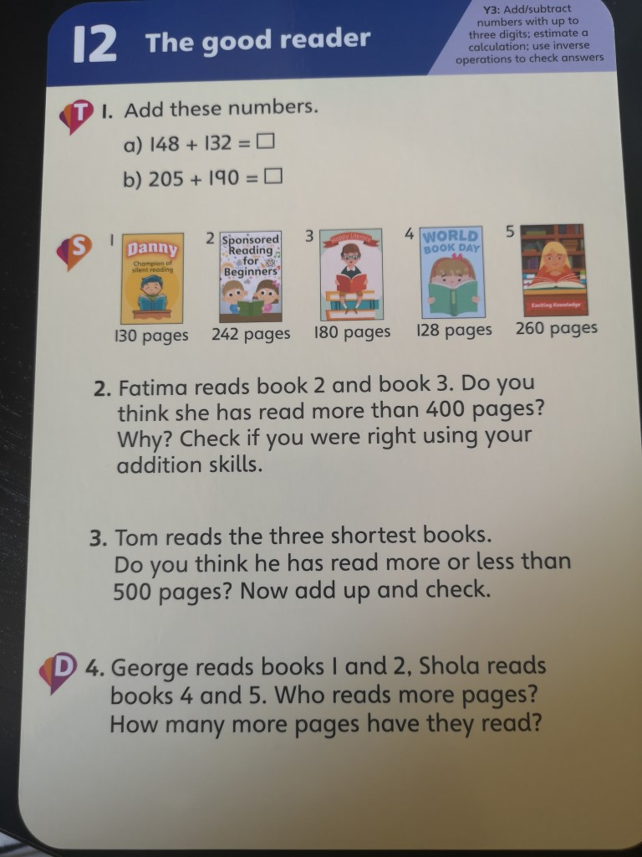

PE
How many of these exercises can you do?
