Multi Faith Week
This week we are going to be learning about Islam in the afternoons instead of Expressive Arts, Project, Computing, Science and PE.
MONDAY 1st JUNE 2020
Iaith
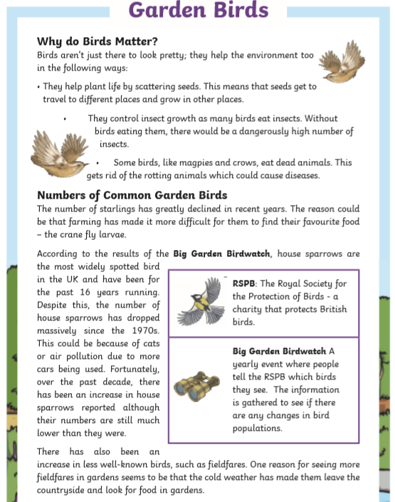

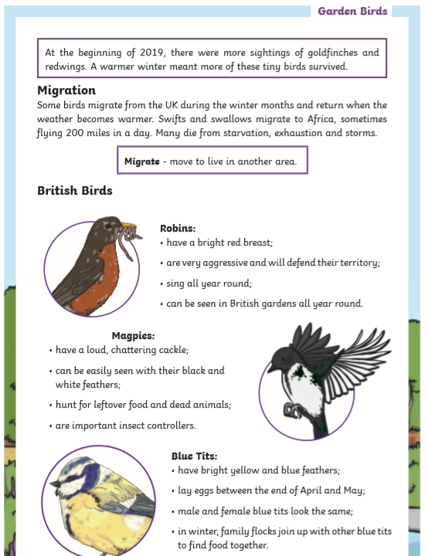
- How do birds help the environment? List three ways.
- Which is closest in meaning to the word declined? Tick one.
  - In partnership
  - Below
  - Reduced
  - Risen
- What is the Big Garden Birdwatch?
- Why do you think the RSPB started the Big Garden Birdwatch? Give two reasons.
- Read the second paragraph of the Numbers of Common Garden Birds section. Why has the author used the word fortunately?
- Why has there been an increase in the number of fieldfares spotted in gardens?
- Fill the table
 | True | False
Some birds migrate from the UK during the summer months.
Robins are aggressive birds.
Magpies eat lots of insects.
Blue tits lay their eggs at the end of June.
- Read the British Birds section. Which do you like the best and why?

MATHS
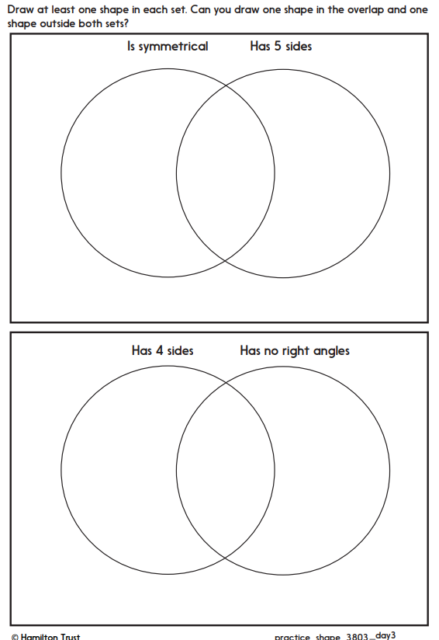

ISLAM
Here are the five pillars of Islam. We are going to look at some of these in more detail. We have already done some reading on Ramadan.

Can you research and tell me what each pillar means?

Can you then create the five pillars of Islam using recycled materials of paint?

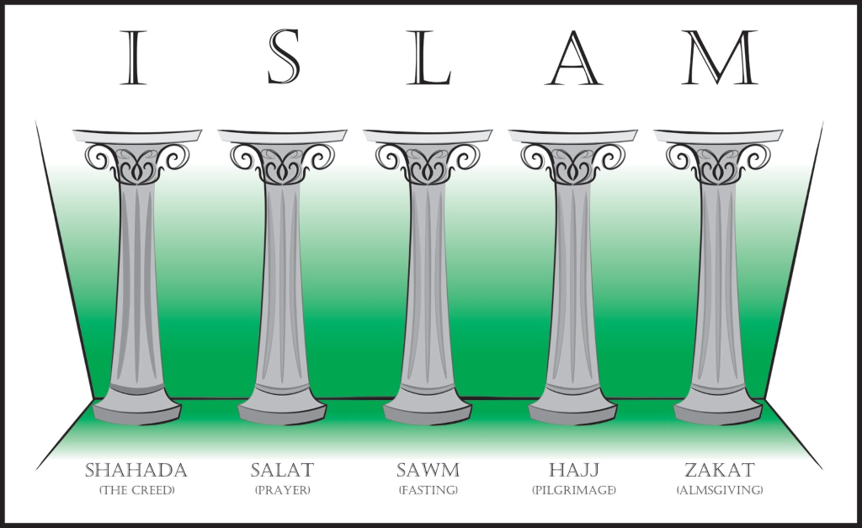

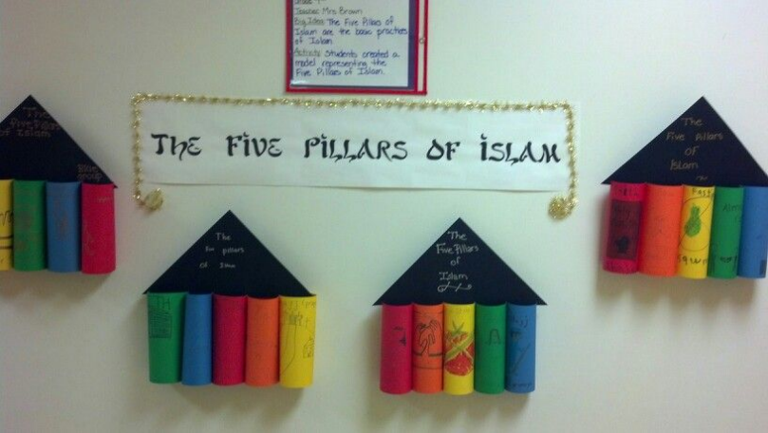
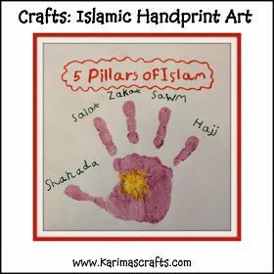

TUESDAY 2nd JUNE 2020

IAITH

https://youtu.be/yB8VHw0s0oA

Listen to the story of The Magical Garden of Claude Monet.
What did you think of the story?
Did you recognise any of the paintings?
What is similar about them?
What sort of colours did Monet use?
What did he like to paint?
What did the girl in the story see on her journey with Monet?

Imagine a conversation she might have had with her mother when she returned to the house. What might her mother have asked her?
Can you write a conversation between Julie and her mother using the correct speech punctuation?

SPEECH
- Each new character's speech starts on a new line.
- Speech is opened with speech marks.
- Each line of speech starts with a capital.
- The line of speech ends with a comma, exclamation mark or question mark.
- A reporting sentence is used at the end (said Jane, shouted Paul, replied Mum).
- A full stop goes after the reporting sentence.

MATHS
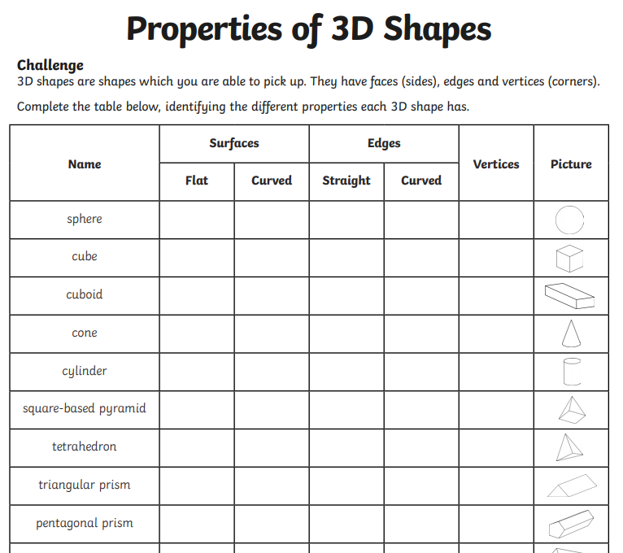

Islam
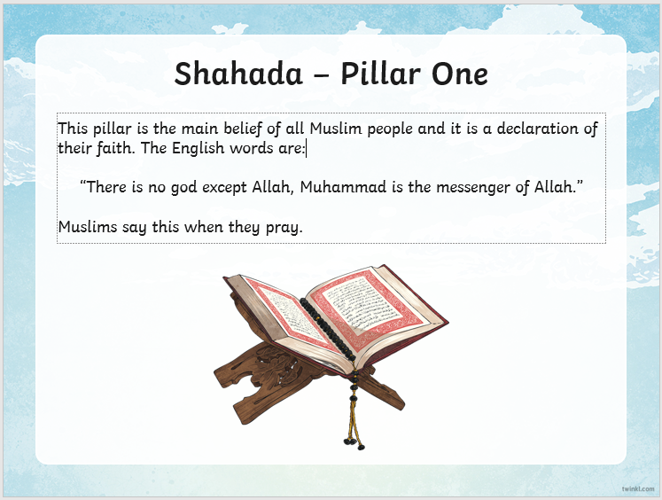
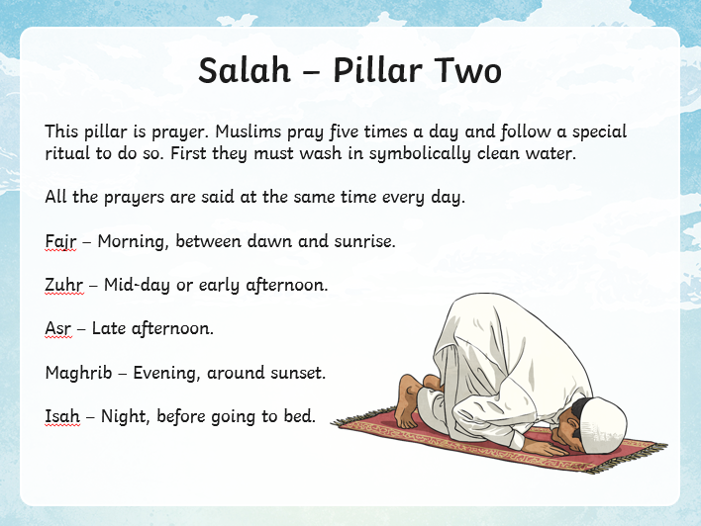

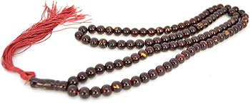
- Muslims use prayer mats and prayer beads while they pray.
- There are 99 beads altogether for the 99 names for Allah and beads are passed through fingers and Muslims recite names or special prayers.
- Look at some names Muslims have for Allah. Use the internet to research
Activities
- Ask children to write down some names they would use for God and decorate the border in the style of an Islamic pattern.
- Draw a set of prayer beads and write information around them to explain how they are used. Encourage children to include an explanation of how important they are to focus Muslims on prayer.

WEDNESDAY 3rd JUNE 2020

Welsh
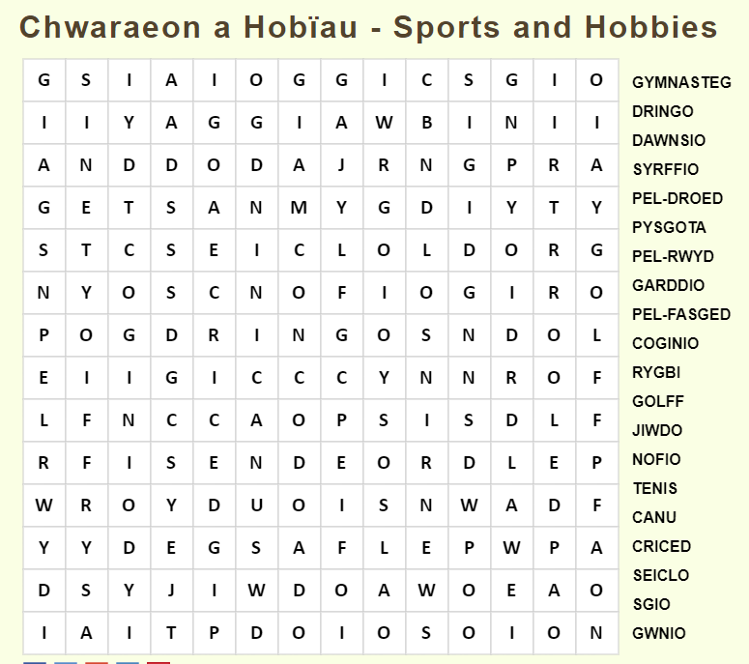
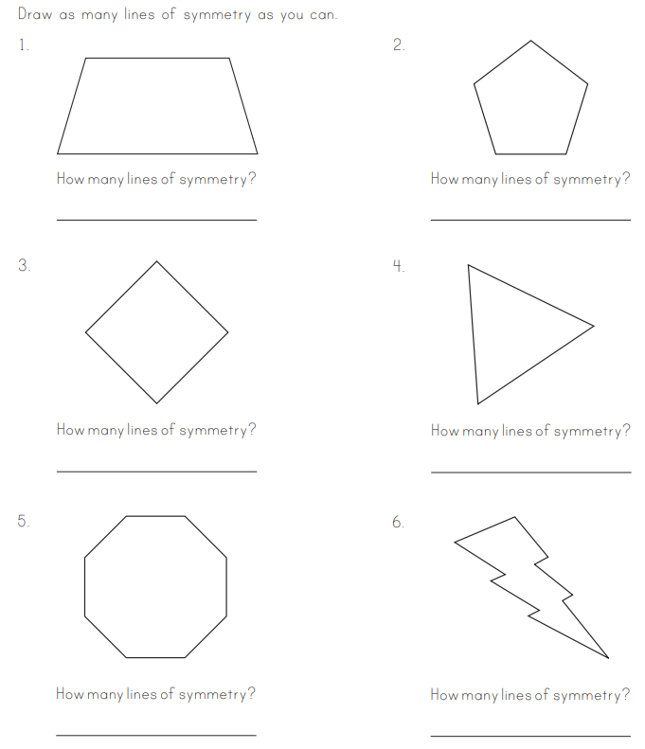
Islam
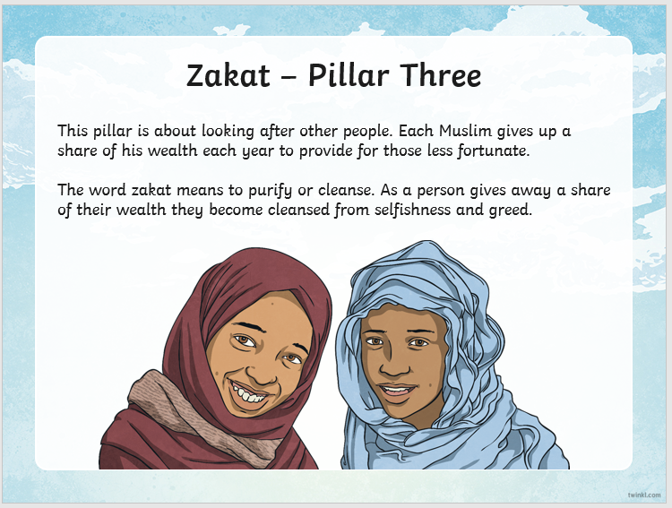
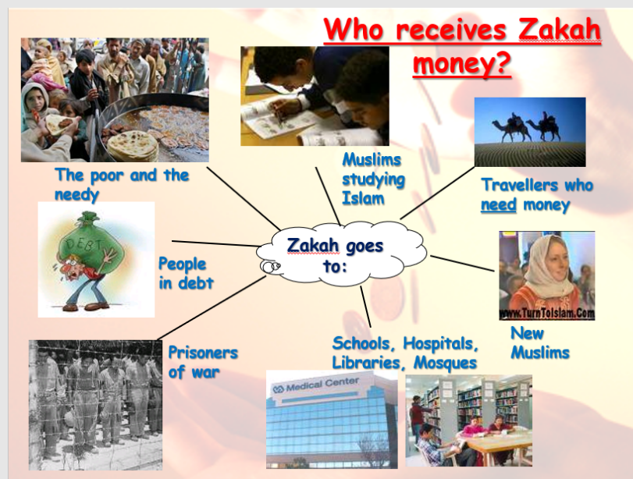

Create a word map on good deeds. Place the word good deeds in the middle of the paper and then write around it. Think about all the good deeds people could do and the charity work.

THURSDAY 4th JUNE 2020
Iaith
Paintings
Look at Monet's paintings of then River Thames in London.
Do you recognise the landmarks?
If you have ever been to London discuss what sights you saw and your experiences. If you have not visited London, what would you like to see.

Imagine the little girl from Tuesday's story took a trip to London with her mother to visit Monet while he was painting. What would she have said/done this time? How would it be different from then garden visit?

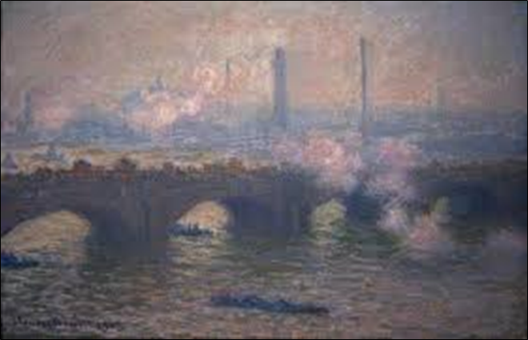
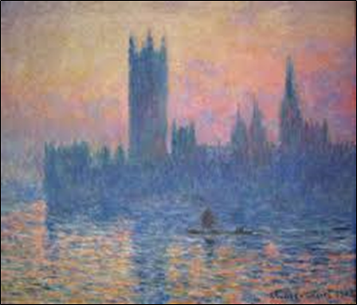

River Thames
We are going to find out a few more things she might have seen and put ourselves in her place, travelling down then Thames.
Watch the YouTube videos below and make a note of everything you can see from the River Thames.
- Draw a river, through the middle of a big piece of paper.
- Start by drawing the most iconic bridges.
- Add (draw and label) then landmarks in the correct place.
- Check against then list of things I saw along the River Thames. Have you included them all?
- Highlight the landmarks and bridges that were around the same time as Monet (1840-1926)
https://www.youtube.com/watch?v=V7jAXmVNXQs
https://www.youtube.com/watch?v=q1IXbwYFwc4#action=share
https://www.youtube.com/watch?v=At1KSxrmAnA#action=share
My List
- Big Ben
- The London Eye
- Gerkin
- Cheese Grater
- Walkie Talkie
- Sky Garden
- Westminster Abbey
- Tower Bridge
- Tower of London
- Canary Wharf
- Cleopatra's Needle
- Cutty Sark
- The Dome
- Millennium Bridge
- Thames Flood Barrier
- London Bridge
- Houses of Parliament
- St Paul's Cathedral
- Shakespeare's Globe
- Tate Modern
- Shard
- HMS Belfast
- City Hall (Helmet)

Maths
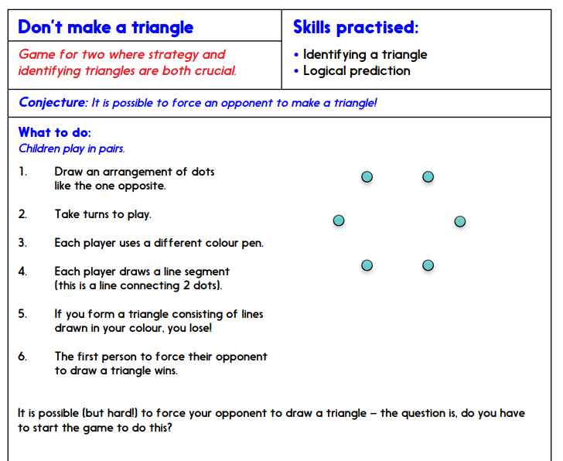

Islam
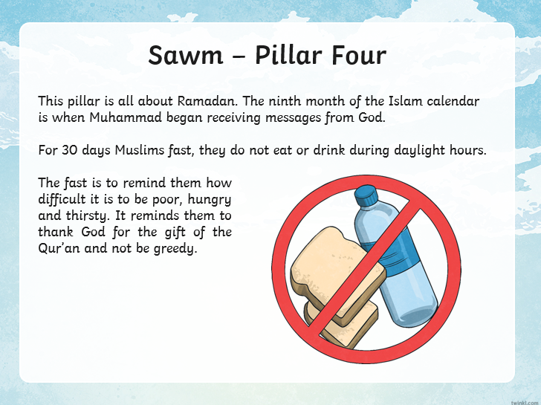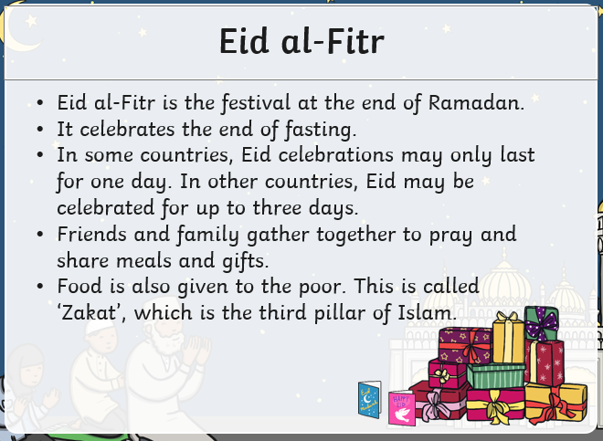
We have already looked into Ramadan (reading activity a few weeks ago). We will look into Eid-al-Fitr which is the celebration at the end of Ramadan.
Can you make a card to celebrate Ramadan or a lantern or a moon and star decoration?
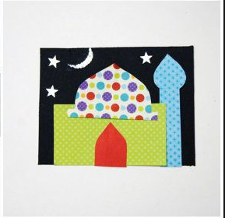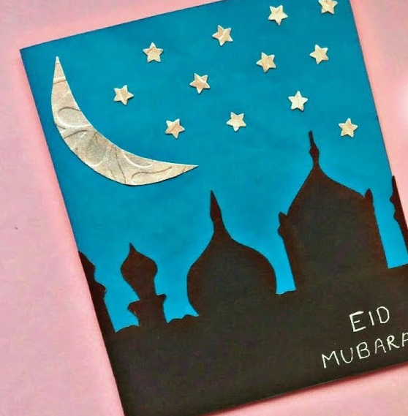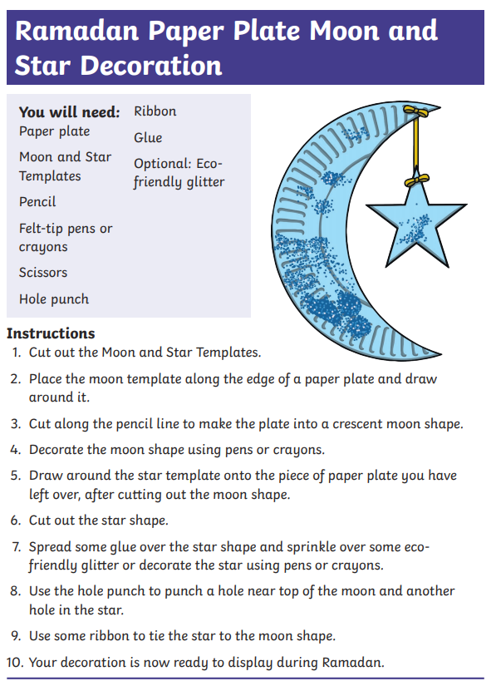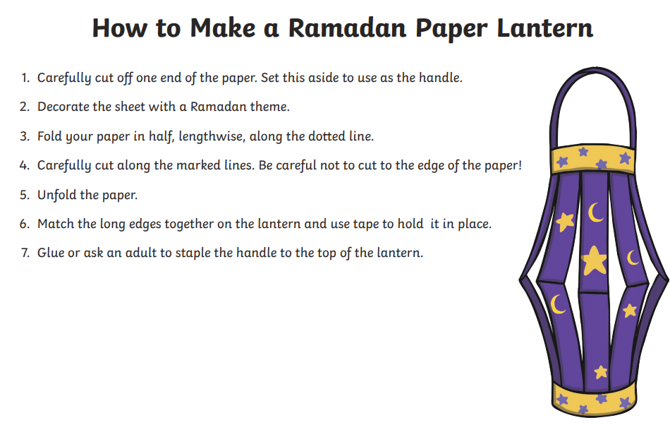

FRIDAY 5th JUNE 2020
Iaith
Write a recount pretending to be the Julie. You have visited Monet and he is taking you on a journey down the Thames passing landmarks (only use landmarks Monet was alive to see). Remember this is not a story you are writing and needs to be more factual. It also has to be in chronological order of what you saw first and so on.

Read
Read then example of a recount (Class Trip).

Skeleton (Plan below)
Use your river from the previous lesson as your plan as this will give you the order of the landmarks.

Write
Here are some of the things I am looking for:
- Past Tense – It has already happened
- 1st person, you are pretending to be Julie
- Title
- Opening Paragraph – Who, What, When, Where and why I should bother reading this?
- Chronological order (each circle of then skeleton is a paragraph)
- Time Connectives
- Powerful Verbs (doing words)
- Connectives to add detail (poster below)
- Adjectives (re-read the story to find some)
- Conclusion

Class Trip (Example)

Last week our class went on the most amazing trip to the Dramcester Water Park. We went so that we could learn about canoeing, bird watching and lots of other activities whilst having fun!

The first thing that we did was to gather in a group by one of the lakes. The instructor, who was called Jeremy, showed us the canoes. He taught us how to climb in and out. We all had to wear safety jackets in case somebody fell in. Jeremy demonstrated how to paddle. After that we climbed into our own canoes and set off. I got myself covered in water! It was great fun.

After that we had our break. Miss Vole gave everyone a hot drink and a biscuit. She said that this would help to warm up anyone who had got wet. As I was soaked, I was allowed two drinks.

Jeremy then showed a film of some of the creatures that live near and in a lake. I hadn’t realised that there were so many different sorts of fish and birds. He took us to a ‘hide’. A hide is like a hut that is close to the water. From the hide we could see all sorts of different birds without them seeing us. Skater kept making silly noises and Miss Vole said that if he continued behaving like a baby he would have to wait inside the coach. That silenced him!

In the afternoon Jeremy set us a challenge. We were put into groups and had to build a raft and then sail it to a red buoy. Luckily, Skater was in our team because he was really good at making the raft. We were first in the water. More importantly, we did not sink! The prize for winning was a Mars Bar each!

When we got back to school, Miss Vole said that she had had a great time. She was really pleased with all of us – and she even seemed pleased with YOU KNOW WHO…. So – it was a great trip and now I’d like to go there with my family. I think that they would enjoy the park.

MATHS
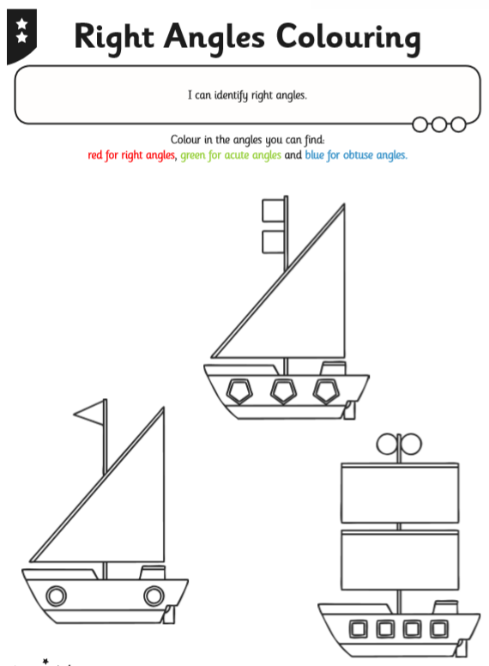
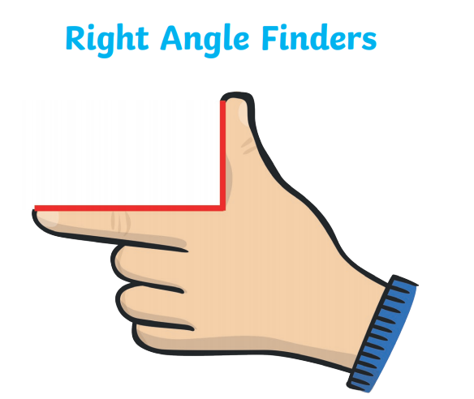
ACUTE – Smaller than a right angle
OBTUSE – Larger than a right angle
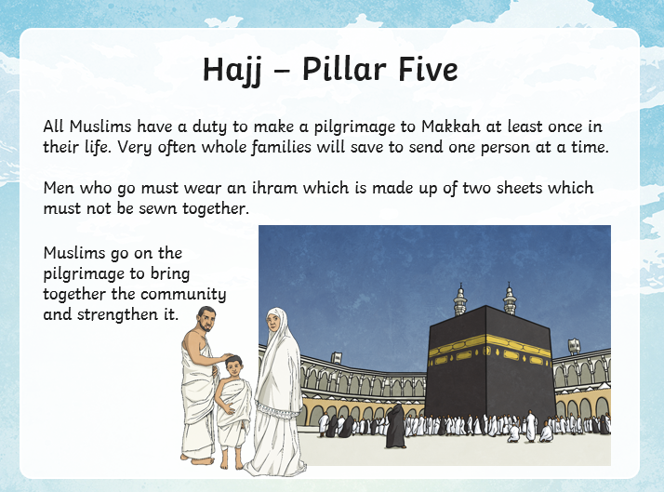
Islam
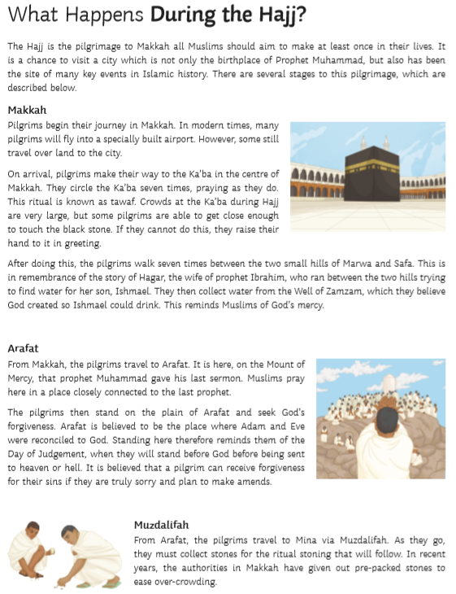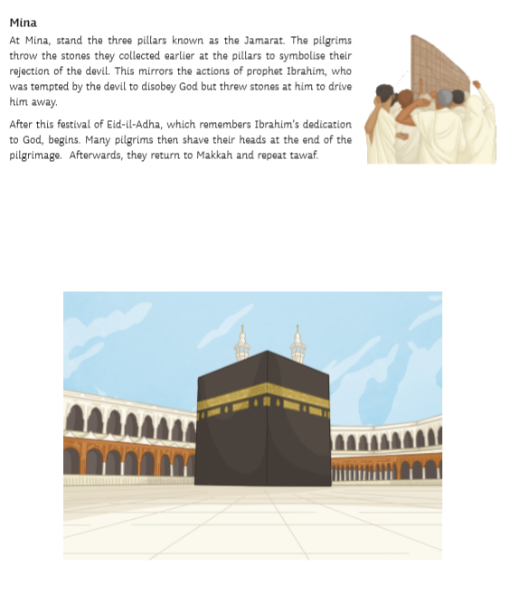Read the information sheet and find out about the main stages of the Hajj. On your map, neatly draw the route followed by the pilgrims. Use arrows to show the direction they travel in. Annotate what happens at each stage.

EXTENSION
Use what you have learnt, describe how you think a Muslim would feel after completing the Hajj.
