MONDAY 15th JUNE 2020
Iaith
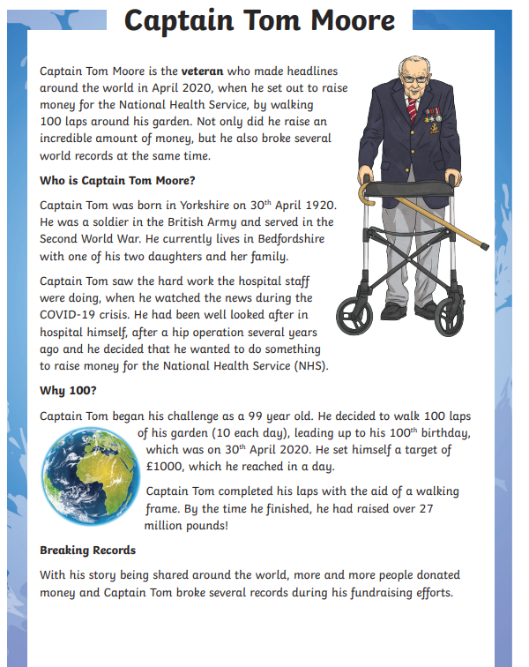
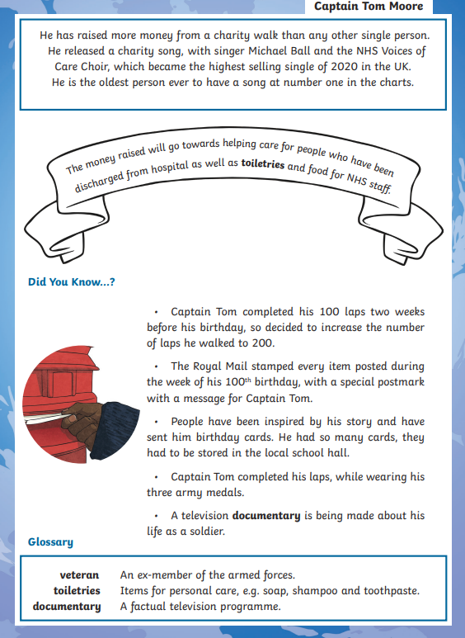

- What does NHS stand for? Tick one.
  - New Hospital Staff
  - National Health Service
  - National Hospital Staff
  - Nurses and Health Staff
- Number the events to show the order in which they happened.
  - Captain Tom began his challenge.
  - Captain Tom released a single.
  - Captain Tom finished his 100 laps.
  - Captain Tom celebrated his 100th birthday.
- Find and copy the phrase that tells us Captain Tom set a new record.
- Who did Captain Tom release a charity song with?
- Fill in the missing words
  - The money ___________ will go towards helping care for people who have been ______from hospital.
6. Give two examples of how Captain Tom raised money.
- Describe Captain Tom in two words and explain your choices.
- Why do you think so many people donated money to Captain Tom?

Maths
Halve these numbers. Remember to partition the numbers into tens and ones.

Find half of the following numbers:
- 124
- 286
- 468
- 99
- 85
- 63
- 33
- 199
- 159
- 157
- 133

Half of ______ is 120
Half of _______ is 462
Half of _______is 86

Bob goes to the shop to buy a toy. There is a half-price sale and the toy costs £134. How much was the toy before the sale?

There are 366 children in the school. Half of these are boys. How many boys are there?

Water, Water, Water
Did you know that 70% of the earth is water (seas and oceans)

Can you research and tell me what the difference between an ocean and a sea is?
Can you place these seas and oceans in the correct place on the map?

Gulf of Alaska Indian Ocean Norwegian Sea
Gulf of Mexico Caribbean Sea North Sea
Mediterranean Sea South China Sea Pacific Ocean
Atlantic Ocean Greenland Sea Red Sea
Arctic Ocean Pacific Ocean Sea of Japan
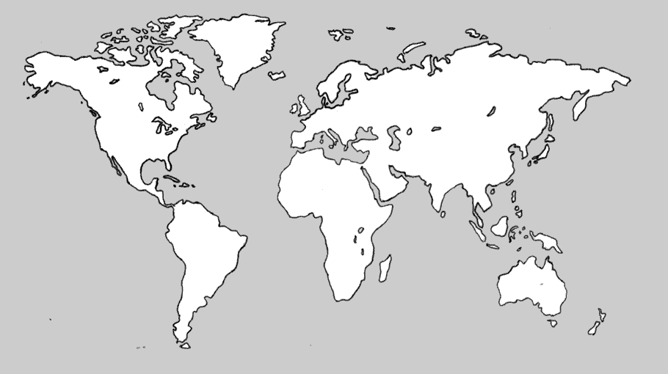
TUESDAY 16th JUNE 2020
Iaith
Who was at fault?
Look at the 10 statements below and rank them as a pyramid, most important at the top.
- The ship's crew could not speak much English
- Violent gales and low tides made it hard to save the ship.
- The ship only had one hull. If it had a double hull it would have to burst through two layers to causes a leak.
- Humans are demanding too much oil to fuel their cars.
- The tug boat wasn't free to help the ship.
- The captain and Milford Harbour Master hadn't agreed on a route into the port.
- No-one in the port spoke Russian
- Oil refineries shouldn’t build them in a beauty spot.
- The clean-up didn’t start straight away.
- The oil refineries were empty and demanded the ship to come in when it was low tide.
Who do think was to blame and why? (The captain, Texaco oil refinery, Milford Harbour Master,

Maths
Roll three dice and create a 3-didit number.

Write the number on the top and create a diamond as shown below.
Halve the hundreds.
Halve the tens.
Halve the ones.
Add both together to find half of the starting number.

Expressive Arts
Here are some examples of a collage made out of coloured paper. You could use any materials in your house.
Can you create a collage of the Sea Empress Disaster?
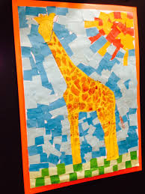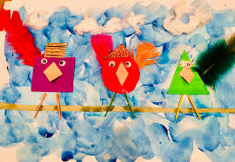
WEDNESDAY 17th JUNE 2020
Welsh
https://www.learn-welsh.net/welshgames

Play a few of these games to help you learn the basics.

Maths
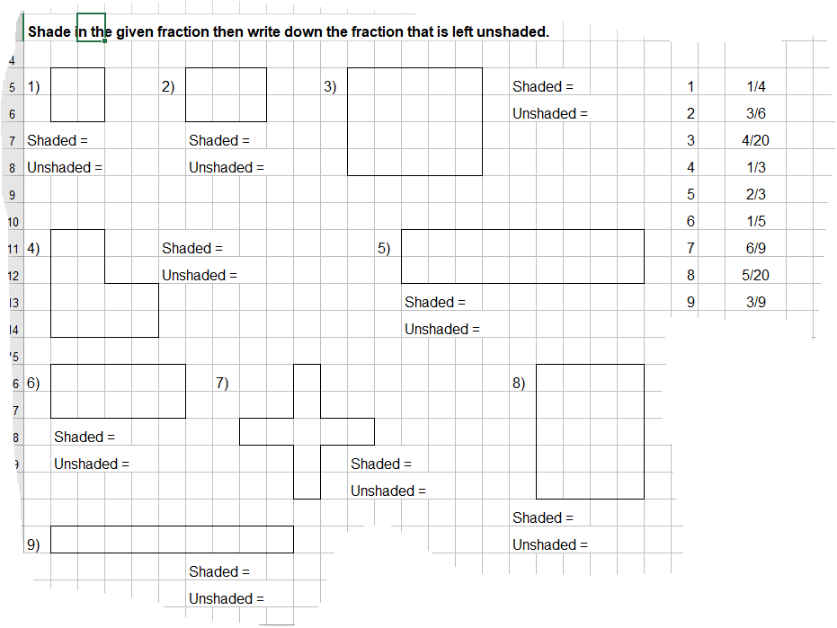
Science
https://youtu.be/PT-qUwCyU_E
Today we will be showing Zinnia all our research! We have the following things to show her from the last few weeks:
- We can draw and label a plant. We know what each part of the plant does.
- We have a list of plants that people like to eat.
- We know all the things plants need to grow strong and healthy.
- We also have bar graphs and charts and tables of our investigation.

Can you create a PowerPoint on everything you have found out about plants?

Time to Design a Space Farm!

Zinnia wants to build a space farm on her planet where they can grow human food.

On a large piece of paper design your space farm for Dock 5 with annotations to show how plants will get the essentials for life and health. Show as much detail as possible.

THURSDAY 18th JUNE 2020
Iaith
These are the different ways of clearing up after an oil spill at sea. Can you think of the pros and cons of each method and write in table?

Method | How it is used? | Pros | Cons
Shoreline Cleaners | Use of chemicals to use on the oil | Reduce floating oil  Reduce impact to bird life | Exposure to chemicals  Does not get rid of the oil  Pollute the water and environment
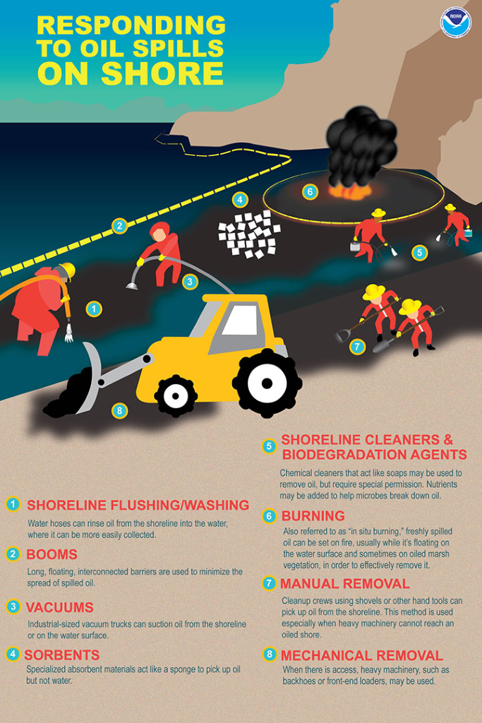

1. Shoreline Flushing: This method uses water to remove or refloat stranded oil, which allows it to be more easily recovered as a slick on the water.
2. Booms: These long, floating barriers are used to keep spilled oil off the beach.
3. Vacuums: Large industrial vacuums can suction oil off the beach or shoreline vegetation.
4. Sorbents: These specialized materials, which can take forms such as square pads or long booms, are engineered to absorb oil but not water.
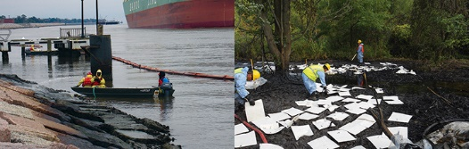
Left, responders pressure wash the Texas shoreline after the tank ship Eagle Otome oil spill in January of 2010. Note the boom to collect any remobilized oil. Right, cleanup crews place absorbent pads to sop up oil after the 2010 Enbridge pipeline spill in Michigan's Kalamazoo River. (NOAA)
5. Shoreline cleaners and bioremediation agents: There are a variety of chemical cleaners for oiled shorelines that usually require special approval for their use.
6. Burning: Responders sometimes will perform controlled burns, also referred to as "in situ burning," of freshly spilled oil floating on the water's surface or on marsh vegetation.
7. Manual recovery: This method involves using good old buckets, shovels, rakes, and other hand tools to remove oil from shorelines. It is very labor-intensive but is often a primary tool for a response when access for larger equipment is impractical, such as on remote beaches or those without road access.
8. Mechanical removal: When access is possible and won't cause too much damage to the shoreline, responders may bring in heavy machinery, such as back hoes or front-end loaders, to scoop up and haul away oiled materials in bulk.
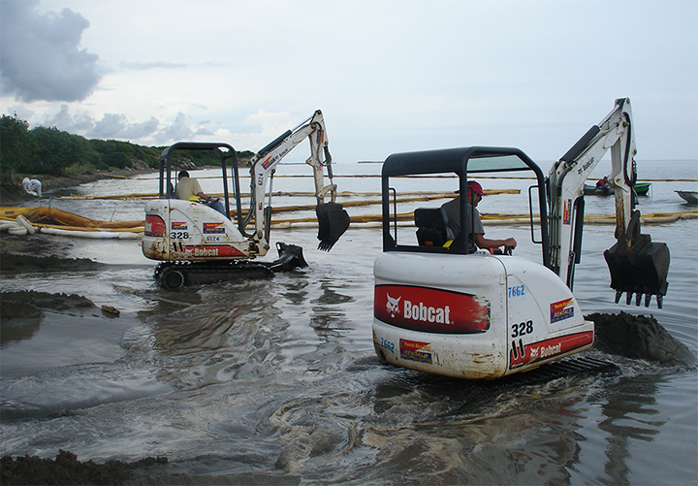
Heavy machinery was brought in to remove oil from a beach in Puerto Rico in 2007. (NOAA)
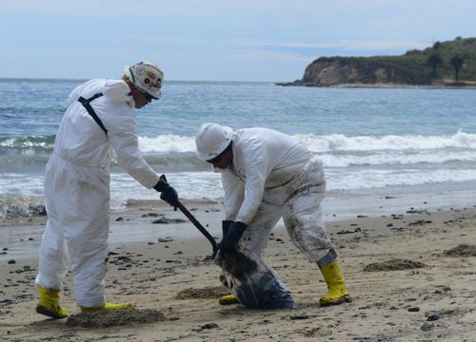
Cleaning up oil from shorelines is a messy job. Beach cleanup crew members use a shovel to place gathered oil and affected sand into a bag as they clean up along a beach near Refugio State Beach, California, May 21, 2015. Cleanup teams used shovels and their hands to gather affected soil and ocean debris along oil impacted beaches north of Santa Barbara. (U.S. Coast Guard)
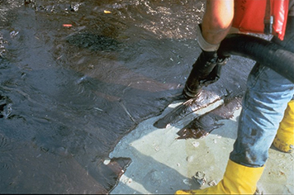
Heavy oil vacuumed from a sandy shoreline after the 1993 Tampa Bay oil spill. (NOAA)

Maths
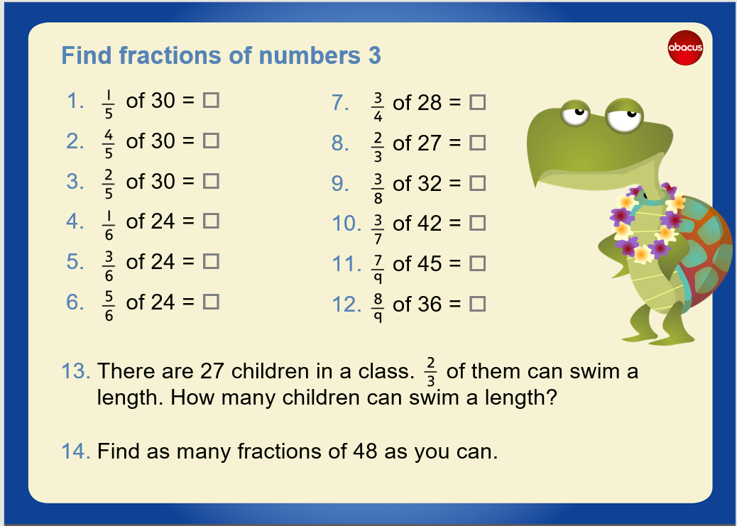
Computing
Using Scratch create an underwater scene where the following happens:
- One creature jumps up and down
- One creature spins
- One creature moves and bounces off the edges
- You will need a background
- You will need at least 3 sprites

Computing
Using Scratch create an underwater scene where the following happens:
- One creature jumps up and down
- One creature spins
- One creature moves and bounces off the edges
- You will need a background
- You will need at least 3 sprites

FRIDAY 19th JUNE 2020
Iaith
We are going to look at newspaper reports and create one on the Sea Empress Disaster. The following video tells us all we need to know about creating a newspaper article.

https://www.bbc.co.uk/bitesize/topics/z2yycdm/articles/z2gk9qt

Use the following website to read your own news articles. What has each article got?
https://www.bbc.co.uk/newsround

You could use alliteration to draw your reader in. For example Watery Weather Washes out Wales. Alliteration is when we start each word with the same letter.

Can you create Headlines that may have appeared the morning after the Sea Empress Disaster. Highlight the one you like the best and will use in your newspaper article.

In the introduction paragraph it important to tell the reader the 5 fancy facts. Can you write a factual sentence on each? Remmeber it is fact and not opinion.

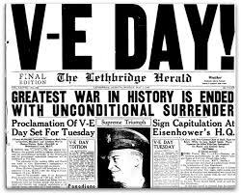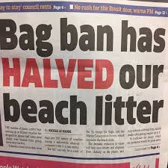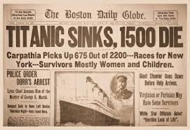

Maths
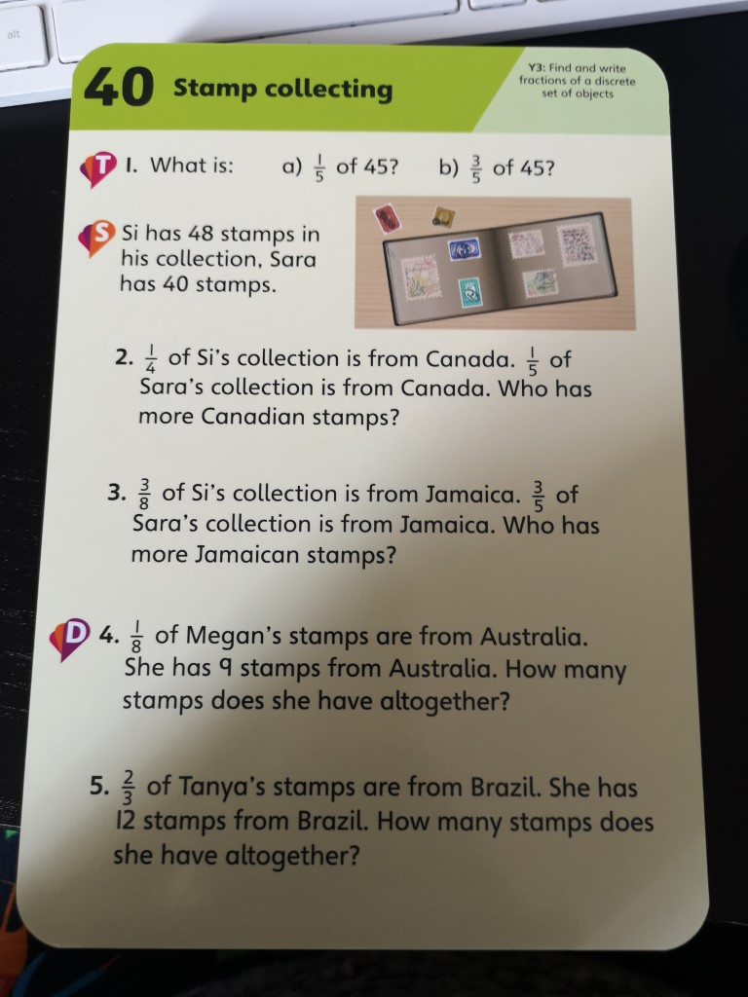

PE
