Over the next 2 weeks you are going to be developing ideas, thinking about characters and setting which will then result in you writing your own story. The images and ideas I will share with you are from ‘Sinbad’ films. I think most of your parents/carers will remember this character. There are lots of films which include Sinbad and more recently Disney released a film called ‘Sinbad, Legend of the Seven Seas’. If you have any of these films or the ability to watch them, I would recommend you do: so you can gather ideas. Don’t worry if you can’t because I will include screen shots in the plan to help you!
In the Pupil voice session, you asked to write stories, some of you asked for these to be linked to pirates and some of you asked to include mythical sea creatures. Hopefully this story writing will allow you to do that!

Monday
Task: Today, look at the images of Sinbad characters then develop a hero and a villain of your own to use in your story.
Heroes | Villains
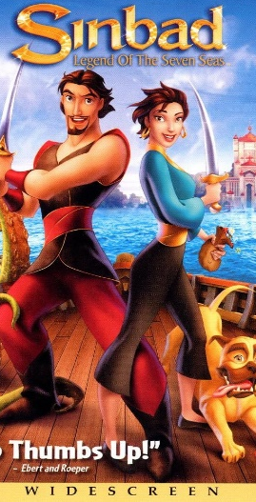  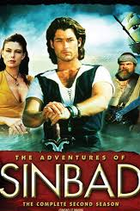  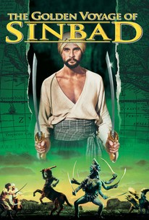  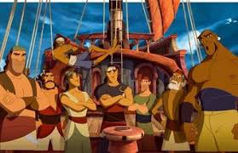 | 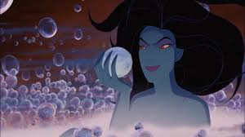  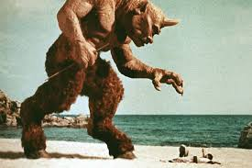  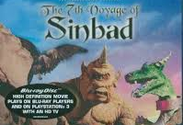  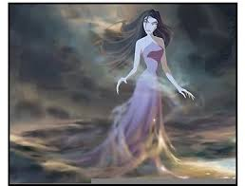

Now it’s your turn!
Use the Character Planning sheets to help you to develop characters for your story.

Tuesday
Today you will be looking at a range of settings. You will need to plan at least the following setting: a setting to start your story from, a setting for the journey, a setting for the problem and then a setting for the end of your story. There are some ideas you can take from below:
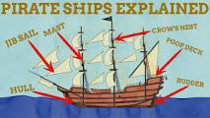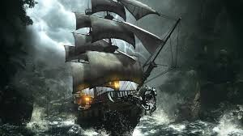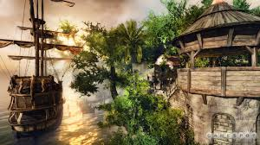
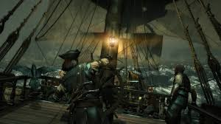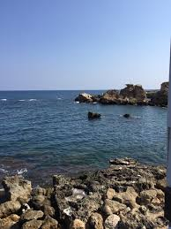
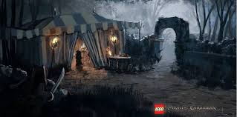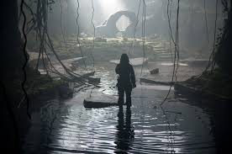

Now it’s over to you.
You could be as arty as you want/can.

Draw your settings then either on the same piece of paper or separately you need to list:
Where it is
What part of your story it will be in
Adjectives (describing words) use your senses – sights, sounds, smells, tastes, touch
Weather

Do this for each of your main settings, listed above.

Wednesday
Task: Story plan. Today you will need to plan your story. You must include the characters and settlings you have already planned. You can use your preferred method of planning but remember, you must have: introduction/set the scene, build up, problem, resolution and ending.
Planning format ideas:
Story mountain
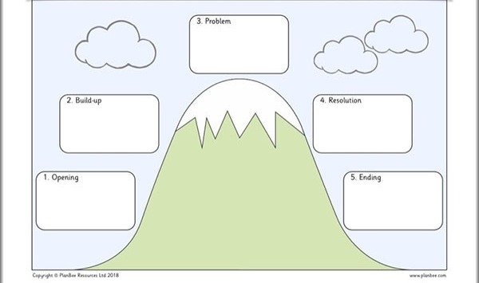
Comic strip
Remember to include your story settings which you planned on Tuesday, especially in your setting the scene part of your story.
Think about adding tension and suspense in your build up.
Think carefully about your problem, it needs to be dramatic enough and must include your villain.
Think carefully about how you will resolve the problem make sure this will be explained properly to the reader.
Make sure you end your story with everything concluded so you have a satisfied reader.
Please don’t have too much killing/blood and guts in your stories that you end up loosing the plot of the story.
Flow chart:
Set the scene

Build up

Problem

Resolution

Ending

Thursday
Task: Grammar for writing. Today you will recap the use of speech marks. Remember, we have done this before but it is something that is easily forgotten!
If you can, have a look at the video clips:
Green and light blue groups
https://www.bbc.co.uk/bitesize/clips/zvftsbk
https://www.bbc.co.uk/bitesize/topics/zvwwxnb/articles/ztcp97h
Dark blue and red group
https://www.bbc.co.uk/bitesize/topics/zr6bxyc/articles/zhqh92p
Sometimes speech is
Speech mark rules:
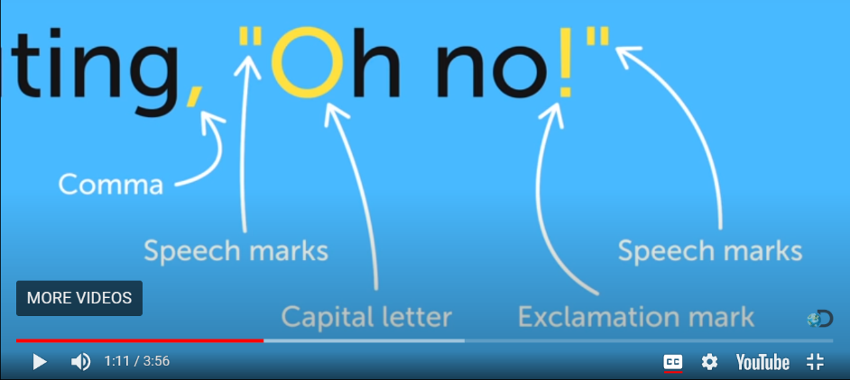

Remember when there is a new speaker, this needs to go on a new line.

Dark blue and red groups this is what you will be working on.

Now it’s your turn.

Green and Light blue:
“Speech Marks”
We use speech marks when we are writing to show what somebody has said. It is very important to also write who has been talking.
Example :
I love this book
“I love this book,” said Lucy

Put the speech marks in the correct places in the sentences below:
- What time is it? asked Angel.
2) I want chicken for dinner, said Monica.
3) Can I play on the computer Mum? asked Kayla.
4) I would like an ice cream please, said Sarah.
5) That costs 12 euro said the shop-keeper.
6) Would you like to read a book? asked the teacher.
7) John hit me, said Henry.
8) Where is the cheese? asked Kayleigh.
9) It is time to go to computers, said the teacher.
10) What is 10 + 2? asked Miss Byrne.
11) Hooray shouted the children
Now write 4 sentences of your own which include speech marks, remember the rules.

Dark blue and red:
“Speech Marks”
We use speech marks when we are writing to show what somebody has said. It is very important to also write who has
Put the speech marks in the correct places in the sentences below:
- What time is it? asked Angel I’m feeling really hungry.
2) I want chicken for dinner, said Monica but we only have beef in the fridge.
3) Can I play on the computer Mum? asked Kayla because I have finished all my work.
4) I would like an ice cream please, said Sarah preferably chocolate and strawberry mixed.
5) That 12 pounds please said the shop-keeper
6) Would you like to read a book? asked the teacher I’ve got a variety to choose from.
7) John hit me, shouted Henry on my arm!
8) Where is the cheese? asked Kayleigh I want some for my sandwich.
9) It is time to go on the computers, instructed the teacher you need to make a Powerpoint.
10) What is 10 + 2? asked Miss Byrne.
11) Hooray exclaimed the child I have finished my work!
Now write 3 more sentences of your own which include speech and punctuate it correctly.

Friday
Task: Today you are going to recap some Alan Peat sentence structures to use in your story. I have put sentences I would like each group to have a go at but once you have done your own group’s work, you are welcome to have a go at other sentence types!
Green group
Write 3 sentences for each Alan Peat sentence type

Light Blue group
Write 4 sentences for each sentence type.

Dark blue group
Write 4 sentences for each sentence type.

Red Group
Have a go at all of the above. Write 1 sentence for each type. Try and make it so you can use these sentences in your story. Also, try and write these sentence types for your story:
The more, the more.
If, If, if, then

