Multi Faith Week
This week we are going to be learning about Islam in the afternoons instead of Expressive Arts, Project, Computing, Science and PE.
MONDAY 1st JUNE 2020
ISLAM
Here are the five pillars of Islam. We are going to look at some of these in more detail. We have already done some reading on Ramadan.

Can you research and tell me what each pillar means?

Can you then create the five pillars of Islam using recycled materials of paint?

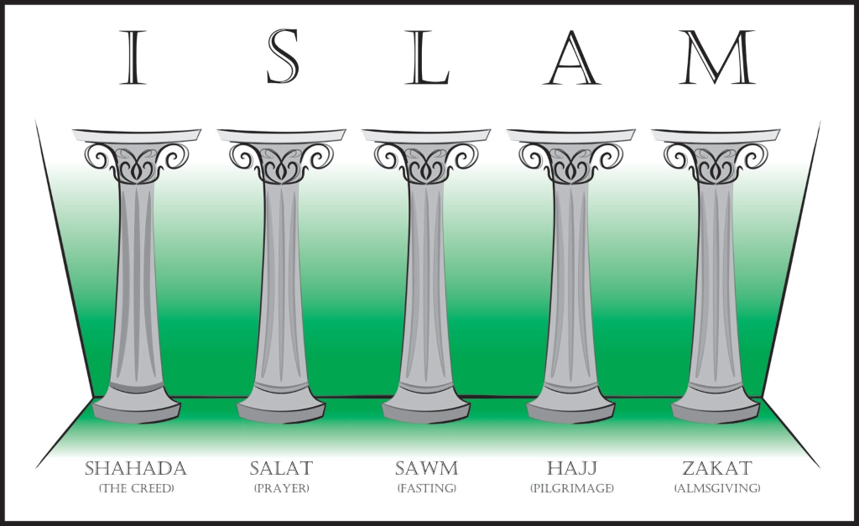

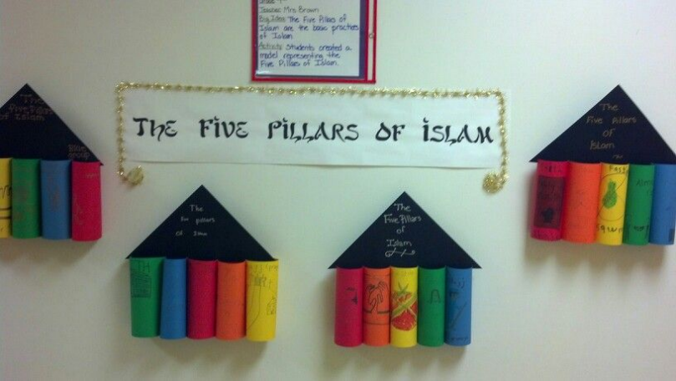
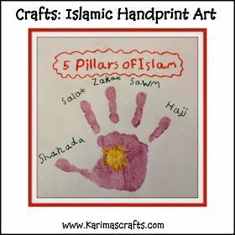

TUESDAY 2nd JUNE 2020
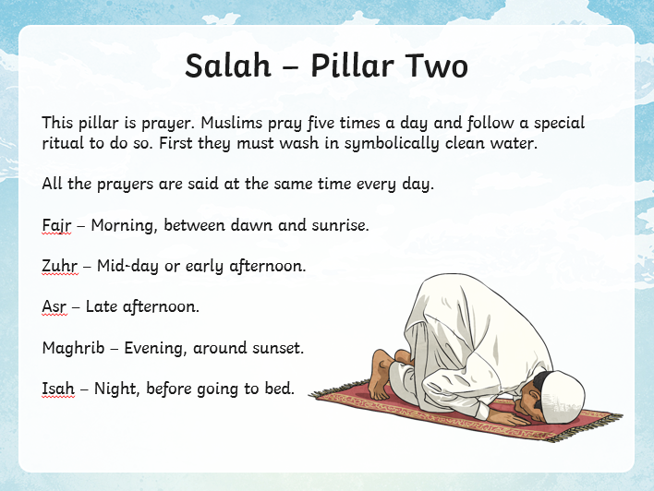
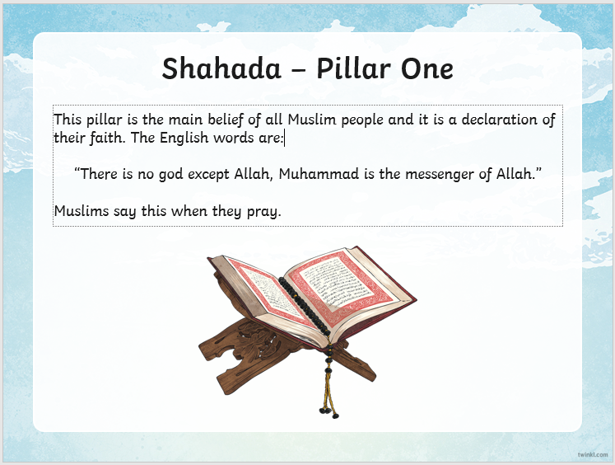

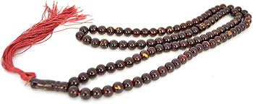

- Muslims use prayer mats and prayer beads while they pray.
- There are 99 beads altogether for the 99 names for Allah and beads are passed through fingers and Muslims recite names or special prayers.
- Look at some names Muslims have for Allah. Use the internet to research
Activities
- Ask children to write down some names they would use for God and decorate the border in the style of an Islamic pattern.
- Draw a set of prayer beads and write information around them to explain how they are used. Encourage children to include an explanation of how important they are to focus Muslims on prayer.

WEDNESDAY 3rd JUNE 2020

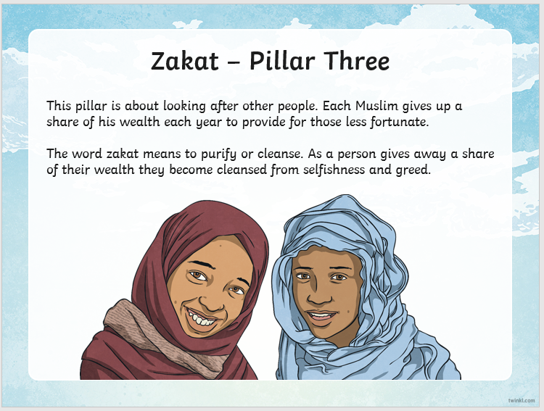
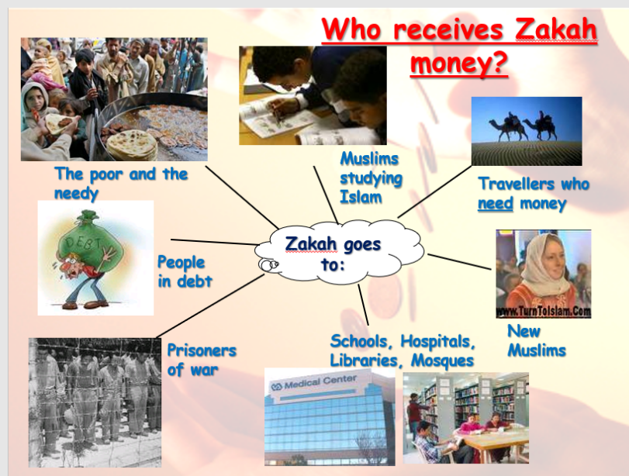

Create a word map on good deeds. Place the word good deeds in the middle of the paper and then write around it. Think about all the good deeds people could do and the charity work.

THURSDAY 4th JUNE 2020

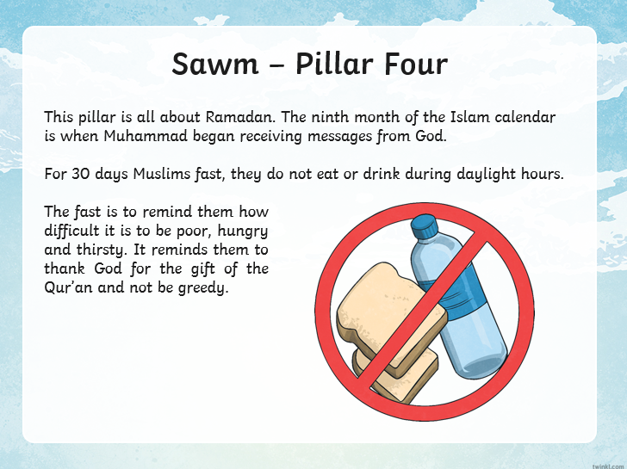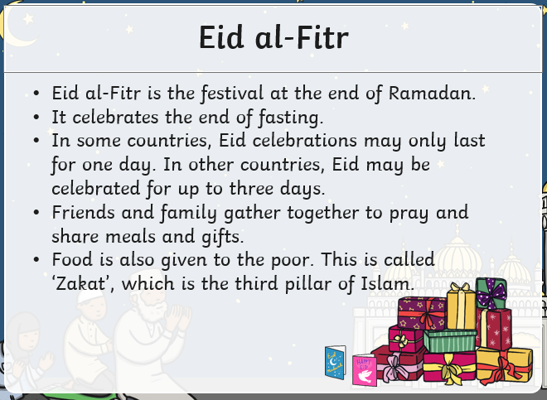
We have already looked into Ramadan (reading activity a few weeks ago). We will look into Eid-al-Fitr which is the celebration at the end of Ramadan.
Can you make a card to celebrate Ramadan or a lantern or a moon and star decoration?
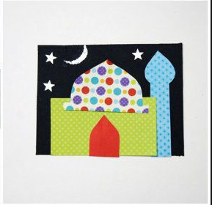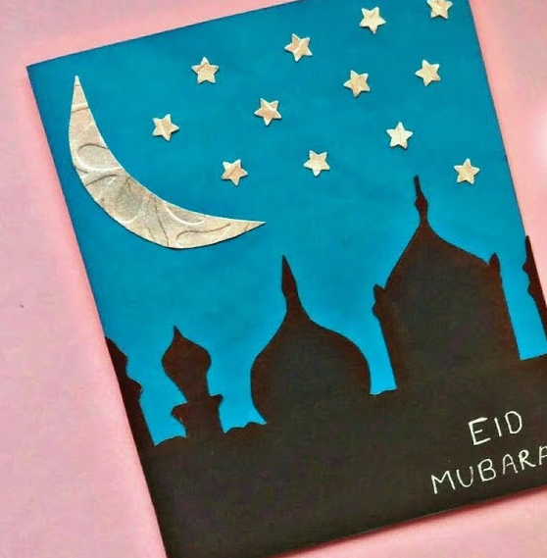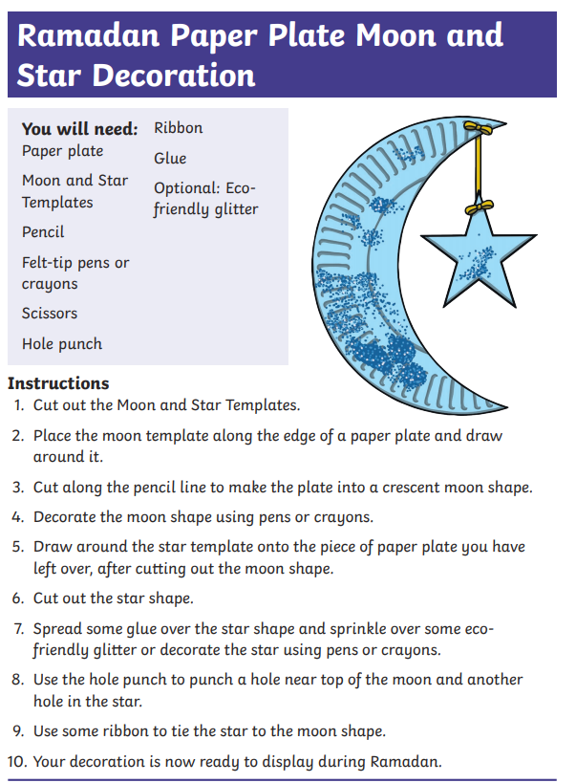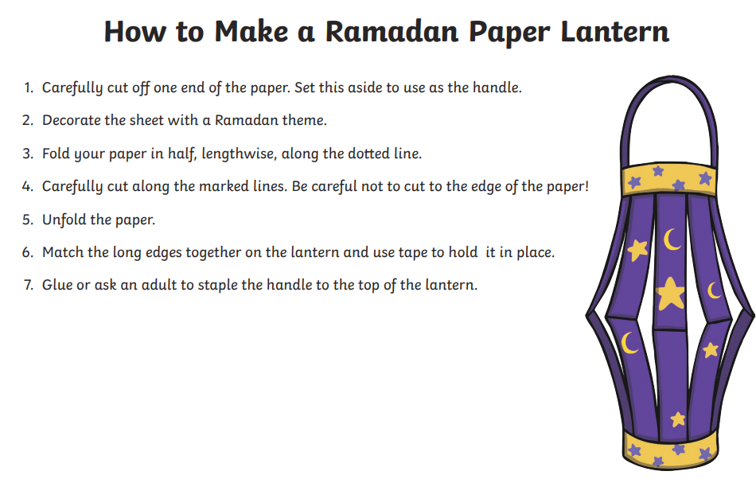

FRIDAY 5th JUNE 2020

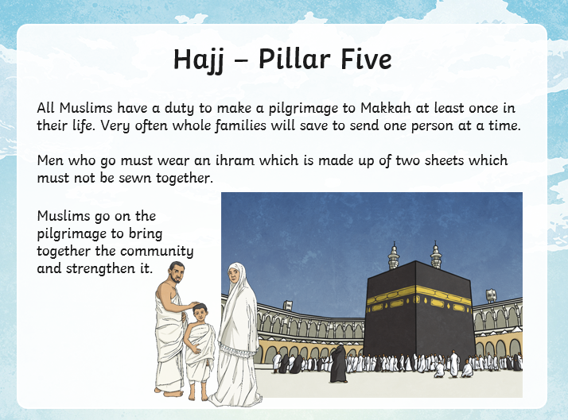
Islam
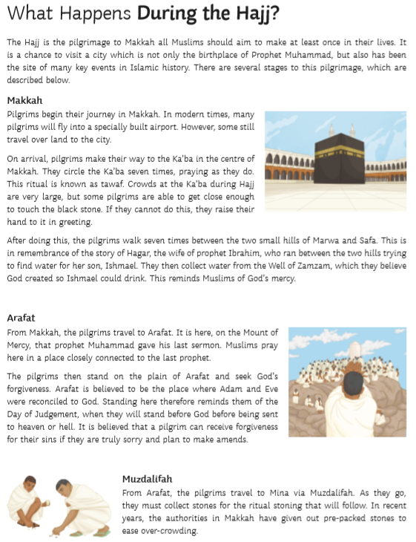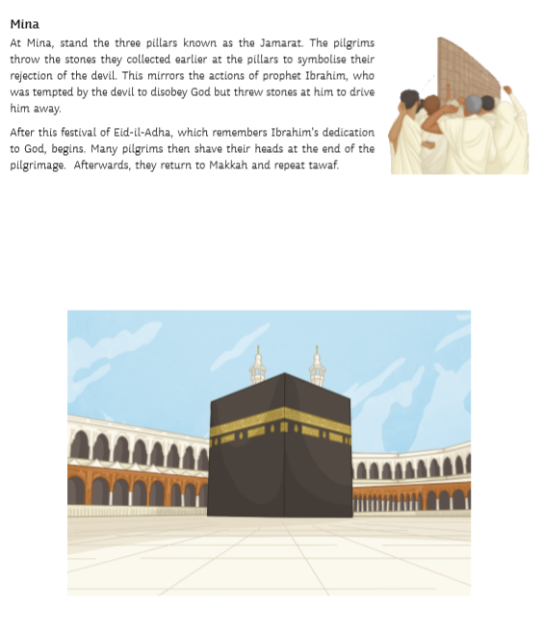Read the information sheet and find out about the main stages of the Hajj. On your map, neatly draw the route followed by the pilgrims. Use arrows to show the direction they travel in. Annotate what happens at each stage.

EXTENSION
Use what you have learnt, describe how you think a Muslim would feel after completing the Hajj.
