MONDAY 18th MAY
Literacy
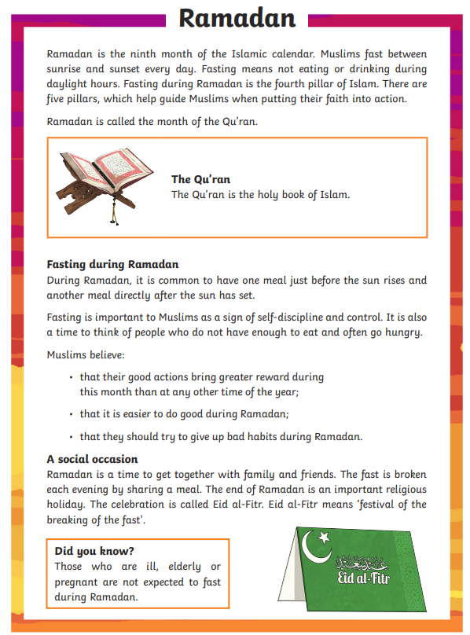
- Ramadan is: Tick one.
  - The fifth pillar of Islam
  - The fourth pillar of Islam
  - The second pillar of Islam
  - The tenth pillar of Islam
- What is the purpose of the five pillars of Islam?
  - To help Muslims put their faith into action.
  - To help Muslims fast.
  - To help Muslims learn to pray.
  - To help Muslims listen.
- What is the Qu'ran?
- Match up these sentences
  - It is common to have one meal of self-discipline.
  - Pregnant women do before sunrise.
  - Fasting is a time not have to fast.
- What do Muslims believe about Ramadan? Tick two
  - That it is easier to do good deeds during Ramadan
  - That they should do bad things at Ramadan.
  - That they should think about people who might not have enough to eat.
  - That they get no rewards from doing good during Ramadan.
- What happens at the end of each day of fasting? Tick one.
  - Muslims go to the Mosque.
  - Muslims share a meal with family.
  - Muslims go to bed.
  - Muslims go to a festival

Maths

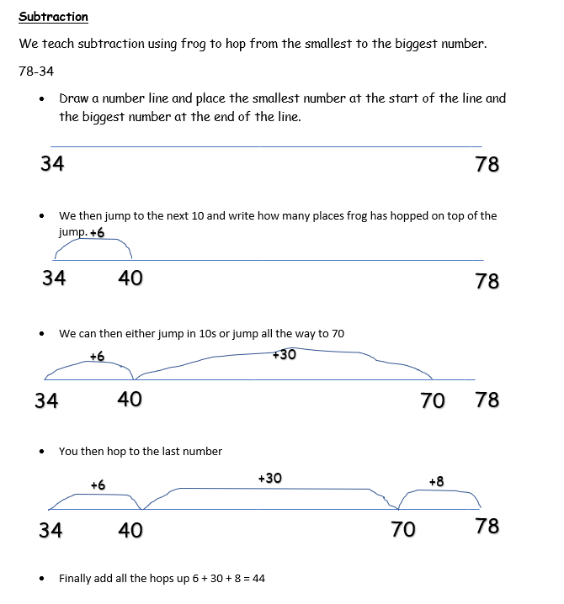

Using frog complete the following.

66-21=
66-24=
79-31=
79-35=
88-23=
88-26=
97-41=
58-16=
72-51=
69-27=

World War II – Pearl Harbor

https://www.youtube.com/watch?v=oGYcxjywx0o

https://www.pearlharboroahu.com/plan-your-visit/plan-your-visit-uss-arizona-memorial/

Watch the Pearl Harbor trailer and look at the Pearl Harbor Memorial website.

Can you write bullet points on things you have found out?
Can you research one of the ships and draw it?

TUESDAY 19th May
Literacy
The Journey is a story about a small boat and the journey it takes along the river.
Read and watch the story.
I would like you to create a story map of then story. I have put a sample below to help. Include some of the great descriptive words such as peaceful and bashed. Can you then use the story map to retell the story?

https://www.youtube.com/watch?v=LJT5e-iH85c

The Journey by Neil Griffiths

On a windy autumn day, Here amongst the slime and muck,
A boat broke free and sailed away. Our little boat got truly stuck!

Swiftly floating out of sight, Not until a springtime food,
It bobbed and weaved into the night. Did it escape the mud.

Underneath the star filled night, Heading down the estuary,
Our little boat passed mountains high. It glided gently out to sea.

As the dawn began to break, Soon the sky turns strangely dark,
The stream became a peaceful lake. As from the depths emerged a shark!

Joined by duck and goose and swan, Damaged by a sudden storm,
Through swaying reeds it drifted on. The sail was ripped and badly torn.

Quickened by then current's draw, Then with one enormous roar,
It tumbled down a waterfall. The boat was washed upon the shore.

Battered, bashed, bumped and tossed, Here amongst the weeds it lay,
Our little boat was nearly lost. Until a boy came by one day…

Reaching water far below, There before his very eyes,
The sailing boat began to slow. He found a wonderful surprise!

Floating past a church and farm, The boat he’d lost long ago!
It drifted on through waters calm. How it got there, he’ll never know!

Next it reached a busy town,
Where rubbish turned then water brown.

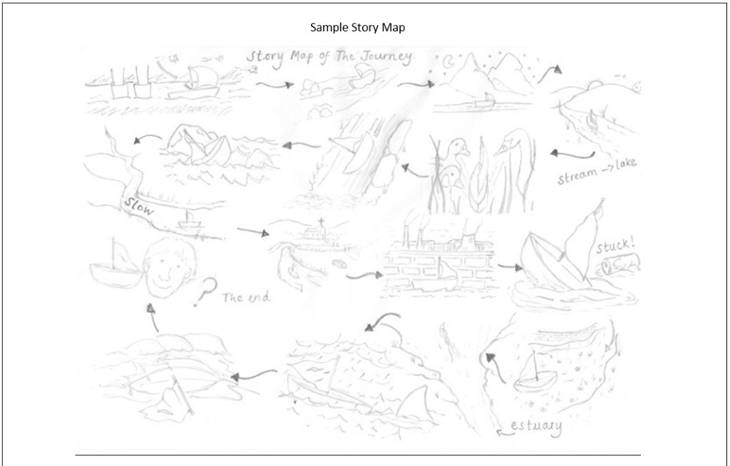
Maths
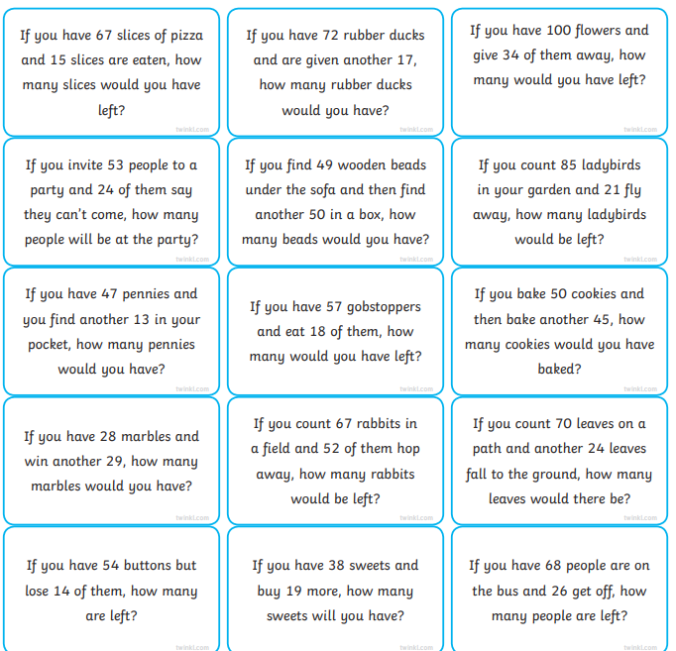
Expressive Arts
Pick one of these to create your design. You should draw and label your design. If you have the right materials you may be able to make your design.
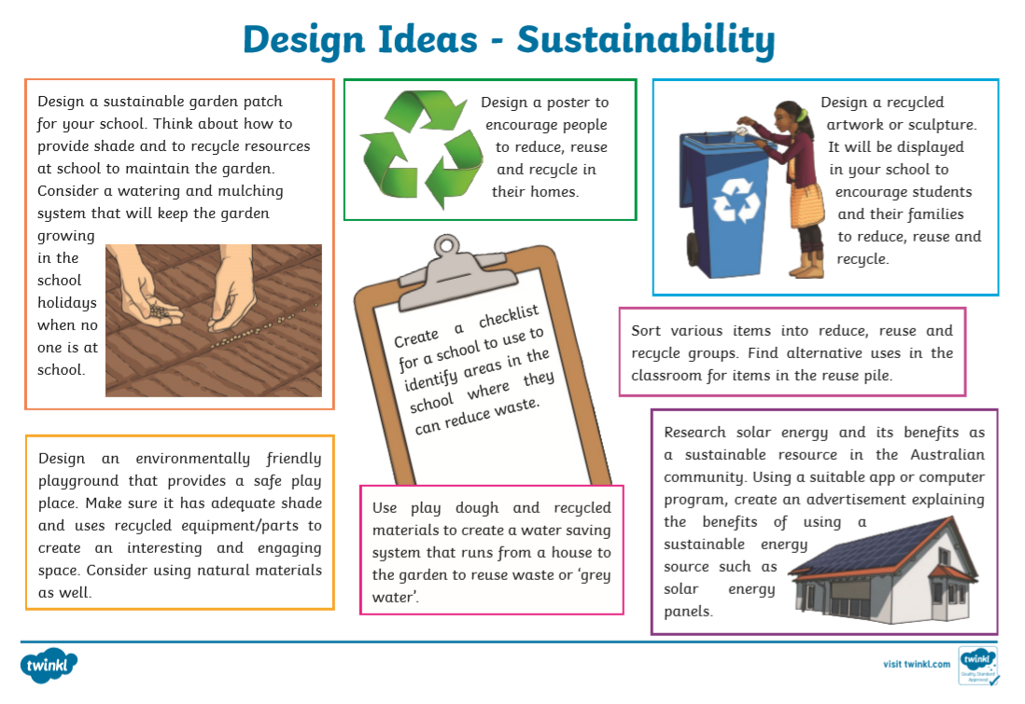

WEDNESDAY 20th MAY
Maths
Roll two dice to create a 2-digit number. If you do not have dice you can find some to use if you type interactive dice into Google.

Create two 2-digit numbers.

65 – 34 =

Can you then use frog to work out the answer?
Repeat 6 times.

Welsh

http://resources.hwb.wales.gov.uk/VTC/ngfl/wsl/bdag/chwaraeonahamdden-de/apps/simple-projector/index.html

You may need to log into HWB first to access this resources.

Work your way through the activities online!

Science
Results

Draw a graph from the table of results. You should do this on HWB J2E and JIT chart.

Remember to create a title and label the axis.

Conclusion

What did your results show?
Explain what happened.
What have you found out?

Would you change anything?

THURSDAY 21st May 14, 2020

Literacy
Recount
We are going to be writing our own recount text. Have a look at then information below.

Skeleton Writing (Plan – shown below)
We use a skeleton to plan our written work. Can you draw out the skeleton to plan your recount? If you need more circles feel free to add them. The events should be in chronological order.

Time Connectives
Place a time connective in between each box so your recount flows nicely. Here are some time connectives:
First, Next, Just then, Meanwhile, When, Before long, Later, In the end, Finally, After a while, Immediately, Eventually, After some time, At First, Until then, After that, In the meantime, Suddenly, Following, Lastly

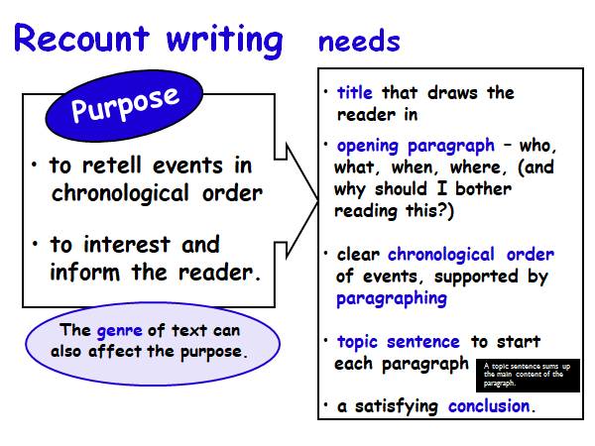
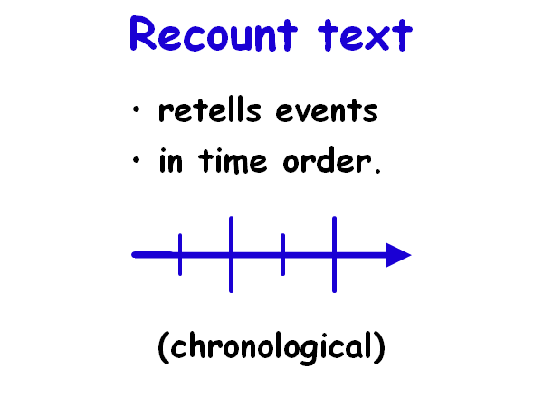

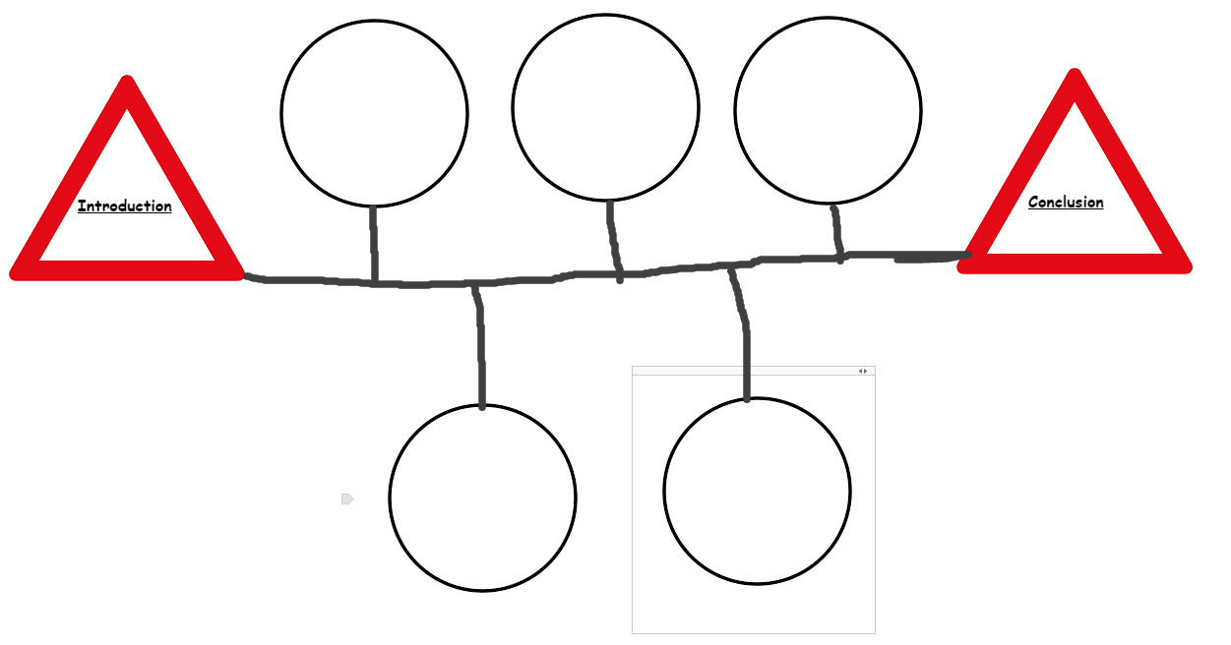
Maths
- If you have 67 slices of pizza and 15 slices are eaten, how many slices would you have left?
- If you had 100 flowers and give 34 of them away, how many would you have left?
- If you invite 53 people to a party and 24 of them say they can't come, how many people will be at the party?
- If you count 85 Ladybirds in your garden and 21 fly away, how many ladybirds would be left?
- If you have 57 sweets and eat 18 of them, how many would you have left?

Computing
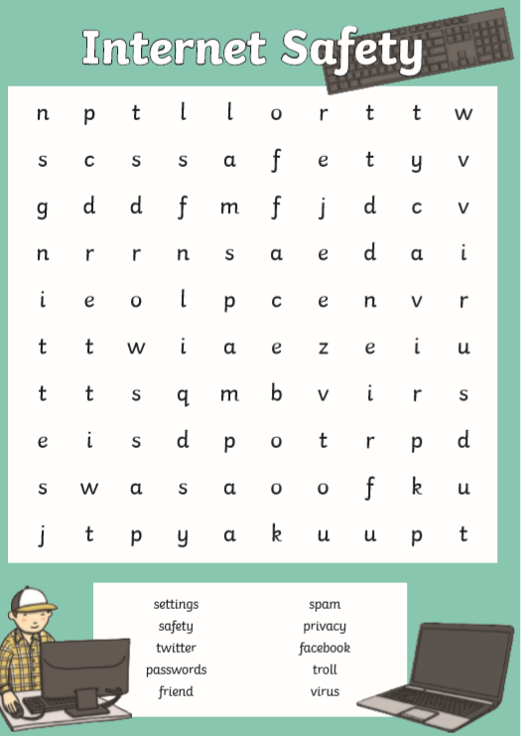
https://scratch.mit.edu/projects/editor/?tutorial=getStarted

Make a clicker game using Scratch. Click tutorials at the top then find the clicker game. Follow the instructions.

FRIDAY 22nd MAY 2020

Literacy
Read
Read then example of a recount (Below-Class Trip).
Write
Use your skeleton from yesterday to write your recount. Here are some of the things I am looking for:
- Past Tense – It has already happened
- Title
- Opening Paragraph – Who, What, When, Where and why I should bother reading this?
- Chronological order (each circle of then skeleton is a paragraph)
- Time Connectives
- Powerful Verbs (doing words)
- Connectives to add detail (poster below)
- Adjectives (re-read the story to find some)
- Conclusion

Class Trip

Last week our class went on the most amazing trip to the Dramcester Water Park. We went so that we could learn about canoeing, bird watching and lots of other activities whilst having fun!

The first thing that we did was to gather in a group by one of the lakes. The instructor, who was called Jeremy, showed us the canoes. He taught us how to climb in and out. We all had to wear safety jackets in case somebody fell in. Jeremy demonstrated how to paddle. After that we climbed into our own canoes and set off. I got myself covered in water! It was great fun.

After that we had our break. Miss Vole gave everyone a hot drink and a biscuit. She said that this would help to warm up anyone who had got wet. As I was soaked, I was allowed two drinks.

Jeremy then showed a film of some of the creatures that live near and in a lake. I hadn’t realised that there were so many different sorts of fish and birds. He took us to a ‘hide’. A hide is like a hut that is close to the water. From the hide we could see all sorts of different birds without them seeing us. Skater kept making silly noises and Miss Vole said that if he continued behaving like a baby he would have to wait inside the coach. That silenced him!

In the afternoon Jeremy set us a challenge. We were put into groups and had to build a raft and then sail it to a red buoy. Luckily, Skater was in our team because he was really good at making the raft. We were first in the water. More importantly, we did not sink! The prize for winning was a Mars Bar each!

When we got back to school, Miss Vole said that she had had a great time. She was really pleased with all of us – and she even seemed pleased with YOU KNOW WHO…. So – it was a great trip and now I’d like to go there with my family. I think that they would enjoy the park.

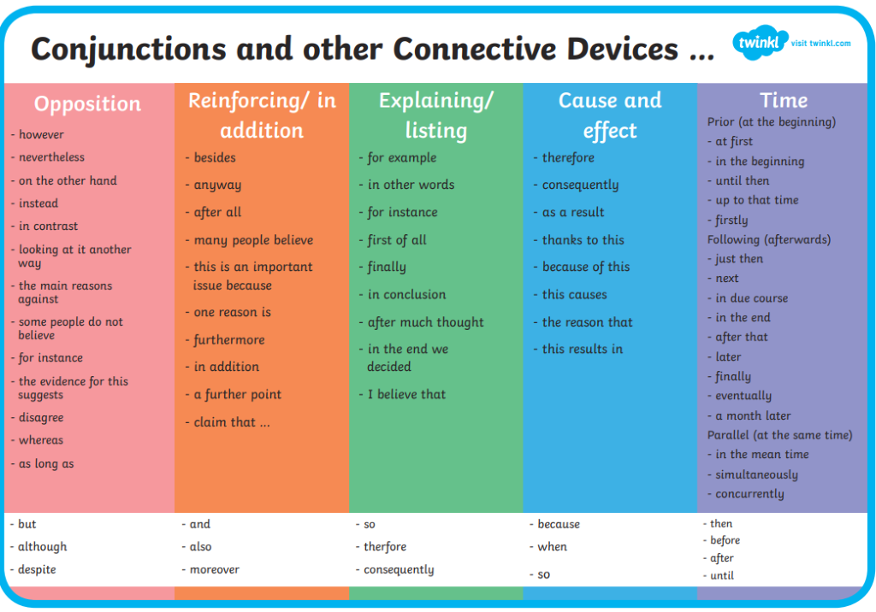

Maths
Green – T
Blue – T & S
Red and Black - All
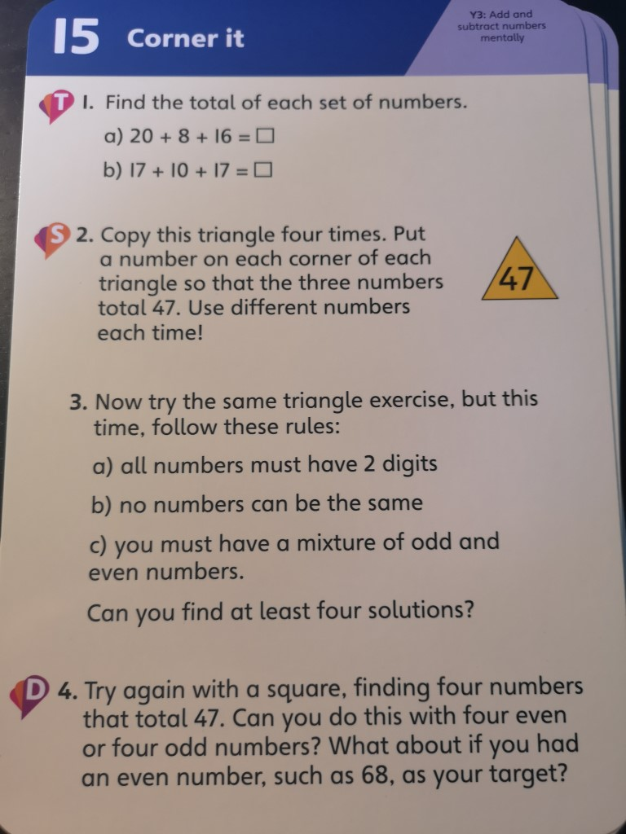
PE/Yoga/Mindfulness
https://www.youtube.com/watch?v=j_3weVPH0-U
https://www.youtube.com/watch?v=R-BS87NTV5I

