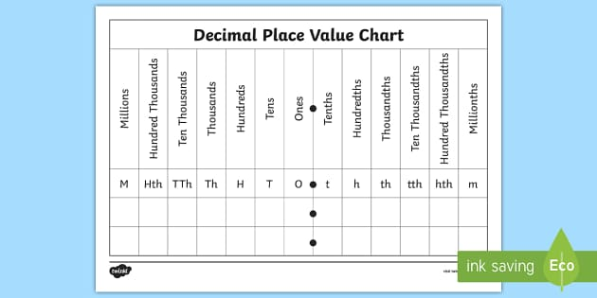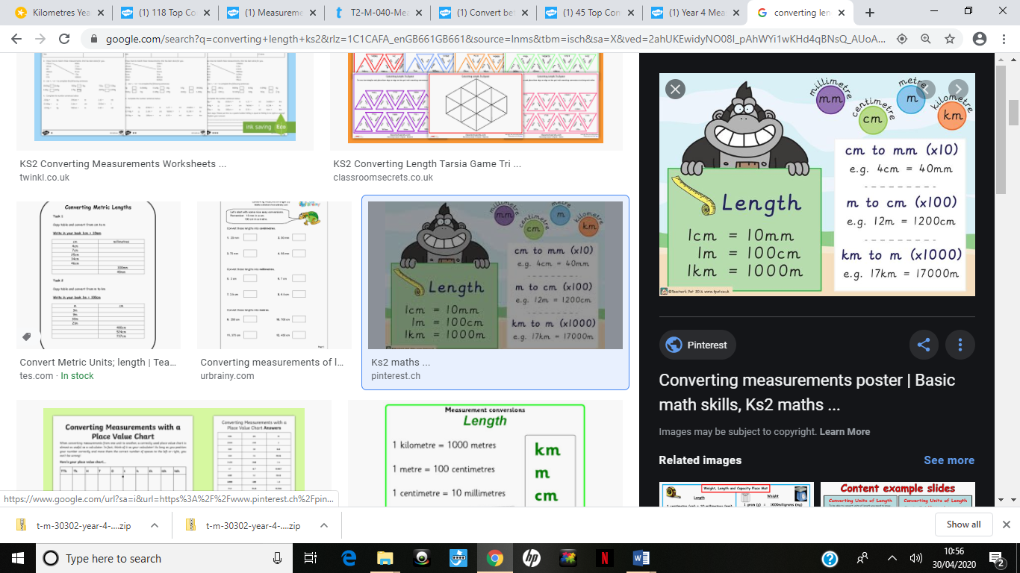**Converting Length**

The **Mischievous Monkey** holds all the knowledge. If a road was 4500m, how would you write that in km? You’d divide by 1000 so move the first digit 3 places which would mean 4.5km.

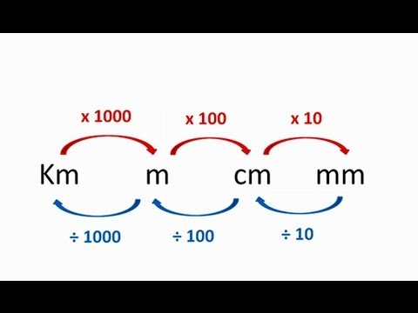

5

4