Foundation Phase – Summer Term – Week 2
These activities are for all children within the Foundation Phase.
Where the work has been differentiated, please feel free to challenge your child/children with the next year group of work.

Daily Activities
- Reading
- Spelling/Handwriting
- Mental Maths
- Joe Wicks

Monday  27/04/2020 | Mathematical Development  R – Count reliably up to 10 objects  https://www.topmarks.co.uk/learning-to-count/underwater-counting  1 – Count reliably up to 20 objects  https://www.twinkl.co.uk/resource/spring-themed-counting-on-up-to-20-activity-sheet-t-n-7444  2 – Count sets of objects by grouping in 2’s, 5’s and 10’s  https://www.twinkl.co.uk/resource/t-n-2362-counting-in-2s-worksheet  https://www.topmarks.co.uk/maths-games/hit-the-button - 2 x tables  3 – Recall 2,3,4,5, and 10 times tables  https://www.twinkl.co.uk/resource/t-n-1341-counting-in-5s-hands-worksheet  https://www.topmarks.co.uk/maths-games/hit-the-button - 5 x tables | Language, Literacy and Communication  Diary Planning-oracy  Talk to someone in your house about why we are at home and why school had to close. How did you feel? What have you been doing at home? Discuss the work you have done so far and all the lovely things you have done as a family. | Knowledge & Understanding of the World  Draw a map of the jungle and mark on the animals that are in the story.  Here is an example....  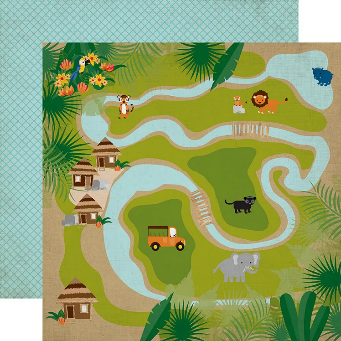  Can you include a key to explain your illustrations?
Tuesday  28/04/2020 | Mathematical Development  R – Count reliably up to 10 objects  https://www.worksheetfun.com/counting/wfun15_count_match_T1_6.pdf  1 – Count reliably up to 20 objects  https://www.sheppardsoftware.com/mathgames/earlymath/BalloonCount20.htm  2 – Count sets of objects by grouping in 2’s, 5’s and 10’s  https://www.twinkl.co.uk/resource/t-n-1341-counting-in-5s-hands-worksheet  https://www.topmarks.co.uk/maths-games/hit-the-button - 10 x tables  3 – Recall 2,3,4,5, and 10 times tables  https://www.twinkl.co.uk/resource/3-times-table-au-t2-m-2388  https://www.topmarks.co.uk/maths-games/hit-the-button - 3 x tables | Language, Literacy and Communication  Diary Planning-timeline  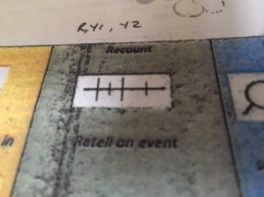  Use a timeline, like the one above, to plot some of the things you have done in order. You don’t need to write in sentences, just use keywords. | Creative Development  Design and create a rainforest habit for an animal of your choice from the story.  You can use any resources that you have within your home.  Here are some examples;  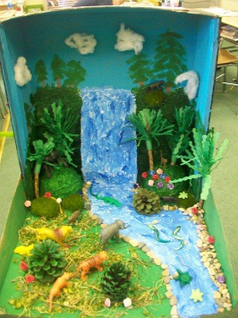  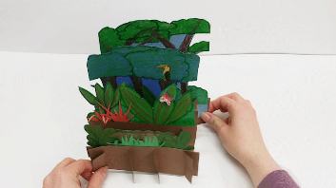  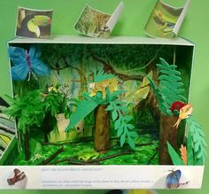
Wednesday  29/04/2020 | Mathematical Development  R – Count reliably up to 10 objects  https://www.twinkl.co.uk/resource/t-n-516-my-counting-worksheet-pets  1 – Count reliably up to 20 objects  https://www.twinkl.co.uk/resource/t-n-5091-pets-counting-11-20-activity-sheet  2 – Count sets of objects by grouping in 2’s, 5’s and 10’s  Fill up a large glass (a pint glass) with DRIED pasta (the smaller the better – maybe macaroni). Can you count the pieces of pasta by grouping in 2’s? Repeat with a different amount of pasta, grouping in 10’s. Repeat with a different amount of pasta, grouping in 5’s. Can you count other objects by grouping in 2’s, 5’s and 10’s?  https://www.topmarks.co.uk/maths-games/hit-the-button - 5 x tables  3 – Recall 2,3,4,5, and 10 times tables  https://www.twinkl.co.uk/resource/seasons-path-missing-numbers-counting-in-4s-activity-sheet-t-t-289755  https://www.topmarks.co.uk/maths-games/hit-the-button - 4 x tables | Language, Literacy and Communication  Diary writing-Introduction  Today write the beginning of your diary. Explain why we are at home and how you felt when school closed. What did your teachers tell you?  You need to:  Write in the past tense-I was, we had.  Write in sentences that make sense.  Use capital letters and full stops.  Write events in order-First, then, next, after that....  Use adjectives-sad, happy, big etc.  Sound words out.  Keep writing neat and tidy.  Use a word mat to help you with spelling.  https://www.twinkl.co.uk/resource/t-l-4541-100-high-frequency-words-word-mat | Welsh Language  Gem Helfa Drysor  Treasure Hunt Game  Place a few hoops around your outdoor area with a specific weather picture card inside each of them.  Hide a selection of weather cards around your outdoor area.  For the flashcards,  see the hyperlink on the website named;  Welsh Flashcards_weather_week_2_activity.  Allow your child/children to hunt for the flashcards. When they find a card, ask the question;  ‘Sut mae’r tywydd?’  Children respond;  ‘Mae hi’n ….....’ read what it says on the card.  The children must then place that card into the corresponding hoop (match the weather).  Continue the game until all of the cards have been found.  You can adapt this activity as you see fit but try to reinforce the vocabulary.
Thursday  30/04/2020 | Mathematical Development  R – Begin to find halves in practical situations  Using playdough, make a variety of shapes. Can you cut them in half equally?  1 – Find halves in practical situations  http://www.snappymaths.com/counting/fractions/interactive/halfornotimm/halfornotimm.htm  2 – Find halves and quarters in practical situations  Baking challenge! Can you bake a cake, make a pizza or cook a pancake? Once it is cooked can you cut it in half equally, and then half again to make a quarter?  3 – Find ½, ¼ and ¾ of amounts.  http://www.primaryresources.co.uk/maths/pdfs/12fracwork.pdf | Language, Literacy and Communication  Diary writing  Today write the rest of your diary. Use your timeline to help describe what you have done. Add details to make your diary interesting to read.  You need to:  Write in the past tense-I was, we had.  Write in sentences that make sense.  Use capital letters and full stops.  Write events in order-First, then, next, after that....  Use adjectives-sad, happy, big etc.  Sound words out.  Keep writing neat and tidy.  Use a word mat to help you with spelling.  https://www.twinkl.co.uk/resource/t-l-4541-100-high-frequency-words-word-mat | DCF  Send an email to your teacher using their Hwb email address found on the school website. You could say hello, include something you have been doing or ask a question.
Friday  01/05/2020 | Mathematical Development  R – Begin to find halves in practical situations  http://www.snappymaths.com/counting/fractions/interactive/halfornotimm/halfornotimm.htm  1 – Find halves in practical situations  Baking challenge! Can you bake a cake, make a pizza or cook a pancake? Once it is cooked can you cut it in half equally?  2 – Find halves and quarters in practical situations  https://www.twinkl.co.uk/resource/t-n-2640-fractions-colouring-sheet-circles  3 – Find ½, ¼ and ¾ of amounts  http://www.primaryresources.co.uk/maths/pdfs/15smartie.pdf  If you don’t have any smarties use colouring pencils/pens, building blocks or lego. | Language, Literacy and Communication  Diary checking  Today you need to finish your diary if you haven’t already. Then you must read your diary through and check:  Each sentence makes sense.  Has a capital letter and full stop.  Is in the past tense.  That you have spelt words as best you can.  Make any improvements that you need to.  Draw a picture to illustrate your diary and colour it in carefully. | Physical Development  Garden games  Bike Riding

