Week 2 – Summer Term
MONDAY 27th April 2020
Literacy
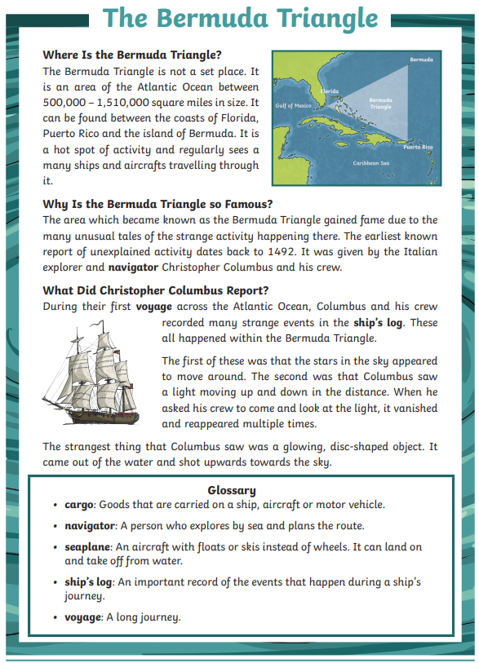
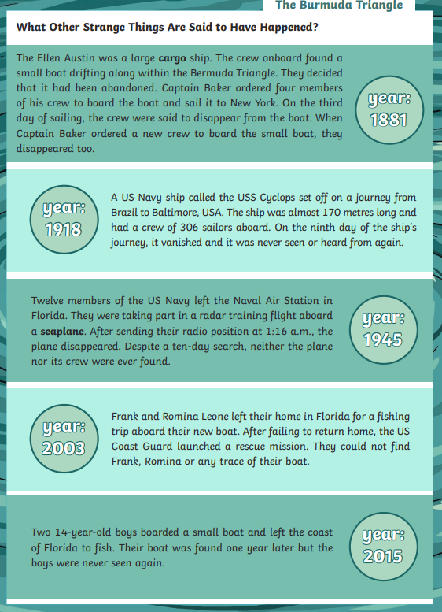
1. In which year did the USS Cyclops disappear?
- 1881
- 1918
- 1945
- 2003

2 Which of these phrases best describe the motion of the glowing, disc shaped object that Columbus reported?
- It fell from the sky and went underwater.
- It hovered above the water's surface.
- It rose from the water and went up to the sky.
- It bobbed along the horizon, blinking strangely.

3 During their first voyage across the Atlantic Ocean...
Give one word that the author could have used instead of the word voyage in this phrase.

4. Look at the section called: Why is the Bermuda Triangle so Famous? Find and copy two different adjectives which describe the activity that occurs in the Bermuda Triangle.

5. What was the name of the captain of the Ellen Austin?

6. Summarise why the Bermuda Triangle is well-known.

- Choose one thing that Christopher Columbus reportedly saw and explain why you think it might have been.

- It is a hot spot of activity...
What does this phrase imply about what the Bermuda Triangle is like?

Maths
- Write these numbers using numerals:
  - Three hundred and seven
  - Nine hundred and ninety
  - Six hundred and eighty eight
  - Two hundred and forty nine
  - Eight hundred and fifty
  - One hundred and three
- 546
  - What is ten more than this number?
  - What is one hundred more than this number?
- Compare these numbers using < or >
  - 987 897
  - 566 565
  - 451 541
  - 877 888
  - 269 962
  - 311 333
- Put these numbers in order from smallest to largest: 658, 346, 585, 856, 463, 634, 588
- Find ten more and ten less than each number:
  - _____765______
  - _____629______
  - _____898______
  - _____502______
- Continue this number sequence:
  - 16, 24,
  - 712, 722, 732,
  - 122, 222, 322,
  - 50, 100, 150,
  - 32, 26, 40, 44, 48,
- Write these numbers using words:
  - 413
  - 592
  - 860
  - 207
  - 722
  - 967
- If you were counting in multiples of 4, what number would come after...
  - 16?
  - 24?
  - 32?
  - 40?
  - 4?
  - 12?

World War II
World War II World Leaders

https://www.ducksters.com/history/world_war_ii/

Use the website to research a world leader. Write what you have found out, add a picture.

TUESDAY 28th April 2020

Literacy

Look at the springtime scene. Can you write sentences about the lovely things you can see, using an appropriate preposition? Use the bank of prepositions to help you.
Green – 4 sentences
Blue – 6 sentences
Red – 8 sentences

By On Behind Next to Through

Between Beside Below Over Under

Inside Outside
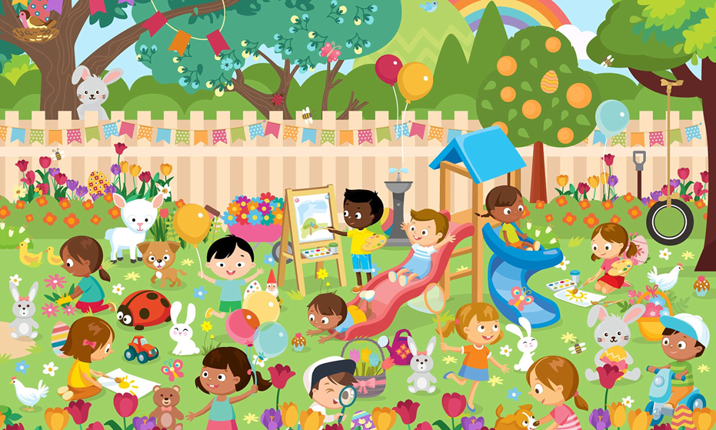

Now draw your own spring scene and write a short description of what you can see. Use a preposition in every sentence.
Maths
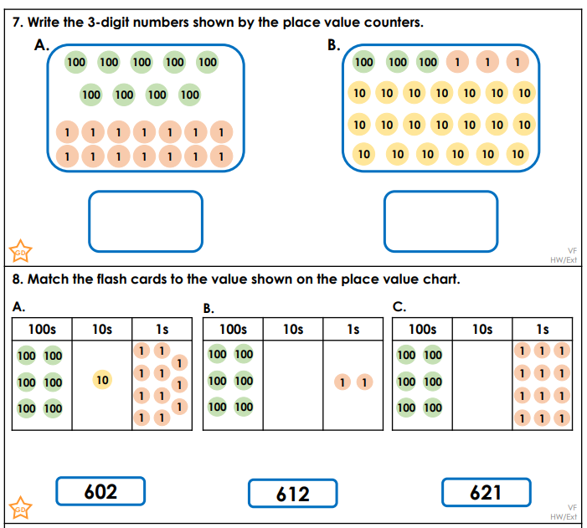
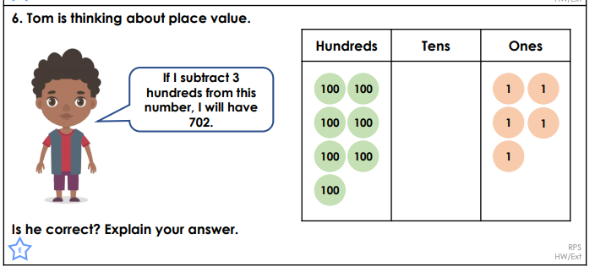
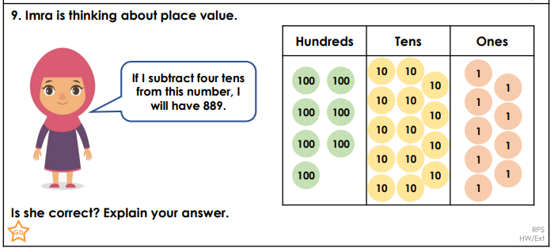
Expressive Arts
Use the following web link to draw different things
http://www.robbiddulph.com/draw-with-rob

WEDNESDAY 29th APRIL 2020
Maths
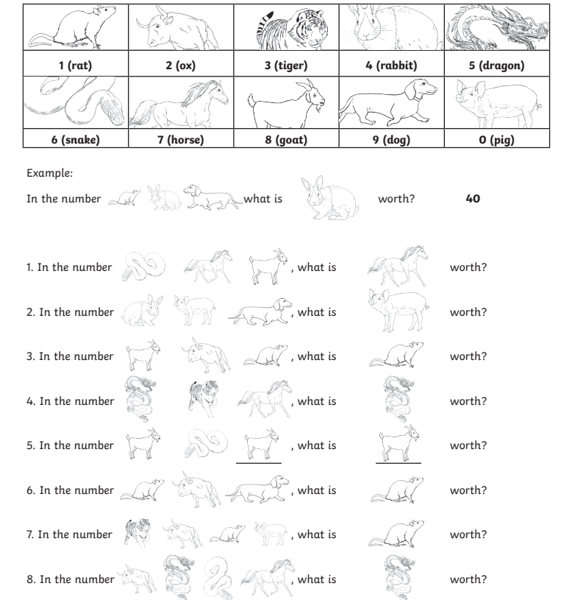

Welsh – Beth wyt ti’n gwisgo? (What are you wearing?)
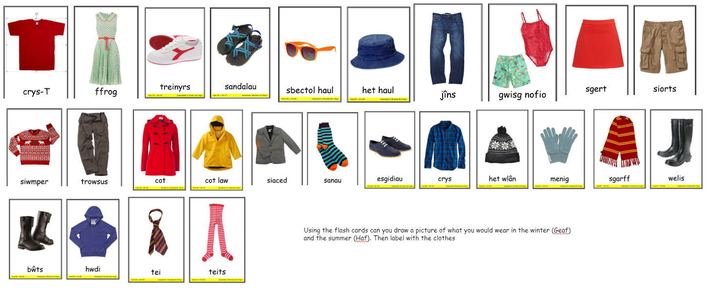
Science

Watch the following link
https://www.youtube.com/watch?v=9bMzrvRbqms&feature=emb_title

An alien called Zinnia from distant Planet Dock5, wants to set up a human hotel on their planet. She needs to know: what plants need to grow strong and healthy; what parts of the plant humans eat; a list of food plants.

https://www.bbc.co.uk/bitesize/clips/zv2qxnb

https://www.dkfindout.com/uk/animals-and-nature/plants/

https://www.sciencekids.co.nz/sciencefacts/plants.html

http://factsforkids.net/plant-facts-for-kids/

https://www.bbc.co.uk/bitesize/topics/zy66fg8

What do plants need to become strong and healthy?

Research and gather ideas using the links above.

If we are going to give Zinnia advice about growing plants in space, we will need to find out a lot more about them. Use books/internet to help you discover facts? Why not make a Did you know...? Poster.

• Why does a plant need roots?
• What happens in the leaves?
• How do plants make new plants?
• Why do leaves change colour in autumn?
• How long can plants live?
• Why do flowers smell?
• Why are most plants green?
• What is pollen?
• How big or small can a plant be?
• Can plants get ill?

THURSDAY 30th APRIL 2020
Literacy
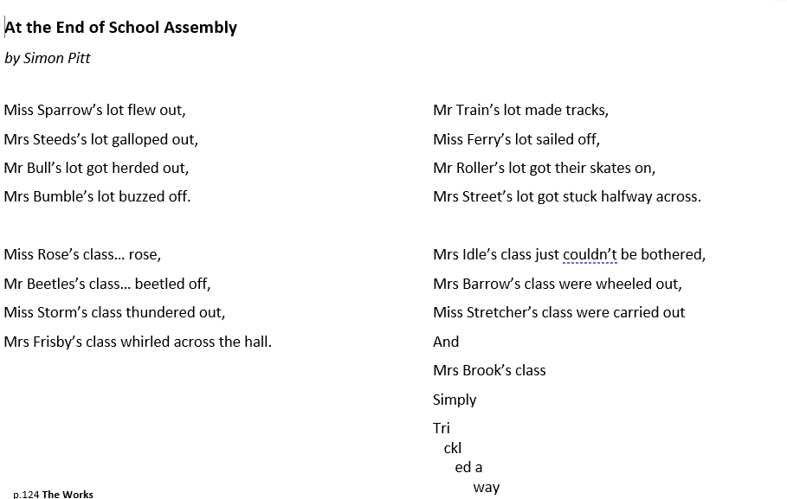
Can you see any patterns in the poem?
What do you notice?
How many lines are in each verse?
What does each line start with?

What is needed to make this poem into a performance?

Can you learn at least one verse of the poem? Think of the actions and look for patterns in the language to help memorise it. Expression will make it easier to learn and more enjoyable to the audience.

Perform your poem to the family.

Maths
Green – T
Blue - T&S
Red and Black – T&S&D

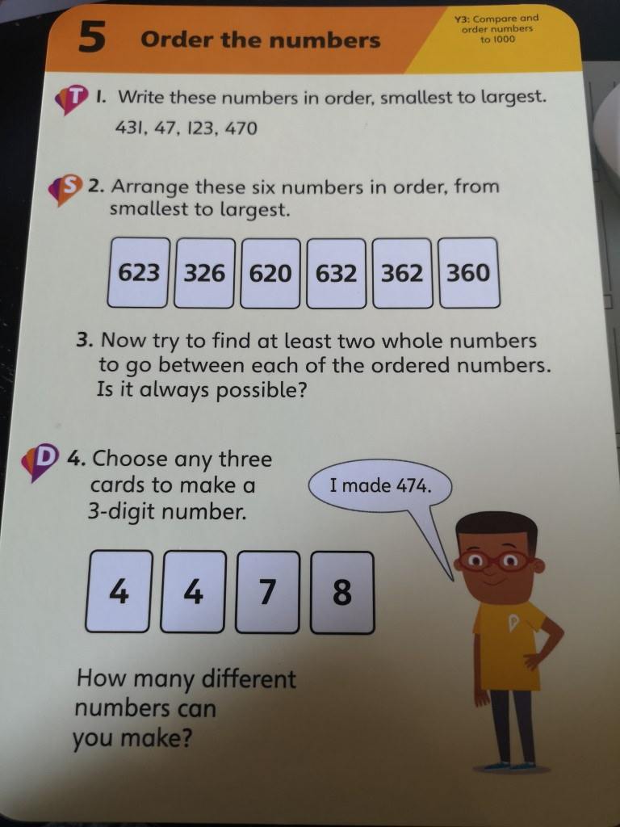
Computing
https://scratch.mit.edu/projects/editor/?tutorial=all

This week click on the 'Make Music' and follow the instructions.

FRIDAY 1st APRIL
Literacy
Read the poem from yesterday, using actions and expressions.
Powerful verbs paint a picture in the reader's head to make us laugh.
A verb names an action. It is a doing word (pick, run, skip, swim).

Write a list of verbs in the first column of the table. There are three poems below to help. Take the highlighter tool (DRAW) and highlight all the verbs. Then write the verbs in the table.

You are now going to change the words from preset to past tense using the following rules:
- Just add ed
- If the word ends in –e or –ie; add -d
- Short vowel, ends in consonant; double the consonant and add –ed
- Word ends in consonant and –y; change –y to -I and add ed

Verb | Just add -ed | Word ends in –e/-ie  Add -d | Short vowel, ends in a consonant  Double the consonant and add -ed | Word ends with consonant and –y  Change –y to -I and add -ed
Pick | Picked
Hike |  | Hiked
Clap |  |  | Clapped
Cry |  |  |  | Cried

My Doggy Ate My Essay
BY DARREN SARDELLI

My doggy ate my essay.
He picked up all my mail.
He cleaned my dirty closet
and dusted with his tail.
He straightened out my posters
and swept my wooden floor.
My parents almost fainted
when he fixed my bedroom door.
I did not try to stop him.
He made my windows shine.
My room looked like a palace,
and my dresser smelled like pine.
He fluffed up every pillow.
He folded all my clothes.
He even cleaned my fish tank
with a toothbrush and a hose.
I thought it was amazing
to see him use a broom.
I’m glad he ate my essay
on “How to Clean My Room.”

Little Boy Blue
© Darren Sardelli More By Darren Sardelli
Published: May 2014
Please cover your nose.
You sneezed on Miss Muffet
and ruined her clothes.
You sprayed Mother Hubbard
and now she is sick.
You put out the fire
on Jack's candle stick.
Your sneeze is the reason
why Humpty fell down.
You drenched Yankee Doodle
when he came to town.
The blind mice are angry!
The sheep are upset!
From now on, use a tissue
so no one gets wet!

If I Were King
By A. A. Milne More A. A. Milne
I often wish I were a King,
And then I could do anything.
If only I were King of Spain,
I'd take my hat off in the rain.
If only I were King of France,
I wouldn't brush my hair for aunts.
I think, if I were King of Greece,
I'd push things off the mantelpiece.
If I were King of Norroway,
I'd ask an elephant to stay.
If I were King of Babylon,
I'd leave my button gloves undone.
If I were King of Timbuctoo,
I'd think of lovely things to do.
If I were King of anything,
I'd tell the soldiers, "I'm the King!"
Source: https://www.familyfriendpoems.com/poem/if-i-were-king-by-a-a-milne

Maths
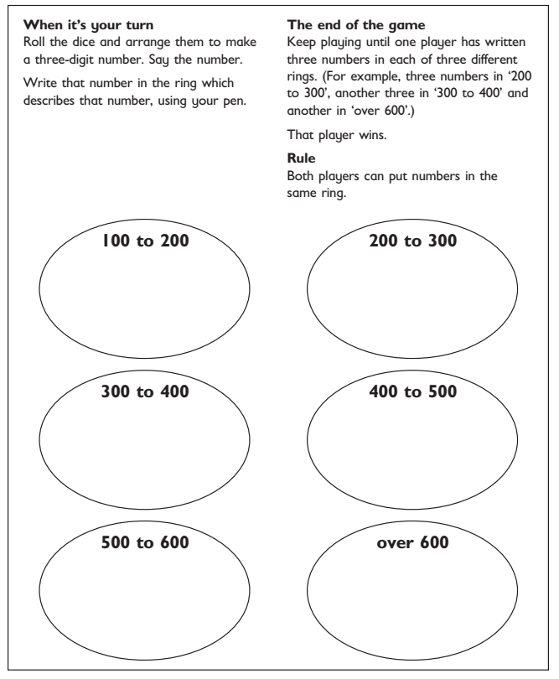

Mindfulness
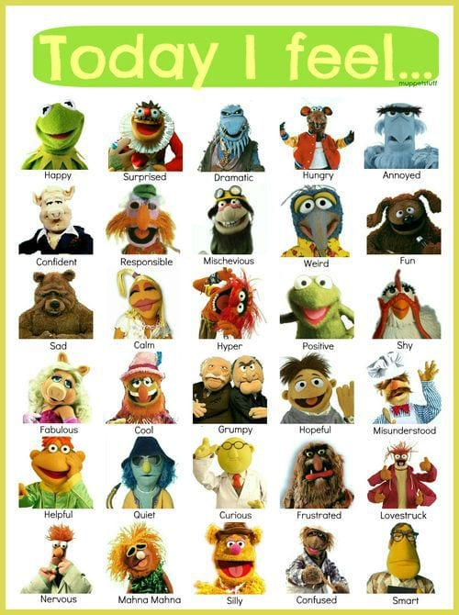

Mindfulness of Emotions

When did you feel like these characters? Can you write a sentence on a few of the emotions?

