Week Commencing: 20th April 2020
Monday 20th April 2020
Iaith
Adjectives – a describing word
Can you think of better adjectives for the following words? Create a mind map where you put the word in the middle and write around it.
- Small
- Big
- Bad
- Nice
- Quiet
- Loud
- Fast
- Slow
- Angry
- Young
- Old
- Hard

Green Iaith Group – Complete the words in Green
Blue Iaith Group – Complete the words in green and blue
Red Iaith Group – Complete all the words

Maths
- Mia just loves swimming, and she bought some new goggles at £9.70. When she took them to the till, they came up as half price. How much did Mia’s goggles cost?
- A One Direction CD costs £10.40, whilst a Little Mix’s CD costs £7.75. How much more does One Direction’s CD cost?
- Josh paid £8.70 for 2 pairs of new football socks. How much does each pair cost?
- Hannah went shopping with £15.10. She bought sunglasses for £9.80 and flip flops for £2.45. How much money does she have left?
- How many different ways can you make the total £3.44? You can use the same value coin more than once. What is the least amount of coins you could use?
- Terry loves biscuits. In the shop you can buy one biscuit for 30p or a pack of 5 for £1. He plans to host a tea party, so decides to buy 10 individual biscuits. Do you agree with his decision? Explain your answer.
- At the toy shop, Marley spent £10 in total. What could he have bought? How much change would he get?
- Toy Car £3.10
- Jigsaw £5.55
- Aeroplane – £2.20
- Trumpet - £4.87
- Ball - 87p
- Pens - £1.90
- Elodie buys three candy canes (30p) and two lollipops (40p). She pays with a £5 note. How much change will she receive?

World War II Project
Neville Chamberlain's Speech

https://www.bbc.com/historyofthebbc/anniversaries/september/war-announced

After listening to the speech can you research the Allies and Axis. Can you colour the Allies in one colour and the Axis in another. Remember to add a key.
Map of Europe
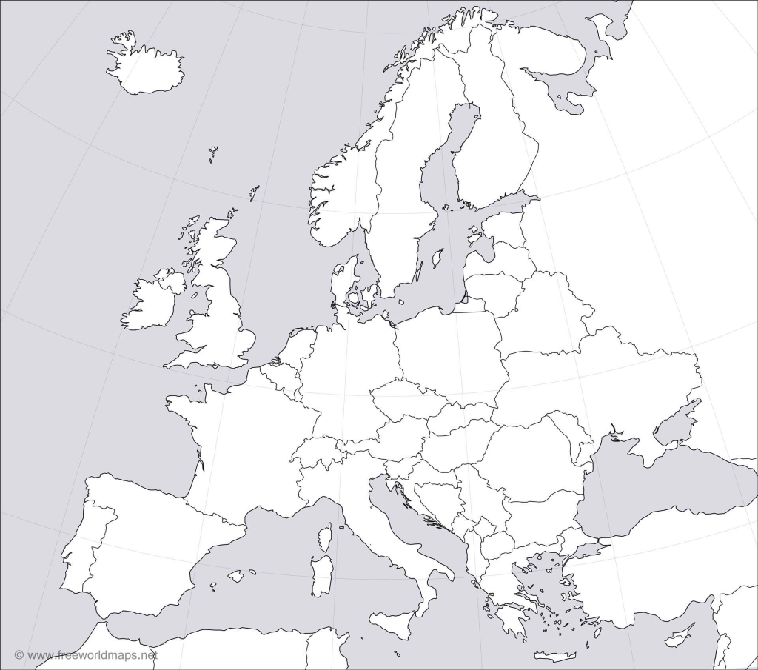
Map of the World

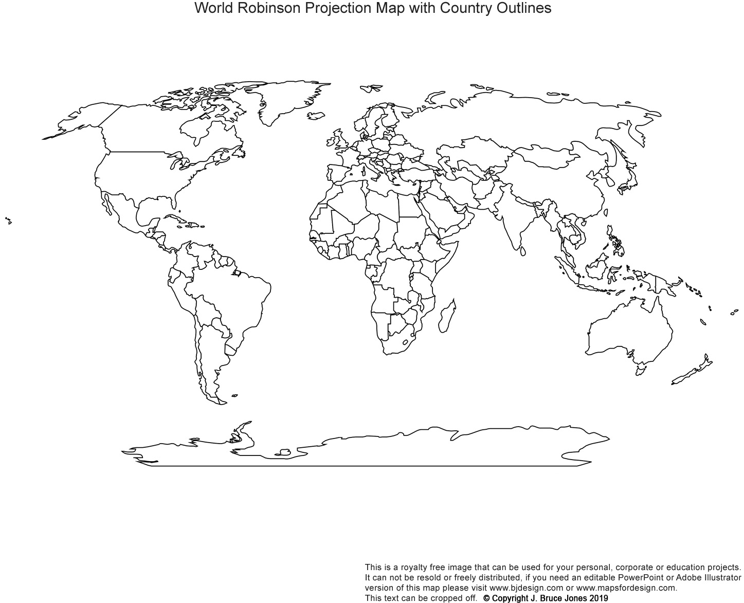
Tuesday 21st April 2020
Literacy
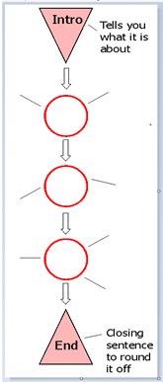
How to be a good friend
Use this skeleton to plan the three different parts of the text. Place the following headings in the circles: break time, lunch time and in class.
- Add a title that usually starts with ‘How…’
- Write a short introduction telling the readers what the text is about
- Each circle acts as a new paragraph. Write steps using words such as first, next and finally.
- You may add a labelled diagram
- Conclusion

Write your work underneath the picture by just clicking on the screen. Remember to underline and make your title and subheadings bold.

Things I will be looking for and marking
Title (bold + underlined)
Subheadings
3 paragraphs
Correct spellings
Capital letters and full stops
Ordering words (first, next, finally)
Conclusion
Labelled Diagram
Use of connectives (and, or, but)

Maths
- Ruby uses 1 note and up to 6 coins to buy the trousers. She uses 2 notes and 7 coins to buy trainers. Find five possible combinations of notes and coins which total less than £20 for each item.
- Draw £17 and 70p, using two notes and five coins. Two coins have fallen out. What is the highest possible total that could be left in the purse?
- Draw £14 and 35p in the purse, using 1 note and five coins. Two coins have fallen out. What is the lowest possible total left in the purse?
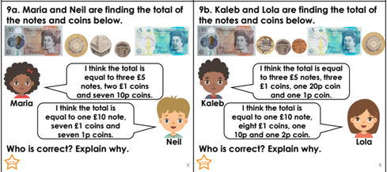
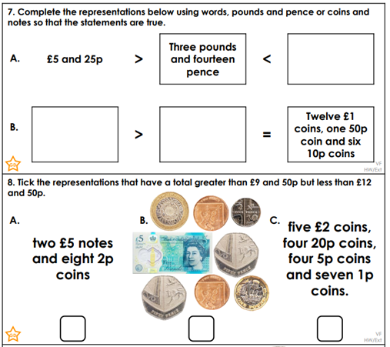

Expressive Arts
Create a jungle scene. Your jungle scene must include the following animals. Take a photograph and send either on Facebook or email.
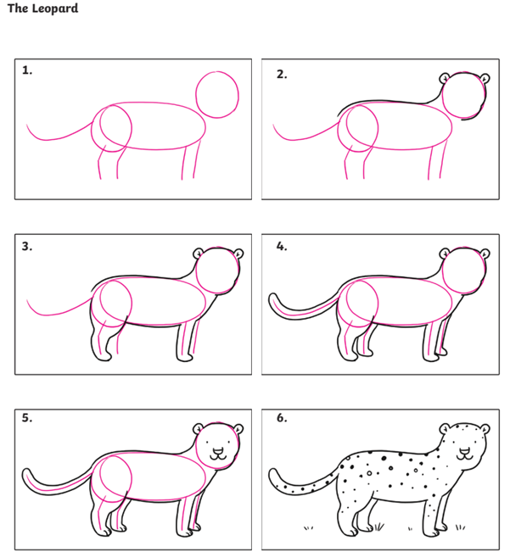
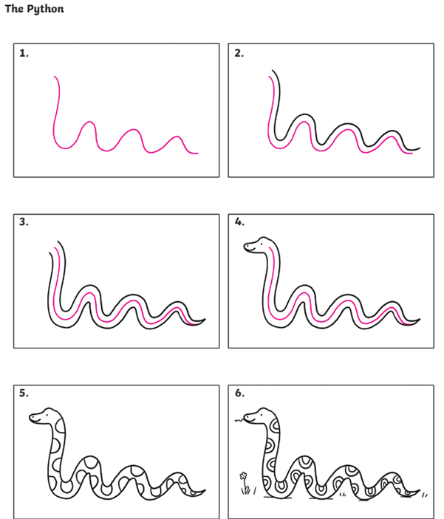
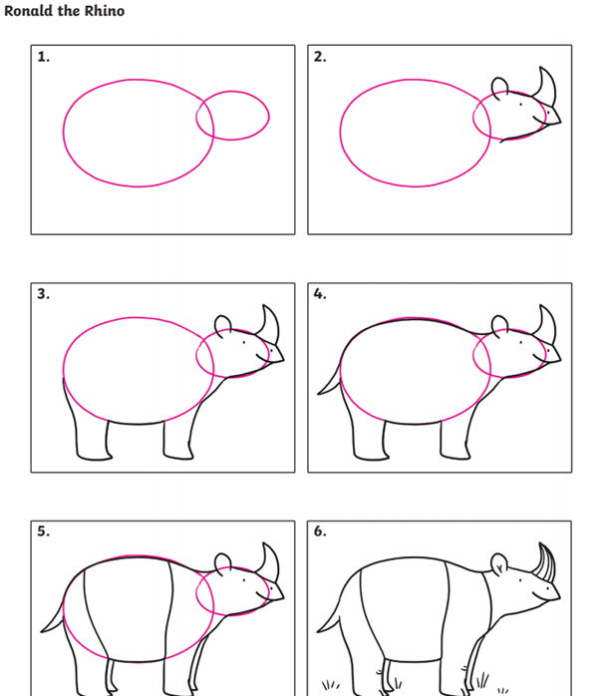

Wednesday 22nd April 2020
Welsh
Cymraeg
Draw a picture of yourself and label with the following labels:
- Ceg
- Gwallt
- Pen
- Coesau
- Braich
- Traed
- Llaw

Maths
Can you make your own shop? It could sell anything from foods, toys or furniture. Create a price list naming the object and putting the price next to it. Place price tags on your objects. Get another person to come into the shop buy things.
GREEN – Your objects need to be 50p or less.
BLUE – Your objects need to be £1 or less. You can also calculate the change needed.
RED – Your objects need to be £5 or less and calculate the change.
BLACK – Your objects need to be £100 or less and you can calculate the change.

You could take a photograph/video or even draw your objects and prices below.

Science and Technology
Find out what happens to your heart rate when doing exercise. Heart rates are calculated in beats per minute (bpm). Your regular resting heart rate should range between 60 and 100 bpm.
Can you draw out this table and fill it in? Think of your own activities
Before completing the activities predict which activity you think will have the highest heart rate. Can you give reasons for your answers?

Activity | Beats in 10 seconds | X6 | Beats per minute
Resting
Jogging
Jumping Jacks

Once you have done the experiment can you tell me what happened and why?
Thursday 23rd April 2020
Literacy
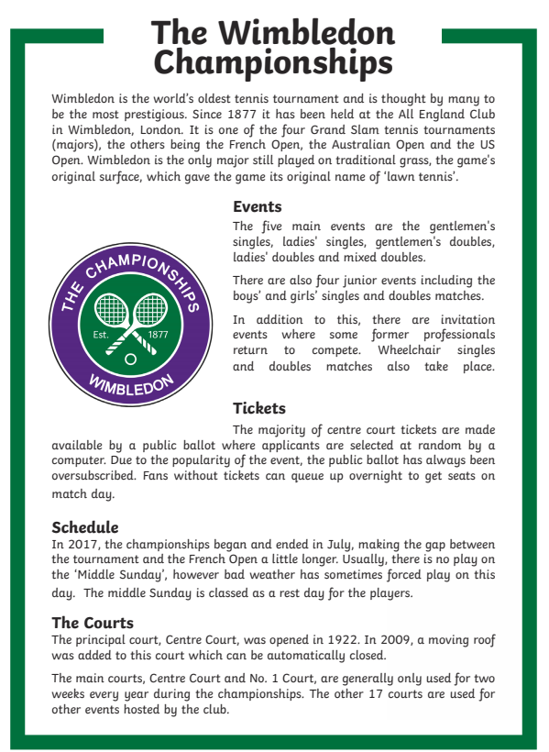

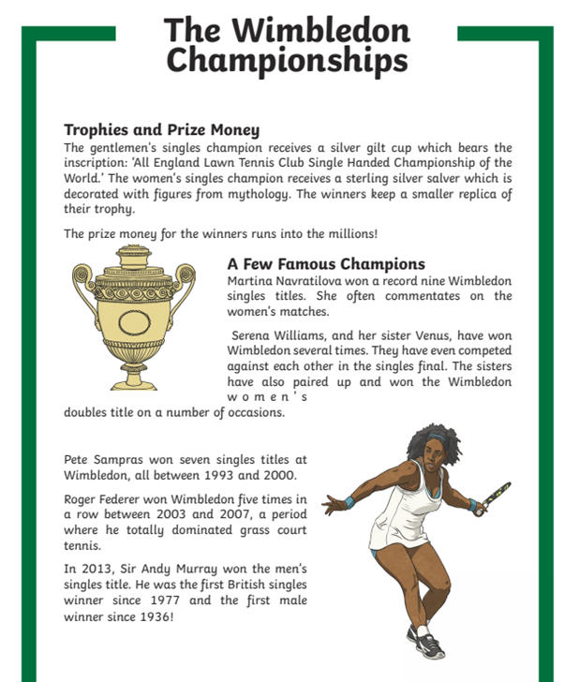
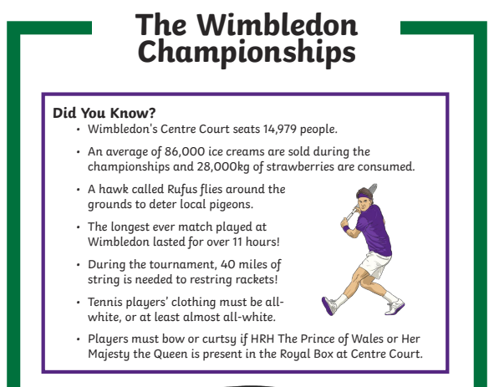

Read the text and answer the following questions.
- List all four Grand Slam tennis tournaments.
- Outline the main events of Wimbledon.
- Why did Wimbledon start later in 2017?
- What is special about ‘Middle Sunday’?
- How are the main show courts used differently to the other courts throughout the year?
- The Williams sisters have player against each other in the Wimbledon women’s singles final. How would you have felt if you had been playing against a family member/best friend in the Wimbledon final?
- Which year was the roof added onto Centre Court?
  - 2006
  - 2007
  - 2008
  - 2009
- Why do you think the winners keep replicas and not the original trophies?
- The hawk which flies around the grounds to scare away pigeons is called…
- What qualities do you think a person needs to become a Wimbledon champion? Explain your choices.

Maths
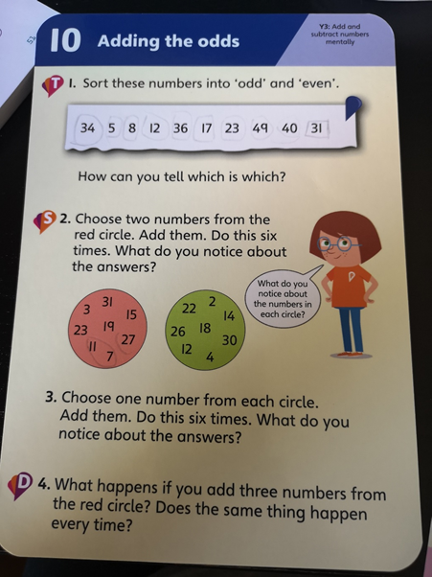
GREEN – T
BLUE – T & S
Black and RED – T & S & D

Computing
https://scratch.mit.edu/projects/editor/?tutorial=all
Click on Animate a Name and then follow the instructions.
Friday 24th April 2020

Maths
This week we have been learning about money. Can you create your own mathematical questions for me to answer? If you need pictures of different coins go to insert picture.
I will answer your questions and then you will need to check that my answers are correct.

Literacy
Use mime and pretend to be the following. Think about the way they might move, their body language, their facial expression and what they might be doing. You could record a short part and send if you want to.
- A weather presenter
- An angry car driver
- Someone winning a race
- A bored child
- Someone who has hurt their knee
- A child opening up a really exciting present
- A conductor of an orchestra
- Someone doing their housework
- A thief
- A postman
- Someone trying to get out of bed
- Someone who has just scored a goal in a football game
- A chatty hairdresser
- Someone taking a strong dog for a walk
- Someone having an argument with another person and then storming off

Mindfulness/PE/Yoga

Sun Salutations & Yoga with Animals - Yoga for Kids

