How to Access Work on One Note
Notebook basically acts as a school work book where children are able to complete work and share with the teacher. Maths and Iaith work will be differentiated and all worked marked.
- Log into HWB (if you have forgotten your password or username please contact me).
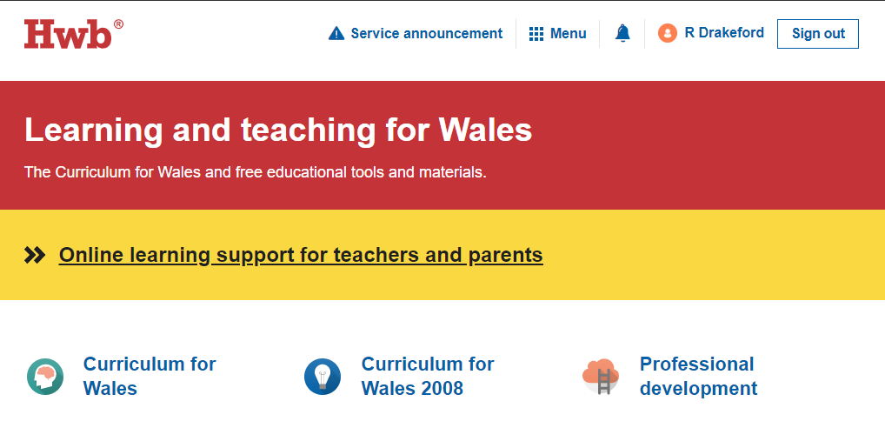
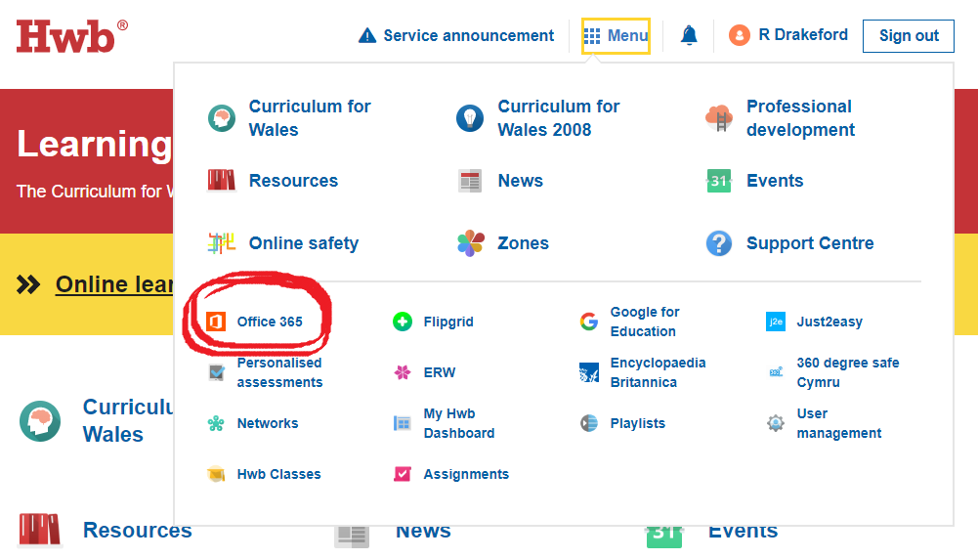
- Click menu and then Office 365. Sometimes it may ask you to log in again, make sure it is the correct username.

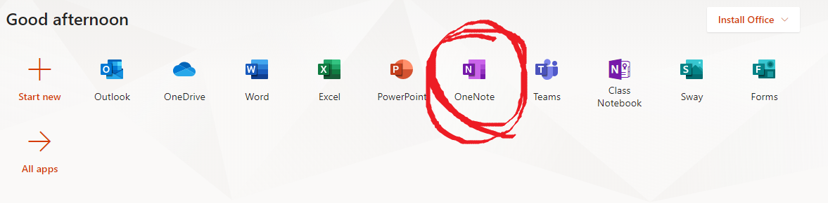
- Click on OneNote

- Then click shared with me and you should be able to see World War II Notebook, click on it to open.
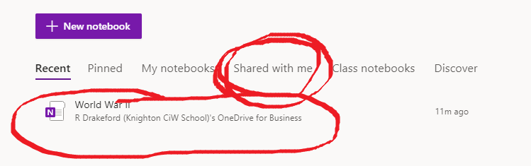

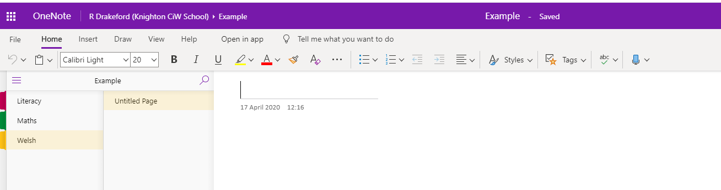
- You should have something that then looks like this. The subjects will be on the left-hand side. When you press on the subject it will open in the next column (Untitled page), it should show the date. Once you press on that you can complete the work.
- You can write straight onto the document. For example, in the maths work you can type the answer at the end of the question. I will then go through the notebooks and mark the work. It is a lovely tool as I am able to add stickers to the work to hopefully motivate the children.
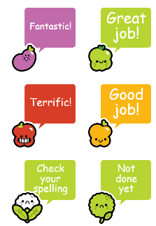

If you are unable to access the Notebook let me know and I will try and help.
Children may want to complete the work on paper. I will place all work on the school website, feel free to photograph or email work across for me to look at.

