5-Sided Paper Flower Instructions

See what happens when you put your flower in water!
Tip: If you do not want to make a folded and cut (kirigami) version of the blossom, skip Steps 3 & 4 and use template 2
- Step 1 Print template on an8 1/2” X 11” sheet of paper
- Step 2 Cut out individual squares along dotted line.
- Step 3 Fold along line A. Fold along line B. Fold along line C. Fold along Line D.
- Step 4 Fold backwards along line E.
- Step 5 Cut along solid black line. Open blossom up.
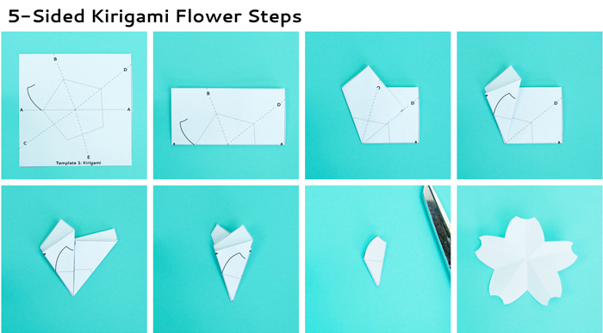
- Step 6 Colour the side with the dotted lines using Koi Watercolour Pens or water based markers
- Step 7 Turn the blossom over and add details in black permanent marker such as Pigma Sensei Pens.
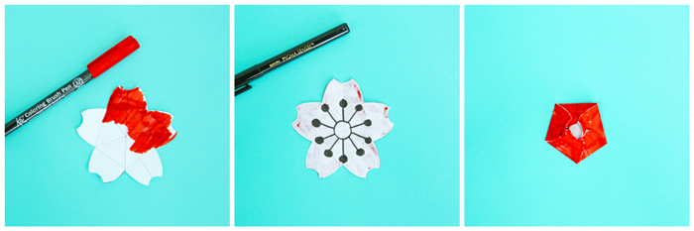
- Step 7 Fold petals along dashed lines. The black details should be in the inside of the blossom
- Step 8 Place the blossom in a plate filled with water.
- Step 9 As the paper absorbs water the petals will open and the colour will be distributed throughout the entire blossom. The black details will remain.
