You Will Need
- Large sheet of paper or recycle an old plastic bag (60cm long by 45cm wide)
- 2 sticks (Thin 60cm)
- Twine
- Ribbon, Optional

Step 1
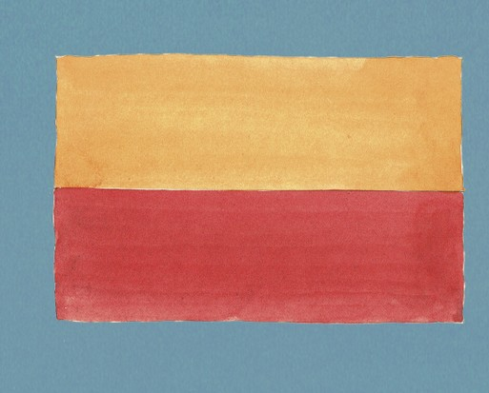
Measure your kite
Make the sail of your kite with a large sheet of paper 60cm long by 45cm wide. A reel of brown paper will do, or buy coloured paper from a craft shop. Fold the paper in half lengthways. On either side, measure 15cm down from the top. Use ruler or other straight edge to draw a line between these marks and the top centre. Draw two more lines from the marks at the side to the bottom centre, to form a diamond.

Step 2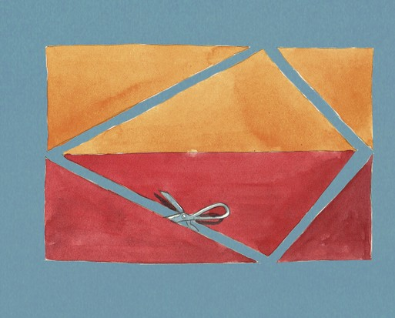
Cut out your kite (Illustration: Liam O’Farrell)
Carefully cut out your diamond.

Step 3
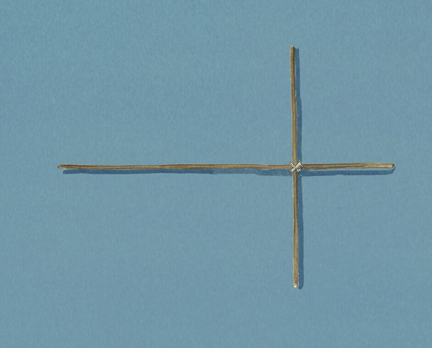
Build the frame
Thin 60cm bamboo plant supports from garden centres make good, lightweight spars. Using secateurs, cut one of them to a length of 45cm. Tie the two spars together with twine – checking that the spar-ends still line up with the corners of the paper sail – then knot firmly. Trim the twine.

Step 4
At each corner, use something sharp (such as a cocktail stick) to pierce two holes on either side of the spar. Thread twine through each hole (this is fiddly!) and tie it to the spar, leaving some loose ends for attaching ribbons. Glue the spars the paper and allow to dry.

Step 5
Attach a piece of twine firmly to the spar at the left and right corners, allowing plenty of slack – there should be about 60cm of twine loose between the two corners. Fix your flying line firmly to this twine. (I reused a reel of old twine from a tangled kite in the cupboard.)
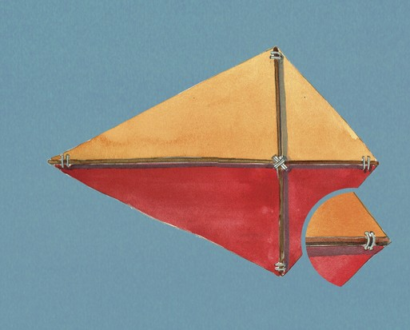

Step 6
Cut two 2m x 2cm strips of crepe paper, and tie them to the bottom of the kite. Add two more strips, around 1m long, to the sides or you could use ribbon instead.
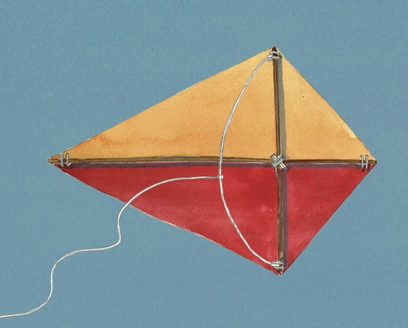
I waited for a dry, breezy day – strong winds might damage your fragile kite. When you’re ready for your kite’s maiden voyage, find a patient, excitable person to help you launch the kite. Stand upwind of the kite, and ask your helper to stand directly downwind. Launch and enjoy the sight of your kite fluttering in the breeze!

