How to Make Homemade Bubbles
INGREDIENTS
- 4 cups warm water
- 1/2 cup sugar
- 1/2 cup blue Dawn dish soap
INSTRUCTIONS

Step #1. Whisk the sugar and water.
Whisk the sugar into the warm water until the sugar dissolves.

Step #2. Whisk in the soap.
Add the dish soap and whisk to combine.

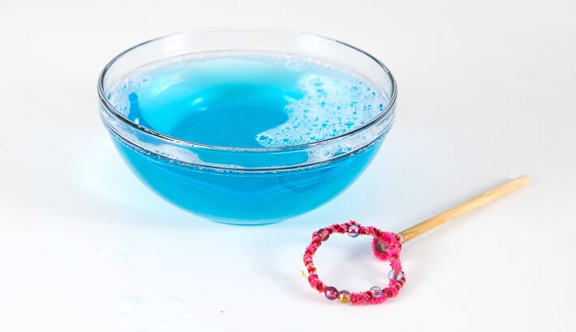

Step #3. Let sit.
This step is only if you have some patience or think to make the solution ahead of time. Letting the homemade bubbles sit for a couple of hours or even overnight helps them work a bit better, but is not strictly necessary.

If you make this on a larger scale you can use a tennis or badminton racket to make loads of bubbles at once!
Have fun!

