The Four Operations
Here is how we are teaching addition, subtraction, multiplication and division.
ADDITION
Here is an example of how we add using expanded column addition.
325 + 643 =
- First we partition the numbers into 100s, 10s and 1s
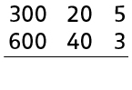

- We then add the ones column 5 + 3= 8
- Then the tens 20 + 40 = 60
- And then the hundreds 300 + 600 = 900
- Finally we put the number back together to make 968

Addition with Carrying
426 + 155 =
- We partition the numbers into 100s, 10s and 1s
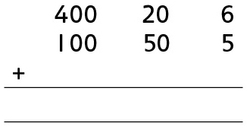
- We then add the ones 6 + 5 = 11. We cannot put 11 under the line as it has two digits and therefore need to carry the ten across.
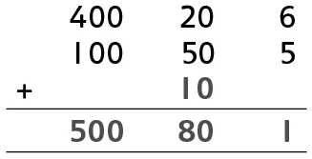
- We then add the tens 20 + 50 + 10 = 80
- We then add the hundreds 400 + 100 = 500
- We then put the number back together = 581

Subtraction
We teach subtraction using frog to hop from the smallest to the biggest number.
78-34
- Draw a number line and place the smallest number at the start of the line and the biggest number at the end of the line.
78
34

- We then jump to the next 10 and write how many places frog has hopped on top of the jump.
+6
40
34
78

- We can then either jump in 10s or jump all the way to 70
+30
70
+6
78
40
34

- You then hop to the last number
+8
+6
+30
78
70
40
34

- Finally add all the hops up 6 + 30 + 8 = 44

Multiplication
We multiply by using the grid method.
23 x 4
- We draw a grid
- We partition into 10s and 1s and place the 2-digit number along the top of the grid.
- We place the one digit on the left hand side.
- 4 x 20 = 80 (if you find this difficult then do 4 x 2 = 8 and then 8 x 10 = 80)
- 4 x 3 = 12
- You then add the boxes up to get the answer 80 + 12 = 92
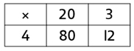
You should be practicing your 2, 3, 4, 5, 6- and 10-times table

Division
We use Chunky Chimp to divide
56 ÷ 4
- How many fours in fifty-six?
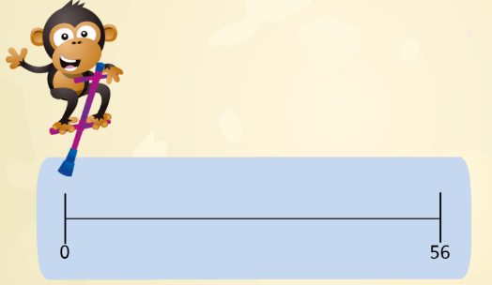
- Chunky Chimp will jump along the number line in 4s to see how many lots of fours make 56.
- Count up how many groups to get the answer

- If Chunky Chimp has a few left over but not enough for a group then we use remainder. 34 divided by five would be 6r4

