Acute angles are less than/more than 90°.
Acute
Key
Obtuse angles are less than/more than 90°, but less than/more than 180°.
Choose 3 colours, fill in the key, then colour the angles as appropriate.
Obtuse
Use a protractor to measure the angles.
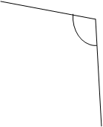
Right angle
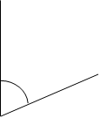
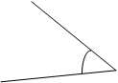
Write an O or an A next to each of these angle sizes to show if it is Obtuse or Acute:

48° 119°
92° 53°
167° 123°
72° 175°
86° 35°

