School Plan for Start and End of Day .

Parents/Carers are encouraged to walk their children to school to decrease congestion. Parents/Carers are asked not to congregate around any entrance, to wear masks (unless exempt) and to socially distance from others. Once children have been dropped off/collected, parents are asked to move away from the entrances.

Entrances/Exits to be used | Pod | Entrance and Exit to be used | Time of entry and Exit
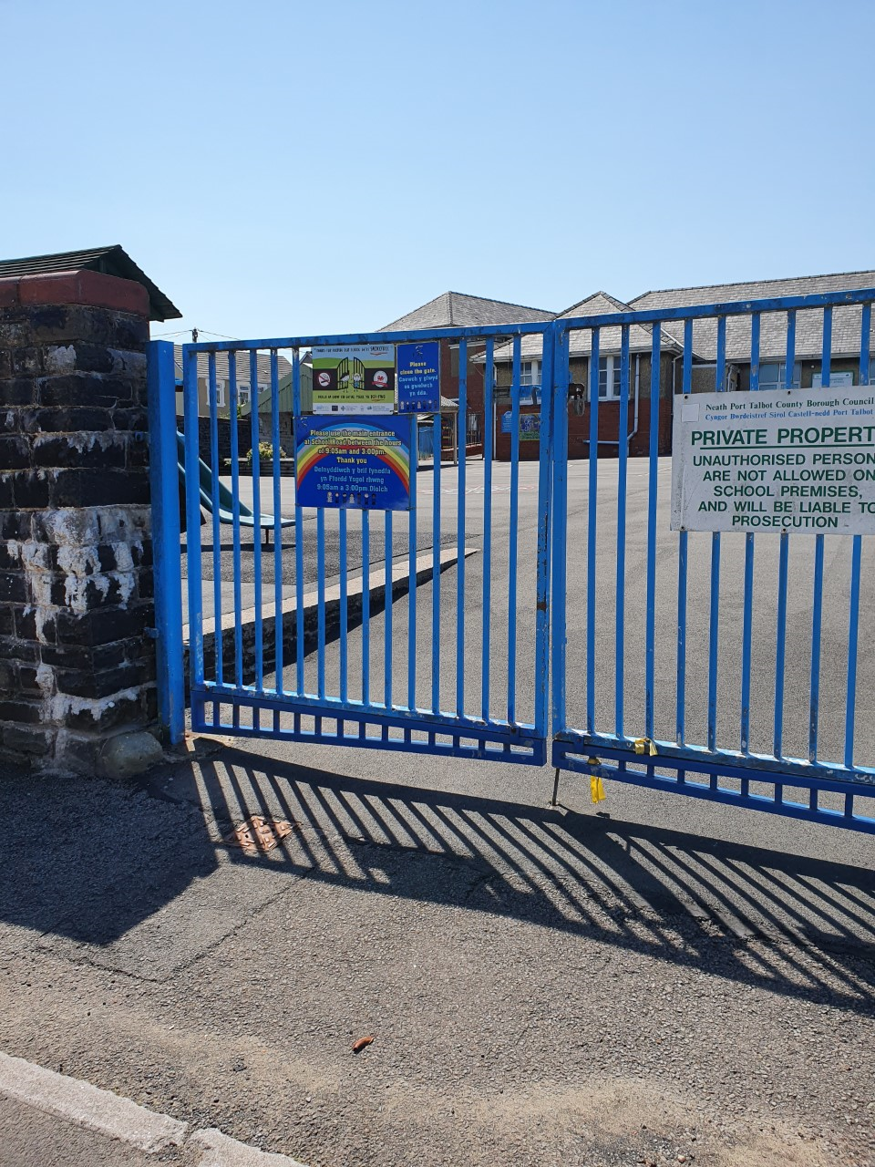 | LSC  Class 1/Class 6 | Main entrance gates Main Road.  Children to be taken through the ‘quiet yard’ into the LSC entrance | Staff to collect children from taxi/parent at school gate on arrival  Staff to escort children to taxi/parents at school gates 3:20pm
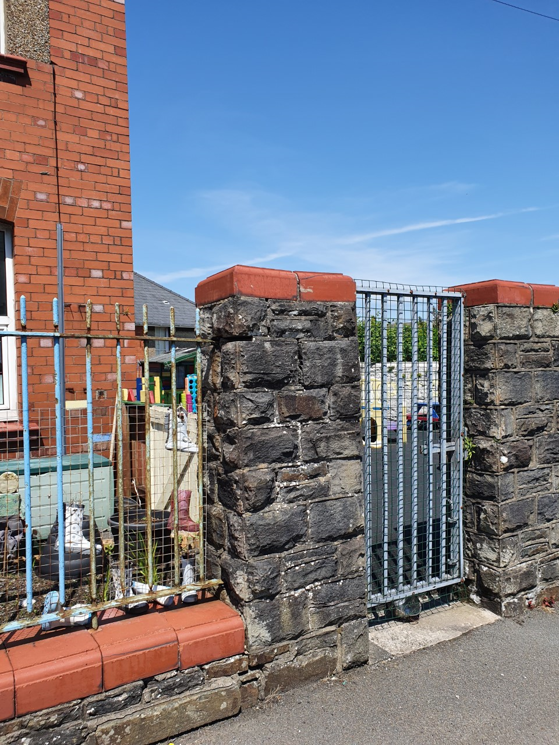 | Class 2  Nursery Reception | Nursery yard entrance on School Road | Morning Nursery/Reception children to arrive at 8:45am Met by staff at gate.  Morning Nursery to be collected at 11:30am at gate.  Afternoon Nursery to arrive at 12:50pm  Met by staff at gate  Nursery/Reception children to be collected at 3:15pm at gate.
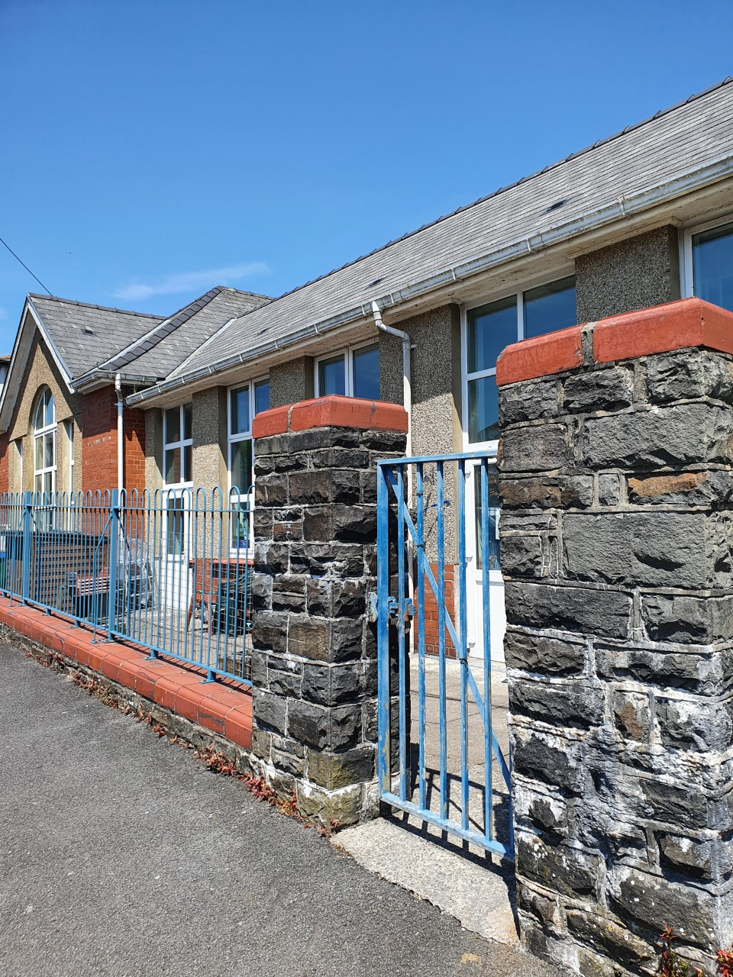 | Class 3  Year 1/2 | Highland Crescent entrance | Children to arrive at 8:55am and met by staff at gate. Children to be collected at 3:25pm at gate.
 | Class 4  Year 3/4 | Main Road entrance school gates. Children to be taken through the bottom yard, up the steps to the upper yard and in through the door in main corridor | Children to arrive at 8:40am and met by staff at the gates  Children to be collected at 3:10pm at the gates.
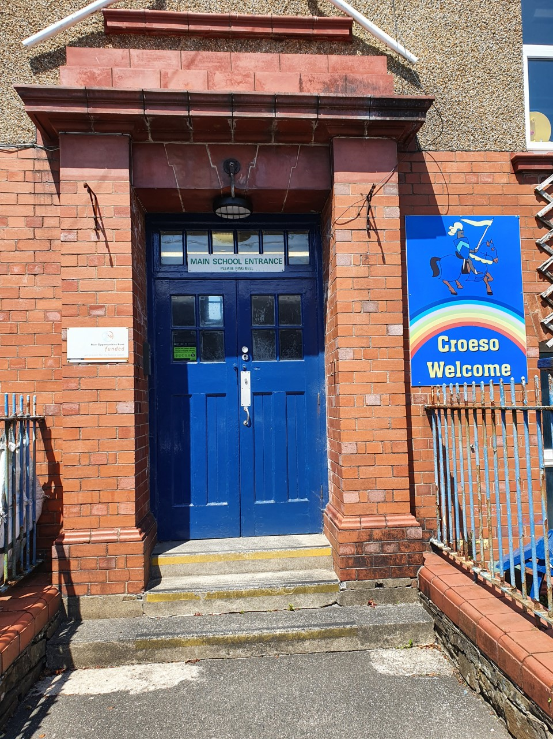 | Class 5  Year 5/6 | School Road entrance,  main school door. | Children to arrive at 8:50am and line up outside railings Children to be collected/sent home at 3:20pm.

