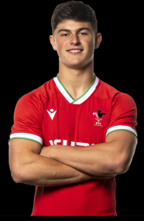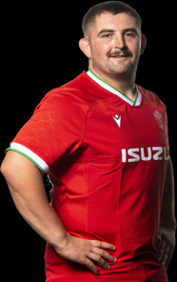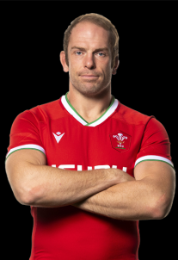J

Age: –

Height:-

Weight:-

Caps:-

Age: –

Height:-

Weight:-

Caps:-

Age: –

Height:-

Weight:-

Caps:-

Age: –

Height:-

Weight:-

Caps:-

Age: –

Height:-

Weight:-

Caps:-

Age: –

Height:-

Weight:-

Caps:-

Age: –

Height:-

Weight:-

Caps:-

Age: –

Height:-

Weight:-

Caps:-

Age: –

Height:-

Weight:-

Caps:-

Age: –

Height:-

Weight:-

Caps:-

Age: –

Height:-

Weight:-

Caps:-

Age: –

Height:-

Weight:-

Caps:-

Age: –

Height:-

Weight:-

Caps:-

Age: –

Height:-

Weight:-

Caps:-

Age: –

Height:-

Weight:-

Caps:-

Louise Rees-Zammit

Taulupe Faletau

Liam Williams

Jonathan Davies

Kieran Hardy

Dan Biggar

Josh Adams

Adam Beard

Josh Navidi

Justin Tipuric

George North

Tomas Francis

Wyn Jones

Ken Owens

Alun Wyn Jones