Parts of a Daffodil
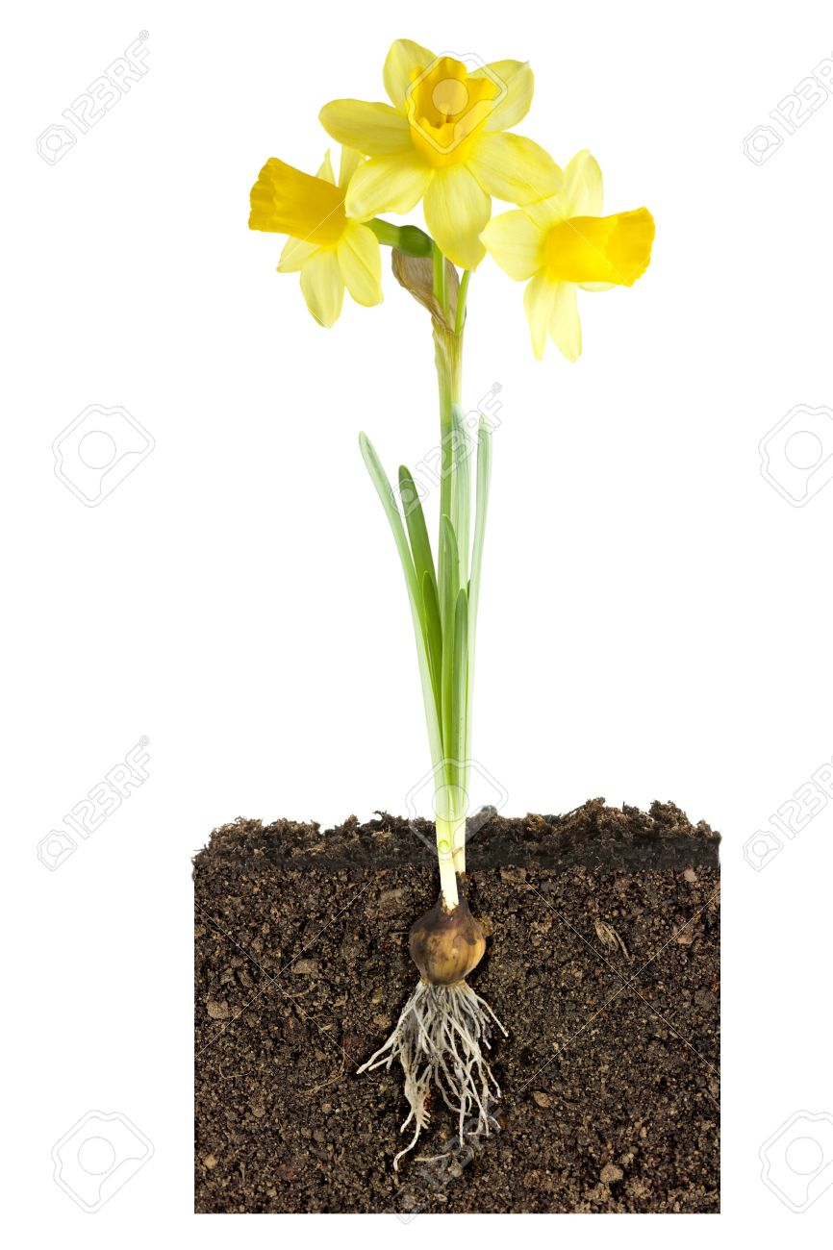
Can you look at this picture of a daffodil and label as many features as you can.

