Can you write some sentences about the picture?
Remember to use capital letters and full stops. Try to extend your sentences too.
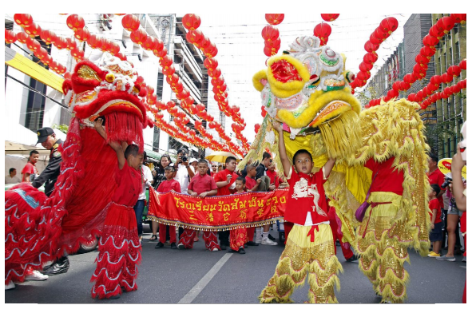

______________________________________________________________________________________________________________________________________________________________________________
Have a go at writing a few sentences about the Chinese lanterns. Try to use some interesting adjectives.

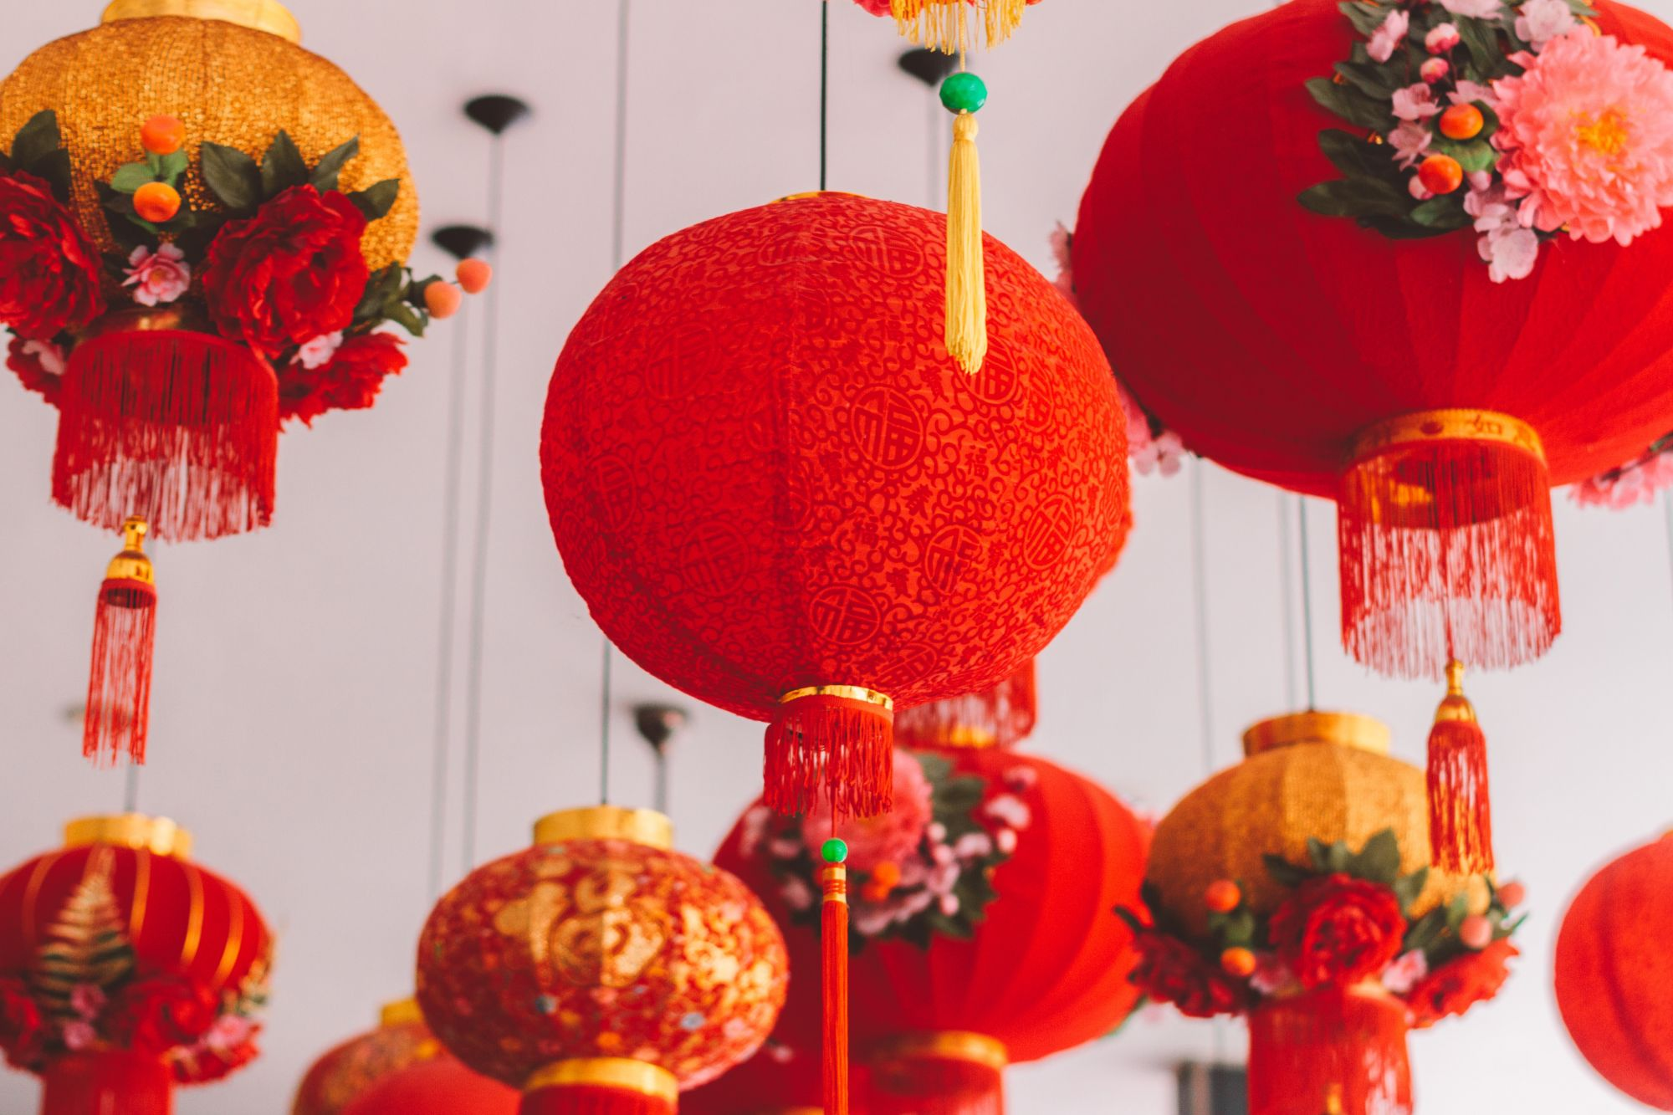

______________________________________________________________________________________________________________________________________________________________________________

Write some sentences to describe what is happening in the picture. Remember to use capital letters and full stops. Include some interesting adjectives too.




