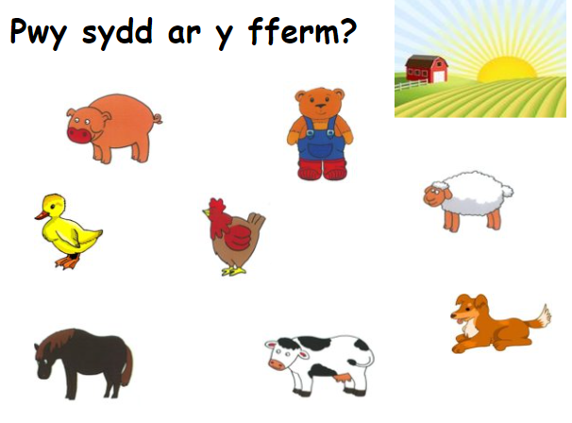

Mae Tedi Twt ar y fferm.

Have a go at writing at least 3 of your own.

_________________________________________

_________________________________________

_________________________________________

_________________________________________

_________________________________________

