Writing Super Sentences
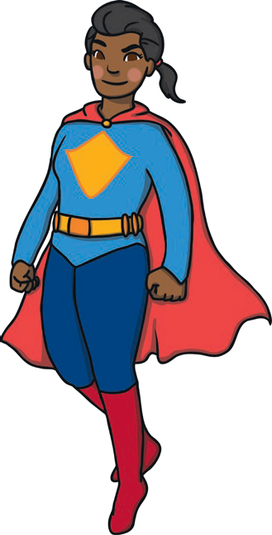
I can use a capital letter at the start of a sentence.
I can use a full stop at the end of a sentence.
- Insert the capital letters and full stops to complete the
sentences.
  - atman has black boots
  - uperheroes can fly up into the air
2. Use the words and pictures to help you
to write your own super sentences.

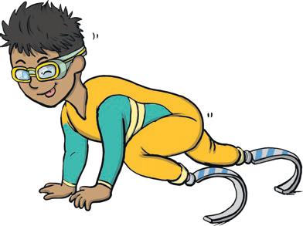
a.
fast
superhero
run

this
can

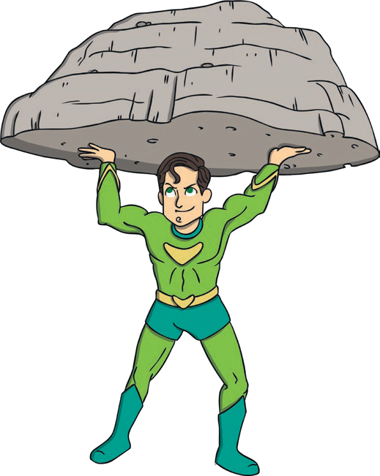
b.
greenman
strong
superhero
is
a

- Use the words and pictures to help you to write your own super sentences, each with a capital letter and full stop.

This superhero can run fast.
  - Greenman is a strong superhero.
Also check for finger spaces, correct word order, consistent letter size and correct orientation.
- Now write your own superhero sentence with a capital letter and full stop.

Children’s own sentences should start with a capital letter and end with a full stop.
Also check for finger spaces, correct word order, consistent letter size and correct orientation throughout.

