Language, Literacy and Communication | Welsh  Cymraeg | Humanities | R.E. | Expressive Arts
Poetry  Think about the different poems that we have created in class, senses poems, narrative or story poems and metaphor and simile poems. Use one of these to create a poem about the planets, outer space or space travel. Once you have completed your poem illustrate it. | Weather diary  Sut mae tywydd heddiw?  What is the weather like today?  Sut roedd y tywydd ddoe?  What was the weather like yesterday?  Sut fydd y tywydd yfory?  What will the weather be like tomorrow? | Research  Can you find out about astronauts space suits from the first ones to the ones they use now. What special features do they have? Can you created a detailed diagram with captions of a space suit. |  | Create a model of a space craft  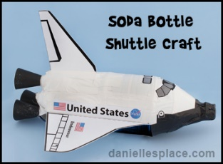
Maths and Numeracy | Science and Technology |  | ICT  TGCH | Health and Well-being
Negative number problems  Work out the different problems on temperatures by ordering, comparing and working out problems. | What is a shooting star?  Can you find out what a shooting star is and present your findings in a fact file.  You could also find out about the different constellations you can see in the night sky. | Create a song or rap based on the Storybots songs about the planets.  https://www.youtube.com/watch?v=Vb2ZXRh74WU | Temperature data  Collect data about the different temperatures either in Wales, around Britain or around the world then create a graph or chart to show the difference. | Complete an online yoga or exercise class.  - Joe Wicks P.E. session  - Just dance  - Online yoga  - Little sports

