School Plan for Start and End of Day

Parents / Carers are encouraged to walk their children to school to decrease congestion.

Entrances/Exits to be used | Bubble | Entrance and Exit to be used | Time of entry and Exit
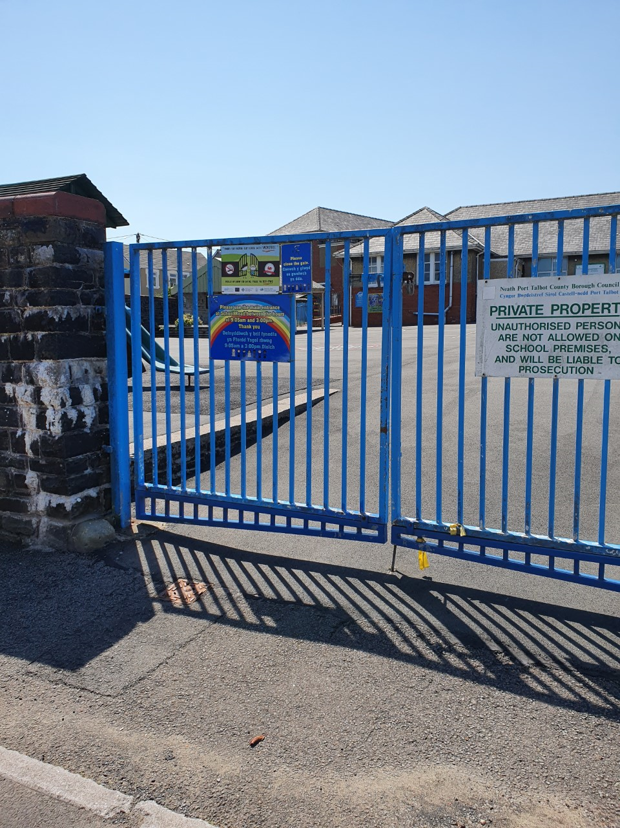 | LSC  Class 1/Class 6 bubble | Main entrance gates Main Road.  Children to be taken through the ‘quiet yard’ into the LSC entrance | Staff to collect children from taxi/parent at school gate 8:50am.  Staff to escort children to taxi/parents at school gates 3:20pm
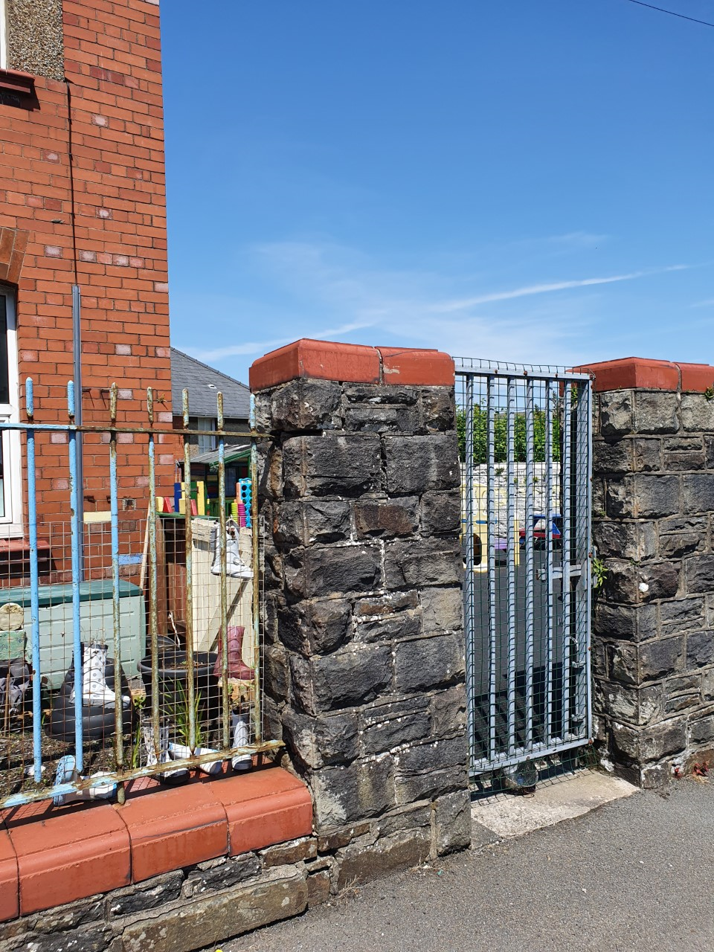 | Class 2  Reception and Nursery | Nursery yard entrance on School Road | Children to arrive at 8:45 am and to be met by staff at gate  Morning Nursery to be collected at 11:30am  Reception children collected at 3:15pm.
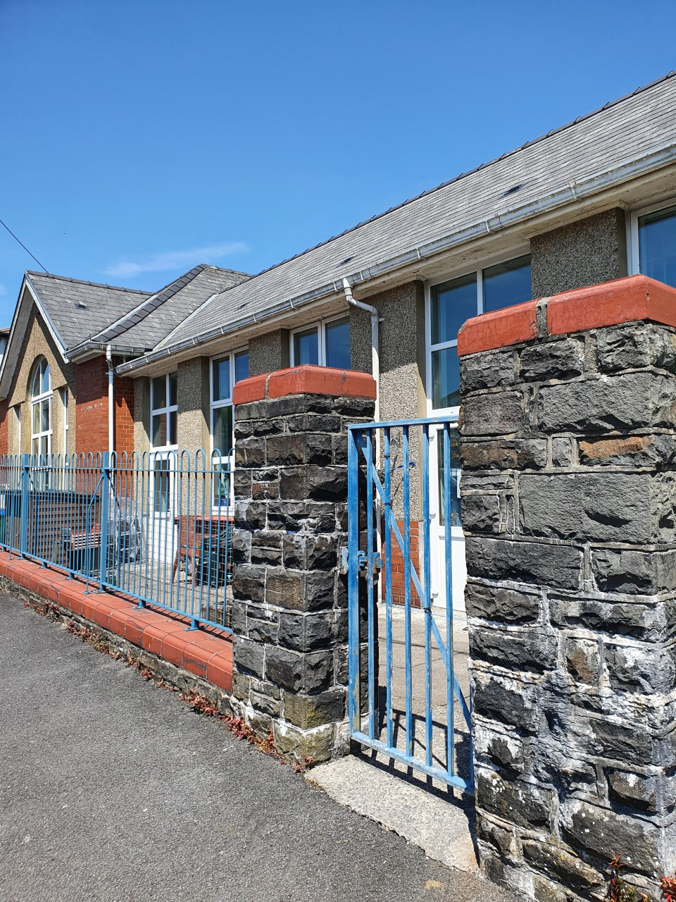 | Class 3 bubble  Years 1 and 2 | Highland Crescent entrance | Children to arrive at 9am and met by staff at gate. Children to be collected at 3:30pm.
 | Class 4 bubble  Years 3 and 4 | Main Road entrance school gates. Children to be taken through the bottom yard, up the steps to the upper yard and in through the door in main corridor | Children to arrive at 8:40am and met by staff.  Children to be collected at 3:10pm
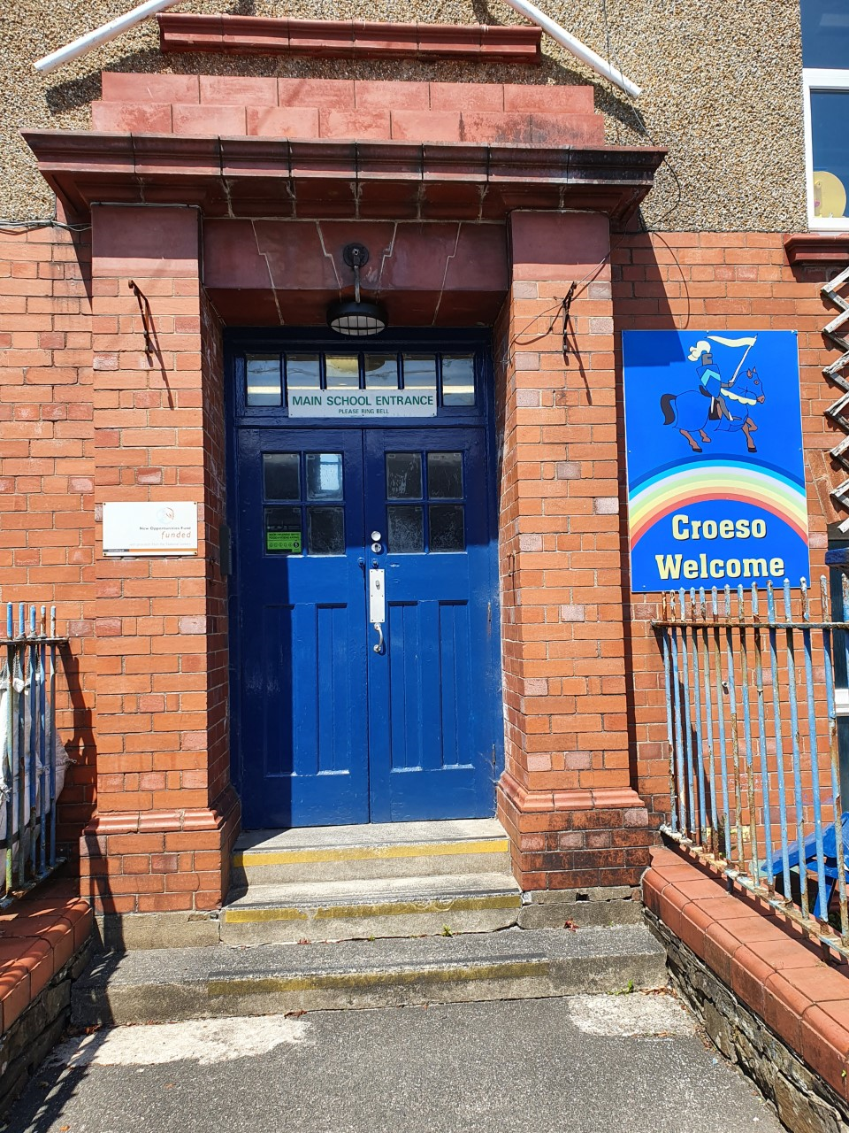 | Class 5 bubble  Years 5 and 6 | School Road entrance, main school door. | Children to arrive at 8:50am and met by staff. Children to be collected/sent home at 3:20pm.

