Speech marks
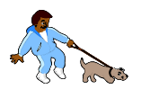
“STOP!” shouted Mark.

Can you put speech marks in the correct place in these sentences? Copy the sentences into your books with the speech marks added.

- Hello, said my mum when I came home from school.

- What time is it? Asked Amjal.

- Stop talking! Shouted the teacher.

- The man in the shop asked, Do you need any help?

- Can you go the shop? Asked Dad. Yes I replied.

- The old lady asked, Can you help me cross the road?

Now try to create some of your own speech sentences.

