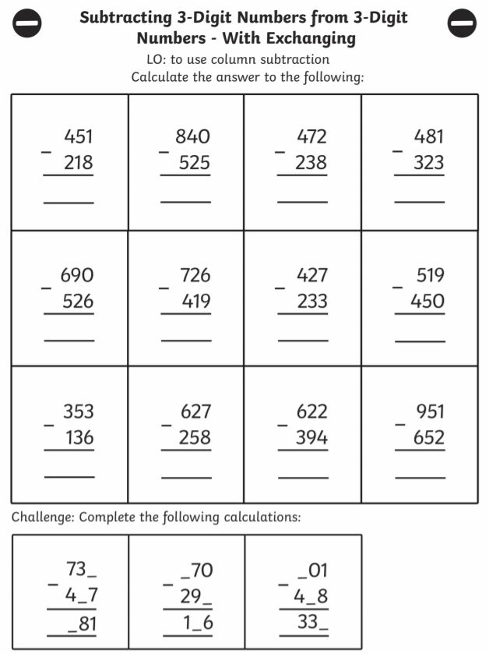

Extra challenge – Complete the following using column subtraction

- 352 - 121=
- 368 - 119=
- 464 – 272=
- 644 – 355=

