Maesmarchog Primary School
Recovery Plan and Risk Assessment for 1st Phase of School Re-Opening June 29th
Rationale

This plan is produced to aid the reopening of Maesmarchog Primary School following the closure of our school on 20th March 2020. This recovery plan has been developed in line with the guidance provided by the Welsh Government document, ‘Keep Education Safe (Operational Guidance for Schools and settings (Covid-19)’ (See Appendix 1) https://gov.wales/keep-education-safe-operational-guidance-schools-and-settings-covid-19
Guidance provided by NPT Council, ‘Neath Port Talbot Check in, Catch Up and Prepare for summer and September Arrangements’ has also supported the development of the plan. (See Appendix 2)
The plan is based on the current available guidance and advice from Welsh Government and Neath Port Talbot Local Authority. It has been written following onsite Health and Safety planning. A Local Authority COVID 19 Risk Assessment has been completed by the school and shared with all staff (see Appendix 3)

This plan has been produced to ultimately enable a safe return to school for pupils. staff and other members of the school community. It has been written following discussion and consultation with the Local Authority, the Senior Management Team of the school, the staff and the Chair of Governors.

The school will be re-opening with measures in place to help us be a COVID secure school, blending face-to face and online distance learning. It is expected to be a “Check in, Catch Up and Prepare” for summer and September opportunity rather than have a purely educational focus.
The plan will be used flexibly and is very likely to evolve and change as children return and guidance changes.

Our aims and decision making will be guided by two clear questions:
1. What is the best support that we can provide for our school community?
2. How do we ensure the highest standards of safety?

As we move forwards these simple questions will guide and inform all our decision making.
We will not implement any plan unless we are convinced that it is the right thing to do and we can do it safely.

This plan has been developed using the following 5 key principles set out by the Education Minister:

1. The safety and mental, emotional and physical well-being of staff and students
2. Continuing contribution to the national effort and strategy to fight the spread of COVID- 19
3. Having the confidence of parents, staff and students - based on evidence and information - so that they can plan ahead
4. Ability to prioritise learners including vulnerable pupils and those with additional leaning needs and
5. Consistency with the Welsh Government’s framework for decision making, to have guidance in place to support measures such as social distancing, managing attendance and wider protective actions.
Overarching Guidance for leaders and governors.
1. The principles outlined above must be evident in all our decision making. Our overall aim is to ensure that our decision making is calm and informed.
2. Our community can expect us to respond clearly and with urgency to any safety issues raised.
3. Senior leaders and governors must consider all the advice made available to them. This includes updated guidance for schools from Welsh
Government and Neath Port Talbot Local Education Authority
4. Excellent communication must be evident throughout the planning and implementation of our safety plans. We will work with all staff and welcome
input from pupils and parents. We will share advice that informs our decision making.
5. In order to build trust in our community, we will always be open and transparent.

This plan will aim to ensure that we safeguard our community by:
- Always being alert to risk
- Reducing risk through effective organisation and controls.
- Reducing transmission risk by limiting interactions within the school community.

Simply our plan is:

- Up to a third of our pupils will be allowed in school at a time. This constitutes no more than 38 children in school on any one day.
- A childcare hub providing care for vulnerable pupils and children of critical workers will return to Maesmarchog and will constitute a portion of this third. Children currently attending the hub must be accommodated on the days they attend. Children of school staff can be registered too for hub provision.
- Reception and Nursery provision will not be provided during the summer term. Home Learning will continue for these pupils however.
- Children who are attending the hub provision will also be provided with opportunities for ‘catch up, check up and prepare’ time with their class teacher.
- Our children will be placed in class pods of no more than 8. They will spend their school day in their pod. They will not mix with other children from other pods and they will play, learn and eat in their pod. The pod will be a ‘safety bubble’ approach. These groups should remain consistent as changing the membership will increase the risk of transmission. Children should attend just one setting wherever possible and should remain in the same small, consistent group within that setting as far as possible. If a child attends more than one setting, for example the hub class, the child will remain in the same, small group in their class ‘check in, catch up and prepare’ bubble in order to minimise the overall levels of contact.
- Children where possible will enter and exit the school through different entrances and will play in separate yards or at different times. However, we are not stating that children are in quarantine.
- Pods will have allocated staff for caring/ teaching and lunchtime supervision. All pods will be allocated a teacher and a teaching assistant that will remain with that pod for the day. This will reduce the possibility of contracting and transmitting the Coronavirus.
- In the school and in each pod, everybody will apply the best standards of hygiene that we can. Each child and staff member will access alcohol-based hand gel (minimum 60% alcohol) on entry into school. Each pod will have access to tissues, antibacterial hand wash, water and antiseptic wipes.
- Children and staff will wash hands on arrival into the class, when leaving the class, before and after food is eaten, before and after handling objects handled by others, after any physical contact with another person and after sneezing, coughing or blowing their nose. Children will be reminded to wash their hands thoroughly with running water and soap for at least 20 seconds.
- Surfaces that are frequently touched will be cleaned throughout the day with antibacterial cleaning materials and a thorough clean will take place at the end of every day.
- Children will be reminded to cough or sneeze into tissues and to dispose of these in pedal bins provided in the class.
- Where possible, social distancing practices will be maintained. All children will be encouraged and reminded to socially distance in all classes. Tables / chairs / furniture will be arranged 2 meters apart. However, given the age and understanding of some pupils, social distancing measures will not always be able to be maintained.
- Signage in and around school will be used to remind pupils to social distance as well as to practice increased hygiene correctly.
- Internal doors, where possible, will be kept open to reduce any touch points.

In order to minimise contact with individuals who are unwell, parents and staff will ensure that those who have coronavirus symptoms, or who have someone in their household who does, do not attend school and seek immediately to get tested. If a child shows symptoms of the virus whilst at school, they will be put in a room away from others (Headteacher’s Office) and parents will be contacted immediately to collect the child. Please provide up to date contact details and ensure that there is always someone available to collect your child on the day they attend school, should this be needed. If a child / staff member within the pod becomes symptomatic and tests positive –the whole pod with isolate for 14 days.

Overcoming Challenges
Achieving the aims outlined above present many challenges. In order to share the contents of key actions and measures contained in the plan, information will be shared on the school website with parents. A letter prior to the phased return of pupils will also be shared on the website and on the school’s twitter feed. This letter will aim to reassure parents by referring to the plan that has been devised and put in place in order to enable the return of learners to be as safe as possible whilst minimising risk of infection.

- Lack of corridor space. The corridor areas will require constant monitoring to ensure social distancing at times of movement. The possibility of pupils crossing in the corridor will also be minimised through the use of different exits and entries for each pod present on any one day, the use of different toilets for each pod of pupils where possible (see below), Cl3 FPh and Cl4 pupils being escorted to the bathroom and the staggering of playtimes and lunch play. There will be no Assembly or gatherings in the hall or corridors.

- Potential shortage of staff. Each pod will have at least two members of staff to teach and care for the children. Our normal staff team has enough capacity for this. The initial focus will be on checking in and catching up with our pupils from Year 1-6, with the exception of younger pupils including Nursery and Reception pupils attending our LSC and hub provision. In the event of staff being taken ill, other school staff will be used to cover.

- Transport. Where possible, children requiring transport who attend the LSC will be transported by parents. Where this is not possible, Neath Port Talbot will provide suitable transport taking account of the NPT Covid 19 guidelines and procedures regarding travelling in vehicles.

- Intimate Care and First Aid. Staff who need to provide pupils with first aid will use appropriate PPE. Staff who provide younger pupils in our LSC or hub provision with intimate care will have access to PPE items: disposable gloves, disposable aprons and if considered necessary, goggles/face guard.

- Visitors to school. Visitors to school will be discouraged unless carrying out essential maintenance or health and safety testing. Parents are politely requested not to enter the yard and school buildings unless absolutely necessary following communication with the school to allow them to do so.

- School uniform. Uniform will not have to be worn. Items of clothing that are comfortable and easily washable are recommended.

- School dinners. A hot meal will be available for pupils every day. Alternatively, pupils can bring in packed lunches and plastic flasks/bottles. Parents are asked to ensure that these are cleaned thoroughly before they are re-used again the following day.

- School bags and coats. It is recommended that pupils bring as few items as possible into school. Pupil’s coats will be kept within the class pod. Each child will have their own set / pack of stationary to use provided by school.

- Implications for after school care. In order to minimise the risk of transmission by having children mixing in different clubs after school, after-school clubs will not re-start this term.

School Plan for Start and End of Day . (Please see CAD map in Appendix 4 noting the location of these entrances)

Parents / Carers are encouraged to walk their children to school to decrease congestion.

Entrances/Exits to be used | Pod | Entrance and Exit to be used | Time of entry and Exit
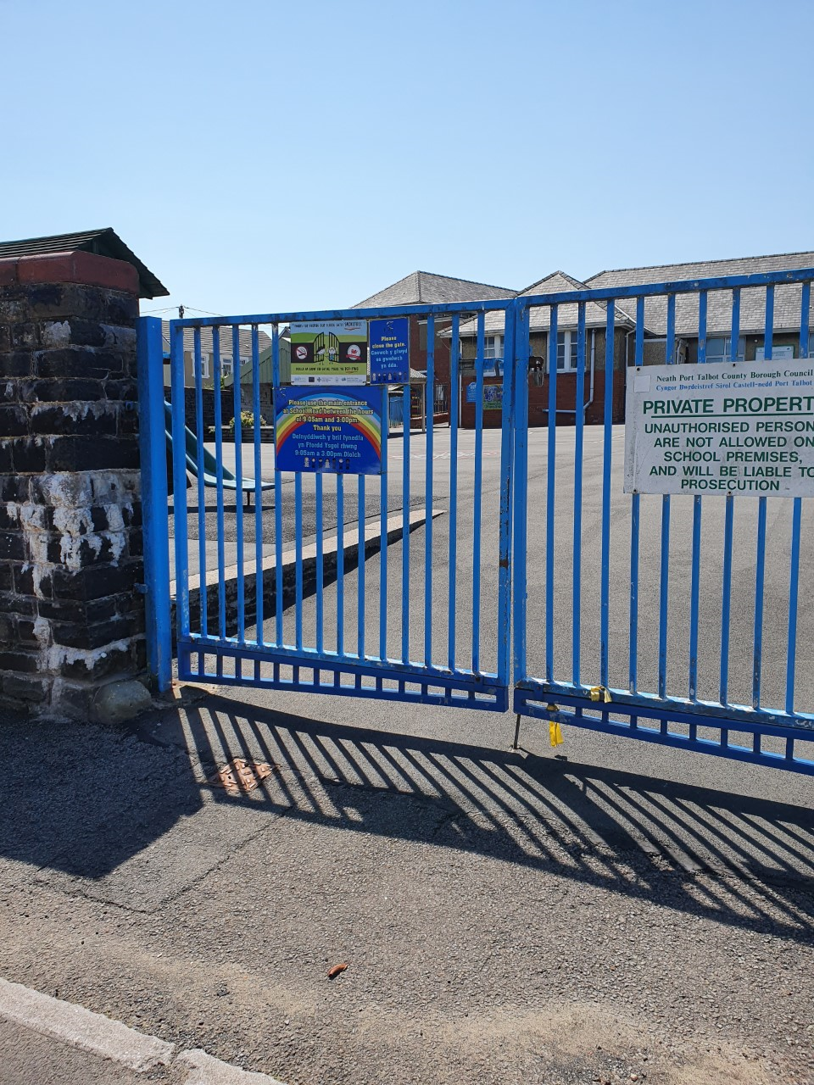 | LSC  Class 1/Class 6 pod (in alternate days) | Main entrance gates Main Road.  Children to be taken through the ‘quiet yard’ into the LSC entrance | Staff to collect children from taxi/parent at school gate 8:50am.  Nursery child to be collected 11:30am  Staff to escort children to taxi/parents at school gates 3:20pm
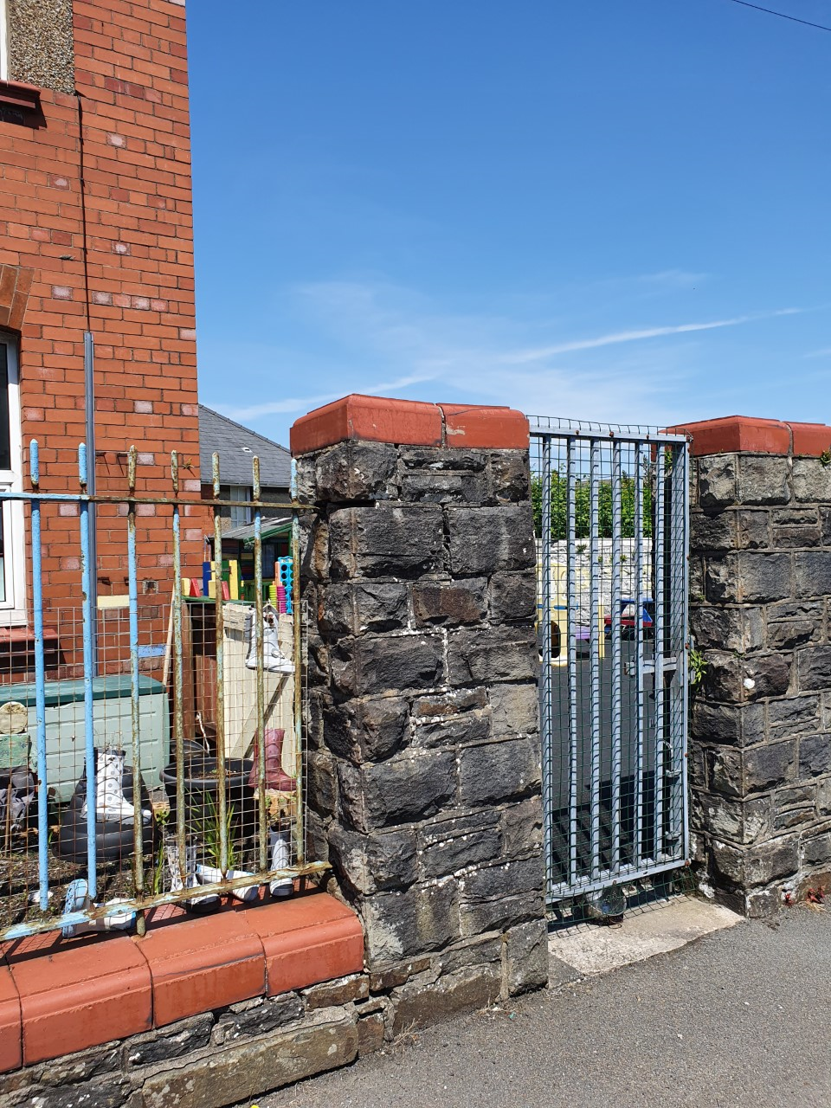 | Hub provision | Nursery yard entrance on School Road | Children to arrive at varying times and are met by staff  Children to be collected at varying times up to 3:20pm
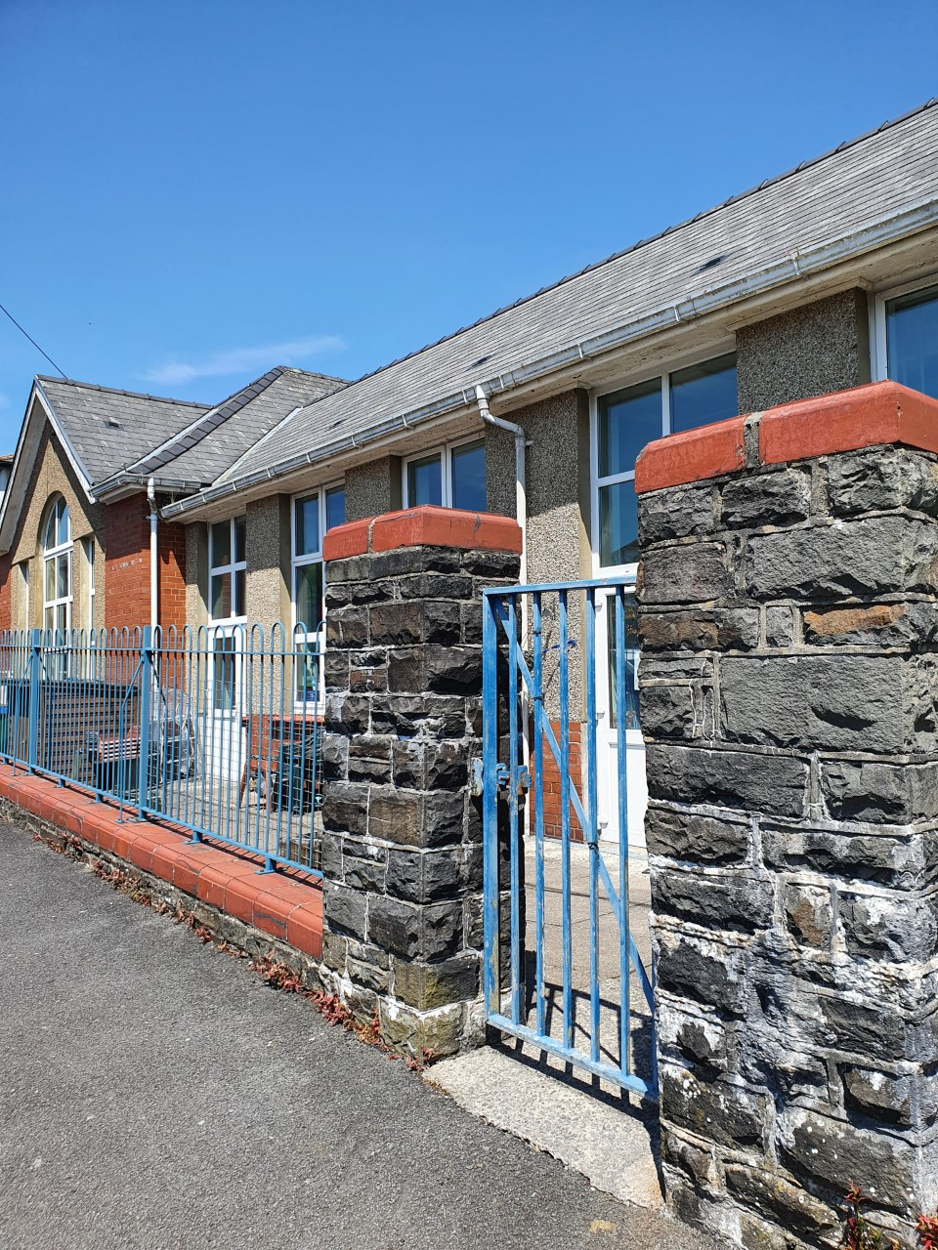 | Class 3 pod 1 and 2 (in alternate days) | Highland Crescent entrance | Children to arrive at 9am and met by staff at gate. Children to be collected at 3:30pm.
 | Class 4 pod 1 and 2 and 3 (in alternate days) | Main Road entrance school gates. Children to be taken through the bottom yard, up the steps to the upper yard and in through the door in main corridor | Children to arrive at 8:40am and met by staff.  Children to be collected at 3:10pm
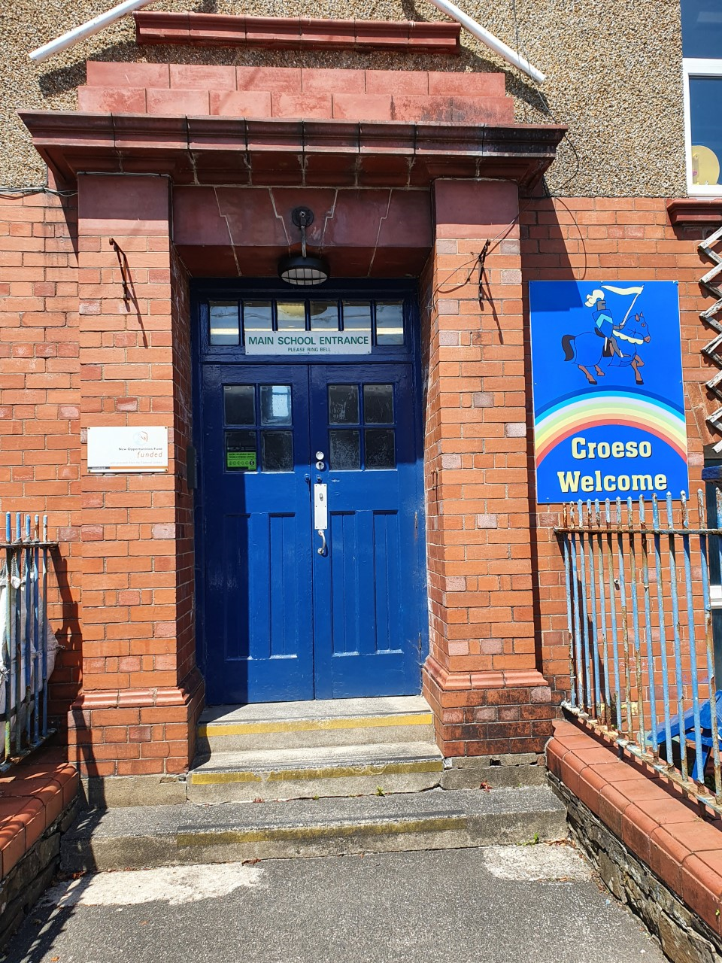 | Class 5 pod 1 and 2 (in alternate days) | School Road entrance, main school door. | Children to arrive at 8:50am and met by staff. Children to be collected/sent home at 3:20pm.

Contact time with pupils will focus on:
- Well-being of pupils–care and concerns addressed, and support provided.
- Teachers having the chance to catch up with learners and their progress thus far with distance learning.
- Check in with pupils and home learning check-up.
- Preparing for summer and new school year. Year 6 will also have a focus on transition and preparation for Secondary
- Providing work for home learning–packs go home.
- Using the digital learning tools to ensure this aspect is kept current and up to date.
Home learning days will focus on:
•Online learning continued –allocate tasks, check in with pupils and provide feedback.
•Well-being of pupils and families.
•Planning, curriculum, and preparation time for staff.
Play time/lunch time Arrangements
Please see CAD map in Appendix 4 noting the location of the different play areas on the yard

If it is wet play, children will remain within their bubble classrooms.

Pod | Location of yard | Morning Play | Lunch play | Afternoon Play
LSC  Class 1/Class 6 pod (in alternate days) | ‘Skinny yard’ and quiet area lower yard accessed via LSC entrance. | 10:30-10:45 | 11:45-12:45 | 2:00-2:10
Hub provision | Nursery yard | 10:30-10:45 | 11:45-12:45 | 2:00-2:10
Class 3 pod 1 and 2 (in alternate days) | Top yard  Yard to be accessed via entrance near dinner hall | 10:30-10:45 | 11:45-12:45 | 2:00-2:10
Class 4 pod 1 and 2 and 3 (in alternate days) | Lower yard  Yard to be accessed via entrance opposite staff room | 10:30-10:45 | 11:45-12:45 | 2:00-2:10
Class 5 pod 1 and 2 (in alternate days) | Lower yard  Yard to be accessed via entrance near Class 2 (basement) | 10:50-11:05 | 12:15-1:15 | 2:15-2:25

Week 1 | Monday  29th June | Tuesday  30th June | Wednesday  1st July | Thursday  2nd July | Friday  3rd July
LSC  Pod | Class 6 | Class 6 | Class 6 | Class 1 | Class 1
Class 3 | Distance learning  preparation | Pod 1 | Pod 1 | Cl3 Hub Group | Cl3 Hub Group
Class 4 | Distance learning preparation | Pod 1 | Pod 1 | Pod 2 | Cl 4 Hub group
Class 5 | Distance learning preparation | Pod 1 | Pod 1 | Pod 2 | Pod 2
Hub | Hub | Hub | Hub | Hub | Hub

Week 2 | Monday  6th July | Tuesday  7th July | Wednesday  8th July | Thursday  9th July | Friday  10th July
LSC  Pod | Class 1 | Class 1 | Class 1 | Class 6 | Class 6
Class 3 | Pod 1 | Pod 1 | Cl3 Hub group | Cl3 Hub group | Distance learning preparation
Class 4 | Pod 2 | Pod 2 | Cl4 Hub group | Pod 1 | Distance learning preparation
Class 5 | Pod 1 | Pod 1 | Pod 2 | Pod 2 | Distance learning preparation
Hub | Hub | Hub | Hub | Hub | Hub

Continued below…..

Week 3 | Monday  13th July | Tuesday  14th July | Wednesday  15th July | Thursday  16th July | Friday  17th July
LSC  Pod | Class 6 | Class 6 | Class 6 | Class 1 | Class 1
Class 3 | Pod 1 | Pod 1 | Cl3 Hub group | Cl3 Hub group | Distance learning  Preparation
Class 4 | Pod 1 | Pod 1 | Distance learning preparation | Cl4 Hub group | Cl4 Hub group
Class 5 | Pod 1 | Pod 1 | Pod 2 | Pod 2 | Distance learning preparation
Hub | Hub | Hub | Hub | Hub | Hub

Toilets
Strictly one in, one out policy, monitored by staff.
Class Bubble | Toilets to be used
LSC  Class 1bubble (in alternate days) | Boys’ and girls’ toilets to be used in the lower building
Hub provision | Class 2 boys’ and girls’ toilets in the basement
Class 3 bubble 1 and 2 (in alternate days) | Boys’ and girls’ toilets main corridor – children to be accompanied to the bathroom
Class 4 bubble 1 and 2 and 3 (in alternate days) | Boys and girls’ toilets main corridor – children to be accompanied to the bathroom
Class 5 bubble 1 and 2 (in alternate days) | Disabled toilet, main corridor
LSC  Class 6 bubble (in alternate days) | Boys’ and girls’ toilets to be used in the lower building

Minimising Adult Interaction
(See risk assessments) Appendix 3
We will use alternative entrances and exits and well as staggering some starting and leaving times of various bubbles to the school to minimise interactions and promote essential adult social distancing. Parents will be discouraged from visiting the School Office. Payment of school dinner money will transfer to online payments. Where essential visits to the office have to be made, times will be made by arrangement with the School Clerk/Headteacher. Parents will be met at the main entrance on School Road by the Clerk or Headteacher in order to exchange any required items or to meet any pupils that are late or being sent home unwell. If a child arrives late their parent will need to buzz the main door on School Road. The Clerk or Headteacher will then take that child to their respective bubble.
We politely ask parents that at the start and end of the school day, please leave the school entrances promptly. Please do not hang around chatting or letting your children play, so that we can conform with social distancing.

Simple Guidance Principles for Staff

- Do not come to work if you have coronavirus symptoms or go home as soon as these develop (informing your line-manager) and access a test as soon as possible. If you are unwell and able to do this, we can assist. If you are very unwell seek medical support as soon as possible through NHS 111.

- If somebody in your house has symptoms, you must not come to work and arrange to have tests.

- Make your well-being a priority. We are here to support and guide. SMT will signpost you to support organisations both at LA level and wider. Ask any question. Assured staff will make calm and informed choices.

- Practise really good hygiene. Each class will have a class pack of tissues, alcohol hand gel (minimum 60% alcohol), antibacterial hand wash and antibacterial wipes. Please inform SMT if any items in your class pack begin to run low.
- Clean your hands and wrists more often than usual – with running water and soap and dry them thoroughly or use alcohol hand rub or sanitiser ensuring that all parts of the hands are covered. Must use sanitiser or wash your hands on entry to the building and when you leave.
- Use the ‘catch it, bin it, kill it’ approach.
- Avoid touching your mouth, nose and eyes.
- Clean frequently touched surfaces often using standard products.

- Limited staffroom use –maximum of 3 staff in at one time in upper building. Sit on marked seats only–Boiler / fridge can be used but each individual cleans after each use. Lower building staff room – only 1 staff member in at a time.

- Staff toilets: - touch points cleaned after use.

- Think about ways to modify your teaching approach to keep a distance from children in your class as much as possible. Avoid close face to face support (noting that it’s understood that this is not possible at all times, which is why hygiene and hand cleaning is so important). Staff should try and maintain a standing distance and communicate from ‘side on’ position when possible.

- Children are not in quarantine but you may benefit from having your own zone in a classroom so you control your contact. You would ask children not to enter this. We can mark out an area with tape that could be a few square meters.

- Ensure that cleanliness and hygiene is excellent in your pod. Ensure that our children practise good hygiene regimes.

- Try and maximise ventilation. Keep your classroom door and windows open if possible, for air flow.

- Teach outdoors when you can and maintain social distancing in these spaces.

- Model social distancing. Staff must demonstrate this. Limit your contact with other staff members, and don’t congregate in shared spaces, especially if they are small rooms.

- PPE. Staff carrying out first aid will have access to disposable gloves and aprons. Staff needing to carry out tasks related to intimate care with a child who may cough, splutter or spit will also have access to moisture resistant mask, goggles/face shield. These will be placed in nappy changing rooms and next to first aid boxes.

- Fire Assembly point is unchanged but when lining up on yard –distance lines rather than close together.

- Photocopier will be cleaned after every use –staff responsibility. (Antibacterial wipes)

18. Clothing: smart / casual dress code, fabrics which are easily cleaned / washed and that are comfortable may be worn by staff.

Signed: Katrina Winston (Headteacher) 24.06.2020 Melanie Davies (Chair of Governors) 24.06.2020

Appendix 1
Keep Education Safe: Operational guidance for schools and settings (COVID-19)
https://gov.wales/keep-education-safe-operational-guidance-schools-and-settings-covid-19

Appendix 2
Check in, Catch Up Guidance from Neath Port Talbot LA
CICU NPT Guidance updated

Appendix 3
Risk assessment document
Risk assessment for schools returning COVID-23 06 2020

Appendix 4
CAD plan showing entry and egress points for pupils.
Maesmarchog Primary Main Block (002) CAD plan showing entrances
Maesmarchog Primary School lower block plan showing entrances

