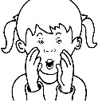
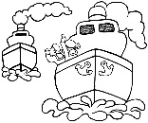
‘oi’ Missing Word Sentecnes
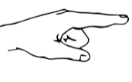
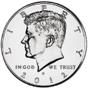
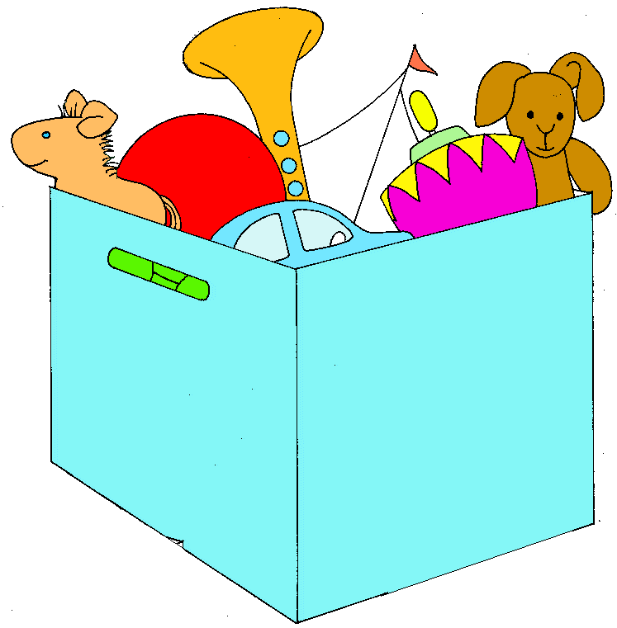
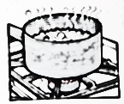
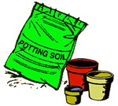
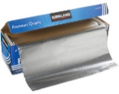
coin point oil boys
foil soil boil toys

1) On Monday my dad gave me a £1 _________.
2) I put three seeds into the _________.
3) If you want to cook noodles you have to _________ water.
4) _________ like to play with Ben Ten _________.
5) If your car is too hot you should put new _________ in it.
6) Do not _________ at the King, it is bad to do.
7) Cover your sandwiches with _________ to keep them fresh.

