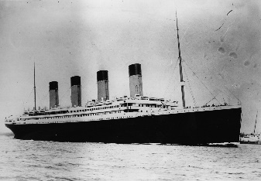Titanic recount

L.O. To use descriptive language when describing a setting.

We are going to be writing a recount about this historical voyage. I would like you to imagine that you are a passenger who is about to board the Titanic for the first time. The first thing that you need to decide is decide if your character is going to be…

…English, Welsh, Irish or another nationality?

…first, second or third class?

…excited or nervous?

…an adult or a child?

…male or female?

Once you have decided what your character is going to be then complete the **character sheet**. Think about why your character is going to be on the ship. Are they working on the ship? Are they a wealthy passenger travelling on the exciting new ship or are they working class travelling to a new life in America?

When you are deciding on your own character, it might be helpful if you read some information that you researched about the different passengers who were on board the ship.

