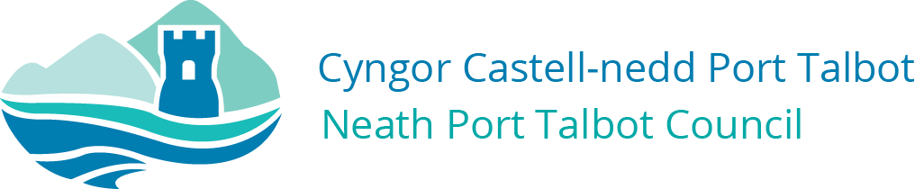

Dear Parents / Carers,

These are the arrangements for those pupils in receipt of a free school meal over the next few weeks:

- There will be a “Grab and Go” bag made by each school kitchen. It will contain a type of sandwich, drink and snack.
- Please attend between 11:30 and 12:30 to collect your meal.
- If you are unable to come to this school then we can make it available at the nearest school to your home address. Please inform us of your intentions.

We are doing our very best to try and support you in these difficult times, it would be very useful if you could let us know that you will want one as this will reduce waste.

We would expect a parent / carer of younger children to pick up the “Grab and Go” bag as to not put our pupils at risk. Can we also remind you about the guidance on social distancing, these are measures you can take to reduce the social interaction between people. This will help reduce the transmission of coronavirus (COVID-19)

We understand that a food voucher system is considered by Welsh Government but no details of this are available yet. We will inform you of any changes to these arrangements.

The government has given clear guidance on self-isolation, household isolation and social distancing.

Chris Millis
Head of Participation/Pennaeth Cyfranogi
Neath Port Talbot County Borough Council
Cyngor Bwrdeistref Sirol Castell-nedd Port Talbot

