Glais Primary School

Policy on Safeguarding

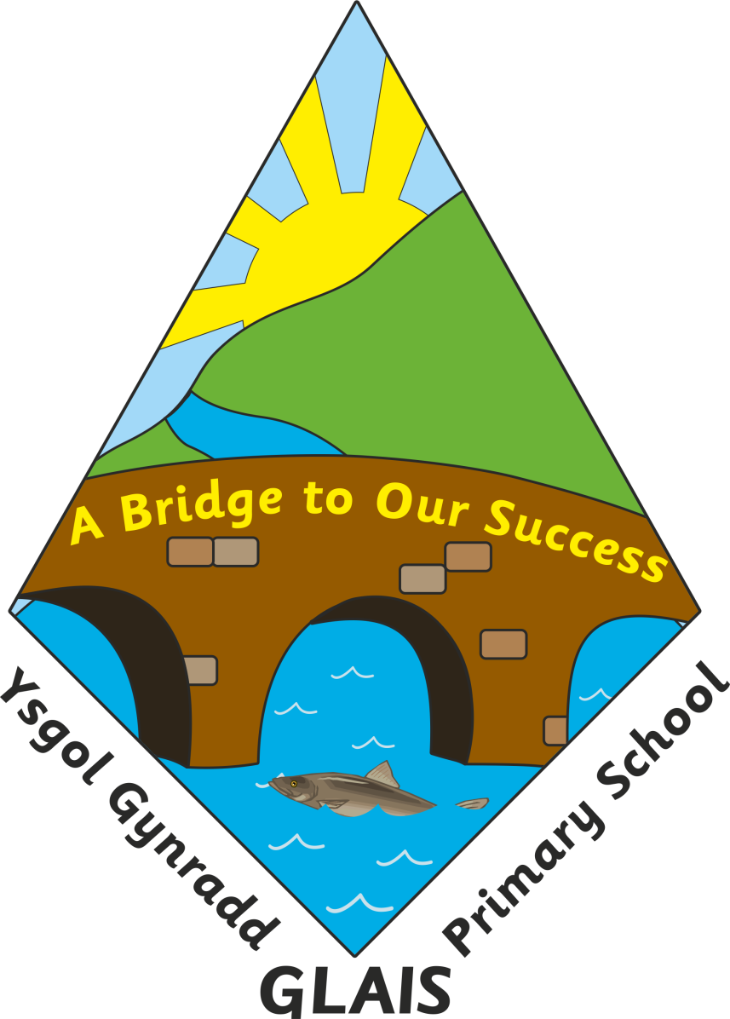

 | Name | Signature | Date
Chair of Governors | Mr Stuart Page |  | Autumn 19
Head Teacher | Mrs Anne Long |  | Autumn 19
Review dates:

Glais Primary School

A Policy for Safeguarding

The Governing Body of Glais Primary School believes that there are five key issues in the complete development of each and every child. We have a duty to ensure that each child:
• stays safe;
• is healthy;
• is able to enjoy and achieve;
• is able to achieve economic well-being;
• makes a positive contribution.

Glais Primary School Safeguarding Children Statement:

At Glais Primary School the health and safety of all children is of paramount importance. Parents send their children to school each day with the expectation that school provides a secure environment in which their children can flourish. We therefore have to ensure that this expectation becomes reality. In order to do this a wide range of measures and policies are put in place:

1. The Health and Safety Policy
The school has a separate health and safety policy, which is monitored regularly by the relevant committee of the school governors. The Headteacher, the Health & Safety Coordinator and the Governors oversee the policy. Any concerns from staff are reported to any of the above who carries out an initial examination, assessing what remedial action needs to take place. Each term there is a fire drill to practise efficient evacuation from the building. The school conducts an annual Fire Risk Assessment. The LA also has a critical incidents plan which details what staff and parents should do in the case of emergencies.

2. Child Protection Policy
The school has a separate Child Protection Policy. The designated staff member for Child Protection is Anne Long, Headteacher or the Deputy Headteacher in her absence and the designated Governor is Stuart Page. It is the Governing Body’s duty to ensure the Child Protection Policy is reviewed appropriately and any deficiencies within the policy addressed immediately. All staff have had appropriate child protection training, which is updated at least every three years. Relevant governors receive training as necessary/desired. Child Protection matters are reported to the Governing Body every term.

The school follows guidelines which assert that physical restraint may be used if there is the possibility that a child may be about to cause harm to him/herself or to another. It also asserts that on no occasion should such physical contact be used as a punishment. All staff have received guidance regarding physical restraint. All allegations of abuse by, or complaints about, a teacher will be dealt with following the Local Safeguarding Board procedures. For any complaints about the Headteacher the Chair of Governors should be contacted directly.

3. First Aid
In school there are three members of staff who have attended the Local Authority three day training for first aiders. Most staff have completed an emergency first aid for schools course. First aid equipment is stored in a cupboard in the stockroom, and a travel first aid kit is available for off-site activities. There are first aid kits in strategic places around the school. The trained member of staff is responsible for maintenance of the first aid equipment, which is checked termly and replenished when necessary. When a child is poorly, or has suffered an accident in school or on the playground there is a protocol for staff to follow:
- An emergency first aider will deal with the accident;
- If in doubt a trained first aider will be consulted;
- The incident will be logged in the accident book by the person responsible for the child
at the time of the accident;
- For head injuries the school will make every effort to contact the parents immediately
and will ensure that parents are made aware of the injury if it has not been possible.

4. Medicines
The school has an Administration of Medicines policy. School policy is that members of staff will only give medicines when the parent has completed and signed the appropriate form requesting that staff administer medicine. If, however, a child complains of a minor ailment during the school day the school administer prescribed “calpol” if the parent has previously left the medication, completes the medication form online and e-mails it to the school. A member of staff will inform the parent that a dose has been administered. For the majority of medicines, however, a dose before and after school is perfectly adequate. Naturally the parents should consult doctors before giving any form of medication. All medicines and permission forms are stored in the main office.

5. Site security
Glais Primary Schools provides a secure site, but the site is only as secure as the people who use it. Therefore all people on the site have to adhere to the rules which govern it. Laxity can cause potential problems to safeguarding. Therefore:
• gates should be closed at playtimes and lunchtimes, unless needed for access to supervised play areas;
• all exit doors should be closed to prevent intrusion unless needed for access to toilets etc.
• visitors must only enter through the main entrance and after signing in at the office. They should be given a visitors badge on entry and must sign on leaving.
• at home time, children will only be allowed home with adults with parental responsibility or confirmed permission in Nursery-Y2, from Year 3-6 children will be allowed to walk home if parents have given permission for them to do so. If the school feels there is a danger at any time, they will inform the parents of their concerns.
• during the school day, children should be collected by an adult. They will not usually be allowed to leave school alone during school hours except in exceptional circumstances with parental and Headteacher agreement;
• Should a child leave the school premises without permission then staff have been informed never to chase after a child, but rather to report immediately to the office. Then parents and police will be informed of the circumstances;
• Visitors who use the school site do so only with the express permission of the Headteacher; this permission can be withdrawn at any time.

6. Attendance
Excellent attendance is expected of all children, but when children are unwell parents are expected to confirm absence by telephone. Glais Primary School has a policy of contacting home to ascertain each child’s whereabouts (First Day Call) if parents have not contacted the school regarding a child’s absence. The school works closely with the Local Authority’s Education Welfare Officer, Lisa Lewis, whenever a child’s attendance and punctuality causes concern. Attendance rates are reported each term to the LA and annually to parents and to the government. Positive measures are in place to encourage children to attend regularly and punctually i.e. 96% attendance pens, and the school is aware of its right to take legal action against parents who do not ensure good attendance and punctuality.

7. Appointments of staff and induction of newly appointed staff and work placements
All staff appointed to work in school have a criminal records search called a DBS check. This search highlights people who have a criminal record or if previous allegations have been made against them. If staff are found to have a criminal record the appointment is reconsidered by the Headteacher and the Governing Body. The LA is informed directly by the DBS authorities. The Headteacher sits on all appointment panels where the candidates are external applicants. New staff are inducted into safeguarding practices. Newly appointed staff are assigned a mentor for the induction period. It is the responsibility of the mentor to familiarise new staff with procedures and policies which affect the health and safety of all at school but especially the children. Supply teachers are sourced through validated supply teacher agencies or the LA and appropriate documentation is obtained.

8. Induction of volunteers
Volunteers who work unsupervised with children are required to have DBS clearance. For a brief activity, such as a school visit or occasional helping out in class, which does not involve the supervision or close contact of children, a DBS check is not required. Visitors who do not yet have clearance will under no circumstance be left alone with a child or group of children.

9. Welcoming visitors
It is assumed that visitors with a professional role (i.e. the School Nurse or members of the police) already have relevant clearance but the office will endeavour to check this before admittance is granted and a note made of anyone entering without clearance.

10. The Design of the Curriculum
The curriculum deals with safeguarding in two ways. Firstly, the curriculum, in subjects such as Personal and Social Education discusses relevant issues with the children. Topics include such themes as Drugs, Sex and Relationships and Stranger Danger. Children are encouraged to explore and discuss these issues. Secondly, the curriculum is designed so that safety issues within the subject are discussed and safe practices taught, such as using equipment properly in PE and Design and Technology. All schemes of work have been audited for safeguarding matters. At all times there has to be appropriate staffing levels and when the curriculum is taken out of school appropriate and agreed pupil/adult ratios are maintained. A risk assessment is carried out for all visits and all trips are finally authorised by the Headteacher, Educational Visits Co-ordinator or LA if the visit is residential. Visiting speakers, with correct clearance are always welcome into school so that they can give specialist knowledge to the children.

11. Internet Safety
Children should be encouraged to use the internet as much as is possible, but at all times in a safe way. Pupils are asked to sign an Internet Agreement and parents are made aware of the need for internet safety. Pupils are not to be left unsupervised whilst online, staff ensure that this does not happen. There are also Local Authority controls on technology. If staff know of misuse, either by a staff member or child the issue should be reported to the Headteacher without delay. As Child Protection Officer the Headteacher has overall responsibility for internet safety.
.
12. Equal opportunities
Within the school prospectus there is a statement for equal opportunities which asserts: “Our aim is to provide equal opportunities to all the children in our care so that they can reach their full potential and take advantage of all aspects of school life regardless of their gender, race, colour or religion.” Children with disabilities must be able to take a full and active part in every lesson and every measure must be taken to ensure this.

13. Behaviour policy
The School has a Behaviour, Expectations, Rights and Responsibilities Policy. Good behaviour is essential in any community and at Glais Primary School we have high expectations. Although the emphasis is always on the positive there are also times when children have to be disciplined in order to maintain the safety and security of all children. There are numerous rewards available to children:

- Stickers
- Showing the Headteacher good work
- Headteacher’s award certificates
- Special privileges/Choices Time

But the sanctions range from:
- A warning
- ‘Thinking time’
- Loss of playtime and/or lunchtime play
- A letter home
- Exclusion

Parents are informed of our praise and sanctions via our prospectus.

14. Anti Bullying Policy
At Glais Primary Schools the definition of bullying is “the intentional, unprovoked use of power by one or more children to inflict pain or cause distress to another child sustained on repeated occasions”.
The school’s response to this is unequivocal. Adults must be informed immediately and action will take place. Children are told that silence is the bully’s best friend. Although bullying in this school is rare the school always acts swiftly with a process of investigation, communication and action, and parents are informed. Bullies will not be tolerated.

15.Race Equality
We want our children to be prepared for an ethnically diverse society. The school will work hard to promote racial equality and harmony by preventing and challenging racism. If anyone ever feels unjustly treated then the school welcomes and values a response. Racism is tackled in both the RE and in the PSE curriculum. The school is a ‘Rights Respecting’ school. The children take part in discussions designed to raise awareness and address prejudices. From time to time visitors work with the children also. All racist incidents are reported to the Local Authority and to the Governing Body when they occur.

16.Photographing and videoing
There has been a lot of controversy about adults photographing and filming young people. The concerns are genuine, however we have taken a sensible, balanced approach, which allows parents to photograph and film providing we have parents’ consent to school taking photographs. Permission is sought on admission to school.

17.Whistleblowing
If members of staff ever have any concerns about the behaviour or intentions of any person within the building, school grounds or within proximity of children, they have a professional duty to inform the management accordingly. This can be done in writing or verbally but staff should be prepared to discuss issues in the confidence that any such matter will be dealt with sensitively and with the necessary degree of confidentiality .

It is important that this document is used in conjunction with other policies, especially all policies mentioned above.

The governing body has a duty under section 175 of the Education Act 2002 to ensure “that their functions relating to the conduct of the school are exercised with a view to safeguarding and promoting the welfare of children who are pupils at the school.

This Policy has been discussed and accepted by the Governing Body

Review
This policy is a working document and is open to regular review by all staff members. Any suggested amendments will be presented to governors for discussion at a meeting following a review. It will be formally reviewed by governors annually.

