Glais Primary School

Policy on Presentation and Handwriting

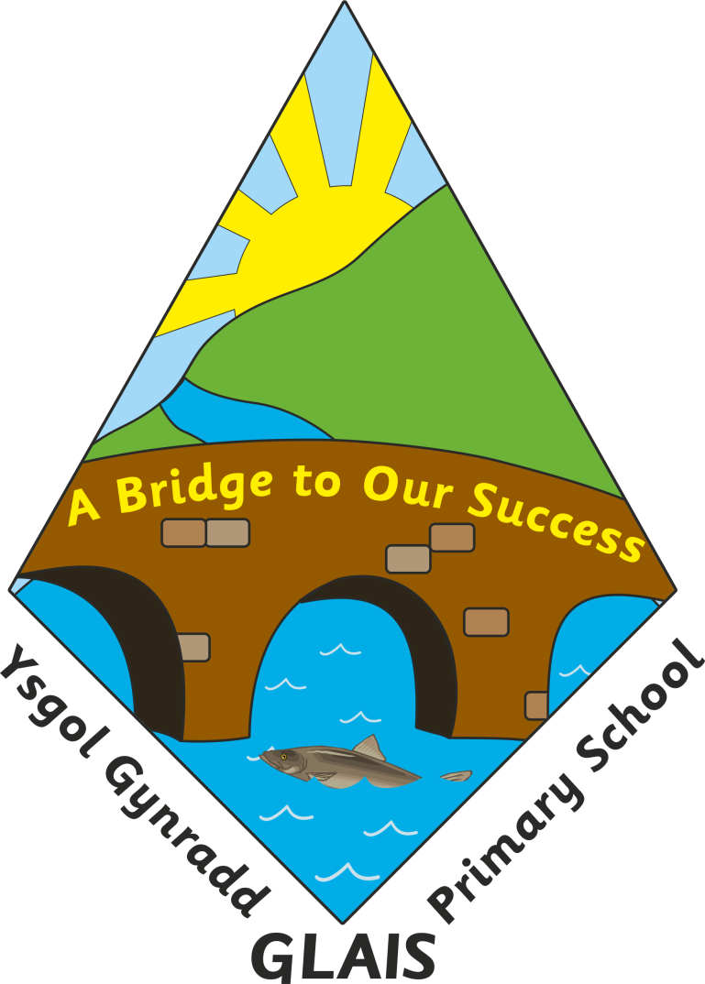

:
 | Name | Signature | Date
Chair of Governors | Mr Stuart Page |  | Sept. 2015
Head Teacher | Mrs Anne Long |  | Sept 2015
Review dates: | Sept 2018

Glais Primary School

Presentation & Handwriting Policy

“Handwriting is the most fundamental building block of being educated.”Department for Education

Rationale

When communicating ideas in writing it is important that children use a handwriting style which is neat and legible. The importance of acceptable presentation should not be under-estimated. It is vital that children can write neatly, quickly, comfortably and legibly as it is a skill needed in many curriculum areas. Children’s self-esteem is also heightened when they are able to take pride in their presentation.

Aims

To instil a positive attitude towards presentation
To present work in a neat and orderly fashion appropriate to the task.
To develop a joined, confident handwriting style that is clear, legible and fluent, which will free the writer to write and not worry about letter formation.

Provision

Handwriting and expected standards of presentation should be taught as a whole class activity.
Intensive teaching is recommended at the start of each school year to clarify expectations, with further reinforcement in weekly lessons.
The teacher should act as a model when writing on the board or marking work, using a fluent joined style where appropriate.
Posters and displays around the school environment should also model expectations for handwriting and presentation.

Handwriting

Pupils will be taught an agreed style across the whole school.
Attention to posture and seating arrangements is important. Children who write with their left hand face particular difficulties and teachers need to be aware of this. Left-handed children should either sit next to other left-handers or on the left side of a right-hander to avoid bumping arms or smudging work.
Children who display specific difficulties with handwriting will have these addressed through such interventions as slanted writing boards, rubber pencil grips, using alternative writing media etc. Individual cases may be referred to the SENCo where necessary.

Presentation

It is very important to ensure consistency towards presentation of work across the school. Staff should focus on the following guidelines to ensure this consistency, taking into account age and ability of children where necessary.

A. Children’s work

- Book covers should indicate:

- Child’s full name
- Subject
- Year Group identifier
- Children should not write anything additional on the covers of their books

- Date of work in books:

- Full written date in all books except numeracy when the digital date will be appropriate. KS2 will write alternate weeks Welsh and English, Foundation Phase will write alternate Welsh and English as appropriate. As a priority, children should be encouraged to write the date and titles themselves, though where necessary, teachers may do this or use other methods such as date stamps or sticky labels with titles printed on. For younger children, teachers are encouraged to work towards this standard as soon as children are able
- Date is left aligned

- Title of work in books:

- It is not necessary for children to write the learning objectives in their books for each piece of work
- Titles should be centre aligned. For younger children, teachers are encouraged to work towards this standard as soon as children are able

- Organisation:

- Date – First line; Title – 2nd line; Start work – 4th line. Children should be encouraged to write from the left hand edge of the page, or margin, though FP does allow for more freedom when first exploring letter shapes and formation.
- Children should not rule off on completion of a piece of work. 4 lines of space should be left for teacher’s comments and children’s responses (Reflect & Review Time)

5 Handwriting

- All staff to teach from school resources
- In FP a “preparation” for handwriting approach is taken with a range of activities related to ‘Write Dance’
- From Pre-school onwards the scheme gives clear and specific guidance about letter formation, letter joining, and advice for left-handed writers
- A wide range of materials is available in school
- All children should write in pencil in their books until teachers are satisfied that they can consistently write in a fluent cursive style or until the end of Year 2
- Children will be given a handwriting pen for use in their own work in school, except for numeracy where all work must be completed in pencil. No other pens should be used
- A ruler should be used to draw all lines and diagrams

- General presentation

- Children should use coloured pencils when illustrating work in books unless it is work that is to be stuck in
- Teachers should encourage a good standard of presentation overall – following the ERW grid
- Errors should be crossed out with a cross by the side of the mistake
- Children may use rubbers at the teachers’ discretion
- Children should be expected to keep their books well presented. Books which are not kept well presented may be sent home to be covered or children asked to re-write work on paper to be stuck over messy work.

- Homework

- Parents will be encouraged to support their children to produce quality work following the handwriting and presentation policy guidelines. Children will be expected to take the same care with homework as they do in their class books and the same standards will be expected unless the teacher has specified differently.

B. Teaching Boards (e.g. whiteboards and Interactive Whiteboards)

- Date:

- Full date or digital date for numeracy left aligned. Welsh and English alternately.

- Title of work:

- Centre aligned

- Handwriting:

- Teacher should model the appropriate cursive handwriting style whenever they are writing for the class to copy, unless this mitigates against children’s ability to read the text. When taking notes, the teacher can use a note-taking style.

C. School Documentation

There is a “House style” for School documentation. This applies to all formal documentation such as policies, Headteacher’s report to governors, letters to parents, etc

1 Font type/size:

- Ariel size 12
- Bullet points should be circle or arrow

2 Cover:

- Use model cover (as used for this guidance) – master stored on school Resources & Pool server and will be provided for staff as required

3 Pages and sections:

- Number all pages – right aligned
- All headings as in this document
- Section headings in bold

D. Display

- There should be an appropriate emphasis on current literacy and numeracy work on display in the classroom
- Displays should have clear titles
- A range of borders, colours and styles is to be encouraged e.g. a balance of handwritten and computer fonts for titles
- Displays should celebrate and reflect recent work. Teachers should ensure that displays are changed regularly
- Classes will be responsible for some boards in communal areas of the school
- Corridors should display a range of work from different year groups
- All subjects of the curriculum should be represented in displays throughout the class. Welsh should be included on all boards
- Where display space is limited, e.g. classrooms, displays in teaching areas should be used as tools for teaching and learning.
- Boards in corridors and halls can be used for celebrating completed work or whole school issues.
- Display of writing could take the form of a class book or work on a board. Children will be encouraged to redraft written work for display, understanding the purpose and audience for which they are writing.
- Any written work displayed will be of the highest standard for that individual child and written in pen where appropriate, unless the genre dictates otherwise (e.g. calculations or jottings perhaps in a maths display).

Assessment

Teachers assess handwriting and presentation as part of their normal marking in line with the marking and feedback policy. They use this formative assessment to inform their further planning. A comment on handwriting or presentation should inform the child how they can improve.

Monitoring

Monitoring of handwriting and presentation comes under the main subject of English and is the responsibility of the English Subject leader. Other curriculum leaders may also monitor in accordance with the School Improvement and development Plan. Monitoring can take the form of lesson observations, sampling and moderation of work, data analysis and looking at teachers’ planning.

General Considerations
The Education Partnership

It is important parents are continually informed about how their children are taught in order that they may support the teacher’s professional judgement and responsibilities. Developing the notion of each element relying on the other and supporting each other is a high priority in our school. The work done thus far has contributed positively to the quality of teaching for learning at Glais Primary School and will continue to be highlighted for development.

Inclusion

All children receive quality literacy and numeracy teaching on a daily basis and activities are differentiated accordingly. Where identified children are considered to require targeted support to enable them to work to age appropriate objectives, a variety of interventions are available. These include the use of IEPs, TA support and support programmes, in particular, individual programmes ‘Toe by Toe, The Power of 2, Letters & Sounds and Rapid Reading. Provision is made for the withdrawal for literacy skills and specific language programmes in small age appropriate groups.

Equal Opportunities

At Glais Primary School we believe that all children regardless of race, gender, ability or age are entitled to equal opportunities. It will be ensured that equal opportunities are addressed as follows:-
- Children with SEN have equal access to the whole curriculum through the use of differentiated learning strategies and tasks. These are based on individual needs.
- Specific teaching strategies are used to maximise access to the curriculum for all children learning EAL.
- Respect for cultural and linguistic diversity is promoted through the use of resources on multi-cultural themes.
- Gender equality is promoted by ensuring that both boys and girls have access to all aspects of the whole curriculum.
- Opportunities to address issues of gender, race etc are provided through appropriate discussions and resources.

Curriculum Cymraeg

Children are encouraged, where appropriate, to develop and apply understanding at the cultural, economic, environmental, historical and linguistic characteristics of Wales

Health and Safety

The physical environment of the school is to be maintained so that it is conducive to the learning process outlined within this policy. A disabled toilet is installed in the main building and there is ramp access to the hall and main school building.

Review

This policy is a working document and is open to regular review by all staff members. Any suggested amendments will be presented to governors for discussion at their first meeting following this review.

