Glais Primary School

Policy for Learning & Teaching

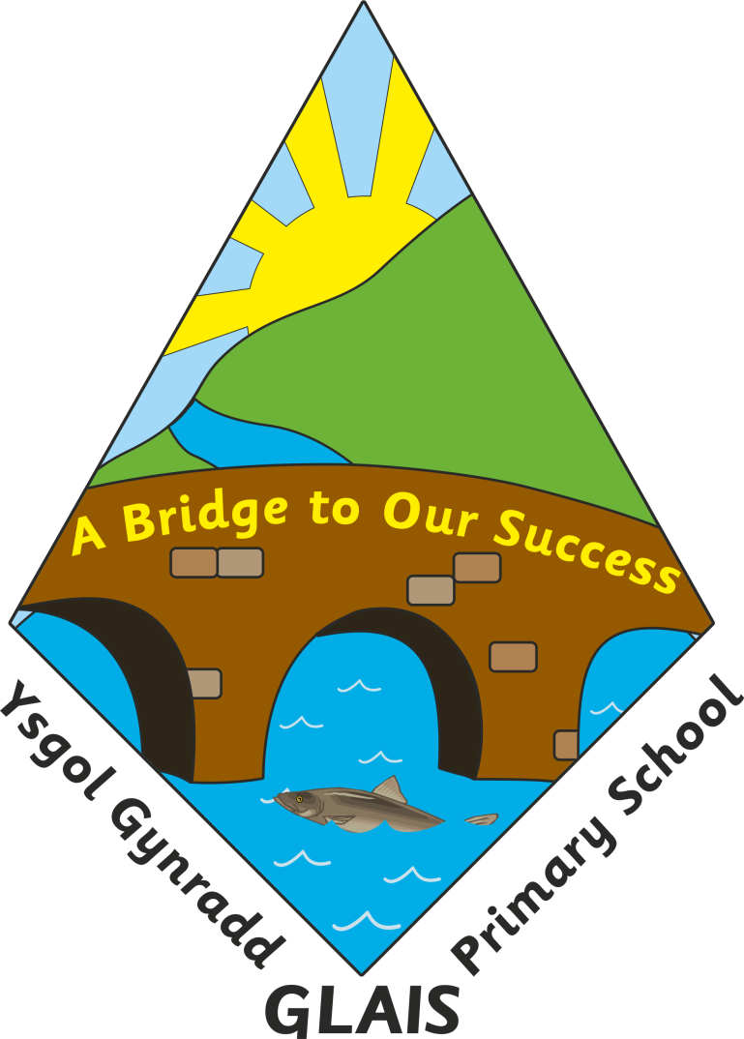

 | Name | Signature | Date
Chair of Governors | Mr Stuart Page
Head Teacher | Mrs Anne Long

Review Dates  (Annual review) | Implemented: Jan 2012;  Reviewed July 2014 Autumn 2015; Autumn 2017; Autumn 2019; Spring 2020

Glais Primary School

Learning and Teaching Policy

Introduction - The Ethos of the School
A BRIDGE TO OUR SUCCESS
“The foundation of Glais Primary School will be the support each gives to others in our school community, with the child placed at the centre of all we do. Our aim is to develop a positive climate which encourages confident, resilient, enquiring learners and staff who possess individuality and positive attitudes. Through a child-enriched curriculum that encompasses all the skills, knowledge, attitudes and values relevant for continued life-long learning, we strive to enable all children to reach their highest potential and become valued and active members of society.”
At Glais Primary School we believe all aspects of the life of the school combine together to affect those who share its life. We believe that these aspects can be explicit and implicit and be part of the informal curriculum, (a combination of attitudes, expectations of behaviour, spirit, morals and environment) and the formal curriculum, with each having an effect on the other. The effects will have a powerful and lasting impact on the character and personality of those who pass through our school and our policy should take account of this.
As this is the explicit philosophy that underpins all that we do at Glais Primary School our learning and teaching policy outlines the way we turn philosophy into sound practice and will act as a guide for our staff and a reference for our wider school community. References to the ‘curriculum’ will refer to elements of both the formal and informal curriculum and draw on the revised curriculum framework for Wales 2022.
In developing our practice, the needs of the learner in the 21st Century, in line with the Donaldson Review, has been a keen focus. We have involved our children in developing a curriculum which is rich, broad, balanced and relevant whilst maximising opportunities to develop, practice and refine skills needed for life, with a particular emphasis on those outlined in the Framework for Literacy and Numeracy and DCF. This curriculum is outlined in our long term planning, developed each term with the children in our medium term planning, then with more specific objectives in our short term planning. During the period of change, as the curriculum framework is personalised for Glais, our planning format may alter to support these changes.
We firmly believe that all those involved with the children at Glais hold the key to raising standards and it is upon them that the success of the school in raising standards ultimately rests. At Glais we have introduced procedures in order to measure our results against standard performance indicators – we undertake baseline assessment, monitor standards in a range of skills, analyse end of Key Stage data and standardised test results and monitor attendance levels.
Having evaluated our performance through a variety of monitoring, including scrutinising pupils’ work and individual test results, targets for improvement are identified. We acknowledge that future developments are based on past achievements and these achievements must be evaluated before we move on. We have therefore established, a number of procedures in order to enable us, as a staff, to undertake internal evaluation of the school, including a robust tracking system to support children of all abilities to fulfil their potential and support them if they are not.
As a consequence, quantitative targets are devised which set out what we would like our children to achieve year-on-year. In order that we can be sure that the practice at all levels within the school is consistent with our agreed aims and principles and that standards of planning, teaching and training are of good quality these must be subject to regular and rigorous review.

To ensure we are successful we have agreed the following:

THE LEARNING ENVIRONMENT

We believe that for the best learning to take place, the correct environment needs to be carefully created. All classrooms will have their own personality but we believe it is possible to identify a series of common features irrespective of the specific subject content, context or ability of the learning situation, to include and environment which:

- Is safe, engaging and interactive
- Has carefully organised materials
- Has opportunities to apply learning across the curriculum
- Has opportunities for independent learning
- Has developed displays that support learning, assessment and pupil achievement and progress.
- Displays positive models
- Maximises space and uses it

THE LEARNER
The Learner Needs Active Involvement
The need for the active involvement of the learner in the education process is paramount. It is through the learner’s involvement and participation that the educational experience becomes relevant and differentiated. The learner needs to be recognised and consulted in the negotiation of the content and methodology of the learning process. The learner needs to participate in assessment procedures in ways that lead to a constructive heightening of awareness of the learner’s strengths, weaknesses and preferred learning style. If the environment supports the learner, the learner is able to set self-challenges which may exceed those set by the teacher and targets are more likely to be met if the learner is involved in the setting of personal target. The introduction of ‘Challenge Books’, ‘Steps to Success’ and ‘Growth Mindset’ strategies were made to help facilitate these objectives. They are now used throughout the school to ensure focus. The learner needs to see the teacher as a ’colleague in the learning situation’. To facilitate this we have adopted many ‘Assessment for Learning’ and thinking skills approaches to learning e.g. TASC. We carry out our medium term planning with the children and the views of the children feed into the short term planning.

The Learner Needs Success
The learner’s need to succeed is vital as it enables all learners regardless of attainment to develop self-esteem, self-respect, self-knowledge, perseverance and confidence. Success for the learner continually helps to support the learner’s active involvement and motivation in a coherent and continuing educational process. The school provides recognition of achievement in addition to attainment through our use of peer to peer support, our written and oral feedback policy, our home/school communication and school celebration assemblies. We also have specific periods where children are encouraged to learn more about things which they feel good at, with these seen as ideal opportunities to develop non-subject specific skills.

The Learner Needs Knowledge and Understanding
There are many ways of acquiring knowledge and understanding. It is important to ensure that a variety of the most appropriate methods to the task in hand are used. This will mean that a wide variety of learning strategies should be used such as ‘active’, ‘participatory’; and collaborative methods which develop skills and understanding through practical, creative and interpretive activities. Opportunities for learners to reflect on, and appraise, their knowledge and understanding and to negotiate targets for further learning will form an important part of the learning process. Through our approach to written and oral feedback, including assessment for learning (AFL) we encourage children to reflect on the progress they have made and the next steps to further improve.

The Learner Needs Challenge
Learners need challenge no matter what their ability. They also need access to expertise – the expertise of adults who can respond in depth to specific needs but who are, above all, experts in teaching. It is recognised that there is a need to develop progressive rigour in terms of structured learning. If the school and individual teacher, respond to the learner’s need for participation in a coherent learning process, the momentum of the learners expectations for success will increase. A learning process that is based on the needs of the child, will develop young people realistically aware of their worth and the worth of others. In sharing our target setting with the children and providing them with a clear indication of their targets for improvement, the children are able to identify success. In providing ‘challenge’ activities, we ensure that children are able to continually strive to achieve the maximum progress possible. To support this aim we believe that there are occasions when vertical grouping, including grouping by ability, are used as appropriate. This is particularly evident across key stage two and within classes in the Foundation Phase.

The Learner Needs to be at the Centre of the Activity
A child focussed curriculum requires the development of skills in order to complete tasks. Skills should be described in their broadest sense and a range of skills should be developed such as co-operation, communication, reflection as well as observation, analytical skills, hypothesising and measuring. Similarly, supported self study develops the learner’s skill to organise, to acquire self discipline, to select and set the learner’s own challenges. The organisation of the variety of activities, with various groupings and contexts requires learners to use and develop these wider skills whilst undertaking rich tasks.
A ‘good’ learning process is one, which develops reflective and analytical skills, verbal skills and the ability to listen to the views of others in participatory and group work. Clearly these are some of the skills, which should emerge from the task-orientated curriculum. Decision-making, participation, exploration, analysis, reflection, oral communication and self-expression should be part of the normal experience of children. The learner needs to be given structured access to the widest possible range of learning tasks and their related skills. Our curriculum has been tailored for this purpose and has the ‘Four Purposes’ at the core of our learning.
At Glais Primary School all these considerations are at the forefront of our planning with the aim of meeting the needs of each individual child.

THE ADULT
The adult needs to build on the learner’s strengths. This is another way of saying that teaching should ‘start from where the learner is’. The recognition of the range of positive abilities of every learner must be the starting point of the teaching process. What the learner can achieve is important, not the learner’s lack of achievement. Building on the learner’s strengths implies identification by the teacher of the differing needs of each learner. There are circumstances in which teachers may be impeded in this task either by their own experience as learners or by the context in which teaching takes place.
The clear aim at Glais Primary School, for the Governing Body, Headteacher and Deputy Headteacher is to continue to assist all members of staff to fulfil their own potential and that of the children in their care in addition to sustaining and developing further an effective learning environment. The school has demonstrated this commitment in a very clear way in the School Development Plan.
At Glais Primary School we seek to ensure that all our staff are of the highest calibre. All members of staff have access to ongoing development, both in school and outside, to help develop their knowledge and understanding of current developments within the education system, the school’s philosophy and how these impact on the Learning and teaching at Glais Primary School.
All staff are entitled to have their development needs identified during ‘Performance Management’ as well as during professional dialogue throughout the year. Part of this will be ongoing observations of practice. These are carried out by the Headteacher, by peers and by external support.

The Teacher as a Researcher
Research based practice is an important aspect of pedagogical development and practice at Glais and all staff are expected to develop their capacity to undertake research to inform practice in their classes, the school and the wider educational world. They are supported in this by a lead within the school and outside agencies.

The Teacher as a Facilitator
To function as a facilitator and catalyst in the experiential learning process teachers will need to be approachable without compromising their authority. The acknowledgement that the teacher is not infallible can assist the active learning process.
The teacher’s willingness to share their greater experience with the learner is, perhaps, the teacher’s most valuable contribution. For many learners, the teacher is one of the most significant adults in their lives and the teacher’s professional fairness, firmness, flexibility and honesty can set the context for positive and happy learning.

The Teacher as an Organiser and Collaborator
The teacher working within our curriculum recognises that the process of learning is at least as important as the end product. Indeed to assume that there is always a final and completed product of the learning process is to misunderstand the nature of human learning. It is important for targets to be set by the teacher in collaboration with the learner and it is vital that these targets are relevant to the learner’s needs. The teacher, collaborating in a learning process which is related to relevant objectives and targets, will use a wide repertoire of teaching styles.
In practice, the variety of teaching approaches demanded by our curriculum may include for example – group work, problem solving, discussion, concept mapping, role play, simulation exercises, research and interviews. However, it must also be remembered that teacher led sessions are also a valuable tool. In the context of our curriculum, it is important that teachers develop, across the curriculum, a participatory approach, emphasising the child’s role in their learning.
The range of skills acquired by learners is directly related to the variety of experiences, learning modes and teaching styles in which they participate. The teacher thus becomes a facilitator, a resource provider and co-ordinator of support staff as well as being an expert. The teacher’s professional judgement in choosing the most appropriate method to suit specific learning needs and objectives is constantly being exercised and is enhanced by the use of a range of assessments. Some methods are listed below.

Exposition
The purpose of exposition should be to prepare and stimulate learners so that, as far as possible, they achieve the various learning objectives under their own initiative. Teachers exposition should:
- Challenge the learners to think
- Be reactive to learners’ needs and so exploit questioning techniques and discussion.
- Be used at different points in the process of learning.
- Use a variety of stimuli
- Be focussed

Discussion
All learners should be encouraged to discuss and explain the work they are doing. With our curriculum learners should have role to play in the discussion and planning of new topics. New topics are introduced using EPIC planning and the learners contribute to the discussion orally, pictorially and with words. This not only helps to stimulate their interest, but also gives the learner a level of autonomy of their learning and clarifies the learners and teacher’s thoughts. Discussion can help learners to:
- Gain confidence
- Develop their use of language and speak coherently and confidently.
- Develop new ideas.
- Develop listening skills.
- Develop reasoned arguments.
- Take turns and appreciate other point of views.
- Clarify their own ideas.
- Develop the social skills needed to work together.
- Internalise experiences
- Give meaning to their environment.
- Identify the next steps in their learning

Multi-sensory Activities
Activities which have an appropriate multi-sensory focus will help learners to understand ideas, develop skills, both intellectual and physical and apply them in a variety of contexts. We aim to plan work which is well structured with a variety of multi-sensory experiences and clear objectives.
In a wider sense it can help learners understand themselves and their environment, give them confidence in their abilities and equip them with the knowledge and skills to meet their present and prospective needs.
At all stages, multi-sensory work should be associated with appropriate discussion and written work, so that an understanding of the underlying concepts is developed and knowledge is applied.
There are various ways of looking at multi-sensory work which include:
- Making and doing: children begin by using paper, clay and constructional toys and progress to working with a variety of materials including wood, fabric and food.
Concepts are learned and skills are practised and consolidated.
- Modelling a concept or relationship: here designing, experimenting, planning and testing are used so that problems may be explored or solved. Insight, particularly of difficult concepts, can often be gained through activities such as drama and modelling.
- Based on real-life situations: learners are often involved in planning or making decisions when organising events, or carrying out other activities in which they are closely involved, for example making decisions during the School Council meetings, Eco School meetings.
- Gaining knowledge through observation and experimentation: observation and practical experimentation that involves learners in first hand experiences is an important consideration.

Problem Solving
Many children entering school are already solving simple problems and these experiences can provide a foundation for further solving activities.
A classroom where a range of activities is taking place in which learners express interest and ask questions, can provide real on the spot problems.
Teachers should exploit these situations because there is greater motivation to solve problems which may have been posed by the learners themselves.
Problem solving can appear to be more time consuming but it promotes real understanding and learning if the problems are real or realistic and not contrived or too abstract.

Exploratory/Investigative Work
Clear distinctions do not exist between problem solving and investigative or exploratory work. Nevertheless, in broad terms, it is useful to think of problem solving as being a convergent activity where learners have to reach a solution to a defined problem. Investigative or exploratory work should be seen as a more open ended activity. This may develop in different ways for different learners who will achieve success at different levels.
It is vital that the teacher creates a supportive atmosphere, so fostering the learner’s confidence.
Many areas of the curriculum offer opportunities for investigative and exploratory activities. During this work learners should be encouraged to
- Explore ideas which are new to them, on occasions these ideas may well come from the learners.
- Investigate and explore the area in which they live.
- Experiment practically and use this as a means of investigating observed phenomena and to speculate about cause and effect.
- Seek alternative explanations and to test them by experimental work.
- Develop qualities such as persistence and co-operation.
It is important that learners are allowed, within reasonable limits to make mistakes and follow false trails in the exploratory process. The teacher should resist the temptation to give the “right answer” or to over direct the learners but should try to create a supportive atmosphere. There may well be more than one correct solution and a number of ways of obtaining them, or no solution as such, at all.

Expressive, Imaginative and Creative Development
The creative and expressive elements of the curriculum provide essential forms of inquiry and expression through which learners organise their feelings and ideas.
- Activities should provide opportunities to develop skills necessary for being audience, creator or performer – thus fostering the two mutual enriching aspects of creative work, appreciation and participation.
- Learners should be allowed time to reflect and ponder upon their own work, the work of their peers and the work of other artists and writers.
- There should be a balance between art forms – each medium has its own unique way of shaping the world and reflecting our experience of it. However, links should be made where they naturally occur.
- The teacher should appreciate that the visual stimulation of the classroom environment has profound effect on the atmosphere of the classroom and on the attitude and interest of the learners.
The good quality presentation of the learners’ work in all phases of education is a clear acknowledgement of the value place upon it by the teacher.
Practice and Consolidation of skills
- Skills should be based on a proper understanding and practised for a perceived purpose in the context of a real situation.
- As skills are tools for problem solving, it is necessary that learners not only know how, but when to use them.
- In order that skills should be mastered, provision must be made for adequate consolidation and practise.
- As some learners master skills more quickly than others, the emphasis given to practise should vary.

Organisation
Many forms of organisation may be used, including children working with children from other classes. The grouping of children has a part to play in the teaching for learning process. A flexible organisation is called for and groupings will need to reflect the range of particular activities and be fluid with a mixture of
- Class work
- Group work (including vertical groupings across the school)
- Individual work
- Co-operative work

It is important that groups should actually work together on a common project or problem so that learners have the opportunity to
- Share ideas and hence learn from each other.
- Co-operate.
- Listen to each other.
- Appreciate the contributions made by other people.
- Interact with one another

Groups may be:
- Interest groups which provide opportunities to share enthusiasm to extend present interests and to develop new ones.
- Ability groups which enable teachers to provide differentiated activities to cater for differences among learners.
- Friendship groups.
- Mixed age/ability groups

The Education Partnership
It is important parents are continually informed about how their children are taught in order that they may support the teacher’s professional judgement and responsibilities. Developing the notion of each element relying on the other and supporting each other is a high priority in our school. The work done thus far has contributed positively to the quality of teaching for learning at Glais Primary School and will continue to be highlighted for development.
Inclusion: All children receive quality literacy and numeracy teaching on a daily basis and activities are differentiated as appropriate. Where identified children are considered to require targeted support to enable them to work to age appropriate objectives, a variety of interventions are available. These include the use of IEPs, TA support and support programmes, in particular, individual programmes ‘Toe by Toe, The Power of 2, Letters & Sounds and Rapid Reading. Provision is made for the withdrawal for literacy skills and specific language programmes in small age appropriate groups.

Assessment of Learning and teaching
Assessment of teaching is carried out in a number of ways which include: listening to learners; work scrutiny; assessment of data as well as classroom observation. Classroom observations are carried out by the headteacher and by peers. Assessment of pupils is an ongoing process to ensure formative assessment. A variety of assessment opportunities are used including Baseline, ERW maths, Salford, standardised tests. These monitoring procedures are laid out in detail in the monitoring policy.

Equal Opportunities
At Glais Primary School we believe that all children regardless of race, gender, ability or age are entitled to equal opportunities. It will be ensured that equal opportunities are addressed as follows:-
- Children with SEN have equal access to the whole curriculum through the use of differentiated learning strategies and tasks. These are based on individual needs.
- Specific teaching strategies are used to maximise access to the curriculum for all children learning EAL.
- Respect for cultural and linguistic diversity is promoted through the use of resources on multi-cultural themes.
- Gender equality is promoted by ensuring that both boys and girls have access to all aspects of the whole curriculum.
- Opportunities to address issues of gender, race etc are provided through appropriate discussions and resources.

Curriculum Cymraeg
Children are encouraged, where appropriate, to develop and apply understanding at the cultural, economic, environmental, historical and linguistic characteristics of Wales

Health and Safety
The physical environment of the school is to be maintained so that it is conducive to the learning process outlined within this policy. A disabled toilet is installed in the main building and there is ramp access to the hall and main school building.

Review
This policy is a working document and is open to regular review by all staff members. Any suggested amendments will be presented to governors for discussion at their first meeting following this review.

