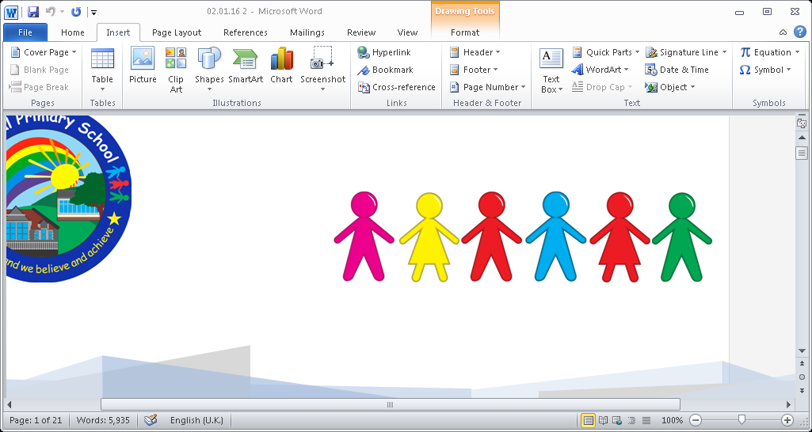

**Designated Members of Staff**

The designated members of staff keep child protection securely, offer advice and support to colleagues, pass on concerns to the relevant authorities and liaise with social workers.

The designated members of staff are Mrs. S Hopkins. Mrs. J. James and Mrs. S Amos

**Confidentiality**

Members of staff and governors may have access to confidential information about pupils in order to undertake their responsibilities. In some circumstances the information may be highly sensitive. Confidential or personal information about a pupil or her/his family must never be disclosed to anyone other than on a need to know basis.

Pupil and staff records are all kept securely.

**Photographing Children**

We understand that parents/carers like to take photos of their children or video them in the school play, at sports day or school presentations. This is a normal part of family life and we do not discourage parents from celebrating their child’s success.

However, there are restrictions on the use of images of children (e.g. data protection) and may be health and safety considerations. We adhere to the following guidelines:

We seek written parental consent for the use of photo- graphs and images for use by the school (including the school website and brochures) when a child joins the school.

If visitors come to the school to make videos or take photographs for use outside the school we will seek specific parental consent

**Policy and Guidance**

The following policies are linked to the information contained in this leaflet:

Safeguarding, Health and Safety, Positive Handling, Pupil Discipline, Attendance, Sex and Relationships, Medicines in Schools, Anti Bullying , E Safety, Confidentiality, Recruitment, Inclusion and Whistle Blowing.

The information enclosed outlines how we as a school and a community intend to keep our children safe. The policies and guidelines are not intended to alienate parents or visitors but ensure the children are safe at all times.

**Safeguarding Advice**

**for**

**Volunteers**

**&**

**Regular Visitors**

Please help us to safeguard the children in our care by following these guidelines.

**Safeguarding**

**Child Protection Advice**

Thank you for your interest in becoming a volunteer or regular visitor. As a school we are committed to safeguarding and meeting the needs of children and we hope this leaflet will provide some useful advice and information when working with children at Central Primary School.

#### **What are my responsibilities?**

#### All those who come into contact with children through their every day work whether paid or voluntary have a duty to safeguard and promote the welfare of children.

#### **DBS checks**

Central Primary’s Recruiting and Selection Procedures specify that all adults who work in 'regulated activity' and work in a 'specified place' such as a school and this work is regular - i.e. once a week or more or 4 or more days in a 30 day period or overnight - will require an enhanced DBS Disclosure. This is to help ensure that unsuitable people are prevented from working with children. If your work with children means that you are supervised at all times, this may not be required.

The Bursar will help you complete the DBS on-line application form and advise which documentation is necessary for you to present for the ID checks to be completed. You can apply to join the 'update service' at the same time to ensure that your certificate is portable. You must show your certificate to your Headteacher as soon as you receive it. The Head may ask you to give signed consent so that he/she can use the update service.

It is a requirement, also, that you inform the Headteacher immediately if you become subject to any criminal investigation, caution or conviction. This helps to protect you as well as the young people in your care.

#### **What should I do if I am worried about a child?**

#### **If whilst working with a child you become concerned about:**

#### **Comments made by a child**

#### **Marks or bruising on a child**

#### **Changes in the child’s behaviour or demeanour**

Please report these concerns to the class teacher, who if they feel it is appropriate will pass the information on to the school’s Senior Designated Person for Safeguarding.

**What should I do if a child discloses that s/he is being harmed?**

Although the likelihood of this is small it is important to know what to do in such an eventuality as children rarely lie about such matters

* Listen to what is being said without displaying shock or disbelief; accept what is being said
* Allow the child to talk freely
* Reassure the child, but do not make promises that might not be possible to keep
* Do not promise confidentiality but explain to the child that you may have to tell their teacher or Headteacher in order that they can provide appropriate help
* **Do not interrogate** the child or **ask leading questions**
* Reassure the pupil that it is not their fault
* Stress that it was the right thing to tell
* Do not ask the child to write a statement
* Do not criticise the alleged perpetrator

Immediately record details (Niggle note) of the disclosure, including wherever possible the exact words or phrases used by the child. Forms for the recording of information of this nature are available from any class teacher and should be completed and returned to the Designated Safeguarding Lead to enable the matter to be dealt with in the most appropriate way.

**Please ensure you have signed and dated the record.**

**What should I do if the alleged abuser is a member of the staff?**

You should report such allegations to the Headteacher.

**What should I do if the alleged abuser is the Headteacher?**

You should report such allegations to the Chair of Governors or the Designated Safeguarding Lead.

**What should I do if I witness worrying behaviour by another adult in school?**

You should always report this to the Headteacher.

**How do I ensure that my behaviour is always appropriate?**

Appropriate relationships with children should be based on mutual trust and respect.

As a volunteer or regular visitor you may well be working closely with children sometimes on a one to one basis.

Children, especially when they are young, are often spontaneously affectionate and tactile and it is important not to alienate them through lack of response or by appearing to reject this. You should, however, be careful about touching pupils.

If you are working with a pupil on his/her own always ensure that the door is left open or that you can be visible to others.

Do not photograph pupils, unless requested to by the class teacher, exchange e-mails or text messages, or give out your own personal details. Any unprofessional contact with pupils (e.g. through a social networking site) may leave you vulnerable to an allegation of abuse being made against you.

Please help us to safeguard the children in our care by following these guidelines.