Hay on Wye Primary
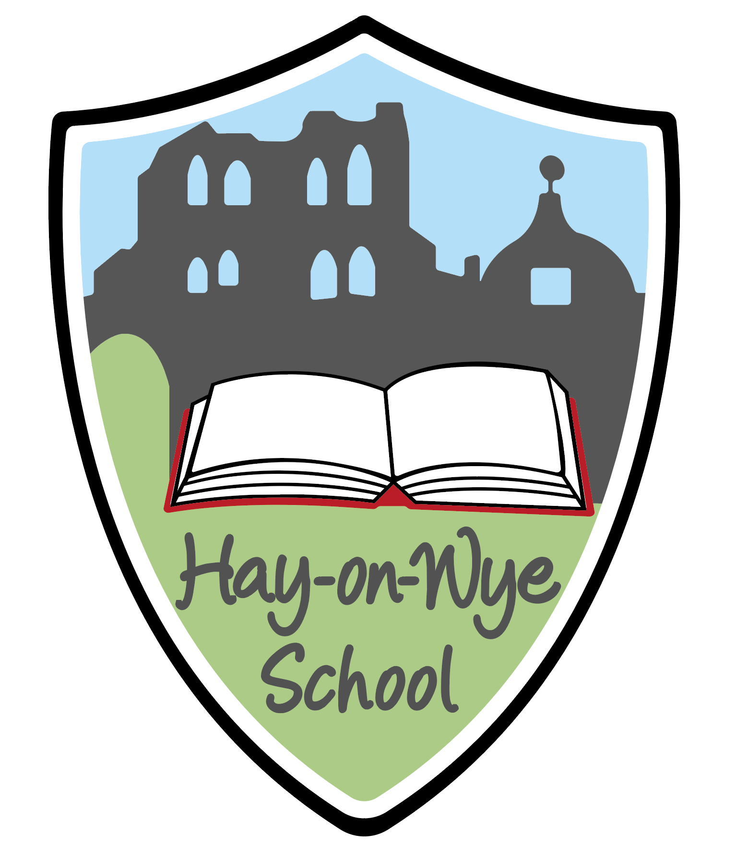
Curriculum Policy

Chair of Governors: ________________________

Date: ____________________________

Date for Review: _November 2020

Curriculum Policy
Introduction

This document describes the school’s curriculum policy and its implementation. By curriculum we mean learning and all other opportunities the school provides for our pupils.

Aims

All children have a right to a broad, balanced and relevant education which provides continuity and progression and takes individual differences into account. Work in school is designed to meet the requirements of the Foundation Phase and the National Curriculum in Wales in addition to the Locally Agreed Syllabus for R.E and Collective Worship.

All school policies at Hay on Wye Primary School have been written and are implemented with regards to the following the school aims:

- To provide an enjoyable, caring and safe learning environment where each child feels secure, valued and suitably challenged.

- To promote a culture of high standards and expectations through achievements in all aspects of school life.

- To promote the spiritual, moral, cultural, mental and physical development of every child within school.

- To promote the use of the Welsh language and an understanding of its culture.

- To encourage independent thinking, learning and problem solving.

- To help children develop lively, enquiring minds with the ability to question and argue rationally and to acquire knowledge and skills relevant to an ever changing world.

- To try to develop the full potential of every individual with an acceptance and realisation that each child’s abilities, capabilities and needs are different.

- To encourage awareness of the scientific, technological, social, historical and geographical aspects of the local environment and wider world and to develop skills in these areas.

- To encourage creative participation in the arts.

- To offer friendliness, courtesy and tolerance towards others and to appreciate and understand religious, cultural and moral values which may be different to their own.

- To appreciate the importance of social skills and the way they interact with other people.

- To encourage children to develop an appreciation and understanding of their environment and the impact people can have upon their surroundings.

- To be at the heart of the local community.

Following the four purposes of the new Curriculum for Wales, we want our pupils to be:
- Ambitious, capable learners who are ready to learn throughout their lives.
We want them to:
- Set themselves high standards and seek and enjoy challenge
- Build up a body of knowledge and have the skills to connect and apply that knowledge in different contexts
- Question and enjoy solving problems
- Communicate effectively in different forms and settings, using both Welsh and English
- Be able to explain the ideas and concepts they are learning about
- Use number effectively in different contexts
- Understand how to interpret data and apply mathematical concepts
- Use digital technologies creatively to communicate, find and analyse information
- Undertake research and evaluate critically what they find

- Enterprising, creative contributors who are ready to play a full part in life and work.
We want them to:
- Connect and apply their knowledge and skills to create ideas and products
- Think creatively to reframe and solve problems
- Identify and grasp opportunities
- Take measured risks
- Lead and play different roles in teams effectively and responsibly
- Express ideas and emotions through different media
- Give of their energy and skills so that other people will benefit

- Ethical, informed citizens who are ready to be citizens of Wales and the world.
We want them to:
- Find, evaluate and use evidence in forming views
- Engage with contemporary issues based upon their knowledge and values
- Understand and exercise their human and democratic responsibilities and rights
- Understand and consider the impact of their actions when making choices
- Be knowledgeable about their culture, community, society and the world, now and in the past
- Respect the needs and rights of others, as members of a diverse society
- Show their commitment to the sustainability of the planet

- Healthy, confident individuals who are ready to lead fulfilling lives as valued members of society who:
- Have secure values and are establishing their spiritual and ethical beliefs
- Are building their mental and emotional well-being by developing confidence, resilience and empathy
- Apply knowledge about the impact of diet and exercise on physical and mental health in their daily lives
- Know how to find the information and support to keep safe and well
- Take part in physical activity
- Take measured decisions about lifestyle and manage risk
- Have the confidence to participate in performance
- Form positive relationships based on trust and mutual respect
- Face and overcome challenge
- Have the skills and knowledge to manage everyday life as independently as they can

The Six Areas of Learning and Experience described in the Donaldson Review are:
- Expressive arts
- Health and Wellbeing
- Humanities (RE is included here)
- Languages, Literacy and Communication (Welsh is included here but has a separate policy)
- Mathematics and Numeracy
- Science and Technology
All teachers have an area of responsibility, based on these six areas of learning and experience. Staff are responsible for:
- monitoring the planning, teaching and learning in their area across the school
- writing monitoring reports and reporting findings back to the rest of the staff
- leading on the development of ‘next steps’, including ideas for further training needed
- using their knowledge of the development of skills in their area across the school to contribute to the School Development Plan

The six areas of learning at Hay on Wye Primary School
- In Expressive Arts (Art, Music, Welsh and Dance/Creative Development), it is intended that pupils will develop their creative appreciation and talent, and their artistic and performance skills. They will have opportunities to explore thinking, and refine and communicate ideas through creatively using their imagination and senses. These skills are also promoted through extra-curricular clubs/activities.

- The Health and Well-being area (PE, PSE, ESDGC/Physical Development and Personal, Social, Emotional and Cultural Diversity) aims to help children and young people to build the knowledge, understanding and skills to develop positive and appropriate relationships, deal with difficult issues and decisions, and learn to live independently. This will focus on sport and physical activity, as well as mental and emotional well-being, and issues regarding sex and relationships.

- The Humanities area will seek to give pupils an understanding of historical, geographical, political, economic and societal factors, providing opportunities to engage in informed discussions about ethics, beliefs, religion and spirituality. It will draw on existing subjects, history, geography, business and social studies, as well as religious education, which Professor Donaldson recommends should remain a statutory curriculum requirement from Reception year onwards.

- The Languages, Literacy and Communication area aims to provide the fundamental building blocks for different forms of communication, literacy and learning about language. It will also give opportunities to learn different methods of communication as well as Welsh and English. Digital competence will be a central part of this area, in line with it being afforded similar status in the curriculum as literacy and numeracy. .

- Through the Mathematics and Numeracy area, pupils will be expected to develop a good, lasting understanding of mathematical concepts and have the confidence to apply numerical skills in everyday life. It will include developing financial skills and applying them to real-life situations. The Area will centre on the discipline of mathematics, including the traditional components of arithmetic and statistics together with logic, providing a strong link with the skills necessary in science and technology.

- Science and Technology are described respectively as acquiring knowledge through observation and experimentation, and subsequently applying this scientific knowledge in practical ways. Computer science is proposed as a specific component within this Area, taking forward the recommendation from the ICT Steering Group’s report to the Welsh Government that it be introduced into the curriculum.

Delivery

The school promotes active, independent learning, enabling pupils to pose their own questions and develop their own ideas. We encourage

- learning by discussion

- variety in approach and delivery

- teaching that takes account of individual pupil’s needs and capabilities

- cross curricular approaches

- pupils to take responsibility for their own learning and to be confident in their own abilities.

Environment

We promote a caring, sharing, healthy environment for our pupils. Extra-curricular activities outside the formal classroom sessions provide an important opportunity for pupils` learning and development and we support and encourage such activities so far as our resources allow.

Children with additional learning needs

The curriculum in our school is designed to provide access and opportunity for all children who attend school. We differentiate the curriculum to adapt it to the needs of individual children.

Key Skills

The Curriculum Planning Guidance document no: 091/2013 sets out the school approach for the implementation of the Literacy and Numeracy Framework. Literacy and numeracy will be developed through the Foundation Phase Areas of Learning and across all subjects in Key Stages 2 to ensure that all learners have opportunities to develop and refine literacy and numeracy skills.

Teachers are expected to:
- integrate literacy and numeracy into their teaching;

- inform discussions with parents/carers, learners, and other teachers about learner performance;

- help learners with their own self-assessment activities and planning for learning;

- monitor, assess and report on individual learner performance. identify learners who may benefit from intervention or who are working beyond age-related expectations.

The following have been identified as Key Skills in “The Skills Framework for 3 to 19 year–olds- in Wales”:
- Thinking

- ICT

Coverage of these key skills is evident in our planning so that children’s progress can be identified and monitored. All subject areas contribute to a child’s progress in these skills.

Literacy Numeracy Framework

The LNF was introduced to schools in September 2013. This initiative promotes the application of literacy and numeracy skills across all curriculum areas. It is the responsibility of all staff to ensure that lessons have an appropriate literacy or numeracy objective taken from the framework.

Curriculum Planning

The LNF is first and foremost a curriculum planning tool that supports all teachers to embed numeracy and literacy in their teaching of the curriculum. Current curriculum planning has been adapted to support cross curricular planning using the LNF and tasks are set that aim to introduce, consolidate, apply and make progress in specific numeracy and literacy skills.

Although the LNF identifies age-appropriate numeracy and literacy skills, planning will need to take into account the different abilities of the pupils.

The LNF will be used as:

- a tool for curriculum planning in order to progress literacy and numeracy skills development across the curriculum

- an assessment tool to track literacy and numeracy skills progression.

The Digital Competence Framework (DCF)
The DCF was first introduced in September 2016. Digital competence is one of 3 cross-curricular responsibilities, alongside literacy and numeracy. It focuses on developing digital skills which can be applied to a wide range of subjects and scenarios.
The Framework, which has been developed by practitioners from Pioneer Schools, supported by external experts, has 4 strands of equal importance, each with a number of elements.
Citizenship – which includes:
  - Identity, image and reputation
  - Health and well-being
  - Digital rights, licensing and ownership
  - Online behaviour and cyberbullying

Interacting and collaborating – which includes:
  - Communication
  - Collaboration
  - Storing and sharing

Producing – which includes:
  - Planning, sourcing and searching
  - Creating
  - Evaluating and improving

Data and computational thinking – which includes:
  - Problem solving and modelling
  - Data and information literacy.

Equal Opportunities

All pupils have access to the full curriculum irrespective of age, gender, race, disability or religion. Individual opinions and ideas will be respected and valued.

Assessment

Children’s progress is constantly monitored through continuous formative and summative assessments. Pupils are also assessed according to the requirements of the Foundation Phase outcomes and National Curriculum levels. Children’s achievements are recorded on the Hay on Wye Primary School Tracking system. These assessments will go on to help with planning any intervention programs that pupils may require.

Reporting

Parent consultation evenings are held in the autumn and spring terms and a written report is issued at the end of the summer term with an opportunity to discuss progress if needed.

Roles and Responsibilities

The Head Teacher has responsibility for the leadership of the curriculum.

Learning teams are responsible for writing policies and for evaluating and monitoring standards in line with the school evaluation cycle.

KS coordinators have a responsibility for supporting colleagues and leading their Key Stage.

Class teachers ensure that the curriculum is delivered.

The Governors monitor all of the above.

