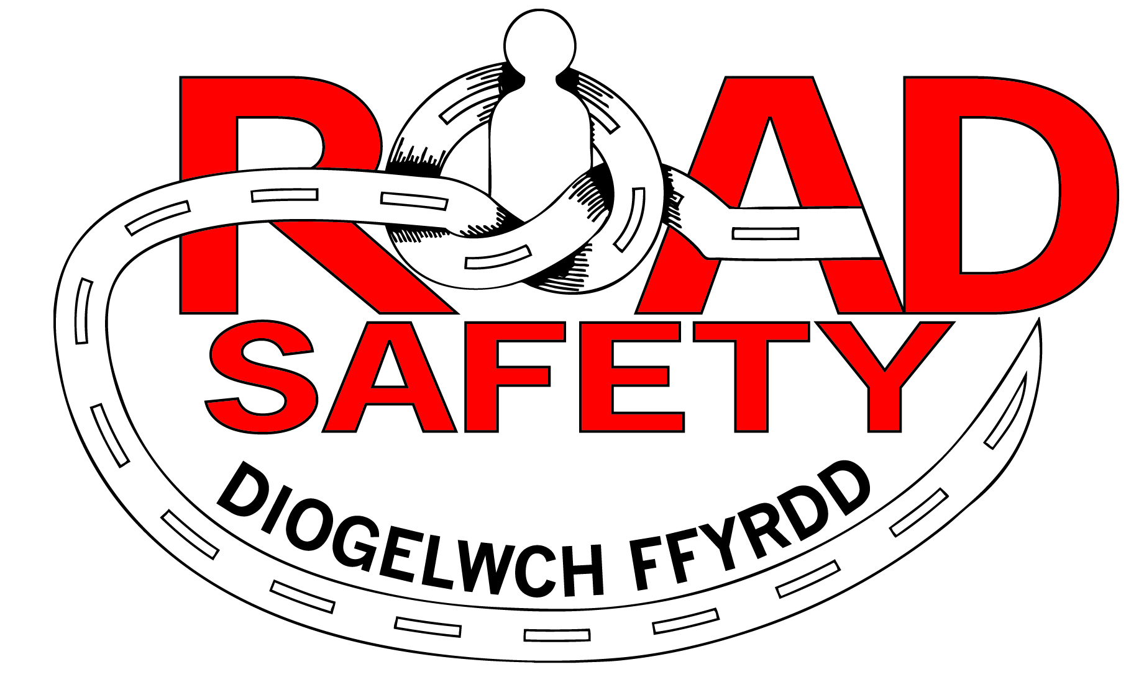

Cyclecraft Cycle Training

Training Date:

We would like to offer your child the opportunity to take part in Cycle Training. Cyclecraft is a Road Safety Scheme designed to equip pupils with the skills and confidence for both on and off road cycling. The enclosed leaflet provides all the information you need however should you have any queries please do not hesitate to call us on 01639 686828.

In order for your child to take part in this training, the following consent form needs to be completed by a Parent or Legal Guardian.

The Road Safety Team strongly recommends that your child wear a cycle helmet during the scheme and at all times when cycling and please could you ensure that your child’s bike is roadworthy prior to the session, specifically that both the front and rear breaks are in full working order that both tyres are fully inflated and have good tread.

PLEASE NOTE: PROGRESS ONTO LEVEL 2 (ON ROAD TRAINING) IS DEPENDENT ON YOUR CHILDS ABILITY TO CONTROL THEIR BIKE AND HAVE THE CONFIDENCE TO DEAL WITH ON- ROAD SCENARIOS.

IN LINE WITH THE WELSH GOVERNMENTS OPERATIONAL GUIDANCE FOR SCHOOLS OUR TRAINERS WILL MAINTAIN SOCIAL DISTANCING FROM PUPILS WHERE EVER POSSIBLE AND WILL BE WEARING CORRECT P.P.E WHERE REQUIRED. WE REGRET THAT WE ARE UNABLE TO CARRY OUT ANY REPAIRS TO YOUR CHILD BIKE. IF THE BIKE IS DEEMED UNSAFE THEN THE PUPIL MAY NEED TO BE EXCLUDED FROM THE SESSION.

I give /do not give consent for my child to take part in Cyclecraft.

I confirm that I have checked the bicycle and understand that my child will be supervised by a qualified instructor.

Pupils Name: ………………………………………………………..

School: ………………………………………………………………..

Parent/Guardian Signature: ………………………………………………………

Date: …………………………………….

Consent to Photograph/Video and Publish

There are occasions when the instructors may take photographs and videos during the activities. In order for Photographs/videos to be taken of your child and possibly published in promotional material, newsletters, documents, website or social media such as Facebook/Twitter, then the following consent form needs to be completed by a parent or legal guardian.
Yes- I give my consent for photographs/videos to be taken and the publication of my child’s photograph for purposes consistent with the above.

No- I do not give my consent for photographs/videos to be taken and the publication of my child’s photograph for purposes consistent with the above.

Parent/Guardian Signature: ………………………… Date:…………………….

Health & Safety

Please complete the following questions to ensure your child’s needs are met during the sessions. Any information provided will be held in the strictest confidence.

Does your child suffer from any of the following:-

Please tick all that apply

Hearing Impairment |  | Mobility Issues
Learning Difficulties |  | Behavioural Issues
Diabetes |  | Asthma
Epilepsy |  | Allergies
Other Please Specify

Please specify details of your child’s condition/difficulty or any needs:

…………………………………………………………………………………………

…………………………………………………………………………………………

…………………………………………………………………………………………

Thank You!
If you any queries, please do not hesitate to contact the Road Safety Team on 01639 686828.





