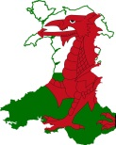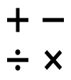

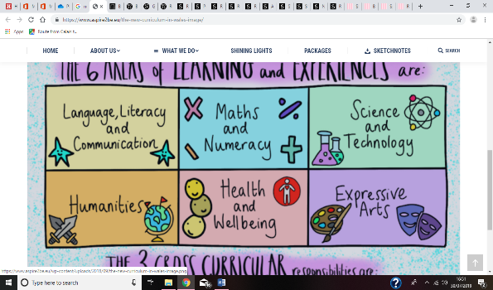

Tourism in Wales

* What is tourism?
* The different types of tourism.
* The positives and negatives of tourism.
* The effects tourism has on our country.
* Why do people want to visit Wales?
* Natural, cultural and entertainment resources.
* Tourist hotspots in Wales .



* Mission.
* Memorial Sacrifice.
* Sacrifice.
* Catholic Virtues.

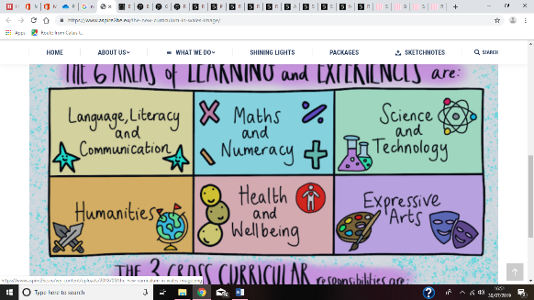

* Reading.
* Punctuation and grammar.
* Handwriting.
* Spellings.
* Persuasive Writing.
* Debate.
* Explanation Writing

**Cymraeg**

* Reading.
* Letter Writing.
* Recount writing.

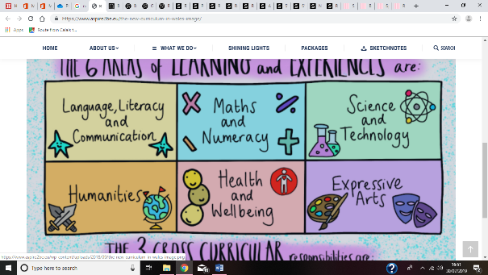

* Time Tables (all)
* Shape, space and measures.
* Area and volume.
* Angles.
* Time.

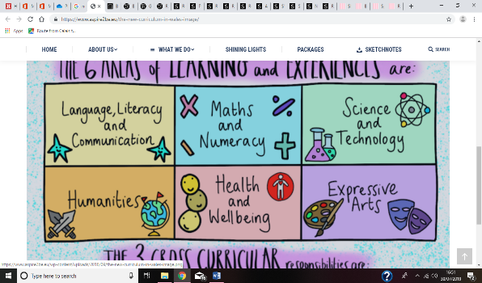

* The Holocaust Memorial Day.
* The Global Community.
* Internet Safety.
* Healthy mind and Healthy bodies.
* P.E.

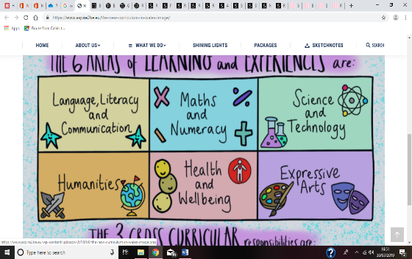

* Music.
* Painting in the style of Welsh artist Rhiannon Roberts.

**Year 6**

**Spring 2020**

***“The green, green, grass of home”***

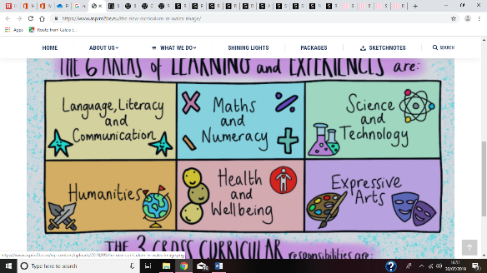

* How sound travels.
* Noise pollution.
* Fair Testing – sound insulation.
* How light travels.
* Renewable energies.
* Multimedia ICT.