Homework

Your homework this half term is to create a mini project about a saint of your choice. You can use books or the internet as your source of information. Please include;

- A title page.
- Pictures of your Saint.
- Facts about your saint (their name, background information, what they are the patron saint of, what they looked like, any famous stories)
- Why you chose this particular saint.

Your project needs to be brought back to school by Tuesday, November 5th.
Enjoy.

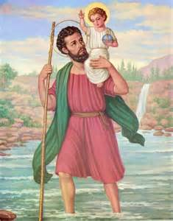
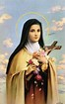
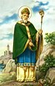
Miss Beesley

