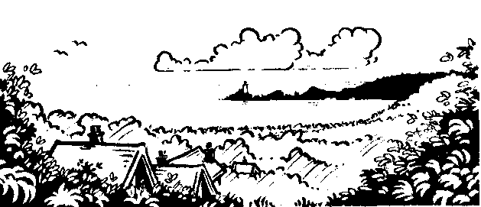
Humanities

Geography:
Where are the rainforests?
Why are they where they are? Climate Zones
David Attenborough
Climate change

R.E.
Judaism
LL&C

English
Narrative Writing
Instructional Writing
Oracy – Home Learning Presentation
Speech marks
Spelling patterns
Handwriting

Welsh
Third Person
Reading – mets maesllan
Oracy Presentations
Slot Drillio

Hendrefoilan Primary School – KS2
Science and Technology
Science
Healthy eating
Exercise and drugs
Science enquiry games
Rainforest habitat and food chains
Plants and trees

ICT
iPad apps to present.
Choose and use appropriate ICT equipment to capture sounds, music, narration, images and/or video.
Coding
Search for and select information from a range of ICT and non-ICT sources
Digital Citizenship
How to cite a site
Seesaw activities

D.T
Mask design

Maths
Number Problems
Probability
Time
Lengths and measures
Money
Graphs and Tables
Properties of Shapes
ratio and proportions
Reasoning

Health and Well-being

P.E.
Rounders
Athletics

PSE
SEAL
Importance of a healthy diet
Importance of regular exercise
Climate change

Heroes of the Earth
Rainforests
Expressive Arts

Art
Henry Rousseau
Mask making
Rainforest Terrariums

Music
Charanga
Appraisal/Composing/Performing

