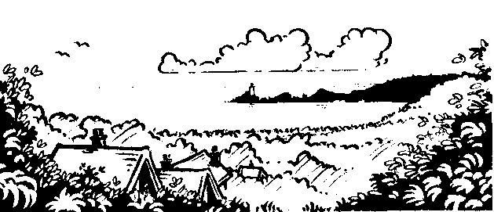
LL&C: English
Recount writing - newspapers
Poetry
Narrative writing
Grammar
Spelling patterns
Thesaurus work
Dictionary work
Handwriting
K&U: History
What did the Stuarts do for us?
Who were the main people?
What was life like in the era?
Stuart houses and homes.
History skills - evaluate sources, give some of the causes and consequences of the main events. Show how some aspects of the past have been represented and interpreted in different ways.

Hendrefoilan Primary School – Year 5: Mr Rees

K&U: Science
What do we know about light and sound?
What does light and sound travel?
How can we measure the strength of light and sound?
How are different sounds produced?
How can light be used?

Maths
Place value
Multiplication/division
Addition/subtraction
Problem solving and Reasoning
Money
Fractions/Decimals
Properties of shape
Data Handling
Ratio/Proportion
Time

K&U: ICT
Select relevant information from a range of given sources including the Internet.
Use a various forms of media to capture images required for a project.
Understand that the features of a digital camera can enhance images.
Create Spreadsheets that include a variety of formula and cell formats, such as money and decimal places.
Create hyperlinks.
Creative: Art/Music/DT
Art
Portraits
Perspective drawing
DT
Home Learning Projects
Bread making
Music
Pupils to follow the Charanga scheme based on the song ‘Livin’ On A Prayer’ by Bon Jovi.
Listen and appraise
Musical activities and Performance
Physical: PE
Football
Gymnastics

Visits
Llancaiach Fawr
Cardiff – Urdd Sleepover
Welsh
Describing people
Responding to poetry
Slot Ddrilio
PSHE/SEAL/RE
Seal programme- New beginnings

