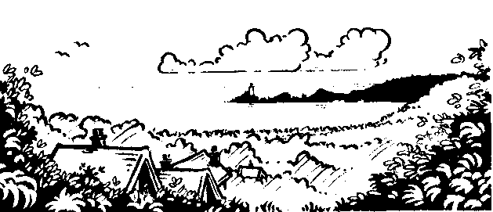
Year 6, Spring Term. Home Learning Menu
Dear Parents
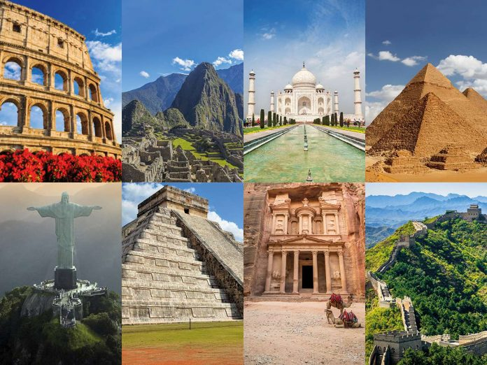
Here is the home learning for the Spring term. The children can choose which task they would like to do each in any order (except for the Oracy task which will need to be ready for the week beginning the 4th March 2019). The children are expected to hand work in every fortnight. The home learning will be celebrated in class and items will be displayed in class.
Additional mental arithmetic books are also available if you wish your child to have these.
The home learning list can be found on the classroom door and on our website.
I appreciate your support with these tasks and if you have any questions please come in and see me or email the office.
Diolch,
Mr Webb
*Home Learning is due on: Fri 25th Jan, 8th Feb, 22nd Feb, 4th March*, 15th March, 29th March.
Home Learning Choice Menu – The Wonders of the World:
Literacy- Oracy  Create a 5-minute presentation to present to the class on any Wonder of the World (Ancient, Modern or Natural). Key notes only- no scripts.  This will need to be ready by  Monday 4th March (giving you half term as well to prepare fully). | Topic  Write a short adventure story that includes visiting any of the Wonders of the World or a place of interest / importance in the World. Be thoughtful and creative so your story is as exciting as possible. Make adventurous vocabulary choices & entertain your class.
Creative  Copy or create a picture of a Wonder of the World- or any other place of interest or importance in the World. You can use any medium you choose (pencils, felt-tips, paint, ICT etc) | Creative  Design and make a model version of any landmark/ place of interest from anywhere in the World. This can be as small or big as you like!
Science and Technology  Research and create a 1 minute video of you talking about any place of interest in the World. Give facts and interesting information about the location and tell us why you chose the specific place. This can be done uploaded to HWB and SeeSaw for the rest of the class to view and enjoy. | Numeracy  Create a factsheet/ poster of numbers linked to all the Wonders of the World. For example, you could research; the tallest, the oldest, the most visited, the number of steps it has, the longest to build, the number of degrees it is wonky!  *Fill your page with fascinating number based facts and make it as eye-catching as possible.

Please don’t forget there is ALWAYS weekly spellings and tables tests and reading should also be done as often as possible. Abacus maths and TT Rockstars are great ‘at home’ resources to help your child with in class maths.

