Year 6 Autumn Term. Home Learning Menu
Dear Parents
Here is the home learning for the Autumn term. The children can choose which task they would like to do each in any order (except for the Oracy task which will need to be ready for the week beginning the 5th November). The children are expected to hand work in every fortnight. The home learning will be celebrated in class and items will be displayed in class.
Additional mental arithmetic books are also available if you wish your child to have these.
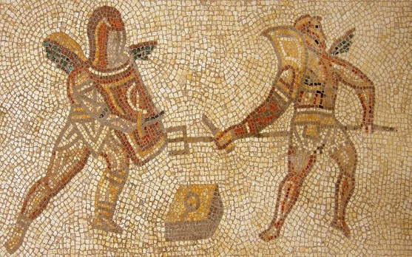
The home learning list can be found on the classroom door and on our website.
We appreciate your support with these tasks and if you have any questions please come in and see us or email the office.
Diolch
Mr Webb
*Home Learning is due on: Fri 28th Sept, 12th Oct, 26th Oct, 5th Nov, 23rd Nov, 7th Dec.
Home Learning Choice Menu – The Romans:
Oracy  Create a 5-minute presentation to present to the class on a topic of your choice. How you choose to present is entirely up to you.  This will need to be ready by  Monday 5th November (giving you half term as well to prepare fully). | Topic  Write an in-depth five day diary of a person living during Roman times. For example, this could be a soldier, a gladiator, an Emperor, a child or a parent. Think about what they would have done and how they would have felt.
Creative  Copy or create a picture of a scene from Roman life. You can use any medium you choose (pencils, felt-tips, paint, ICT etc) | Creative  Design a Roman tiled mosaic, this can be of a picture or a pattern with a Roman theme of your own choice.
Science and Technology  Research and create a factsheet on the Romans. Include as many interesting facts as you can discover. Present your research on one page- this can be done using ICT and uploaded to HWB and SeeSaw. | Numeracy  Complete the maths sums using Roman numerals. The sheet has a hint section to help you.  *Get the task sheet for your group from the ‘Home Learning Wall’ in class.

Please don’t forget there is ALWAYS weekly spellings and tables tests and reading should also be done as often as possible. Abacus maths and TT Rockstars are great ‘at home’ resources to help your child with in class maths.

