Headteacher/Pennaeth: Dunvant Road, Killay
Aimee Field Swansea. SA2 7LF (01792) 290223 Heol Dyfnant, Cila
Fax: (01792) 208606 Abertawe. SA2 7LF

Email/Ebost: Hendrefoilan.school@swansea-edunet.gov.uk
Spring Term 2017
Friday January 27th 2017
Dear Parents,

Contents
- After School Club (ASC) Inspection
- ASC closures
- Pupil Voice Forum
- Dates

After School Club (ASC) Inspection
Following rigorous inspection, we applied to vary our registration and increase the numbers in our After School Club. The Care and Social Services Inspectorate Wales have advised that this variation of registration certification can take up to six weeks.

We are very sorry if you have not been guaranteed a place and thank you if you have managed to make other short-term arrangements. Please contact me if you have been turned down and need further information. If you cannot arrange any alternative childcare after school and we will make every endeavor to assist.

Reminder: No After School Club on Monday 30th January - Epi pen training
No After School Club Monday 6th February – Safeguarding training

Pupil Voice Forum
Grace Gosby and Esther Bullock represented Hendrefoilan Primary at the Pupil Voice Forum, held at Moriston Comprehensive School. The girls made important decisions regarding the plans for school meals, learning welsh in schools and how we play in school. Increasing our pupils’ voice is high on our list of priorities this year and Grace and Esther did a wonderful job of raising the schools profile and having their say. I was very proud of their clear decision-making and inspirational ideas. The Chief Education Officer, Mr Lindsay Harvey, attended and chatted with the young people. He assured me that their input in these events is shaping the future of educational provision in Swansea

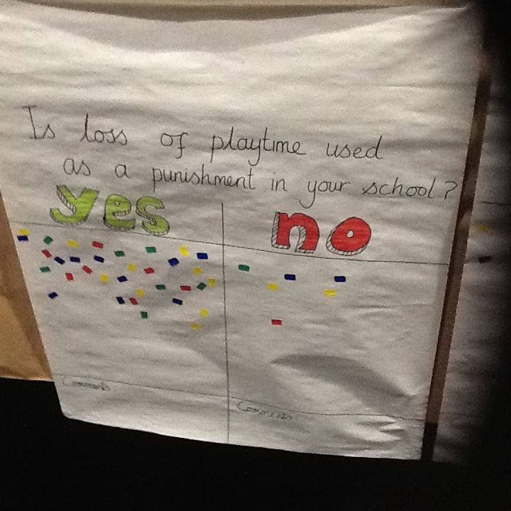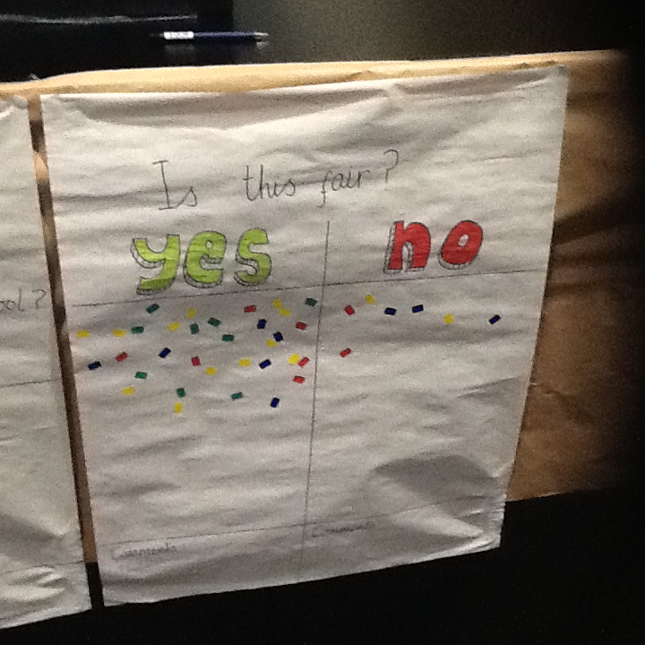

The girls representing Hendrefoilan at the Pupil Voice Forum

Please visit our website at https://hendrefoilan-primary-school1.j2bloggy.com/

Dates
Monday 20th February – Friday 24th February – Half Term week

Wednesday 1st March – St David’s Day Dragon Parade and Eisteddfod
Monday 6th March – Parents’ evenings
Thursday 9th March – Y4 Techniquest
Wednesday 29th March – Nurses talk Y6
Friday 7th April – Last day of Spring term for pupils

Monday 10th April to Friday 21st April – Easter Holidays
Thursday 20th July – Last day of Summer Term for pupils
Friday 21st July – INSET day

