HENDREFOILAN PRIMARY SCHOOL PROSPECTUS
2017 - 2018

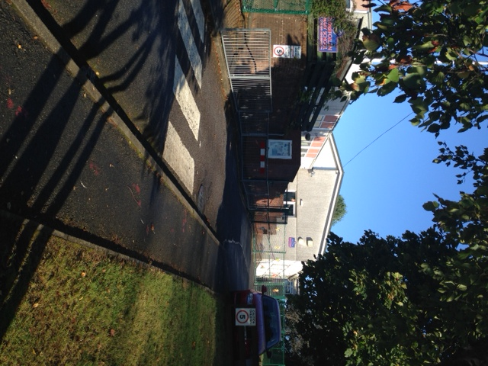

Headteacher: Mrs. Aimee Field
Dunvant Road
Killay
Swansea
SA2 7LF

Contents
- Introduction and School Hours
- A Letter from the Headteacher
- Vision and Motto
- The Governing Body
- Aims of the school
- Academic Organisation
- All areas of responsibility at Hendrefoilan
- Some details about securing the safety and wellbeing of our pupils
- Child Protection and Safeguarding Policy and Procedures
- Arrangements for general welfare & Well Being of Pupils
- Admission Procedures
- Transfer to Olchfa
- Attendance
- Transport to School
- Security
- School Development
- Early Years and Infant education
- National Curriculum Information
- Assessment of Progress
- Target Setting
- The General School Curriculum
- Sporting Activities
- Religious Education & Collective Worship
- Arrangements for the teaching of Welsh
- English as an Additional Language
- I.C.T.
- P.S.E.
- Pastoral Care/Well Being
- Arrangements for Children with Additional Learning Needs
- Sex Education
- Homework
- After School Clubs/Extra Curricular Activities
- Breakfast Club
- After School Club
- Healthy tuck shop
- Lunchtime Arrangements
- Water Bottles
- Toilet Facilities
- Playground Buddies
- School Council
- Parents meetings with the Governing Body
- Parents, Volunteers and the School PTA
- Parent & Toddler Group
- Car Parking
- Medical
- School Nurse
- Head Lice
- Careers Education and Work Experience
- School Uniform
- School Rules and Discipline
- Equal Opportunities
- Disability Equality
- Race Equality
- Dealing with Bullying or Racist Incidents
- Complaints Procedure
- School visits/visitors
- Inspection of Documents
- School Achievements
- School Terms & Holiday Dates
- Appendix 1 Teacher Assessment Results

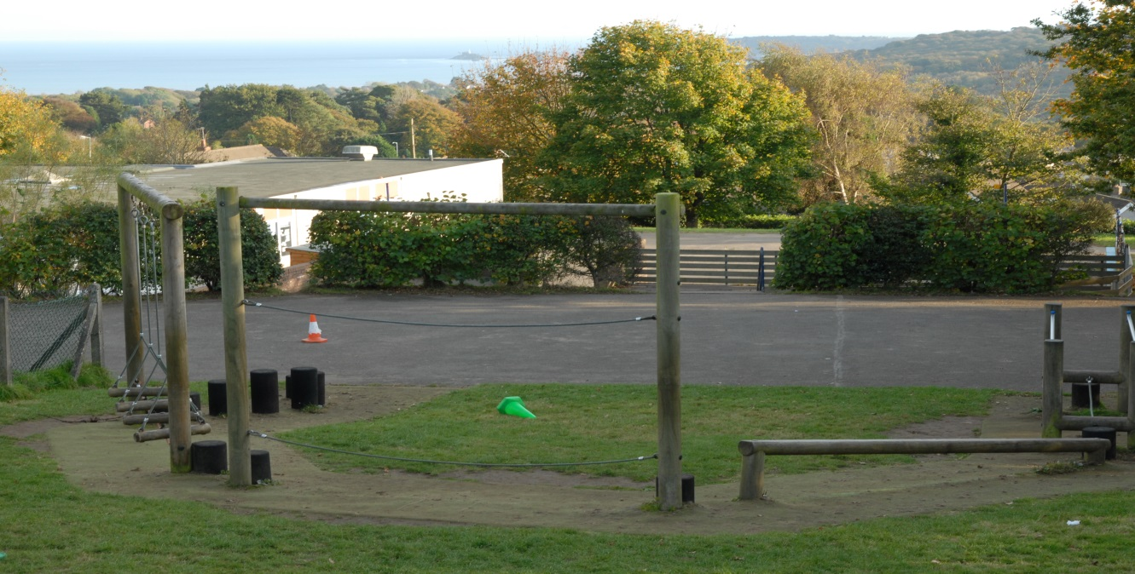

Introduction
Hendrefoilan Primary School is in Killay in Swansea. It currently has 216 pupils, aged three to eleven years, in eight classes. This includes a nursery that can hold 40 pupils, who attend on a part-time basis. Around 1% of pupils are eligible for free school meals, which is well below the average for Wales. The school identifies about 12% of pupils as having additional learning needs, including a very few who have statements of special educational needs. Most pupils are from white or mixed ethnic backgrounds. Approximately 19% of pupils speak English as an additional language.

School Hours:
Reception - Year 2

08:50 - 09:00 Registration 10 minutes
09:00 - 10:15 Lesson time 1 hour 15 minutes
10.15 - 10.30 Assembly time 15minutes (5x a week)
10.50 - 11:50 Lesson time 1 hour
13:00 - 13:05 Registration 5 minutes
13:05 - 14:20 Lesson time 1 hour 15 minutes
14:40 - 15:20 Lesson time 35 minutes teaching

Total lesson time: 4 hours 05 minutes
Total lesson time per week: 22 hours 15 minutes

Years 3 - 6

08:50 - 09:00 Registration 10 minutes
09:00 - 10:15 Lesson time 1 hour 15 minutes
10.15 - 10.30 Assembly time 15 mins (3x a week)
10:50 - 12:05 Lesson time 1 hour 15 minutes
13:00 - 13:05 Registration 5 minutes
13:05 – 15.20 Lesson time 2 hour 15 minutes

Total lesson time 4 hours 45 minutes
Total lesson time per week: 23 hours and 45 minutes

Nursery - 8.50 a.m. - 11.40 a.m.

We expect your child to arrive promptly by 8.50am. We believe that it is very disruptive for the class and disrespectful to the teacher to arrive late without an acceptable reason.
A Letter from the Headteacher
On behalf of the staff, I would like to welcome you and your child to Hendrefoilan Primary School. We work in close co-operation with the Governors, parents and friends of the school. This ensures that your child receives the best educational environment in which to learn and enjoy their primary education. Our school takes pride in the high standards that have been achieved over many years. This is the result of hard work increasingly high standards of teaching in a caring environment, together with a committed Governing Body and the support of parents and wider community partnership. This information booklet will provide many of the answers to questions you might have. If you require any further information please contact the school and we shall be pleased to answer your queries or concerns.

The school was-inspected under the Estyn framework in December 2015. The inspectors were impressed with some of the work the school does and we are proud of the good aspects of the report. Inspectors rated that out of the ten categories, 5 were judged as ‘Good’ and 5 were judged as ‘Adequate’.

The school was re-inspected during the Estyn monitoring visit in May 2017. At this time Hendrefoilan was judged to have made good progress towards meeting recommended improvements and the school was removed from a category requiring Estyn monitoring. Please see Appendix 1 for a summary of the Estyn Follow up Report.

The staff at Hendrefoilan led by the Senior Management Team and the Governing Body, endeavour to provide the children with a school that they feel an integral part of and that they are intensely proud of, as we believe that in this way children feel more valued, have more self-confidence, develop more fully and achieve more.

Hendrefoilan Primary School is a fully inclusive school and we value all children equally regardless of age, ability, background, gender, religion or race. We value our pupils and believe that their time in school should be rewarding and fulfilling. Visitors to the school often comment on the warm welcome they receive and the politeness and courtesy our pupils display.

A Shared Vision for Hendrefoilan Primary School
Hendrefoilan Primary School is a safe, nurturing school, where staff and pupils are warm and welcoming. At Hendrefoilan Primary, we nurture a love of challenge and inspire aspiration and self-belief. The school community inspires enthusiasm and a curiosity for learning. We encourage independence and have high standards in behaviour and attainment. The desire to improve is fully embedded and all meet their full potential
We believe that education should be an enjoyable, continuous process with strong home/school links providing that vital continuity. Our mission statement:

School Motto
‘Learn, Enjoy, Inspire, Achieve’

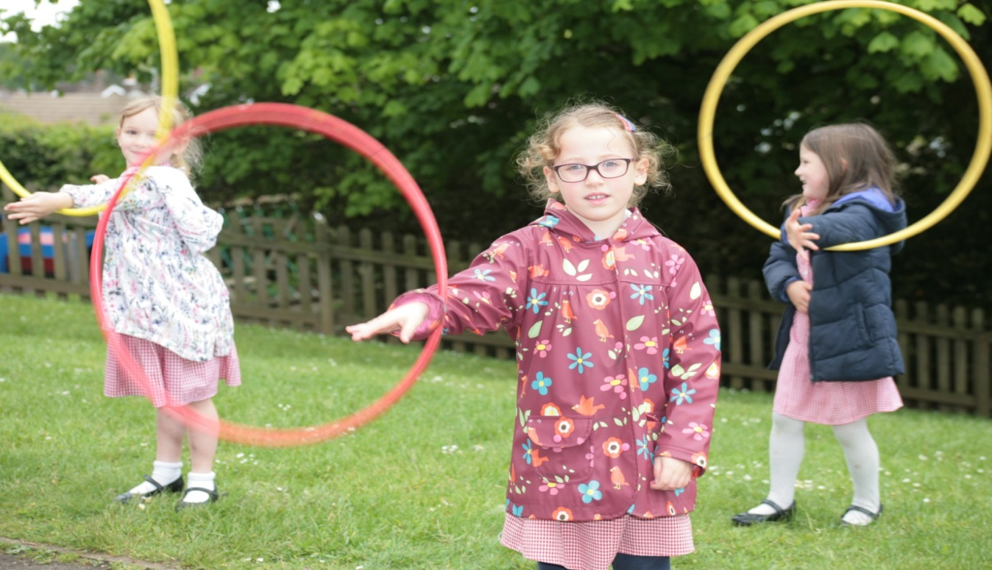

The Governing Body
You may well have met some of the Governing Body already - for your information, the members are:
Vacancy Community 17.05.20

Mrs. S. Poole Community 19.04.20

Cllr. M. Jones LA 16.10.18

Mr. D. Cahill, Vice Chair LA 2.12.17

Mrs K. Novis LA 27.7.21

Mrs. D. Bennett, Chair Community 2.9.20

Vacancy Parent

Mr J Neal Parent 1.3.21

Mrs. P. Cole Parent 7.3.18

Mrs V. Shah Parent 1.9.20

The following Governors and the Clerk can be contacted through School

Mrs. A. Field Headteacher
Mr J Webb Deputy Headteacher
Mrs C Bews Teacher Governor
Mrs. C Lingard Non-Teaching Staff Rep.
Mrs S Williams Clerk to Governors

The Governing Body usually meets half-termly and will be happy to hear any suggestions you may have about the way the school is run. Governors also look forward to getting to know you better during your child’s time at Hendrefoilan Primary School.
The aims of Hendrefoilan Primary School are:
- To develop the whole child – intellectually, emotionally, socially, physically, morally and spiritually
- To cultivate a climate of success for all children, celebrating all of their achievements in all aspects of their lives.
- To involve our pupils in the learning process and empower them to participate in all aspects of school life.
- To help learners to become confident, self-reliant, self-respecting and responsible global citizens who will make a positive contribution to society.
- To develop in all individuals the capacity to work both collaboratively and independently and the ability to determine the appropriate method for the task.
- To develop a personal moral code, sensitive to the needs of others.
- To actively seek to raise all standards and be part of an on-going self-evaluation process.
- To promote equality of opportunity and respect for all irrespective of race, gender, ability or religion. The school has an equal opportunities and anti-racist policy, which all staff adhere to. This can be viewed on request.
- To preserve and develop our own cultural identity within Wales, while at the same time promoting an understanding of, and a respect for other cultures locally and globally.
- To provide regular physical education lessons within school time and to offer, when possible, after school sporting activities which would include team and co-operative games.
- To promote a healthy lifestyle (we are proud of the fact that we are accredited as a Healthy School).
- To raise students’ awareness of sustainable development issues thought classroom study and community action.
- To empower our pupils by becoming literate, numerate and technologically able to function effectively in an ever-changing Twenty-first Century. Values: The school promotes core values: Tolerance; respect; fairness; a positive attitude; honesty; responsibility; friendship; trust and appreciation. These shape our thoughts, feelings and actions and were devised in consultation with all stakeholders. Hendrefoilan Primary is a Rights Respecting School.

Hendrefoilan Primary School is a place:
• Where children, staff, parents and community – can smile, feel safe and comfortable and enjoy
• Where children and staff feel valued and respected
• Where all achievement is celebrated
• That stimulates and inspires
• That promotes and models healthy living and care for the environment both locally and globally
• To be proud of
• Where the most important things taught and learned are our values
• Where the most important rule is to treat others, as you would wish to be treated yourself

The Hendrefoilan Teacher will:
- Be clear about what the children should hope to attain from an activity
- Have a clear understanding of the abilities and needs of individual children
- Be sympathetic to those needs and differentiate accordingly
- Set realistic and useful targets, which will benefit children
- Plan with assessment in mind
- Keep a clear, uncluttered and precise focus for learning activities
- Stimulate and inspire children and colleagues
- Create an environment and atmosphere conducive for learning
- Promote all aspects of health and well being
- Allow children to feel comfortable in learning and enable them to enjoy learning
- Know when to teach and when to allow children to learn
- Encourage, praise and celebrate achievements (including individual achievement irrespective of level and degree of success)
- Teach and enable children to discuss and explore our values
- Know what, how and when to teach,
- Be clear and precise in objectives,
- Set clear, specific and achievable outcomes for pupils,
- Plan with assessment in mind and will know how and when to let children learn.

Parents and Pupils will:
- The school operates a home / school agreement system.
- Parents are encouraged to participate in this agreement.
- Be encouraged to support and enhance the school ethos and to contribute positively to the teaching and learning environment.
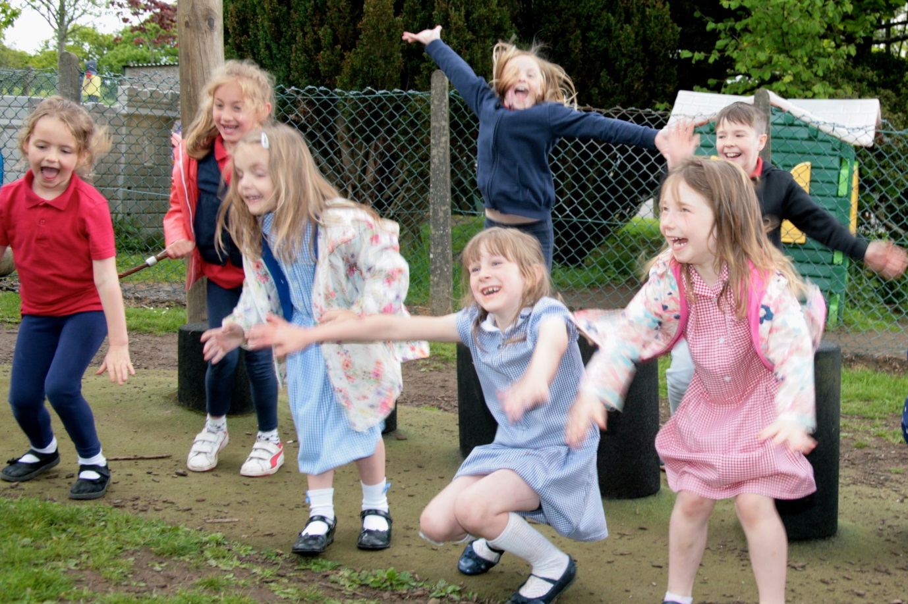

Academic Organisation September 2017
Classes:
Nursery – Mrs A Mills, Mrs S Dolbear and Mrs K Fairweather
Reception – Mrs Griffiths (Monday Thursday and Friday), Mrs J Hughes (Tuesday and Wednesday), Mrs Schocker and Mrs Jones
Y1 – Ms D Burn (Tuesday to Friday)/Mrs D Tidy (Monday), with Miss Webber and Miss Black
Y2 – Mrs Davies with Mrs Bowen
Y3 – Mrs Howard
Y4 – Mrs Bews (Monday, Tuesday and Friday)/Mrs Tidy (Wednesday and Thursday)
Y5 – Mr Kelleher
Y6 – Mr Webb
PPA – Mrs Kneath
Attendance Officer – Mrs McCredie

We have a Nursery classes and children who are 3 or 4 may attend. Children are eligible for fulltime Education in September of the school year in which they are 5. All classes are mixed gender and ability.

Areas of responsibility at Hendrefoilan
Mrs. A. Field Headteacher
Mrs. J Webb Deputy Headteacher, Teacher Year 6, Assessment, Maths
Mr. M. Kelleher ICT/DCF
Mrs C. Bews Y4, Science
Mrs. S. Howard Cross Curricular Literacy
Mrs. Mrs. C. Davies Additional Learning Needs, Expressive Arts
K. Griffiths Foundation Phase Leader, Language Literacy and Communication
Ms. D. Burn Foundation Phase Leader, Health and Wellbeing
Mrs. D. Tidy Teacher cover, Welsh and Curriculwm Cymreig
Mrs. J. Hughes Reception, Health and Safety
Mrs J Kneath Teacher planning preparation and assessment time
Mrs. A. Davies School Secretary
Mrs C Lingard Administrative and Organisational Assistant
Mrs. G. Bowen Teaching Assistant
Mrs. C. Coffey Teaching Assistant
Miss A. Webber Teaching Assistant
Miss C. Chapple Teaching Assistant
Mrs K. Fairweather Teaching Assistant
Miss M Morris Teaching Assistant
Mrs. I. Schocker Teaching Assistant
Mrs. J. McCreadie Teaching Assistant
Miss S Black Teaching Assistant
Mr. S Jones School Caretaker
Mrs. J. Stabler School Cook
Mrs. W. Deakin Kitchen Assistant
Mrs. R Rounak Lunchtime Supervisor
Mrs. K. Fairweather Lunchtime Supervisor
Mrs.S Roberts Lunchtime Supervisor
Mrs. S Dolbear Lunchtime Supervisor
Mrs V Rees Cleaner Supervisor
Mrs. H Worgan Cleaner
Mrs W Deakin School Crossing Patrol
Miss A. Webber Breakfast Club Supervisor
Mrs. B. Boorman Breakfast Club Supervisor
Mrs. K. Fairweather Breakfast Club Supervisor
Mr.C NcNaughton After School Club Manager
Miss. S Black After School Club Supervisor
Mr Matthew Ward After School Club Supervisor
Miss M Morris After School Club Supervisor

Some details about securing the safety and wellbeing of our pupils
Fire Safety:
- Assume the sound of a continuous bell is an actual fire alarm
- Fire exits – all ground floor classrooms/main entrance/ Infant & Junior (2) entrances/ Nursery/ classroom/ Junior Hall
- Fire Evacuation procedure displayed in the school
- Assembly point – “Top” Playground
- Class teachers to be present and to account for all children & inform Headteacher

Health and Safety Risks:
Hazards:
- Outside steps – hand rails available
- Steep path to Nursery/Reception (alternate route available)
- Risk Assessments – school activities (Class teachers)/ adventure playground/fire (HT)
- Safeguarding - Health and Safety related policies – staffroom/HT
- Site management hierarchy – HT/DHT/ class teachers/support staff (see Policy)
- Please report concerns to the Headteacher

DBS checks:
- For all staff members & volunteers working directly with children – DBS checks kept securely in school
- For all visitors unsupervised, working directly with children – Headteacher to have sight of current DBS check
- Visitors without a DBS must be escorted at all times.
Traffic Management:
- Authorised vehicles only to enter car park area.
- All vehicles to move at “Dead Slow” pace.
- Normally no parent cars are allowed in the school grounds
- Observe double yellow lines.
- Children MUST cross using the Zebra Crossing.
- Proceed only on road areas.
- Car parking Bays are clearly marked – please park carefully and with consideration for other

Site security
- Pupils are not permitted to open the doors to parents and visitors
- The pupil entrance doors are closed during lesson time
- The pupil entrance doors are left open at playtimes/lunchtimes for access to the toilet – the doors are kept under observation by the teacher on duty/midday supervisor
- The Nursery entrance door is kept open if pupils are outside – the door is kept under observation
- All visitors at playtimes/lunchtimes are approached by the office staff/Headteacher/midday supervisor
- Gates to the front steps in front of Year 1 classroom and top gates locked by 9.05am.
- Auxiliary and Catch up staff to be responsible for the closing (by 9.05 am) and opening (at 3.00 pm) of the school’s “Top Gates”.

Child Protection and Safeguarding Policy and Procedures
The School takes its responsibility for ensuring the safety and welfare of pupils very seriously. This includes taking appropriate action including a direct referral in the event of suspected child abuse or neglect.

The school has adopted and follows the procedures set out in the All Wales Child Protection Procedures 2008. This document provides:
- Clear definitions of child abuse and neglect;
- Agreed principles which underpin work to safeguard and promote the welfare of children;
- A detailed explanation of the child protection process;
- Clear guidance and inter-agency protocols for all stages of concern.

Copies of the All Wales Child Protection Procedures 2008 file are held in the Headteacher’s office. In addition to the Procedures file, the City and County of Swansea has produced an information leaflet specifically for school staff. This document: Child Protection Information and Guidance for Schools Notes for Staff is made available to all staff who work in the school. Copies of the leaflet are available in all classrooms and in the staff room. The guidelines are regularly brought to the attention of staff through training and are part of the school induction process for new permanent staff. Relief and temporary staff as well as volunteers are given a copy of the above leaflet during their own induction process.

The Headteacher, Mrs Aimee Field, is the school’s designated person with lead responsibility for dealing with child protection. In her absence the Deputy Head teacher, Mr John Webb, is the named person responsible for child protection. In the event the allegation is about the Headteacher, please contact Mrs Dorothy Bennett, Chair of Governors.

Arrangements for the General Welfare and Well Being of Pupils
Class teachers are responsible in the first instance for their pupils and oversee general progress and welfare. The Head teacher has overall responsibility and should any significant problem or changes occur these should be reported to her. If any changes occur at home that might affect progress or behaviour in school, you are asked to inform the class teacher and Head teacher as soon as possible so that a special eye can be kept on your child. Likewise, if you child appears unhappy at school or is having a particular difficulty with schoolwork, it is important that we know so that appropriate steps can be taken to remedy matters.

The Inclusion Co-ordinator, Mrs Davies is the person responsible for co-ordinating Looked After Children. Our first priority is your child’s welfare and therefore there may be occasions when our concern about your child means that we have to consult other agencies even before we contact you. The procedures we follow have been laid down by the All Wales Child Protection Procedures.

The Educational Welfare Officer visits school regularly and will always make a home visit to enquire about frequent or unexplained absence. If your child has been absent for any reason, you must explain his or her absence as soon as possible by speaking to class teachers, writing an absence note or telephoning the school secretary. We cannot accept an explanation from a child.

If your child is late arriving at school he /she must be signed in at the school office in order to receive a present mark. If you wish your child to leave early for an appointment, you must give a verbal explanation in person to the class teacher or send a letter of explanation. You will also need to sign your child out at the school office. If for any reason a different adult is collecting your child to usual, please let the school know.

Designated staff have received First Aid Training. If your child is taken ill or has an accident at school, a first-aider will, if possible, attend to him or her. We will always attempt to contact you in serious cases. If we fail to contact you, we will do all we can to help your child by taking him or her to a doctor or to hospital.

Admission procedures
The LA is the admissions body and decide on admissions to schools. They have set criteria which include catchment area, special needs and so on. Ideally all catchment area pupils would be admitted into their catchment primary school. Where there are more pupils than places, the LA decides on entry. Unsuccessful applications may be put forward for appeal. Details of these procedures are available from the school and /or the LA. If you wish to enrol your child at Hendrefoilan Primary School, you should firstly contact the Head teacher to ensure that there is sufficient space available as there is a working admission policy of a maximum of 30 pupils per age group.

Transfer to Secondary School
We believe that a clear understanding of the curricular and social needs of pupils can only be achieved if a partnership is established between the Head and Teachers at Hendrefoilan School and their colleagues at Olchfa School or other secondary schools. To this end, there are regular transition meetings, as well as pastoral and consultative meetings for the teachers involved. If transferring to Olchfa, the Y6 children from Hendrefoilan spend four days at Olchfa during the second half of the summer term; attend performances of school productions, and cluster competitions. Y5 children attend a Challenge Day at Olchfa together with the other feeder primary schools. During the school year, children may also have access to a wide range of facilities at Olchfa including science and computer facilities.
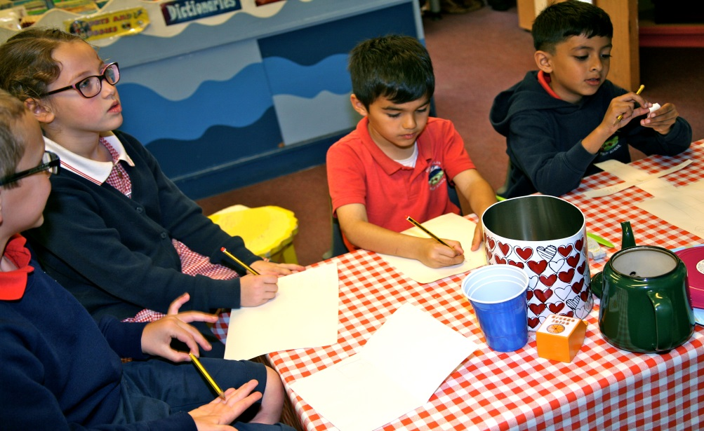

Nursery
This year, most children will be admitted to nursery the term after their 3rd birthday. Parents are encouraged to visit the nursery with their child prior to entry. This will allow the child to get accustomed to nursery life and will enable parents to see at first hand the quality provision offered at our nursery.

Reception Children – Parents of Reception Class pupils are required to apply for a place on-line, usually in the January before September entry. Prospective parents are invited to contact the school to arrange a visit during school hours, not only to see the Headteacher and staff, but also to sample the working atmosphere of the school. An admissions meeting for parents of children with statements of SEN will be set up to formalise details. This meeting will usually be attended by a member of the LA or Special Needs staff. Every possible effort will be made to ensure that the needs of children with impairments are considered at the admissions meeting. It is important that the school makes every effort to remove barriers (physical and attitudinal) so that impairment does not necessarily lead to disability.

Attendance
All schools must distinguish in their attendance registers between authorised and un-authorised absences of pupils of compulsory school age. Authorised (i.e. legal) absences cover: medical/dental appointments; educational visits; religious holidays and sickness. Parents are expected to contact the school and notify us about the nature of their child’s illness by 8.30am. The teacher needs to be informed in writing of the reason for absence, if this is not done, the absence has to be categorised as unauthorised. Unauthorised (i.e. illegal) absences are recorded and their rates will be published in annual reports and the school brochure. Please note any holidays taken during term time are unauthorised and a holiday form still needs to be completed. These are available from the school office.

Requests for children to stay in at playtimes are normally refused in the case of minor ailments. We feel that if a child is well enough to be in school they need the benefit of a fresh air break. The school places great emphasis on attendance and has an ambitious target of 96% attendance. For 2016/2017, our attendance was 95.1%. We have several strategies in place to encourage good attendance including prizes for 100% attendees and certificates. At primary level, good attendance depends foremost on a positive attitude by parents. At this young age, your children depend on you to get them to school regularly and on time. Please make sure your child attends school regularly.

In the case of absence, always send a letter or telephone the school on the day of absence, to explain the absence. Our registers are electronic and we record number of minutes late as well as absences. We contact parents if a child is not in school by 9.30 am.

Children who are substantially late, i.e. arriving at school after 9.30 am, will be marked as an unauthorised absence. Please make sure your child/children come to school on time.

All absence without explanation is unauthorised.

If your child is frequently absent the EWO (Education Welfare Officer) will pay a visit to your home.

Transport between home and school
Parents are responsible for transporting their children between home and school. Due to parking difficulties, we encourage as many parents/pupils as possible to walk to school.

School Security
The school has a secure entry system and a Health & Safety Team who undertake half-termly checks. We consider the security and health and safety of all adults and pupils of Hendrefoilan Primary School to be of the utmost importance. CCTV monitors the school entrance and other key areas.

School Development
The Senior Leadership Team (together with Governors) review policy, practice and standards, set targets for school improvement and monitor the progress of developmental plans. All staff are involved in the self-evaluation process. This year’s targets are:

Key Question 1 Standards | Key Question 2  Wellbeing and attitudes to learning | Key Question 3  Teaching and learning experiences | Key Question 4  Care, support and guidance | Key Question 5  Leadership and management
Develop pupils’ extended writing and numerical reasoning in everyday situations. | Improve whole school annual attendance. | All teachers adapt work to challenge all pupils.  Improve pupils’ ability to review and extend their own progress.  Introduce the digital competency framework. |  | Extend middle leadership to ensure strong leadership in line with Successful Futures.  Ensure that performance management objectives are closely aligned to individual pupil targets.  Introduce and monitor an afternoon nursery ‘wrap around’ service.

Early Years and Infant Education
At Hendrefoilan we aim to develop the whole child. We strongly support a multi-sensory experienced based approach, where children are encouraged to use all their senses to find out about the world around them. We endeavour to create a safe, healthy, caring, interesting environment for happy children. The children’s own language and cultures are valued. Between the ages of 3 and 6 children follow ‘The Foundation Phase Framework’ which has seven areas of learning and experience within it. These areas of learning are not discrete subject areas, but are integrated and over lapping areas of experience.

The seven areas of learning are language, literacy and communication; Welsh language development; mathematical development; personal and social development, well-being and cultural diversity; knowledge and understanding of the world; creative development and physical development. Developing the home/school link is vitally important in the Early Years and parents are encouraged to take an active part in their child’s learning and to discuss any concerns that they might have with teachers. Having set the foundations in Early Years we continue to build on the practical learning experiences as the children progress through Year Children still discover and develop through first hand involvement and master new skills that will help them prepare for future learning in Key Stage 2 (juniors).

Information about the National Curriculum
Throughout your child's school life, he or she will follow the National Curriculum. The National Curriculum is designed to provide a firm foundation in language, mathematics and science, and to provide children between the ages of 7 and 16 with the opportunity to achieve their best. Your child will follow the National Curriculum through three key areas of development of his or her compulsory school life in primary school. These are:
Foundation Phase
Key Stage 2
And Key Stage 3

The National Literacy and Numeracy framework (LNF)
The LNF provides a framework for understanding the progress learners make in developing and applying their literacy and numeracy skills. Through expectation statements, the LNF sets out the skills we expect learners to develop throughout their time in school, from ages 5 to 14, and is broken down into year groups. The literacy strands are: Oracy across the curriculum; reading across the curriculum; and writing across the curriculum. The numeracy strands are: Developing numerical reasoning; using number skills; using measuring skills and using data skills. At Hendrefoilan Primary School we integrate literacy and numeracy into our teaching at every opportunity. This helps learners with their own self-assessment activities gives teachers the opportunity to assess, monitor and report on individual learner performance. Tasks are differentiated to account for flexibility in learners’ current positions in literacy and numeracy skills development. Weekly problem-solving-based tasks allow learners to practise and demonstrate a number of elements/aspects within the same task.

The school is reforming its curricular organisation in line with the Successful Futures review of the Curriculum in Wales, by Professor Donaldson. The purpose of this review and reform is to encourage learners to be ambitious, enterprising, ethical and healthy individuals. The curriculum at Hendrefoilan is based on six areas of learning and experience:
- Expressive arts
- Health and well-being
- Humanities
- Languages, literacy and communication
- Mathematics and numeracy
- And science and technology

Assessment of Progress
Teachers plan with assessment in mind. Initially, your child will be assessed on entry. During each school year every pupil will be assessed against National Curriculum criteria. At the end of the Foundation Phase (Year 2) and Key Stage 2 (Year 6) National Curriculum assessments will be carried out as well as National Tests for Y2 to Y6 in Reading and Numeracy (Procedural and Reasoning). In addition, the school uses standardised NFER tests in Reception and Y1 and operates a ‘tracking’ system to monitor progress. All parents are encouraged to work in close co-operation with the school. Regular Parent Teacher consultations are held for parents to be informed of children’s progress and targets.

However, such basic information in the form of tables, derived from brief tests, which measure only a small part of total school life, may not be the best indicators of a successful, or even an unsuccessful school. It does not indicate the progress that your child has made since starting at Hendrefoilan Primary School. In our opinion, the best information concerning your child's attainment and achievement can be had from your child and your child's teacher and we would urge you to talk to both of them to find out how your child is doing. Should you wish to discuss the data, please do not hesitate to contact the Headteacher.

Target Setting
Targets for pupil attainments are incorporated into the annual School Development Plan, published during the Spring Term. Progress in meeting these targets is published in the Governing Body's Annual Report to Parents, published in the Autumn Term each year. In the latest available assessment information (2017), the percentage of children achieving the Foundation Phase Indicator in 2017 is 89%. In Key Stage 2, the percentage of children achieving the Core Subject Indicator is 91%.

We consider all children have a bright future and therefore encourage every child to work to their potential and to experience success in some aspect of the school's life. We build into our teaching a continuous process of evaluation and development. We try to learn as much as we can about each individual child's needs and use that understanding for more effective teaching and learning. Every one of our children has 'Individual Targets for Learning ' which set out his/her most important targets in all areas of the curriculum, especially in English and Maths. These are devised with the child and shared with parents.

The General School Curriculum
The school operates a broad skills based curriculum, (using the National Curriculum 2008 framework) which develops the child’s knowledge, skills and experiences. The emphasis will be on developing key skills in Literacy and Numeracy, ICT and Thinking. ‘Cwricwlwm Cymreig’ and Personal and Social Education features greatly in cross-curricular activities. Subjects are taught through themes or topics, and an experiential, child centred approach is favoured. Great emphasis is placed on mastery of all core subjects, Maths, English, Science, ICT, and when necessary, subjects are taught discretely to individuals, groups or whole classes. The work that we plan for your child is designed to meet his/her particular needs with the requirements of the Foundation Phase/National Curriculum in mind. We try to be sympathetic to the needs of individuals.

Our record keeping and methods of assessment are geared to checking on your child's progress through the Foundation Phase/National Curriculum. We are committed to developing basic skills at all levels to ensure all pupils are numerate and literate as these are the foundations for all other learning. We believe that children learn in a variety of ways - from their teacher, from each other, by discovery and particularly through their senses. Our lessons are designed to provide your child with a wide range of experiences to stimulate those senses. The emphasis will be on practical tasks, enquiry based activities, visits and discussion so that children will have lots of first-hand experience and plenty of opportunities to lead their own learning.

Your child will be expected to work independently but also encouraged to work co-operatively with other children. Our teaching will emphasise the need to respect and understand fellow pupils regardless of colour, religion, race or gender. Teachers plan conscientiously and appropriately to ensure that all children receive an appropriate and challenging curriculum.

Sports Activities
Our school has excellent grounds and we have a large pitch and a hard court. We also have a large hall. There is a wide range of sports activities undertaken during the year where children represent the school. These include swimming, football, cricket, netball, tennis, rounders, gymnastics, dance, athletics and cross-country. The school has a successful tradition of participation in sporting events, both at an individual and team level. Pupils receive 2 hours of Physical Education (PE) per week. Any child taking part represents the school and this is recognised as a privilege equal to academic and artistic achievement. It also fosters team spirit and the development of skills. We aim to give children of all abilities the opportunity to participate in competitive events. In PE children are expected to wear shorts, t-shirt and gym shoes (not heavy trainers).

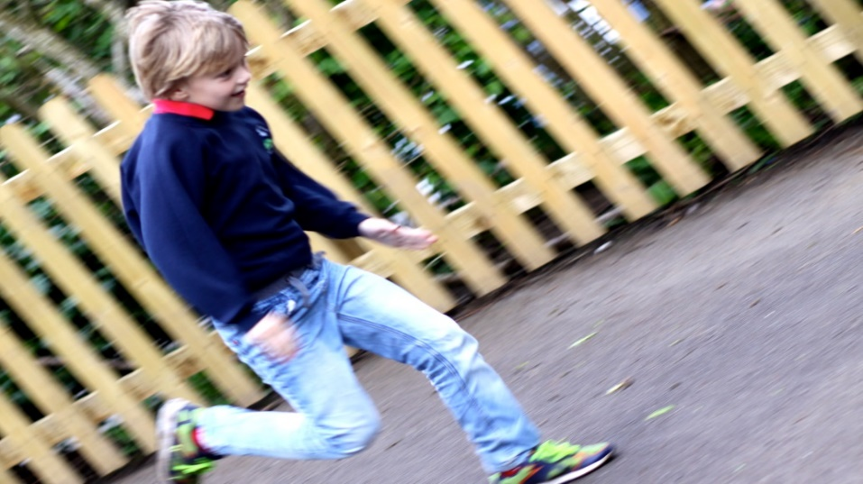
Religious Education and Collective Worship
The school teaches R.E. according to the agreed syllabus and brings aspects of various religions into themes taught. An assembly is held daily and is based on Christian principles. Staff, children and community persons all contribute to our assembly programme. We believe contact with faiths and cultures is essential for your children to grow up together as tolerant friends. Therefore, there is often a multicultural element to R.E. and Assembly. Assembly is a particularly important meeting point during the day when we share our faith, our prayers and our news. You have the right to withdraw your children from R.E. and Assembly if you wish, but we hope that you will not find it necessary. Religious Education in the school follows the course of study set out in the Education Reform Act 1988 that aims to develop knowledge of Christianity and an awareness of other world religions.

Arrangements for the teaching of Welsh
Welsh is taught as a second language from Nursery age. The National Curriculum requires certain levels of competence in writing and reading Welsh, which children will be expected to attain by Year 6. It is the school's aim to use the Welsh language in such a way as to ensure that children see, hear and use it as a natural part of school life. It is given a prominent role in many school activities. Children also have an opportunity to learn about the culture and heritage, as well as the language of Wales, through such activities as St. David's Day celebrations. Our teaching of Welsh is supported by the LA’s team of peripatetic Welsh teachers', 'Athrawon Bro', who visit the school once a fortnight to work alongside teachers and pupils in promoting the Welsh Language. Teachers undertake relevant training to do this. None of our pupils have Welsh as a first language in the home.

Children who have English as an Additional Language - E.A.L.
Hendrefoilan is proud of its diverse make up, as we believe this adds to the richness of the learning experience in the school. Our everyday teaching is delivered through the medium of English but the school works in partnership with the LA’s EMAU Service and can access when necessary, teachers who are expert in teaching children who have English as an additional language, to support equal opportunity for pupils and assist pupils to reach their full potential.

ICT – Information Communication Technology and the Digital Competency Framework (DCF)
Our children are growing up in an ever-changing world with evermore-fantastic technological developments. Therefore, we believe that it is our duty to equip our pupils with ICT skills that they can use to explore the world they live in and make best use of the equipment that is available to them. To enable us to do this we have a computer suite and 30 iPads, with direct, but protected, access to the internet. Each classroom has an Interactive Whiteboard and access to networked computers, which has in our experience generated increased interest in the lessons themselves and raised standards of teaching and learning as pupils are actively encouraged to show what they know and can do. Children are also encouraged to use iPads to record and report what they are doing to a variety of audiences. As new technology becomes available the school and its staff strive to maintain their level of knowledge in order to make the best use of the new advances and to pass on that knowledge to the children. We have our own website, so please visit us at:
https://hendrefoilan-primary-school1.j2webby.com/
Personal and Social Education (PSE)
The School follows National Guidelines on PSE. Topics include: citizenship, moral attitudes, social considerations, emotions, responsibility, drugs and sex education.
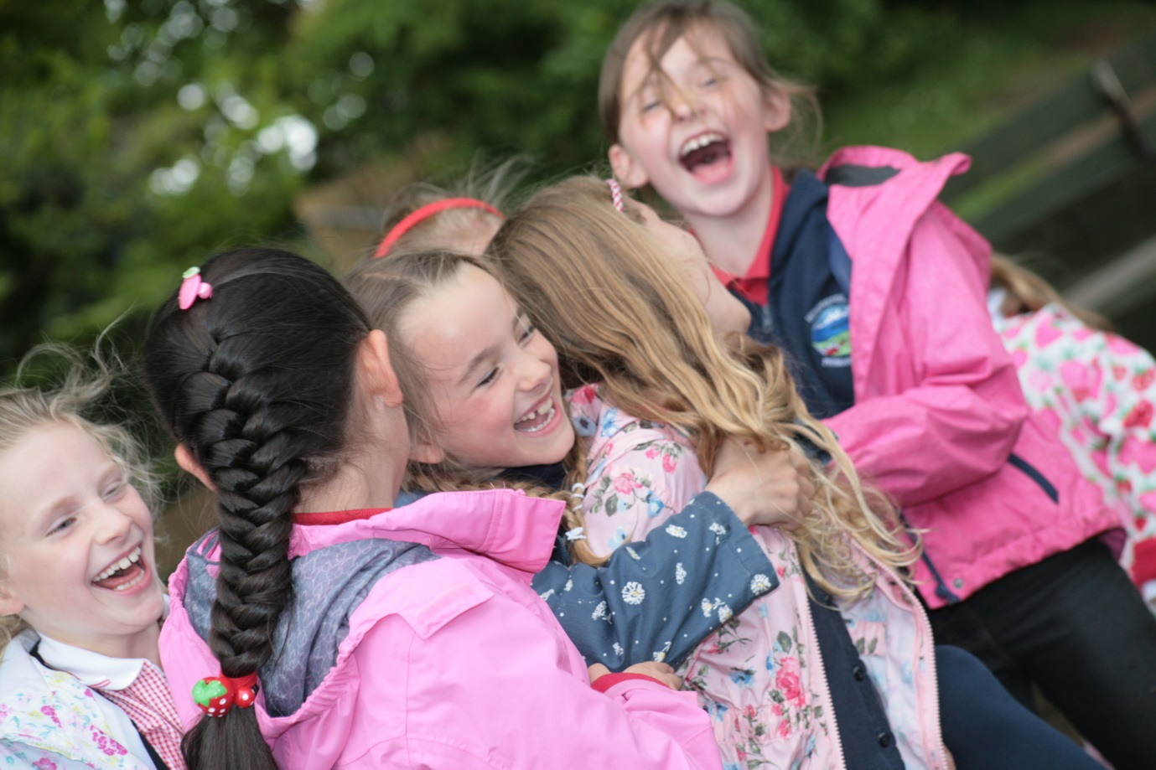

Pastoral Care/ Well-being
The school aims to have a caring, healthy, happy and secure atmosphere. Where necessary, and with the permission of the parents, the school liaises with other caring agencies. There is a close co-operation at all times with Olchfa Comprehensive and other secondary schools. The class teacher is responsible to the Headteacher for the general care of your child. The children are encouraged to become aware of themselves and develop a positive and responsible attitude to their work and play, and to develop a caring concern for the needs of others.

When a child is taken ill at school, every attempt is made to contact the parents as soon as possible. Minor accidents are dealt with promptly by members of staff, teaching assistants, or the supervisory assistants depending upon the time of the mishap. Should further medical attentions be required, the parent is notified, and requested to accompany the child. If the parent cannot be contacted, a member of staff will escort the child to the hospital, whilst further attempts to contact the parents are made. (This will be carried out only under the authorisation of the Headteacher or her appointed representatives).

Regular contact is maintained between the school, the Educational Welfare, and School’s Psychological Services. During morning and afternoon break, children are supervised in the playground by teachers and authorised teaching assistants; at lunchtime children who remain in school are looked after by the supervisory assistants.

Arrangements for Children with Additional Learning Needs
Consideration of children’s additional learning needs forms an important part of school life. All children are special and as such they all deserve the help and support we can give them. In addition to the educational needs of more able and talented and slow learning children, many other difficulties are catered for including physical, social or behavioural problems. The school works in partnership with the speech and language therapist who visits each term.

All children with special educational needs are placed on the Special Educational Needs List and parents are informed and involved from the outset as we know from experience that the sooner we all work as a team the sooner the children start to make better progress . We have staff trained to identify pupils with speech and language difficulties and deliver a programme of work. We have established excellent working partnerships with outside agencies such as Exchange Counselling Service, Occupational Health, Child & Family Services and Educational Psychologist. The school’s SENCO, works in partnership with one teaching assistant and with every class teacher to help improve pupils’ learning, in a variety of ways. The team works with some of the children in the classroom supporting curriculum work, but where necessary, children are withdrawn to work in a quiet place, on a specific reading, mathematical or language task.

The Headteacher is an Associate Member of the British Dyslexia Association and can administer testing. We have trained teaching assistants who are able to support pupils identified as having speech and language concerns. All staff are trained in cognitive behavioural therapy and we have teaching assistants trained in Makaton sign language.

Parents are always made very welcome - your co-operation is actively encouraged and sought after, particularly if your child is experiencing difficulties of any kind. We will make time available for you to come and discuss ways that you can give your child extra support. Hendrefoilan is a fully inclusive school. Should you or child have any disabilities or specific needs we will endeavour to address them. A copy of the school’s Special Needs Policy can be obtained from the School Office.

We are able to admit disabled pupils to mainstream classes where they can be offered full access to the curriculum. The children will also be given appropriate curriculum and sensory input to suit their own individual needs. The whole school is wheelchair accessible with appropriate toilet facilities.

Sex Education
Following the guidance of the Education Reform Act 1988, Governors and staff have decided that Sex Education should be included in the school curriculum within a carefully planned Health Education Programme. This forms part of the broader spectrum of Personal and Social Education, which takes account of the needs of pupils as they develop and mature through the years of compulsory schooling. Other aspects which often arise are taught in an integrated way through themes and topics. The children will follow activities in science which will develop knowledge and understanding of the organization of living things and of the processes which characterize their survival and reproduction. The teaching staff will deal with any question in a factual and sensitive manner. Parents are requested to make an appointment with the school if they wish to view the teaching materials we use in the classroom. Parents also have the right to withdraw their children from part of the Sex Education provided. This preference should be made in writing to the Headteacher, but we hope this will not be necessary.

Homework
There has been a great deal of research published in recent months that supports the view that children who regularly do homework, achieve significantly higher results in basic literacy and numeracy, than those who don’t. In the light of this, we are reviewing our homework policy, which in future will include the following elements:

Home Reading: It is impossible to stress strongly enough, how important this is. Your child will have a Home Reading book and a record book to accompany this. Please set aside at least 10 minutes every day to sit with your child to hear him/her read. It is essential that it should be an enjoyable experience that is a regular part of your child’s daily routine.

Spelling / Tables Practice: Children will be expected to learn tables and spelling work when set. You may feel that some words are quite difficult. Don’t be put off, your child will often find these “difficult” words interesting - they will certainly be relevant to the work going on in the classroom - and therefore will be motivated to learn and remember them, using the Look, Cover, Say, Write, Check method practised at school - if you are unsure of how this system works, please ask your child’s class teacher.

Maths: Some activities are for practice and some are meant to get the children to think, but they are all meant to be enjoyable. You do not have to teach any maths - just join in when your child needs a partner to work with.

English / Topic Work: From time to time, your child’s class teacher will give a topic for home research. This will support work going on in school and is an ideal opportunity for your child to “pick your brains”, visit the library or local sites if appropriate - and will give a valuable opportunity for home involvement. Alternatively, a whole class project book for creative writing may be sent home for your child’s contribution.

Homework is also an opportunity for children to access information using I.C.T. (Information Communication Technology) for example, researching information on the internet.

Breakfast Club / Extra Curricular Activities
The school encourages pupil involvement in a range of extra-curricular activities, which are organized and run on a voluntary basis by staff and parents. There are a variety of activities available to the children during their schooling. These include visits of educational interest, choir, chess, dance, gardening, Eco, flute, brass, rugby and football. They may vary from year to year, depending on the interest and talents of the staff, parents and pupils. Extra-curricular music is offered by the music coordinator and the peripatetic music teacher. Instrumental tuition is offered for violin, brass, flute and clarinet. In addition, children from the school take part in sports matches, athletics meetings, fund raising events for various charities, drama and musical performances for parents and the community.

We offer two major out of school hours services. These are: Breakfast Club. The school operates an early bird Breakfast club which runs from 8 am to 8.20 am. We also have a Breakfast Club for Nursery to Year 6 pupils. The club starts at 8.20 am and finishes at 8:50am each weekday during term time at a cost of £1.50 per child per day. Pupils attending the club must receive a breakfast and will be supervised and dismissed to their respective classes at 8:50am. Pupils have to register by 8.30am and will be able to play and socialise once they have finished their breakfast.

After School Club
Qualified staff run this club from the end of school to 5.15 p.m. Mr Craig McNaughton is the ASC manager. Please contact him via the school office. This club provides a snack and a drink and offers pupils various activities as well as providing quiet areas for completing homework etc. The fee for this service is £5.00 per session. Please contact the school for further details.

Morning Healthy Tuck Shop
There is a fruit Tuck Shop for all pupils led by Y5/6 pupils, which sell a range of fruit every morning break time. Free milk is available for all pupils from nursery to Y2.

Lunchtime Arrangements
School meals are provided for all full-time pupils at the cost laid down by the Local Authority. Cooked meals are prepared on site and a vegetarian option is offered. A salad bar is available daily. Pupils are encouraged to try new foods offered and ensure they make healthy choices according to advice given on the ‘Eat Well Plate’ which is clearly displayed in our school dining hall. A menu is available from the school office. Dinner money is paid via Sqjuid (£2.25 per day). You will be provided with unique log in details by the school office staff. Provision is also made for those pupils who wish to bring a packed lunch. The organisation of school meals, particularly the supervision of the children, is a difficult exercise and the success of the work depends entirely on the close cooperation between the teacher on duty, kitchen staff, lunchtime supervisors, children and their parents. We encourage independence and good behaviour at lunch times.

Water Bottles
Pupils are encouraged to drink two bottles of water a day as part of a healthy lifestyle. Pupils can purchase a plastic water bottle and are expected to fill these at home and can then be topped up during break times from the water fountains situated around the school. Please ensure your child’s name is clearly marked on the bottle.

Toilet Facilities
The school recognises that well-maintained toilet facilities where learners feel comfortable and safe and have open access to throughout the school day, are essential for health, well-being, and learning and we plan to develop our facilities in a programme of school improvement. They are suitable for the range of anticipated users, including learners with disabilities and special needs, with adequate lighting, sanitary disposal, fixtures and fittings.

Playground Buddies
Children in Year 6 are chosen to become Playground Buddies. These children are trained in helping younger children to play together, being peer mediators and fostering good friendships. There is a range of equipment available for pupils to play with during lunchtimes. The yards are separated into different zones to cater for a range of activities.

School Council
We strongly believe in involving the children in all areas of school life so that they become part of the education process. We want children to be an integral part of the school and intensely proud of it. In order to give pupils a clear voice we have established an active and effective Eco school council. We see the council as a way for the children to influence whole school matters that are important to them. Each class elects two representatives and the council sits monthly to discuss agenda items. The council have been involved in meaningful projects that have included formulating the school vision and improving the schoolyards, and even interviewing candidates for the Headteacher post. The children have shown themselves to be more than capable in their role as councillor.

The children’s representatives have highly original ideas and perceptions that often cut straight to the problem and offer simple and effective solutions. The school works with charities that promote active citizenship such as ChildLine, Zac’s Place (Homeless Hostel) and the Samaritans Purse. Pupils and parents are encouraged to become aware of local, national and global issues faced by children.

We promote a sense of community and respect. Hendrefoilan School pupils are encouraged to be active and informed citizens who look after their school local community and beyond to develop a positive future for all. Children have a variety of roles – Buddies, Hendrefoilan Happy Helpers and Eco Council. Children take their responsibility very seriously and show commitment for the good of our school. These activities develop children’s sense of wellbeing as they focus on needs of others around them and their relationship with those around them.

Parents meeting with the Governing Body
The Schools Standards and Organisation (Wales) Act 2013 (The Act) removed the requirement for school governing bodies to hold an annual meeting with parents. Instead, new arrangements were introduced to enable parents to request up to three meetings in any school year with a governing body, on matters which are of concern to them. At Hendrefoilan Primary School, the Governing Body will continue to produce an annual written report to parents and provide a general meeting for parents with Governors to present the report. The Governing Body will also continue to communicate and engage with parents over the school year via newsletters, twitter notices or surveys as necessary. Governors may call an extra parents’ meeting if they believe that an issue, which affects the school, needs to be discussed.

We operate an Open Door policy and parents are encouraged to contact the school office and make an appointment with the class teacher or Headteacher to discuss any issues.

Hendrefoilan Primary has a complaints policy and procedure in place; copies can be obtained from the school office or our school website.

Parents, Volunteers and the School
At Hendrefoilan Primary School, we see the partnership between the parents and teachers as being of paramount importance. Therefore, parents are welcome in the school at any time. However, if the school is in session please appreciate that it is impossible for a teacher to leave the class unattended to be involved in detailed discussion about an individual child. Therefore, we ask you to phone or visit should you wish to discuss your child, and an appointment will be made for you. The partnership between parents and the school is evolving in a variety of ways, both on a professional and social level. On a professional level, every effort will be made to keep you informed as to what we are doing in school to educate your child via Parent Consultation, our school website and information/newsletters.

Parent consultations are held twice a year to give parents an opportunity to see work and discuss progress. Children set great store by their parents attending these sessions. Please make every effort to attend (N.B. alternative arrangements can be made if necessary and we endeavour to provide translators at these meetings if required). We are always seeking parent helpers. Should you feel you could help in any way, please contact your child’s teacher, as your support is invaluable. If you are able to spare some time, we would be very pleased to hear from you.

The ‘Friends of Hendrefoilan Primary’
‘I am sure that all parents are aware of the financial burdens that the school faces on a day-to-day basis. The consequences of which are that the extra, and often essential, equipment that is required for the children are not affordable from the limited budget available. The role of the PTA is to work very closely with both parents and school staff in order to provide financial assistance towards the purchase, or maintenance of equipment.

This is achieved by organising social and fund raising events from which the proceeds help to supplement the school's budget. The primary objective of the PTA is to promote and support the environment that our children are being educated in. We are therefore reliant on you, the parents, for our success, and I therefore invite you to attend any of the regular PTA meetings in the future.’

Kind Regards – Mrs Jenny Brisley, Chair of the PTA

Hendrefoilan PTA is a properly constituted body of, as the name suggests, parents, other family members and teachers. It has been in existence for a number of years. A committee of parents and teachers is elected at the A.G.M., which is usually held during the Autumn Term. A considerable amount of money has been raised for the school in recent years that has been of great benefit to pupils. New faces and new ideas are always needed. You will be made most welcome if you are able to come along to events or meetings. Please search and join our facebook page – Hendrefoilan PTA, for more information and regular updates.

Car Parking
Due to the considerable danger of traffic, servicing the school, parked cars or entering the school site for dropping off creates a hazard for which the Education Authority cannot accept any responsibility in cases of accidents. Parents are therefore asked not to enter the school site by car and to ensure by example that children exercise caution when entering and leaving the school in order to prevent a serious or even possibly fatal accident. Parents are asked not to park/drop off/pick up on the yellow lines outside the school gates.

Medical
If your child is unwell and unable to remain in school, you will be informed. Please make sure that we have your current contact telephone number as it prevents problems should we need to contact you. Please inform us of any allergies that your child may suffer from. We receive numerous requests to administer medicine to children. Swansea County Council recommends that only prescribed medicines be given (no drops, injections etc.) We cannot administer these medicines without your authority, so please use the form provided at the end of the brochure or ask in the office for a spare form. All medicines will be stored safely and should be clearly labelled with the name and class of child. (Ventolin inhalers will be kept in the classroom with the child concerned – please ensure that the inhaler is clearly labelled and an asthma card is completed).

It is the parent’s responsibility to ensure the medication is in date.

School Health Nurse Service
The School Health Nurse Service provides education, support, advice and assistance in all issues related to health and public health for school-aged children and the wider school community. They will work closely with school to provide evidence based sessions in the classroom in line with the PSE & SRE curriculum. School Nurses are also available to discuss and advise on a 1:1 basis if appropriate.

Head lice
This is a community problem that does manifest itself in school life from time to time. Details for dealing with head lice can be obtained from the school or from your local health centre. If your child is found to have head lice the school will contact you and you will be asked to collect your child for immediate treatment. Please note it is sometimes necessary for further treatment because eggs can take up to 7 days to hatch. This action is necessary to protect other pupils.

Careers Education and Work Experience
Wherever possible and appropriate, personnel from Industry, commerce and the services will contribute to pupils’ learning experiences through cross-curricular work topics. Hendrefoilan Primary School also works in partnership with Olchfa Secondary School< Barclays Bank and the Gower College Literacy Co-ordinator. The school also enjoys partnerships with Swansea University, Swansea Metropolitan University and Swansea College and offers placements and training to student teachers, child-care trainees and student nurses.

School Uniform
There is a school uniform, which though not compulsory, is actively encouraged. Children are also expected to wear their uniforms at special school functions or when representing the school. Our school uniform consists of: navy sweatshirts/cardigans/hooded sweatshirts embroidered with the school logo. red polo shirts embroidered with the school logo. (All the above are available from J and S Supplies in Tycoch square, Swansea) A white shirt / blouse, grey/black trousers / skirt can be worn with the above. Red striped / check dresses can be worn in the summer. Please note that jewellery other than watches and stud earrings should not be worn. If jewellery is believed to be a danger to your child or to others they will be asked to remove it immediately. Please help us by not sending your child with chains and rings, whilst they may look pretty in school they are a health risk.

Lost Property
Please ensure that your child’s clothing and personal possessions are named. We frequently end up with numerous items that are never claimed. Please ensure lunch boxes are also clearly labelled with your child’s name. Children are provided with all equipment needed for use at school and each item is marked with the pupil's name. If items of school property are lost or deliberately damaged, parents will be asked to pay for replacements. We ask parents of pupils in KS2 (Juniors) to provide their children with equipment. The equipment list can be found on the school website.

School Rules and Discipline
Every community needs clear, enforceable rules in order to protect people and property and to ensure an efficient organisation. School rules are kept to a minimum and are very simple, based mainly on the moral education stressed through the whole curriculum, emphasizing care, concern, politeness, obedience, respect, honesty, between pupil and pupil, pupil and teacher, pupil and all other persons connected with the school. School rules were devised by teachers and pupils. A copy of these rules and the school’s policy is available on request and on the website along with the Behaviour Policy. We believe in positive behaviour management and in order to reinforce acceptable standards of behaviour, a merit system is in place involving awards in assembly, golden table and the Brilliant Blue book. Should your child receive a merit award for academic achievement, good behaviour, etc. please be lavish them with your praise

Parents may be invited to school to discuss their children’s behaviour, particularly if it is of a disruptive nature or means that because of bad behaviour the child is under-achieving. Fortunately, most pupils at our school show a caring, responsible attitude, particularly the Upper Juniors who now share a monitoring role with the staff as Hendrefoilan Happy Helpers. They understand, for example, that behaviour such as bullying and racism are not tolerated. Failure to comply with these standards results in a withdrawal of privileges which is the chief method of punishment. In exceptional cases, suspension will be considered.

Equal Opportunities
Discrimination based on creed, colour, culture, origin, gender and ability is unacceptable in our school. Every person in school will contribute towards a happy, healthy and caring environment by showing respect for and appreciation of each other, as individuals. All staff will practise an equal opportunities philosophy that is in line with the City and County of Swansea’s Equal Opportunities Policy and the Equality Act 2010. Promote the principles of fairness and justice for all through the education that we provide in our school. We ensure that all pupils have equal access to the full range of educational opportunities provided by the school.

Disability Equality
The school has a duty under the Disability Discrimination Act to collect information on any disability your child or immediate family/carer may have. This is to ensure the school can seek to meet your individual needs. All information provided will be treated with the strictest confidence.

The school’s Accessibility Plan is part of our SEP (School Equality Plan) is reviewed every three years or sooner if necessary and a copy can be obtained from the school office.

Race Equality
It is the right of all pupils to receive the best education the school can provide, with access to all educational activities organised by the school. We do not tolerate any forms of racial harassment which includes racist name calling, racist caricature based on prejudice, the stirring of racial hatred and the drawing or writing of racist materials. We are committed to combating racial discrimination and racial harassment by challenging stereotyping and prejudice whenever it occurs. We endeavour to make the school a welcoming place for all ethnic and national groups represented in the community including travellers, asylum seekers and refugees. Children are encouraged to be aware of what racism means through the Citizenship programme and are encouraged to report incidents where there is the suspicion of racism. We ensure that all recruitment, employment, promotion and training system are fair to all, and provide opportunities for everyone to achieve.

We constantly strive to remove any forms of indirect discrimination that may form barriers to learning, for example by ensuring that book resources reflect a diverse society and do not contain negative images.

How will the school deal with bullying or racist incidents?
Should an incident occur, we will act immediately to prevent any repetition of the incident as follows:
• The head or deputy head teacher will deal with the matter:
• If the incident happens at lunchtime, the children involved will be kept apart from each other, the allegation logged, and a report made immediately by the senior midday supervisor to the head or deputy for full investigation.
• The incident will be reported in the incident file.
• All persons concerned with the incident will be interviewed.
• No excuse will be accepted for a racist action whatever the provocation.
• If the case is found proven against the child, the child will be warned as to future conduct, will be punished in an appropriate manner and the incident logged.
• Parents will be informed by phone. A second incident will result in the parents of the offending child being informed in writing.
• A third incident will result in exclusion, dependent upon the time lapse between the first and third incident.

Wherever there is a pattern of unacceptable behaviour, pupils will be disciplined. In serious cases, parents will be called to the school and will be expected to co-operate with the school in enforcing acceptable standards of behaviour. The ultimate sanction is a period of suspension of a pupil by the Headteacher, which is permanently recorded in the School Log Book and reported to the School Governors and LA.

Complaints Procedure
If you have, a complaint under Section 23 of the Education Reform Act (relating to the Curriculum, Religious Education or Religious Worship) the LA has prepared a Formal Complaints Procedure, a copy of which is available from the School, the Education Department or the school website. In the event of any complaint, you should first try to resolve the matter by making an appointment to discuss the matter with the Headteacher.

Meeting with staff
Meetings with teachers, the Deputy Headteacher and Headteacher are by appointment only. If you wish to make an appointment, please contact the main school office on 290223. It is school policy for pupils to be taken into the school, from school lines, by the teachers. Parents and visitors must be signed in at the school office.

School Visits / Visitors
Children enjoy visiting places and learn much from first hand experiences. We have an extensive programme of educational visits and visitors to our school linked to different areas of the curriculum. Parent consent is required for a pupil to participate in an off-site visit. We are not allowed to charge directly, but may request a voluntary contribution, towards the cost. Parents experiencing difficulty in meeting costs are always welcome to approach the Headteacher; you may be assured that strict confidentiality will be observed. We organise a residential visit for Y6 pupils each year; Stout Hall, Careg Adventure Activity Centre. This provides excellent opportunities for studies of areas of contrast. If you are in receipt of ‘Free School Meals’ you may be entitled to financial assistance.

Inspection of Documents
Documents required to be made available by Regulation may be inspected and, where appropriate, copied at the school during school hours by arrangement with the Headteacher.

Recognition of School Achievement
In recognition of achievement and excellent standards in both Basic Skills and in supporting staff in carrying out their jobs and provide the highest levels of teaching and learning, the school has been awarded the nationally recognised Basic Skills Quality Mark. We have been granted National Healthy School Phase 4 Award, which indicates our commitment to the Healthy Schools Scheme for the past 12 years. We are a Platinum Eco Green Flag school and have International Links with schools in Catalonia. We regularly perform in the local Olchfa Choir Competition, Killay Precinct and St Hilary’s Church Killay and have a successful record of accomplishment in recitation, choir, dance and playing musical instruments. We have a level 1 Rights Respecting School Award.

Finally, Hendrefoilan Primary School is a lively, busy and exciting school. We have very committed school staff who work terrifically hard to provide the very best. We are working hard to provide a happy, successful, all-round education for the children in our care, one that caters for their individual needs and enables them to fulfil their potential. We look forward to a long and successful partnership with you and your children in the years to come. We are delighted to have your family with us. We hope you will all be happy in our school.

School Term & Holiday Dates 2016/2017

Term | Term begins | Term ends | Mid-term holiday |  | Term begins | Term ends | Total days
 |  |  | Begins | Ends
Autumn 2017 | Monday  4 September | Friday  27 October | Monday  30 October | Friday  3 November | Monday  6 November | Friday  22 December
 | 40 |  |  |  | 35 |  | 75
Spring 2018 | Monday  8 January | Friday  16 February | Monday  19 February | Friday  23 February | Monday  26 February | Thursday  29 March
 | 30 |  |  |  | 24 |  | 54
Summer 2018 | Monday  16 April | Friday  25 May | Monday  28 May | Friday  1 June | Monday  4 June | Tuesday  24 July
 | 29 |  |  |  | 37 |  | 66
Total: |  |  |  |  |  |  | 195

Bank holidays
- 30 March 2018 - Good Friday
- 2 April 2018 - Easter Monday
- 7 May 2018 - May Day
- 28 May 2018 - Spring Bank Holiday

Appendix 1 – Estyn Follow up Report (Estyn, May 2017)
“The school has introduced a structured whole-school writing programme to improve pupils’ extended writing which teachers follow carefully and with enthusiasm. As a result, most pupils' ability to write extended pieces has improved since the core inspection. Leaders scrutinise pupils’ books regularly to evaluate progress in developing pupils’ extended writing skills across the curriculum. Most teachers identify more opportunities for pupils to apply their numeracy skills across the curriculum. Consequently, nearly all pupils have a better understanding of how to use number skills to solve problems.”

“When comparing attendance to similar schools, the school has remained in the lower 50 % for three out of the last four years. However, the school has improved its systems for tackling non-attendance. As a result, it has raised attendance to just above 95% two years in succession. The school has achieved improvements in pupils’ attendance by implementing a new policy in April 2016, through the governors monitoring attendance figures regularly as part of their termly meetings and by raising pupils’ understanding of why it is important to attend school. It has introduced rewards for the class and for individual pupils who attain the highest attendance each week and each term.”

“The school has worked hard to improve parents’ understanding of the importance of pupils’ regular attendance at school through various communications, including newsletters. This includes regular publication of school and class attendance figures to highlight progress.”

“Attendance officers monitor pupils’ attendance diligently and they follow up pupils’ absence with parents immediately if pupils do not attend school without a reason. They liaise effectively with external agencies where a pupil’s absence is an on-going problem. They monitor registers regularly to ensure teachers use the appropriate codes consistently and that the registers are in line with statutory requirements.”

“Nearly all parents now comply with the school’s attendance requirements and they seek the headteacher’s permission before taking their child out of school for a holiday. However, a very few parents continue to take their child on holiday without the headteacher’s permission. In these cases, the school works effectively with the Educational Welfare Officer to liaise with parents.”

“Most teachers use a suitable range of strategies to meet the different needs and abilities of pupils in their classes. In many lessons, teachers use questioning effectively to develop pupils’ skills at an appropriate level, for example to extend their thinking in mathematics. Whole-school training and involvement in moderation activities has improved all teachers’ understanding of pupil outcomes. Teachers analyse the progress of specific groups of pupils with greater accuracy and set appropriate targets that take good account of pupils’ prior achievement.”

“The school has developed a comprehensive assessment for learning policy as a result of quality professional learning and school to school support. Discussions with a small sample of pupils show that teachers implement the identified strategies consistently in the core subjects in most year groups. Most teachers use success criteria consistently to support learning in English. In the best examples, success criteria are used confidently by pupils to accurately review their own and others’ progress.”

“Pupils’ use of the ‘traffic lights’ system to evaluate their performance is used consistently throughout the school. However, teachers do not always ask pupils to explain the reasoning for their evaluation and it is not always clear why the pupil has chosen a particular colour to represent their assessment. Nearly all pupils use teachers’ comments well to help them improve their learning. The introduction of the ‘think bubble’ strategy to pose a question to further develop thinking and understanding helps most pupils to extend their learning effectively.”

“The introduction of specific times in the school day for pupils to reflect and act on teachers’ comments is effective in helping pupils to improve their work and meet their targets. Opportunities for pupils to take a lead on how and what they learn are increasing. Most pupils reflect that ‘Chilli Challenges’ allow them to extend their learning.”

“The school has a member of staff and nominated a link governor with appropriate knowledge and training to lead on health and safety. The member of staff and nominated governor meet fortnightly. They have worked effectively to revise health and safety policies, protocols and risk assessments. Health and safety is now a standing item on governing body meetings.”

“The headteacher has undertaken a range of important and useful training, including for managing risks, managing accidents and supporting employee wellbeing. Staff have received training in food hygiene and first aid. The school has improved the process of accident reporting. Risks are reviewed regularly and reduced as much as possible. For example, the nominated health and safety personnel liaise effectively with the caretaker to ensure that identified hazards around the school are remedied within a short time span.”

“The headteacher and senior leaders have supported the development of middle leaders’ monitoring skills well. Core subject leaders are gaining in confidence and becoming increasingly proactive within their leadership role, such as when reporting the outcomes of monitoring to governors. Core subject leaders have carried out comprehensive monitoring of teachers’ planning, pupils’ work and the views of learners. These evaluations are robust. More focused and regular staff meetings have allowed core subject leaders to engage the wider staff in the analysis and evaluation of new initiatives. As a result, there is a general consensus and understanding about the next steps in developing the literacy scheme of work.”

“As a result of good quality support from the local authority and leadership of the chair of governors, the governing body has significantly improved its ability to support the school’s work in monitoring progress. A review of the governing body’s core purpose has resulted in a change from an operational to a more strategic emphasis. Governors’ work in committees is increasingly productive, where they are appointed according to their expertise. This has led to wider governor involvement in the monitoring of progress against improvement targets.”

“Governors have participated in quality assurance activities relating to the standards attained by pupils through work scrutiny, for example. Consequently, they are better able to evaluate the progress made by the school in addressing a range of recommendations from the core inspection. Governor involvement in the review of pupil attendance has resulted in a change in policy, involving the introduction of rewards for pupils with consistently good attendance. Such involvement has resulted in the governing body’s improved understanding of the strengths and areas for development of the school. Consequently, it is better equipped to help the school to move forward.”

“The school has developed a greater degree of rigour in the performance management system. It has revised all job descriptions and staff have a clear understanding of their roles. The headteacher and all teachers across the school have a common target related to raising pupils’ standards of achievement as well as their leadership role and personal development objective.”

“The headteacher carries out classroom observations and mid-year reviews for all teachers. The feedback from classroom observation and mid-year reviews is well focused and useful in helping teachers to further improve their performance. The headteacher encourages staff to analyse their own class data and pupils’ progress prior to any meeting so that teachers can hold a meaningful discussion about their progress against their objectives. The school has introduced performance management for teaching assistants. This provides teaching assistants with good opportunities to discuss their work and professional learning needs, and it contributes well to developing whole school accountability for raising pupils’ standards of achievement.”

“The school has matched professional learning development opportunities to staff objectives well. They are appropriately costed and match to key objectives in the school development plan. For example, staff have received training in developing pupils’ writing from speaking and reading activities and they are beginning to apply these strategies effectively in their teaching. Those teachers taking on leadership roles have had good opportunities to work with one another, for example on book scrutiny exercises, and they have visited other schools locally to improve their understanding of their roles and standards of pupils’ achievement.” Estyn Report. May 2017.

Appendix 2 Teacher Assessment Results
The Foundation Phase
2017 – 2018 data. Foundation Phase Indicator (FPI)
- Attainment in the FPI is good when compared to national data and LA data and in comparison to the family.
- As per target, 26/29 pupils attained the available outcome 5 or above in the FPI.
- Many SEN pupils (73%) attained their aspirational target of outcome 5 in the FPI.
- The 27% of SEN pupils’ not attaining outcome 5 have significant learning needs and are new to English. Of the two boys and one girl who did not attain FPI, all are supported at school action plus and one was undergoing LA formal assessment. The one girl who attained outcome 4 is new to the school, new to English and has additional learning needs.
- All three SA+ pupils’ made good progress in relation to their prior achievement in skills (met in their IEP and INCERTs targets).
- Targets indicate that pupils’ attainment in the FPI increases to 97% in 2018 and 2019.
Outcome 5
Language Literacy and Communication (LLC)
- Pupils’ attainment in outcome 5 LCC is good in comparison with national and LA data and in comparison to the family.
- Of the 26/29 outcome 5s available 100% of pupils attained them.
- All three SA+ pupils made good progress in relation to their prior achievement in skills (as met in their IEP and INCERTs targets).
- In 2018 and 2019, targets indicate that 97% of pupils will attain outcome 5 in LLC.
Mathematical Development (MTD)
- Attainment in outcome 5 MTD is good in comparison with national and LA data and in comparison to the family.
- As is the case with LLC, of the 26/29 outcome 5s in MTD 100% of pupils attained them.
- The three pupils at SA+ made good progress in relation to their prior achievement in skills (as met in their IEP and INCERTs targets).
- In 2018, targets indicate that 100% of pupils will attain outcome 5 MTD and 97% will attain MTD in 2019.
Personal and Social Development (PSD)
- Attainment in outcome 5 PSD is good in comparison with national and LA data and in comparison to the family.
- Of the 26/29 outcome 5s in PSD available 100% of pupils attained them.
- The percentage for PSD attainment at outcome 5 has been located in quartile 1 since 2013/2014 and only drops to 89.3% (quartile 4) when including the three pupils at SA+.
- In 2018, targets indicate that 100% of pupils will attain outcome 5 PSD and 97% in 2019.
Outcome 6
LLC
- Pupils’ attainment in outcome 6 LCC is good in comparison with LA and national outcomes and against family outcomes.
- An increasing quality of provision in teaching and learning has contributed to the substantial improvements in more able pupils’ literacy skills in the Foundation Phase, raising the percentage of pupils attaining outcome 6 to its highest position in five years at 53.6% (quartile 2).
- In 2018, the number of pupils predicted to attain outcome 6 is 60% and in 2019, predictions increase to 62%. This is a result of improved literacy leadership and the school’s drive to improve the standards of the most able pupils.
MTD
- Pupils’ attainment in outcome 6 MTD is good in comparison with LA, national outcomes and against family outcomes.
- The numeracy skills of Foundation Phase pupils show improvement and there is a significant increase in the percentage of children attaining outcome 6+ over the last five years from 2012/2013 at 29.6 (quartile 3) to last year at 57.1% (quartile 1).
- In 2018, the number of pupils predicted to attain outcome 6 is 60% and in 2019, predictions increase to 62%.
- This is a result of strong subject leadership and the improved numeracy skills of the most able pupils in the Foundation Phase.
PSD
- Pupils’ attainment in outcome 6 PSD is good in comparison to LA and national outcomes and against the family.
- The school has strengthened its position to 82.1% (quartile 2). Next year predictions increase to 86%.
Key Stage 2
Core Subject Indicator (CSI):
- Pupils’ attainment in the CSI is good in comparison to national and LA levels and in comparison to the family.
- As per target, 29/31 (93.5%) children attained level 4 or higher in the CSI and the school went up a quartile.
- Many pupils (71%) with SEN attained their aspirational target of level 4 in the CSI.
- By the end of KS2, three pupils with a statement made outstanding progress: one attained level 4; and one attained level 5 in English. In maths and science; two of the three attained level 4; and one attained level 5.
- The high attainment of Y6 pupils with a statement mirrors the 2015/16 school end of KS results.
- Standards in maths and science of pupils at SA+ and with statements are well above expectations because of high quality SEN support.
Level 4
English
- Pupils’ attainment in English is good in comparison to national and LA levels and in comparison to the family.
- As per target, of the 29/31 level 4s in English available, 100% of pupils’ attained them.
- All three pupils with statements of SEN made strong progress.
- Attainment levels for these pupils was limited by their special needs, nevertheless one attained level 4 and one attained level 5 in English.
- The third pupil with a statement of ASD and the ‘c band’ funded pupil made good progress in his English skills and attained level 3.
Maths
- Pupils’ attainment in maths is good in comparison to national and LA levels and in comparison to the family.
- As per target, of the 30/31 level 4s in maths available, 100% of pupils attained them.
- Three pupils with a statement did exceptionally well against their target.
- Despite the limiting factor of their special needs two of these three pupils excelled by gaining level 4 and one gained level 5 maths.
Science
- Pupils’ attainment in science is good in comparison to national and LA levels and in comparison to the family.
- As per target, the school has improved the percentage of pupils attaining science level 4 or higher to equivalent of that for maths.
- Of the 30/31 level 4s in science available, 100% of pupils’ attained them.
- Three pupils with a statement did exceptionally well against their targets.
- Despite the limiting factor of their special needs two excelled by attaining level 4 and one attained level 5 science.
English
- Pupils’ attainment in level 5 English is good compared to national and LA levels and in comparison to the family.
- Over the last three years there has been a significant upward trend.
- English at higher than expected levels has risen from quartile 3 (40.0%) in 2014/2015 to a high position in quartile 2 (58.1%) in 2016/2017.
- The school maintains its strong position in relation to family data because of strengthened provision and improving standards in extended writing.
- Next year’s predictions increase to 65.5%
Maths
- Pupils’ attainment in level 5 maths is good compared to national and LA levels and in comparison to the family.
- The school’s percentage score has sharply increased from 40% (2014/2015) to 58.1% in 2016/2017 and the school consolidates its position in the upper quartiles.
- The school maintains its strong position in relation to family data because of strong leadership and improving standards of numerical reasoning.
- Next year’s predictions increase to 69%.
Science
Pupils’ attainment in level 5 science is excellent compared to national and LA levels and good in comparison to the family.
The Level 5 attainment percentage has increased
- Pupils’ attainment in level 5 science is good compared to national and LA levels and good in comparison to the family.
- The Level 5 attainment percentage has increased to the highest position in five years (58.1%).
- Pupils’ science scores are particularly strong and show substantial improvement in attainment over last year’s cohort in the percentage attaining level 4s and 5s.
- The school’s provision for science has improved and is aligned with literacy and numeracy.

Next year’s predictions increase to 62%

