Week 1: ea words
Test date: 15 Sept
Own Spellings
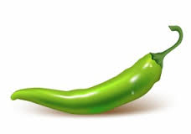  Mild | - head
 | - bread
 | - tread
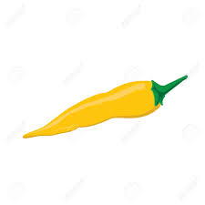  Spicy | - wealth
 | - health
 | - spread
 | - feather
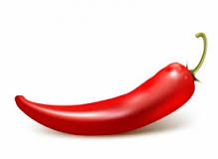  Hot | - leather
 | - weather
 | - ready
 | - steady
 | - beach
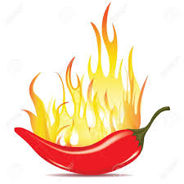  Flaming Hot | - beautiful
 | - bearable
 | - beaches
 | - appealing
 | - agreeable
Tables this week | 2, 5, 10

Week 1: ea words
Test date: 15 Sept
Own Spellings
Mild | - head
 | - bread
 | - tread
Spicy | - wealth
 | - health
 | - spread
 | - feather
Hot | - leather
 | - weather
 | - ready
 | - steady
 | - beach
Flaming Hot | - beautiful
 | - bearable
 | - beaches
 | - appealing
 | - agreeable
Tables this week | 2, 5, 10

