Towers, Tunnels and Turrets

Autumn Term

Dosbarth Langland – Mrs Evans

**St David’s Catholic Primary School**

**Language, Literacy and Communication development**

This term is set to be an exciting one as we step back in time! We will be investigating Castles; Medieval and fairy tale! We will write recounts, letters, report speech, label, and learn the features of story writing.

We will continue with Read, Write, Inc and practise our handwriting using the penpals scheme.

Reading is very important as always and the children will be assessed on this in May. Please support your children reading daily at home and by using the Reading Eggs programme.

Spellings will be given on Wednesday and handwriting on a Friday.

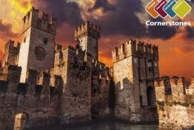

**Mathematical development**

We will be learning to read and write numbers to 100 and beyond ,sequencing and place value. Use and understand mathematical signs and symbols for addition, subtraction and equals.

We will learn number facts to 100!

Recognise coins and pay for items up to 50p then £1.

We will look at length; using non-standard units then metres, 1/2 metres and centimetres. We will understand and order the days of the week, recording them when ready.

We will learn about pattern, 2D and 3D shapes.

*Children will need to wear a watch as we will be learning about time.*

Year 2 children will need to know the 2 times tables for rapid recall.

Problem solving and ‘Talk it, Solve it’ we be weekly.

**Maths homework is on a Friday**

FIRM FOUNDATIONS HIGH EXPECTATIONS

**Personal and Social development, well-being and cultural diversity**

We will learn about new beginnings and how we ‘get on’ with each other. We’ll design healthy meals and study the healthy eating plate. We’ll link this to our ‘Rights’ work and develop our learning behaviours such as; perseverance, resilience, problem solving and motivation.

**St David’s Catholic Primary School**



**Religious education**

*Come and See*

Beginnings – We will be looking at how God was at the very beginning and is at all our new beginnings

Signs and Symbols – we will link this to Baptism

If any pupils will be making their First Holy Communion this year then please let me know as well as your Priest as the Parishes will be starting their classes soon

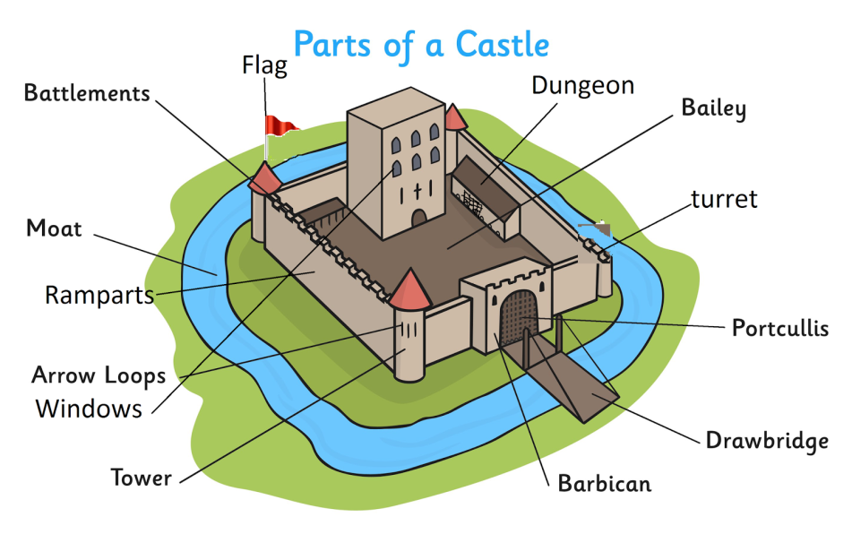

**Knowledge and understanding of the world**

We will step back in time to investigate Towers, bridges, and amazing structures. We will learn about Castles and castle life comparing life in the past to today. We will learn of the works of Isambard Kingdom Brunel and find out about bridges and tunnels. We will learn about animals that burrow and living things and their habitats. We will also work scientifically and to test which materials are best for building. It’s going to be very interesting!

FIRM FOUNDATIONS HIGH EXPECTATIONS

**Welsh**

Doli Glwt will be making her way to your house over the next few weeks, please return her to school as soon as possible so everyone gets the chance to take her home.

We will be learning;

· To count * talk about families

· To say our feelings * comment on weather

· To say what we like * Name items of clothing

All in WELSH!

**St David’s Catholic Primary School**



**Physical Development**

PE will be on a FRIDAY and children will need an indoor school PE kit which they are welcome to wear to school.

Our focus this term will be attack and defend !

We will learn about invasion games learn rules and elements of games and play simple cooperative/competitive games

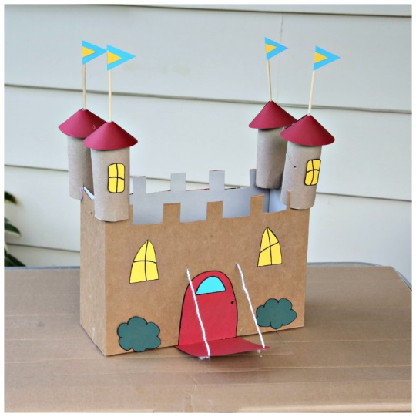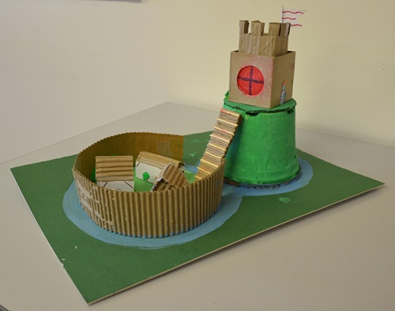

**ICT**

We will learn to understand what personal data is; look at our passwords/ usernames and why they are important

Learn about our ‘Digital footprints’ and our data trails. Look at how to be sensible online, cyberbullying and how to deal with it.

Learn how to do safe searches online.

Learn to find a balance between ‘cybertime’ and other activities.

As well as using ‘HWB’ packages and iPad’s to enhance our learning.

Continue with Reading Eggs and start the TTRock stars programme to enhance our Times Tables.

**Creative Development**

We will be using our design and technology skills to build castles and towers. We’ll look at mechanisms and learn how draw bridges and catapults work. We’ll draw castles from observation and paint castles in the style of Paul Klee. We’ll design our own coat of arms and look at symbols from the past and what they represent.

FIRM FOUNDATIONS HIGH EXPECTATIONS

**Day to day**In Year 2 we teach children to be responsible our fruit tuck shop is just 20p! This is run by the children who ask and respond in welsh for their snack, recognise money, calculate change and discuss healthy eating so lots of real life skills being learnt for just 20p!

Please could children wear a **watch** to school as it really helps when learning to tell the time.

Our class pet is a hamster called **‘Sir Cuddles’** if you would like to take him home on the weekend please let me know

**St David’s Catholic Primary School**



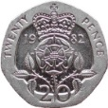

**Enhancements**

Oystermouth castle visit – We will be visiting Oystermouth Castle several times to first observe and draw, then to go inside and explore and finally to act out a battle!

We will also visit Caerphilly Castle on 27th September (see Consent form) to see the castle walls, moats, draw bridge and even dragons!

If you have any toys/books at home that you would like to share with the class then please send them in. Or if you have any items for our role play **Castle** we would be most grateful. Also if you have any talents you would like to share with us please let us know. Finally if you have any ideas for trips or guest speakers then please let me know.

[EvansC808@hwbmail.com](mailto:EvansC808@hwbmail.com)

Home challenges to try – 10 house points for each one completed!

* Find out about famous engineers. Search the web and use non-fiction books to find out about their life and work. Draw a picture to show one of their most famous achievements and think about why their work was so important.
* Go on a bridge hunt with your grown ups around the local area , take photos to show the class. What types of bridge did you see?
* Play a tumbling tower game such as Jenga with your family. What are the best ways of keeping the tower upright?
* Design and create a model of a famous structure from around the world, using junk materials found at home. Will you choose London Bridge, the Leaning Tower of Pisa or a famous castle? Bring in your model for 10 house points!
* Make an information book about castles, bridges or tunnels. Include drawings, writing, images off line and diagrams. What fascinating facts can you find out to amaze your class?

FIRM FOUNDATIONS HIGH EXPECTATIONS

FIRM FOUNDATIONS HIGH EXPECTATIONS