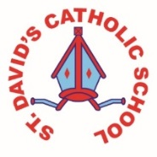
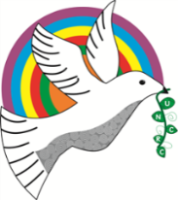
Class Caswell

Information for the week: 06/07/18
Literacy: | This week the children have completed lots of recounts based on stories from the Bible such as Levi and Zacchaeus. They are writing lists for our Woodland picnic next week.  They also wrote a persuasive piece of language on Gruffalo crumble.
Numeracy: | The children have worked on using number bond knowledge to work out trickier sums and have completed problem solving based on a party. The children experimented with ideas and listened well to the problem and work on a solution in groups.
Religion: | Our Topic of Reconciliation is underway and we are linking it to choices we make in our world.
Any other information: | Huge apologies for no communication over the past fortnight. Hwb has changed again and I struggled to log on. If you are struggling the reason is that now the user name needs to be followed by Hwbcymru.net. Instead of simply writing the child’s user name.  Final Woodland Walk is Wednesday! We shall have a Gruffalo tea party. Hopefully serving Gruffalo snacks. If you can accompany us then let me know asap.  Fun Run Macmillan- ALL children will bring home a sponsor and a reminder. They will all be able to write who they are running for on a special piece of paper that will be pinned to their back. Can you email or write in who you’d like on your child’s back please. I fear sending them home will result in them getting lost or not returned etc. I vow to write all names requested on the children’s backs but please let me know.
Homework | I have absolutely loved the Andy Goldsworthy art I have received, we could sell some of it I’m sure!

