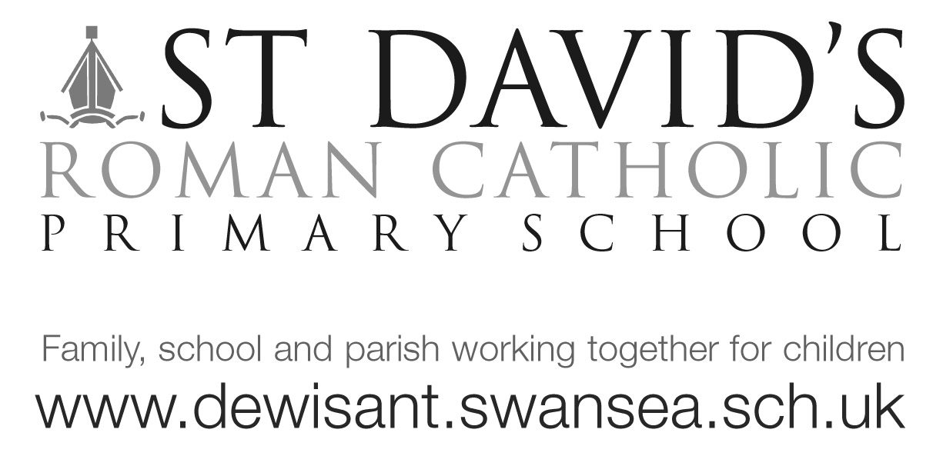
Dear Dosbarth Langland, 25/5/18

Wow what a week! The children created fantastic sensory write ups on the computer of our trip to Margam and were able to import images into their documents too! Check out their hwb pages for their work. We really enjoyed our Fire safety training and the fire officer was impressed with their knowledge of the Great Fire of London.

In religious studies we have been learning about the gifts the Holy Spirit give us and have learnt that the Holy Spirit helps and guides us. The children were very well behaved in our Pentecost service at Our Lady Star of the Sea and enjoyed walking back with a Year 6 partner. Please continue to pray for our First Holy Communion children.

We have really enjoyed studying different artists this term and the children are keen to have an exhibition!

We’ve continued reading ‘George’s Marvellous Medicine’ and have written lists of what we’d put in our own concoctions. We will continue reading next term and our literacy focus will be recipes, for this reason I’ve asked the children to write their favourite recipe for homework. I will compile all the recipes and hopefully we will be able to have a class recipe book! Please feel free to add photos or pictures of the item you make. You may wish to complete the worksheet or use HWB to write your recipe. Good luck! Please remember to add a ‘Warning’ i.e. may contain nuts!

Thank you for coming to Sports day today, it was a shame about the weather as we had to cut it short but your continued support means a lot. We will make sure the children get to race again.

Many thanks
Mrs Evans EvansC808@hwbmail.net

Please see Twitter @stdavidscps for our class photos

