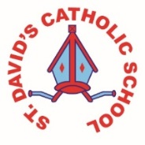
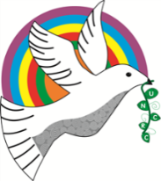
Class Caswell

Information for the week: 18/05/18
Literacy: | This week the children have continued their work on instructions and have developed what instruction writing needs. They then used this to create instructions for making a Pentecost crown. So the ‘bossiness’ may continue for a while- sorry. They also followed instructions to make cucumber sandwiches for our royal party
Numeracy: | The children worked on halves and quarters this week and we’ll continue this in their challenges next week.
Religion: | The children have listened to the story of Pentecost and created crowns. They also wrote about the story and we had a little session on speaking in different languages. We’ll continue this next week and celebrate the birthday of the church.
Any other information: | Next Tuesday Y1 will walk to Mass to celebrate Pentecost If any Reception parents feel their children could manage the walk there and back let me know and I’ll send a consent form.  The children had a wonderful time at the royal party. They made ,masks, flags, decorated biscuits and prepared their own cucumber sandwiches- how posh!  Trip letter to be sent out Monday (I promise). We have finally had confirmation! Yay!
Homework | Homework is practical this week! Practise halves and quarters. Make a cake and cut into quarters or even more pieces and talk about the parts. If you prefer use pizza. Take photos and email me or upload to child’s file on Hwb.  ChamberlainS5@hwbmail.net
NEEDED | Tomato sauce squeezy bottles please. We want to decant our bigger paint pots into them to enable the children to independently access the paints.  Empty toilet rolls!!!!!

