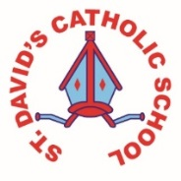
Class Caswell

Information for the week: 04/05/18
Literacy: | This week we’ve continued to read non- fiction books to read about woodland animals. The children have thought about fact questions for Oscar the Owl interviewed him on Tuesday! Alongside this the children have created fact files using a computer programme.
Numeracy: | It’s been all about the money this week. Counting out amounts to 5p then 10 and beyond. Giving change.
Religion: | As this is the month of May the children have painted Mary and flowers for our display. They have discussed holy days and holidays and looked at the vocabulary we will be using during this topic.
Any other information: | The children have been out on a flower hunt and found a number of different species in abundance. The children estimated, tallied and counted.  Snack money envelopes have been sent home.
Handwriting and money worksheets for homework (don’t forget you can do it practically).
Enjoy your bank holiday!!

